
Republika ng Pilipinas
BARANGAY TATALON
Distrito IV, Lungsod Quezon
TANGGAPAN NG PUNONG BARANGAY
0977-203-0336 - Email Add: brgy.tatalon@quezoncity.gov.ph



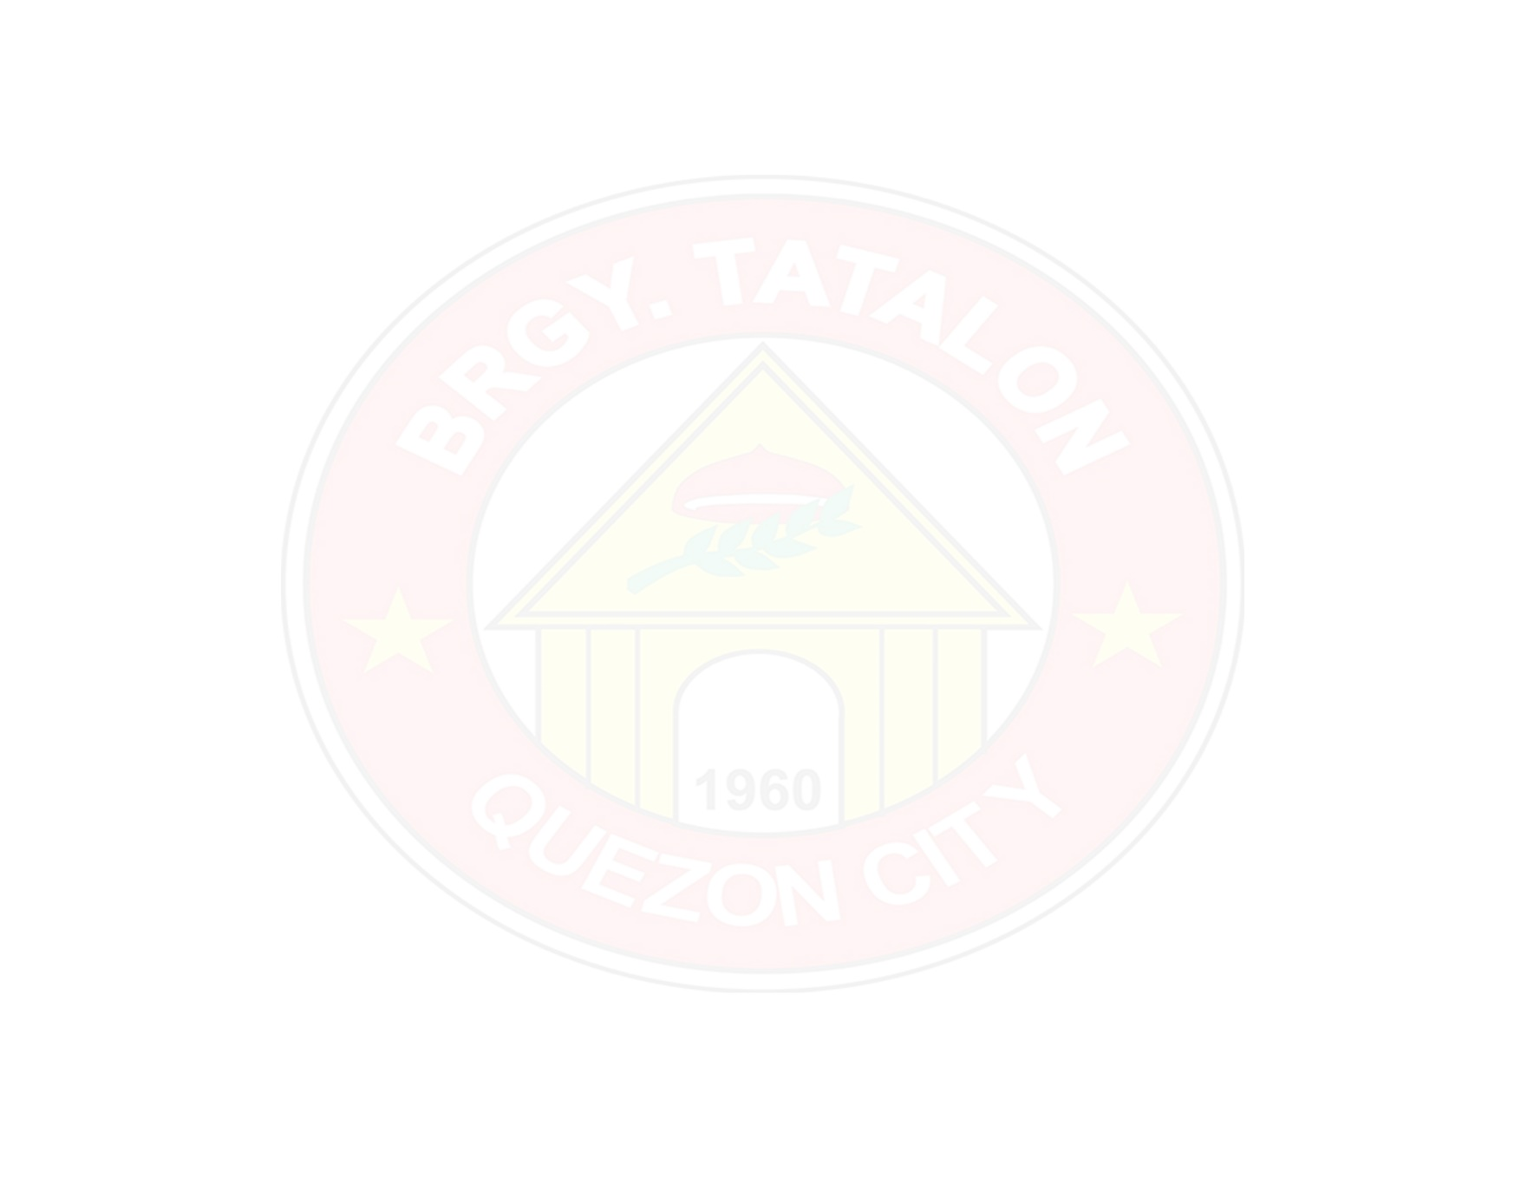
BARANGAY CLEARANCE

TO WHOM IT MAY CONCERN:

This is to certify that this office interposes no objection to the application of R.U DARUSSALAM, to unload ONE WING VAN (TRUCK) LOADED WITH SPARE PARTS, on JULY 14, 2026, at 9:00 AM-ONWARDS located at No. 64 KALIRAYA ST., Barangay Tatalon, Quezon City, provided that all Barangay and City Ordinances shall be strictly followed and observed.

Issued this 14th day of July, 2026 at Barangay Tatalon, Quezon City, Metro Manila.

EMMANUEL T. DEL MUNDO
Punong Barangay

Not Valid Without Official Seal
Valid Until December 31, 2026

