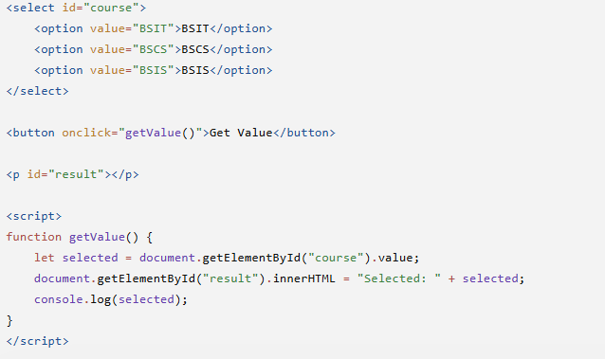

<div id="app">
<h2>Mathematical Computation</h2>

<input type="number" v-model.number="num1" placeholder="Enter first number">
<input type="number" v-model.number="num2" placeholder="Enter second number">

<br><br>

<button @click="compute">Compute</button>

<p>Addition: {{ sum }}</p>
<p>Subtraction: {{ difference }}</p>
<p>Multiplication: {{ product }}</p>
<p>Division: {{ quotient }}</p>
</div>

<script src="https://unpkg.com/vue@3/dist/vue.global.js"></script>

<script>
Vue.createApp({
data() {
return {
num1: 0,
num2: 0,
sum: 0,
difference: 0,
product: 0,
quotient: 0
};
},
methods: {
compute() {
this.sum = this.num1 + this.num2;
this.difference = this.num1 - this.num2;
this.product = this.num1 * this.num2;
this.quotient = this.num2 !== 0 ? this.num1 / this.num2 : "Cannot divide by zero";
}
}
}).mount("#app");
</script>

