Degree Completion Roadmap for Students

# Group members and contact details

* Tully McDonald: [tmcdon26@myune.edu.au](mailto:tmcdon26@myune.edu.au)
* Mark Anderson: [mander53@myune.edu.au](mailto:mander53@myune.edu.au)
* Nelson Pray: [npray@myune.edu.au](mailto:npray@myune.edu.au)
* Nicola Howard: [nhoward7@myune.edu.au](mailto:nhoward7@myune.edu.au)

# Client name and contact details

* Client: Student Services at UNE
* Contact: Timothy Bartlett-Taylor - [tbartle4@une.edu.au](mailto:tbartle4@une.edu.au)

Table of Contents

Summary of the project 3

Specification of client requirements 4

Input 4

Processing 4

Output 4

Statement of Project Scope 5

Project goals 5

Assumptions 5

Limitations/constraints 5

Acceptance criteria 5

Exclusions 6

Feasibility Statement 7

Time constraints 7

Group skill sets 7

Resource constraints 7

Technologies required 7

Budget 7

Overall 7

Assignment of Team Member Responsibilities 7

Project timeline specified using a Gantt chart. 8

Identification of project risks 9

Availability of group members and the client. 9

Team members keeping different schedules 9

Simulation of course handbook rules. 9

Time constraints 9

Further development 9

Appendix 10

1. Sample of the student data provided by SS 10

2. Sample of the student data upload form 10

3. Sample of the output after processing student data against the rule set 10

4. Sample of the potential roadmap for the student 11

5. Sample of proposed rule set for the B.A. degree 11

## Summary of the project

The client, UNE Student Services (SS) requires a working prototype to enable students to complete a self-check to see where they are up to within their degree. Currently this is a manual process performed by SS and they would like to have it automated. The platform should allow for students to input the units they have passed, including advanced standing credits granted. After selecting a course version, the tool should display the remaining units required to fulfill their degree.

## Specification of client requirements

### Input

A student should be able to load information regarding their degree progress onto an online platform for further processing.

These details will include all relevant information such as:

- course name and version

- major selected by the student

- names of units that the student has achieved credits for (including any Advanced Standing credits granted)

(Appendix 1: Sample of the student data provided by SS)

(Appendix 2: Sample of the student data upload form)

### Processing

After the student submits their course progress, the platform will then process the information using a set of predetermined rules. These rules will be provided by UNE’s course handbook which is available on their website at <https://handbook.une.edu.au/courses/>.

Each course and version published in the handbook has a different set of requirements and options available to the student. As such, each combination of course and version will need to be encoded into an electronic format that used can be used by the processing engine. The processing engine will match the student information provided with a one of these electronic rules that have been adapted from the handbook.

### Output

Once the processing has been completed, the platform will display how the student’s progress compares to the rules from the course handbook. It will identify any mandatory units that have not been completed and provide a list of units that still need to be attempted.

(Appendix 3: Sample of the output after processing student data against the rule set)

An additional output that the client requested is for the platform to suggest a roadmap that the student can follow. The roadmap should provide the student with a clearly catered course plan which outlines units yet to be completed, and when these units can be attempted. The unit availability takes into account pre-requisites, co-requisites, restrictions, the student's preferred study load along with any other relevant factors.

The client is particularly interested to know the time and effort required to develop and produce this working prototype. Their decision to move forward on this project will be dependent on whether the application is feasible within limited time and budget constraints.

(Appendix 4: Sample of the potential roadmap)

## Statement of Project Scope

### Project goals

This project is a prototype aimed at demonstrating whether there is potential to convert the client’s existing manual process into a fully automated electronic system that requires minimal human intervention. As such, the outcomes of the system do have some flexibility in that the client has asked that we set about to achieve as much as possible within our limited timeframe.

The fundamental deliverables are:

* A desktop web-based platform that allows a student to upload their current course progress in CSV format.
* At least six (6) rule sets for the courses being evaluated in this prototype, that is, B.A., B. Comp and B. Nursing for the 2021 and 2022 versions. The rule sets will be created manually during development as we are unable to obtain correctly formatted rule sets from the existing API.
* The processing engine (know as the backend). This will read the information from the CSV and match it with one of the rule sets that have been created. If it finds a matching rule set, the processing engine will compare the student data to the rule set to produce an outcome. (Appendix 5: Sample of a JSON rule set for BA degree)
* An outcome will be rendered on desktop-website in a format that is easy to understand. If the platform is unable to compile the results, it should display the reason on the website and refer the student to SS for further investigation.

### Assumptions

* The student’s course details and progress information will be produced by a system that does not currently exist. Therefore, the client has agreed to provide sample data in the form of CSV files which contain the necessary data to use for processing.
  + The CSV files provided will be consistent per course and version and will contain all units completed, as well as any units achieved from Advanced Standing. Where applicable it will contain the elected Major(s)/Minor(s) for the course.
  + If the information indicates that a unit has been completed, the assumption is that the necessary prerequisites have also been satisfied.
  + The student has satisfied their progression rules and all other mandatory requirements.

### Limitations/constraints

* The number of courses that can be processed will depend on their complexity. This prototype will concentrate on processing the B.Arts, B.Nursing and B.Comp degrees. If there is time, further work around more complicated degrees may be attempted.
* The roadmap of how to achieve completion of the degree will be time dependent. If this is developed, the checking of prerequisites for units suggested on the roadmap may not be feasible.
* It may be difficult obtaining data and feedback from the client timeously due to more pressing commitments.

### Acceptance criteria

* The website should be visually appealing and easy to use.
* The outcome displayed to the student must be easy to understand.
* The result produced must be accurate, at least to the same standard as achieved by the client’s manual process. The system will be tested against invalid data to ensure the platform picks up any discrepancies.
* The system must be able to identify when invalid data is provided and display informative messages to the student should it not be able to produce an outcome.

### Exclusions

* The system to produce the student information in CSV format will not form part of this prototype.
* Satisfactory Course Progression rules will not be evaluated, for example, any rules that require a minimum grade.
* The results displayed on the website will not be in a format suitable for printing.

## Feasibility Statement

### Time constraints

The deadline for the project submission is the end of Trimester 1. However, as the client’s main focus is to see a working prototype, we should be able to achieve the fundamental requirements. As such, some non-critical requirements, such as achieving acceptance on the look and feel may not be met.

### Group skill sets

All aspects of this project's requirements can be met by the existing skill set of the team members. The team members have a good understanding of the end goal for the project and as such the capabilities to achieve that goal are within the time frame.

### Resource constraints

Acquiring useable course rules data via an API has proved to be infeasible. However, after consultations with the client, we will be able to simulate the data by creating the course rule sets manually.

### Technologies required

* This project should be achievable using Open Source software solutions and the prototype should be able to run on UNE Turing’s system.
* Communication via UNE’s internal email system, Slack, Zoom and Teams as required.
* Project time expenditure will be recorded using Clockify.
* Version control is via Github.
* The platform will be built on client-side JavaScript, HTML and CSS
* There is no need for server-side processing or data storage. As mentioned, the website will be hosted on Turing.
* No additional software, training, libraries, hosting, or other resources are anticipated to be required

### Budget

* No financial budget has been specified by the client.
* There are no foreseeable upfront costs as outlined under Technologies required.

### Overall

* A product that fulfils the client’s needs will be delivered within schedule. That is, a website to demonstrate the potential look, feel, and functionality of the proposed tool.
* Should time permit, further graphical enhancements and/or core functionality beyond project specifications may be possible.

## Assignment of Team Member Responsibilities

* Coordinator: Nicola
* Documentation: Nicola, Mark
* Web Design: Tully, Nelson
* Overall technical design and architecture: All
* Development and testing: All

## Project timeline specified using a Gantt chart.

## Identification of project risks

### Availability of group members and the client.

This is a critical component to the success of the project, as having key stakeholder unavailability may significantly delay the project. This has already been experienced in the initial weeks due to illness and/ leave.

We are now in contact with other stakeholders at SS, so we do have other alternatives should our key stakeholder be unavailable.

### Team members keeping different schedules

This may prove a challenge for communications and for ensuring that consistent progress is made throughout the trimester

After some initial teething problems in getting the group together, we seem to have been able to find suitable time for a weekly meeting. Once we are underway with the main development side, it will be easier to work independently using version control tools. Additionally, access to Slack is seamless so a response to a question can be obtained from a team member at any time of the day.

### Simulation of course handbook rules.

There may be fringe cases that make electronic processing of the rules difficult or impossible to implement. A lack of understanding or overlooking an important consideration may potentially lead to incorrect results.

As this is a prototype to determine the concept’s feasibility, this is not seen as a major risk. If the prototype is unable to process degrees with simple rules, it will provide the necessary proof that the overall project is not achievable.

Some of the errors that may occur during the encoding of the rules may easily be mitigated by having a stakeholder who has experience with the course handbook evaluate the manually generated rule sets.

### Time constraints

Time is a consideration as due to the Trimester only spanning 15 weeks, and several delays have been experienced early in the project.

No significant delays in the coming weeks are anticipated. The group has a good understanding of what is required and should be able to move forward with developing the prototype.

### Further development

The feasibility of a more robust and universal version of the project remains uncertain as is it entirely reliant on the existence and accessibility of computer-readable course data.

This again is deemed low risk as it will be the client’s decision on how they wish to proceed based on the outcome of this project.

## Appendix

### 1. Sample of the student data provided by SS



### 2. Sample of the student data upload form

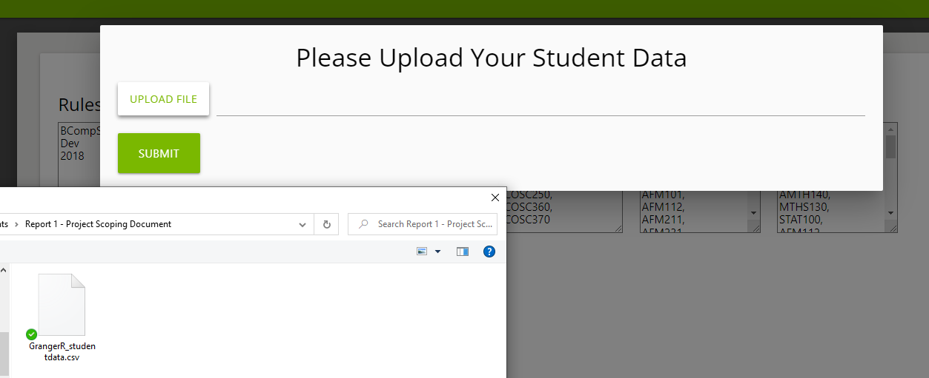

### 3. Sample of the output after processing student data against the rule set

### 4. Sample of the potential roadmap for the student

### 5. Sample of proposed rule set for the B.A. degree

