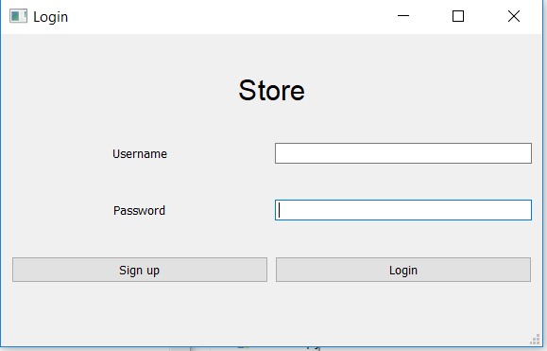

Here is the window at the start of the program.

The user can either Sign up, to create a new account, or Login to his/her existing account.

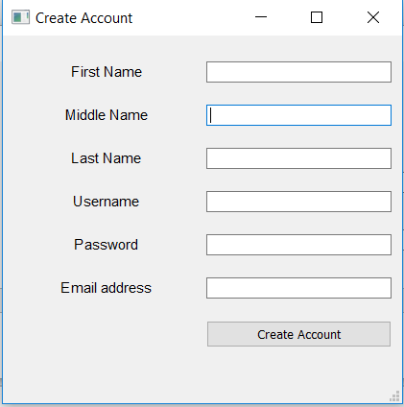

If the user chooses to Sign up, this window will pop up.

The user is required to input his First Name, Middle Name, Last Name, Username, Password, and Email address. Pressing on the Create Account button will save the user inputs into the database.

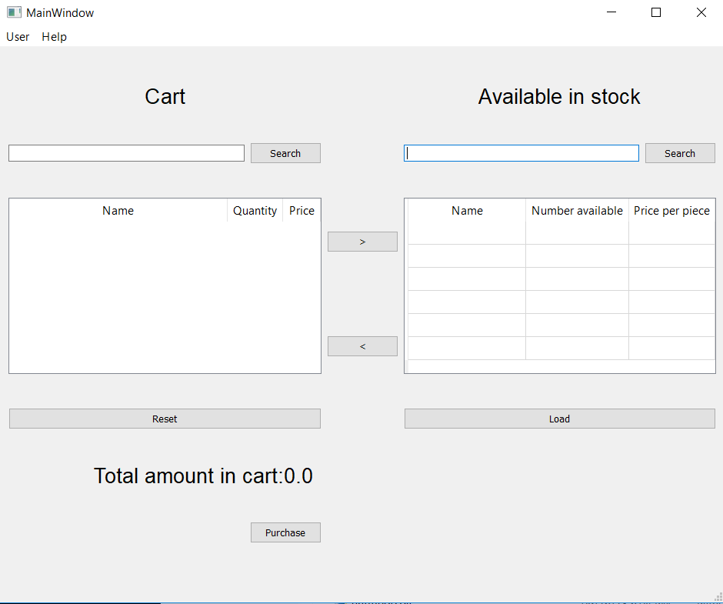

If the user chooses the Login button and the input credentials are correct, this window will appear. This window shows the items in the user’s cart as well as the available items in the shop.

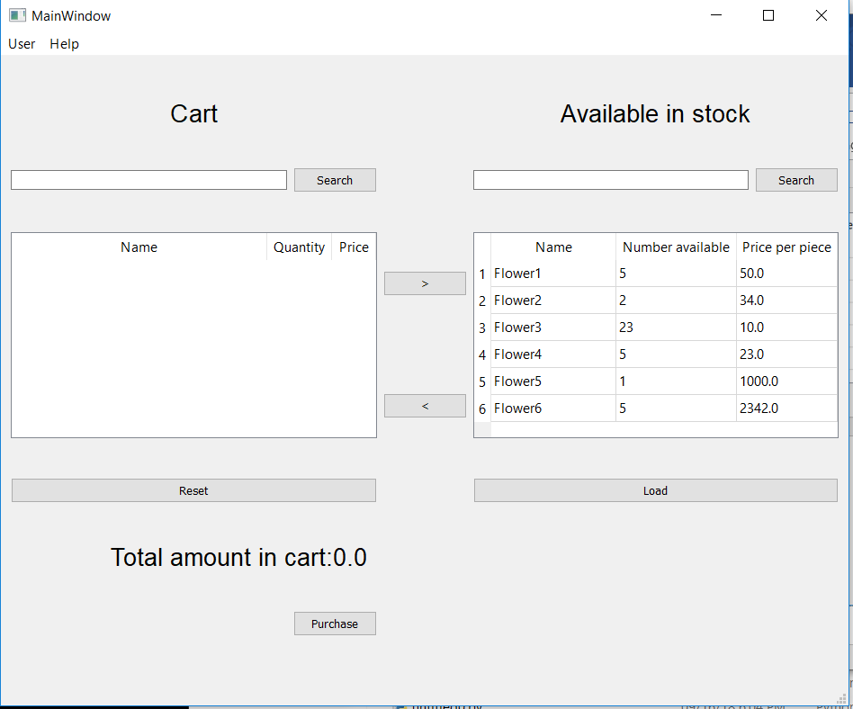

Pressing the Load button will load the available items in the stock to the table. The user will be able to see the Name, Number of items available, and the Price per piece of each item.

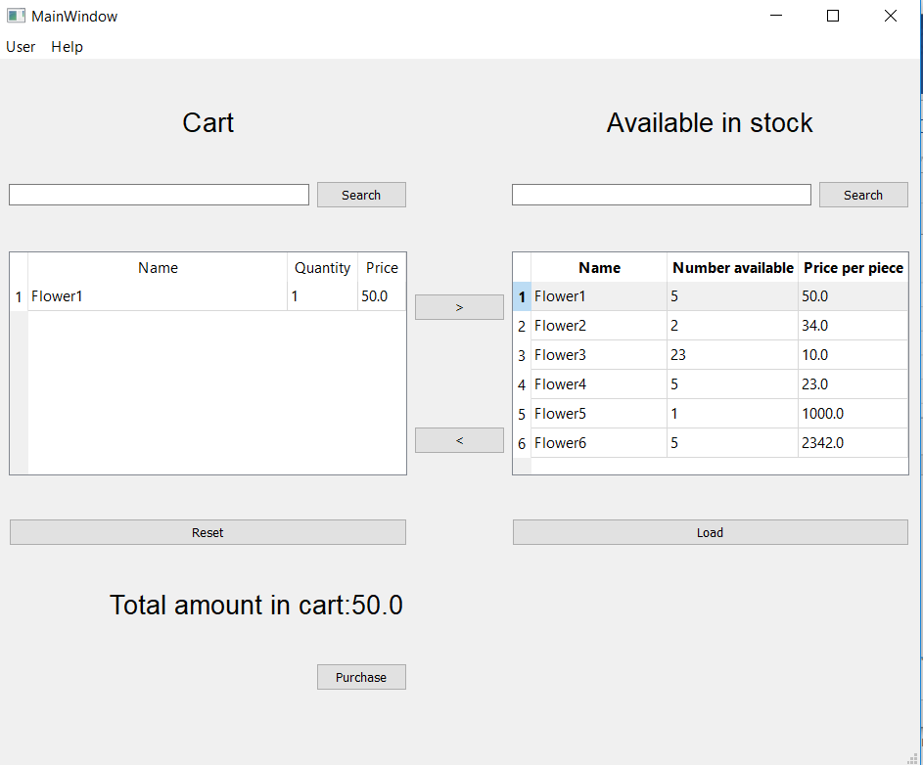

If the user wants to put an item into his/her cart, the user must first select the item in the table and then push the < button. The Name, Quantity, and Price of each item will appear on the table. The Total price of the items will also appear as seen from the picture.

The user can also choose to return items to the available stock table, or choose to empty his/her cart and return all the items.

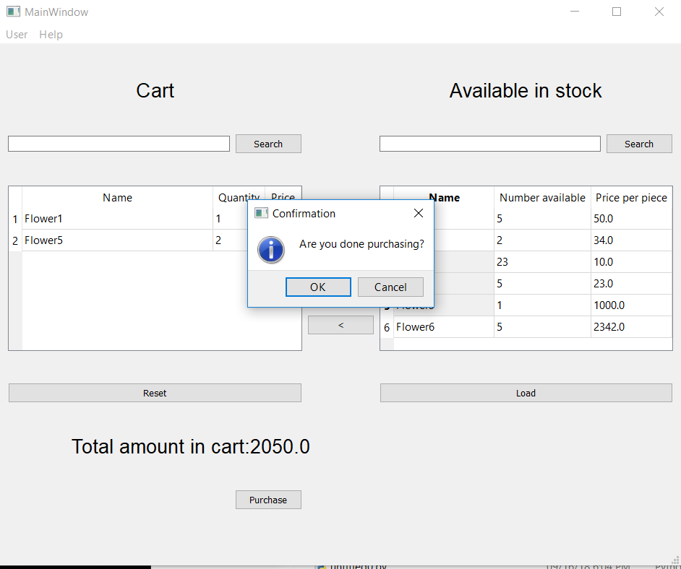

After the user if done selecting his/her desired items, pressing the purchase button will require a confirmation and then the transaction will be done.