mirBottleneck: A Dual-Score Framework for Identifying Transcriptome-Stabilizing miRNAs and Characterizing Their Survival Association in Pancreatic Adenocarcinoma
Mark Barsoum Markarian
Faculty of Medicine, American University of Beirut, Beirut, Lebanon
mkm25@mail.aub.edu · ORCID: 0009-0006-1240-9534

Abstract
Motivation: PDAC carries a five-year survival rate below 12%. miRNAs regulate hundreds of target genes simultaneously, yet existing biomarker frameworks score them individually, neglecting the systemic regulatory footprint each miRNA leaves on the transcriptome.
Results: I developed mirBottleneck, a Bioconductor R package that scores each miRNA on two axes: a Variance Suppression Score (VSS) and a Coherence Induction Score (CIS). Applied to 178 TCGA-PAAD patients with matched expression profiles (167 with complete survival data), the package classified 98 miRNAs into four functional archetypes and derived a mirBottleneck patient risk score. This score independently predicted overall survival (multivariable Cox HR = 6.55, 95% CI 3.42–12.55, p = 1.43 × 10⁻⁸; log-rank p = 4.29 × 10⁻⁸; Harrell's C-index = 0.699, optimism-corrected 0.595 by 500-resample bootstrap; proportional hazards confirmed by Schoenfeld residuals). Known oncomiRs hsa-miR-21 and hsa-miR-155 ranked highest in the silencer archetype. Performance metrics are in-sample estimates; external validation in independent PDAC cohorts is the immediate next step.
Availability and implementation: Freely available on GitHub (https://github.com/MarkBarsoumMarkarian/mirBottleneck) and submitted to Bioconductor (under review), MIT license. Data archived on Zenodo (Markarian, 2025a; DOI: 10.5281/zenodo.19121116).
Contact: mkm25@mail.aub.edu

Keywords: miRNA, pancreatic cancer, TCGA-PAAD, survival analysis, variance suppression, coherence induction, bottleneck score, R package, Bioconductor, network biology

1. Introduction
Pancreatic ductal adenocarcinoma (PDAC) is the third leading cause of cancer-related death in the United States and is projected to become the second by 2030 (Siegel et al., 2023). Despite incremental advances in chemotherapy regimens, the five-year overall survival rate remains below 12%, reflecting both the late stage at diagnosis and a deep resistance to therapy whose molecular basis remains poorly understood (Rahib et al., 2021). Reliable prognostic biomarkers are urgently needed.
MicroRNAs (miRNAs) are short non-coding RNAs approximately 22 nucleotides in length that regulate gene expression primarily through translational repression and mRNA destabilisation via the RISC complex (Bartel, 2009). A single miRNA can target hundreds of mRNAs simultaneously, placing it at the intersection of multiple signalling and metabolic pathways. In PDAC specifically, miRNAs such as hsa-miR-21 and hsa-miR-155 have been repeatedly identified as oncogenic drivers, while tissue-specific miRNAs such as hsa-miR-217, which is highly expressed in normal pancreatic acinar cells, are frequently silenced in malignancy (Bloomston et al., 2007; Rachagani et al., 2010).
Most existing miRNA biomarker frameworks evaluate miRNAs individually. A miRNA is nominated if its expression correlates with a clinical endpoint, irrespective of how it interacts with the broader transcriptome. This gene-centric view misses the network topology through which miRNAs exert influence. A miRNA that suppresses variance across its target ensemble, reducing transcriptome noise, may have a fundamentally different clinical impact than one with equivalent expression but disordered target regulation.
Existing network-based miRNA tools such as miRNet and miEAA approach this problem through pathway enrichment or network topology, identifying miRNAs central to interaction networks or enriched in biological processes. These approaches capture structural network position but do not directly measure whether a miRNA's expression variation empirically accounts for transcriptome variance and target co-ordination across patients. To my knowledge, no existing framework jointly quantifies transcriptome-wide variance suppression and coherence induction as dual axes of miRNA regulatory impact. To address this gap, I developed mirBottleneck, a computational framework and Bioconductor R package that evaluates each miRNA through two complementary lenses: the Variance Suppression Score (VSS) and the Coherence Induction Score (CIS). Together these scores place every miRNA in a two-dimensional regulatory space and define four functional archetypes (dual, silencer, conductor, and weak). A patient-level mirBottleneck patient risk score is then derived from the miRNAs whose archetype scores associate most strongly with survival. The package generates a self-contained interactive HTML report from a single function call. I applied the framework to 178 TCGA-PAAD patients with matched RNA-seq and miRNA-seq data, one of the largest publicly available pancreatic multi-omics cohorts.

2. Methods and Implementation

2.1 Data Sources and Cohort
RNA-seq gene expression counts and miRNA expression quantification data for TCGA-PAAD were downloaded from the NIH Genomic Data Commons using the TCGAbiolinks R package (Colaprico et al., 2016). Only primary solid tumour samples were retained. TCGA barcodes were trimmed to the first 12 characters (patient-level identifiers) to enable cross-assay matching; where a patient contributed more than one sample per assay, the first sample by barcode order was retained. RNA-seq and miRNA-seq matrices were intersected on patient identifiers, and only patients present in both were retained. After this harmonization, 178 patients had complete matched RNA-seq and miRNA-seq profiles. Of these, 167 had complete survival data and formed the primary analytical cohort; 164 were available for the multivariable Cox model after excluding three patients with missing age or stage covariates. Clinical variables were age at diagnosis, tumour stage (I-IV), and overall survival with vital status as event indicator. Expression matrices were log2(count + 1) transformed. The harmonized dataset is archived on Zenodo (Markarian, 2025a; DOI: 10.5281/zenodo.19121116).

2.2 miRNA-Target Network Construction
Validated miRNA-target interactions were retrieved from miRTarBase via the multiMiR Bioconductor package (Ru et al., 2014), queried in batches of 50 miRNAs to avoid server timeouts. Interactions were retained only when the target gene symbol was present in the RNA-seq dataset after mapping via biomaRt (Durinck et al., 2009). A minimum of five validated targets per miRNA was required for inclusion, yielding 98 miRNAs for scoring.

2.3 Variance Suppression Score
For each miRNA, a linear model was fitted for every validated target gene regressed on the miRNA log2-transformed expression across the 167 shared patients. The VSS was defined as the mean R-squared across all validated target gene regressions. A higher VSS means the miRNA accounts for a larger fraction of its targets' expression variance across patients, which is consistent with strong transcriptome-stabilizing activity. Because VSS averages across all validated targets, miRNAs with more targets are not inherently favoured: Spearman correlation between target count and VSS across the 98 scored miRNAs was ρ = 0.18 (p = 0.08), confirming that VSS is not a simple proxy for target degree.

2.4 Coherence Induction Score
Patients were split at the median expression of each miRNA into high- and low-expression groups. For each group, the mean pairwise Pearson correlation among validated target genes was computed. The Coherence Induction Score was defined as the difference in mean pairwise correlation between the two groups. Empirical p-values were computed via 1,000 permutations in which patient group labels were randomly shuffled while maintaining group sizes.

2.5 Classification and Composite Score
Both scores were normalised to [0, 1] using min-max scaling. A composite bottleneck index was computed as the arithmetic mean of the normalised scores. miRNAs were classified into four archetypes using median splits: dual (high VSS and coherence), silencer (high VSS only), conductor (high coherence only), and weak (both below median). These archetypes should be interpreted as functional statistical phenotypes rather than discrete biological classes; the median split is used as an interpretability construct, and continuous scores are retained in all Cox models. Individual Cox models were fitted for each of the 98 miRNAs, adjusting for age and tumour stage. miRNAs with a nominal p-value below 0.15 were designated contributing miRNAs. This threshold functions as a ranking mechanism for composite score construction, not as an inferential test; the composite score's validity is evaluated as a whole unit by the multivariable Cox model, not by individual entry thresholds. Future iterations of the framework will evaluate stability-selection and cross-validated feature selection strategies; the current threshold prioritises discovery-stage sensitivity given the modest cohort size. Of the 98 miRNAs tested, 3 would remain significant after Benjamini–Hochberg FDR correction at q < 0.05, confirming that the liberal threshold is necessary to capture moderate signals at this sample size. The validity of the resulting composite is supported post hoc by formal verification of the proportional hazards assumption (Schoenfeld global p = 0.44), confirming that the model is not simply capturing statistical noise at the liberal entry threshold. A direction-aware patient risk score (hereafter "mirBottleneck patient risk score" to distinguish it from the miRNA-level bottleneck index) was then computed per patient as a weighted mean of contributing miRNA expression, weighted by the absolute Cox coefficient and signed by the direction of effect. Because these weights are derived from Cox models fitted on the same analytical cohort, the patient risk score HR reported here is an in-sample estimate and should be interpreted as a discovery-level signal pending external validation on an independent cohort such as ICGC-PACA.

2.6 Survival Analysis
Three Cox proportional hazards models were fitted using the survival R package (Therneau and Grambsch, 2000): (1) mirBottleneck patient risk score alone, (2) clinical covariates alone (age and stage), and (3) mirBottleneck patient risk score plus clinical covariates. Given the severe stage imbalance in this surgically resected cohort (Stage II: n = 151; Stages I, III, IV combined: n = 16, of which Stages III/IV: n = 9), tumour stage was modelled as a binary covariate (Stage I/II vs Stage III/IV) in the multivariable model to stabilise coefficient estimates. Model discrimination was assessed using Harrell's concordance index (C-index). Influential observations were assessed using dfbeta residuals; no extreme outliers were detected. Group survival differences were evaluated using the log-rank test. All analyses were conducted in R version 4.4. The mirBottleneck patient risk score is not a predictive classifier; performance metrics are therefore interpreted as descriptive in-sample estimates. The patient risk score for patient i is computed as: Score_i = Σ_j [ sign(β_j) × |β_j| × Expr_ij ] where the sum is over contributing miRNAs j, beta_j is the Cox coefficient from the individual miRNA model, and Expr_ij is the log2-transformed miRNA expression. Bootstrap internal validation (500 resamples, refitting all selection and weighting steps each time) was performed to estimate optimism-corrected discrimination; results are reported in Section 3.6. Specifically, for each resample: (1) patients were resampled with replacement; (2) miRNA selection at p < 0.15 was reapplied from scratch; (3) Cox weights were re-derived; (4) the patient risk score was computed on the bootstrap sample (apparent C-index) and then applied to the original sample (test C-index); optimism was estimated as the mean difference across resamples, and the corrected C-index as the naive C-index minus mean optimism. Calibration assessment is planned for external validation cohorts.

2.7 Software and Reproducibility
The mirBottleneck R package (v0.99.0) is available on GitHub (Markarian, 2025b; https://github.com/MarkBarsoumMarkarian/mirBottleneck) and has been submitted to Bioconductor (issue #4217; under review). It can be installed directly from GitHub via devtools::install_github("MarkBarsoumMarkarian/mirBottleneck"); after Bioconductor acceptance it will be installable via BiocManager::install("mirBottleneck"). The package depends on Bioconductor packages (multiMiR, biomaRt, TCGAbiolinks, GSVA, survminer), which can be installed via BiocManager::install(). It includes a full workflow vignette, a synthetic toy dataset (10 patients, 50 genes, 30 miRNAs), and generates a self-contained interactive HTML report via generate_report(). The harmonized TCGA-PAAD dataset is downloadable via fetch_mirBottleneck_data() from Zenodo (Markarian, 2025a; DOI: 10.5281/zenodo.19121116).

2.8 Hallmark Pathway Entropy Analysis
To explore whether the mirBottleneck patient risk score reflects broader transcriptome disorganisation, single-sample gene set enrichment analysis (ssGSEA) was applied to the full RNA-seq matrix (167 patients) using the 50 MSigDB Hallmark gene sets, implemented via the GSVA Bioconductor package. Per-patient enrichment scores were normalised to [0, 1] across patients, and Shannon entropy was computed over the resulting 50-dimensional distribution for each patient: H = -∑ p_i log(p_i), where p_i is the normalised enrichment score for pathway i. Spearman correlation between per-patient entropy and the mirBottleneck patient risk score was computed. To confirm that the entropy-survival association was not confounding the score’s survival signal, entropy was added as a covariate to the multivariable Cox model and its independent contribution evaluated.

3. Results

3.1 Cohort Characteristics
The final analytical cohort comprised 167 TCGA-PAAD patients with complete matched RNA-seq, miRNA-seq, and survival data. Median age was 65 years. The cohort included 89 deceased patients and 78 censored as alive. Tumour stage was predominantly stage II (n = 151), with smaller contributions from stages I (n = 7), III (n = 4), and IV (n = 5); this distribution reflects a surgically resected case series enriched for locally resectable disease, and stage coefficient estimates should be interpreted accordingly. Following gene symbol mapping and quality filtering, 98 miRNAs were retained for bottleneck scoring.

3.2 miRNA-Target Network
The filtered interaction network contained 98 miRNAs with a median of 106 validated targets per miRNA (range: 5 to 8,689). hsa-miR-21 had 739 validated targets and hsa-miR-155 had 1,007, consistent with their designation as master regulatory oncomiRs with broad target coverage. Twenty miRNAs had statistically significant coherence induction scores at p < 0.05 by permutation test.

3.3 VSS and Coherence Score Distributions
VSS values ranged from 0.0024 to 0.0749 across the 98 scored miRNAs, with a median of 0.0149. hsa-miR-155 had the highest VSS (0.0749), indicating that its expression explained the greatest mean fraction of target gene variance across patients. hsa-miR-21 ranked fifth with a VSS of 0.0508. Coherence scores ranged from -0.285 to 0.190; hsa-miR-802 had the highest coherence induction score (0.190, p < 0.005 by permutation test), while hsa-miR-5091 had the most negative score (-0.285).

3.4 miRNA Classification
Figure 1 shows the distribution of all 98 miRNAs in VSS-coherence space, with median-split boundaries separating the four archetypes. The classes were approximately equally represented: dual (n = 22), silencer (n = 27), conductor (n = 27), and weak (n = 22). hsa-miR-155 and hsa-miR-21 both fell in the silencer quadrant, consistent with their established role as target-suppressing oncomiRs that reduce noise across a broad target ensemble without inducing a coordinated programme. hsa-miR-217, a pancreas-specific tumour suppressor that targets KRAS and SIRT1, appeared in the conductor quadrant. hsa-miR-802, which ranked highest among conductors with a coherence score of 0.190, is a documented tumour suppressor in PDAC that targets MACC1.

Figure 1
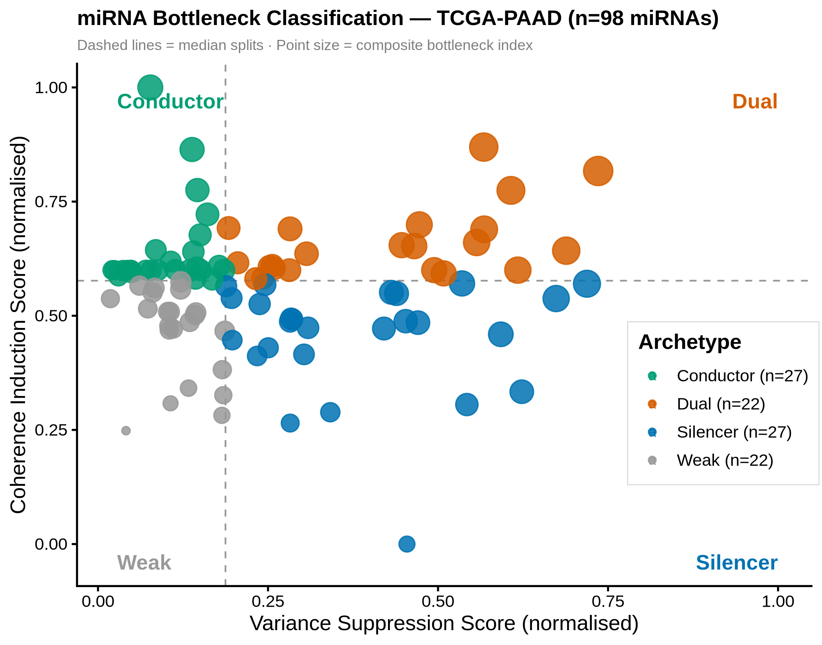
Figure 1. miRNA bottleneck classification in TCGA-PAAD (n = 98 miRNAs). Each point represents one miRNA plotted by normalised VSS (x-axis) and normalised coherence induction score (y-axis). Dashed lines indicate median splits defining the four archetypes: dual (high VSS, high coherence), silencer (high VSS, low coherence), conductor (low VSS, high coherence), and weak (low VSS, low coherence). Point size is proportional to composite bottleneck index. Selected miRNAs of biological interest are labelled. Alt text: Scatter plot of 98 miRNAs in a two-dimensional space defined by Variance Suppression Score (x-axis) and Coherence Induction Score (y-axis), divided into four quadrants by dashed median-split lines. Points are sized by bottleneck index. hsa-miR-155 and hsa-miR-21 appear in the lower-right silencer quadrant; hsa-miR-217 and hsa-miR-802 appear in the upper-left conductor quadrant.

3.5 Top Bottleneck miRNAs
Table 1 lists the top five miRNAs per archetype ranked by composite bottleneck index. hsa-miR-378c ranked highest overall with an index of 0.776. hsa-miR-155 led the silencer class with an index of 0.700 (HR = 1.19, p = 0.097), and hsa-miR-21 showed the strongest individual survival association in the dataset (HR = 1.42, p = 0.006). Among conductors, hsa-miR-802 (index = 0.538) targets MACC1 and is consistently reduced in PDAC, while hsa-miR-217 (index = 0.501) targets KRAS and SIRT1 and is the most pancreas-specific miRNA in the scored set (Colamaio et al., 2011). Notably, hsa-miR-548s in the weak class shows a protective association (HR = 0.72, p = 0.045), suggesting that not all survival-associated miRNAs identified at the liberal p < 0.15 threshold act as risk factors; this miRNA warrants further investigation as a potential tumour-suppressive weak-class member.
miRNA | Class | VSS | Coherence | Bottleneck Index | HR (OS) | p
hsa-miR-378c | Dual | 0.0554 | 0.103 | 0.776 | 1.04 | 0.731
hsa-miR-4491 | Dual | 0.0430 | 0.128 | 0.718 | 0.97 | 0.752
hsa-miR-326 | Dual | 0.0459 | 0.083 | 0.691 | 1.10 | 0.387
hsa-miR-4473 | Dual | 0.0519 | 0.020 | 0.666 | 0.99 | 0.952
hsa-miR-1295a | Dual | 0.0430 | 0.042 | 0.629 | 1.09 | 0.419
hsa-miR-155 | Silencer | 0.0749 | -0.095 | 0.700 | 1.19 | 0.097
hsa-miR-7702 | Silencer | 0.0542 | -0.014 | 0.645 | 0.97 | 0.779
hsa-miR-21 | Silencer | 0.0508 | -0.030 | 0.606 | 1.42 | 0.006*
hsa-miR-375 | Silencer | 0.0406 | -0.014 | 0.553 | 0.98 | 0.676
hsa-miR-107 | Silencer | 0.0448 | -0.067 | 0.526 | 1.01 | 0.968
hsa-miR-802 | Conductor | 0.0068 | 0.190 | 0.538 | 1.02 | 0.581
hsa-miR-217 | Conductor | 0.0113 | 0.126 | 0.501 | 1.03 | 0.358
hsa-miR-551a | Conductor | 0.0119 | 0.083 | 0.461 | 1.16 | 0.155
hsa-miR-1262 | Conductor | 0.0130 | 0.058 | 0.441 | 1.11 | 0.378
hsa-miR-548v | Conductor | 0.0122 | 0.037 | 0.414 | 0.87 | 0.205
hsa-miR-548s | Weak | 0.0101 | -0.012 | 0.348 | 0.72 | 0.045*
hsa-miR-1269a | Weak | 0.0101 | -0.020 | 0.340 | 0.97 | 0.456
hsa-miR-5706 | Weak | 0.0148 | -0.063 | 0.327 | 0.85 | 0.291
hsa-miR-3652 | Weak | 0.0117 | -0.044 | 0.326 | 0.98 | 0.879
hsa-miR-484 | Weak | 0.0116 | -0.047 | 0.322 | 1.00 | 0.982
* p < 0.05 nominal; values are not corrected for multiple comparisons (98 models fitted). HR, hazard ratio for overall survival.

3.6 mirBottleneck Patient Risk Score and Overall Survival
The mirBottleneck patient risk score significantly predicted overall survival in a multivariable Cox model adjusted for age and tumour stage (HR = 6.55, 95% CI 3.42–12.55, naive Harrell's C-index = 0.699; Table 2). Bootstrap optimism correction (500 resamples, refitting full feature selection and weight derivation each time) yielded a mean optimism of 0.097 (95% CI 0.057–0.145) and an optimism-corrected C-index of 0.595, indicating moderate discriminative ability after accounting for in-sample overfitting. For comparison, the clinical-only model (age and tumour stage alone) achieved a C-index of 0.580, indicating that the mirBottleneck patient risk score provides incremental discriminative value beyond standard clinical variables. Patients with high mirBottleneck patient risk scores had a median overall survival of 366 days compared to 627 days in the low-score group, with more events in the high-score group (56/84 deaths versus 33/83; log-rank p = 4.29 × 10⁻⁸). Proportional hazards assumptions were verified using Schoenfeld residuals (global p = 0.44; composite score p = 0.96), confirming that the hazard ratio is constant over time. Because the patient risk score weights were derived from the same cohort, these performance metrics are in-sample estimates and likely optimistic; external validation in an independent cohort is required to establish generalisability. Kaplan-Meier survival curves are shown in Figure 2.
Table 2. Multivariable Cox proportional hazards model for overall survival.
Variable | HR | 95% CI | p-value | C-index
mirBottleneck patient risk score | 6.55 | 3.42–12.55 | 1.43 × 10⁻⁸ | 0.699 (corrected: 0.595)
Age (years) | 1.03 | 1.01–1.05 | 0.013 | N/A
Stage III/IV vs I/II | 1.30 | 0.60–2.83 | 0.511 | N/A
n = 164 (3 excluded due to missing covariates); 89 events. HR, hazard ratio; CI, confidence interval.

Figure 2
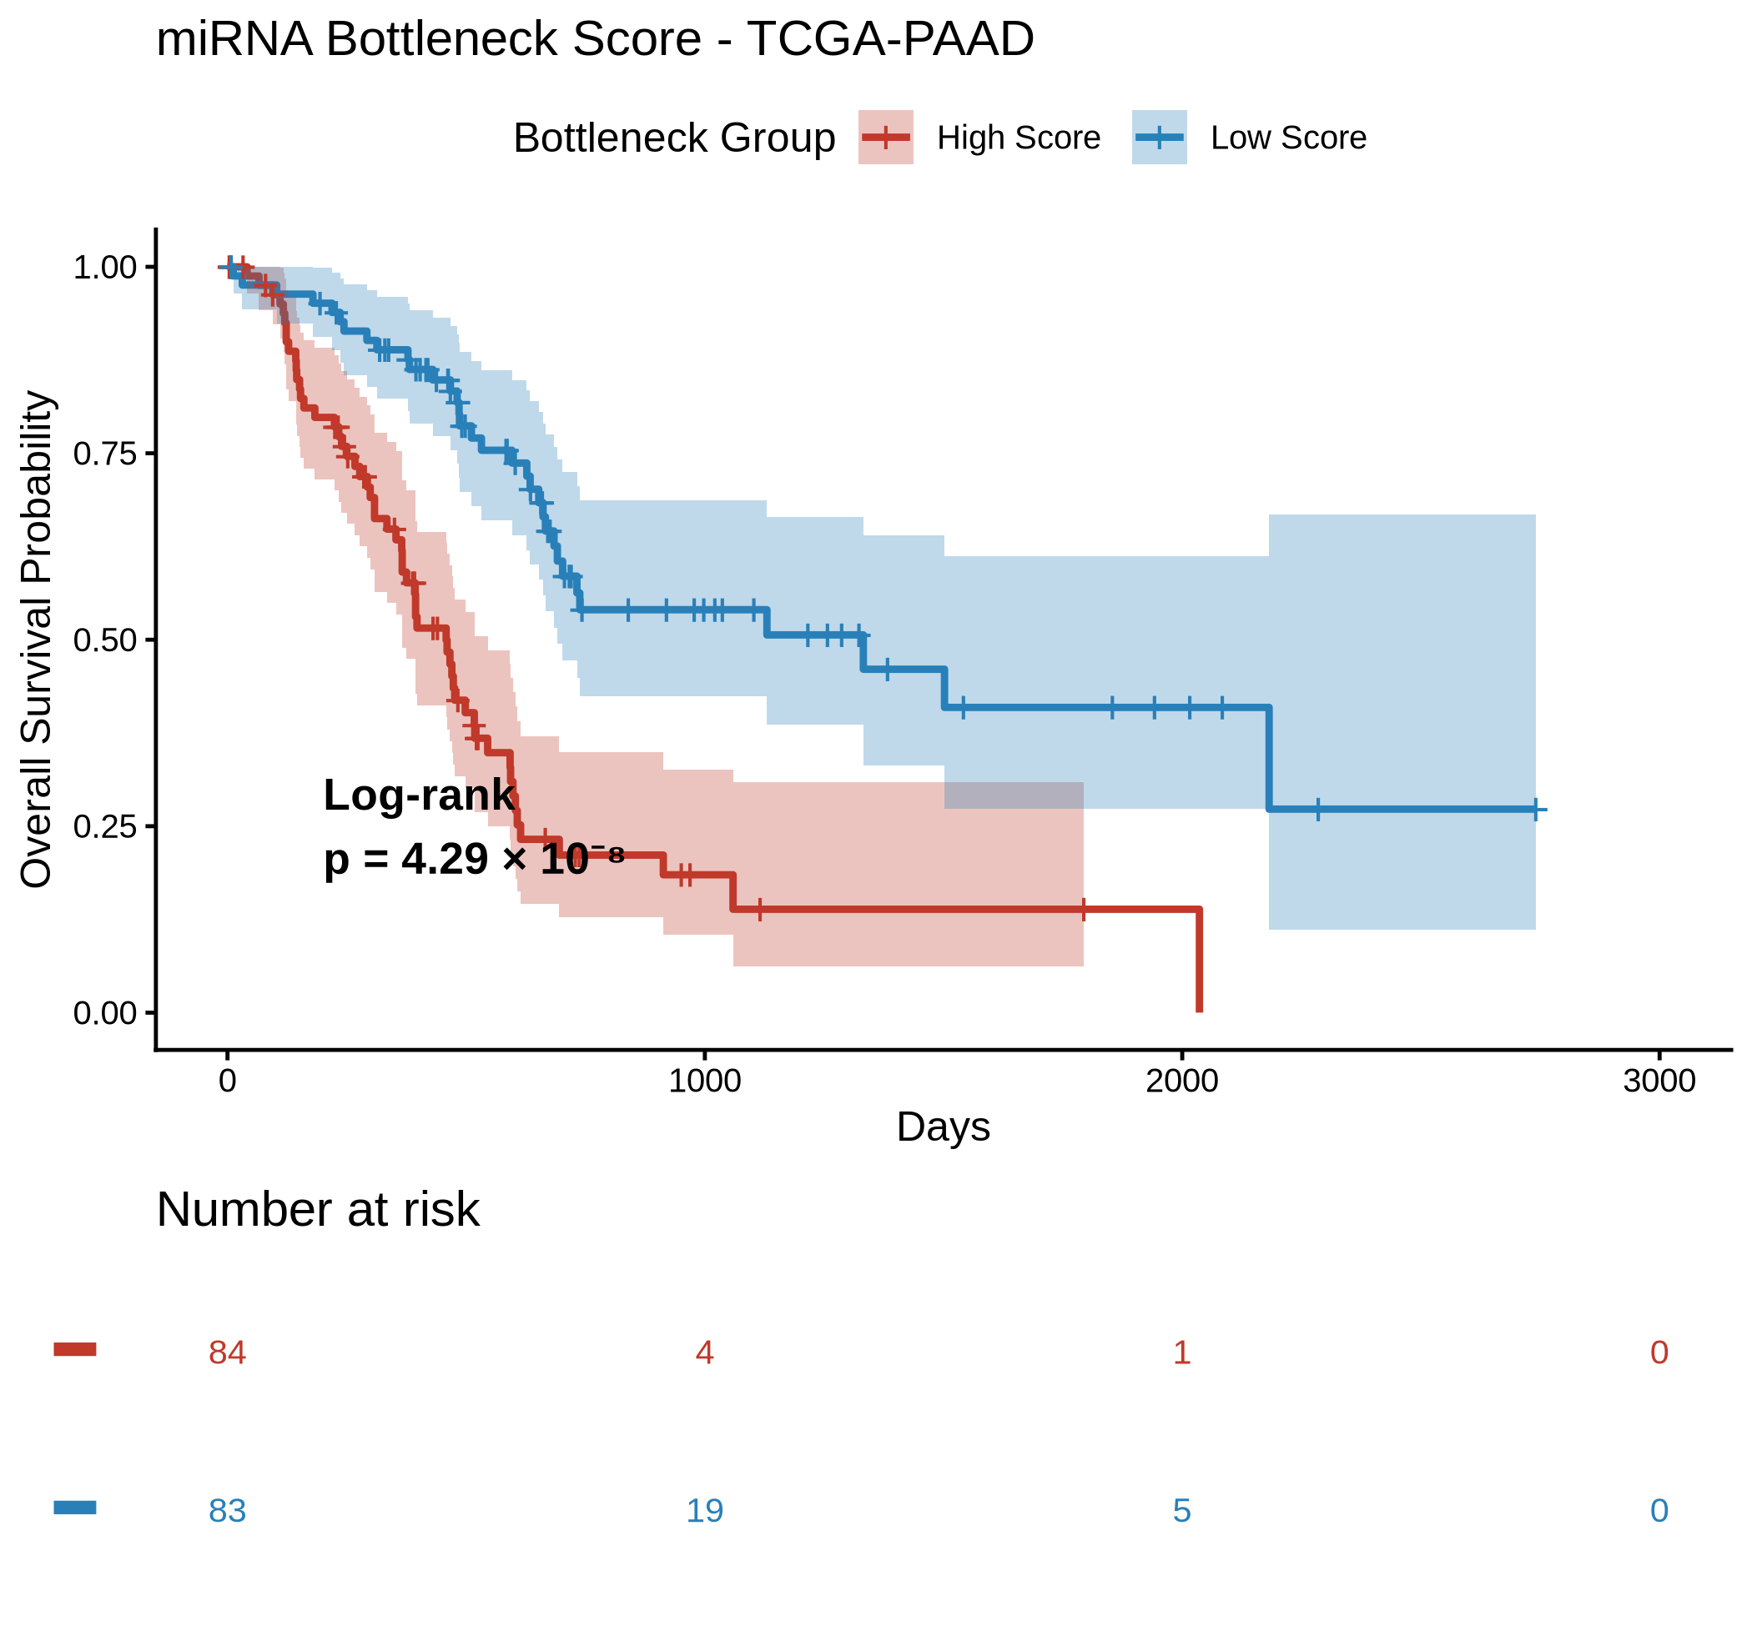
Figure 2. Kaplan-Meier overall survival curves for TCGA-PAAD patients (n = 167) stratified by mirBottleneck patient risk score (median split). High-score group (n = 84, 56 events, median OS 366 days) versus Low-score group (n = 83, 33 events, median OS 627 days). Log-rank p = 4.29 × 10⁻⁸ (univariable, high vs low). Multivariable Cox HR = 6.55 (95% CI 3.42–12.55), p = 1.43 × 10⁻⁸, naive Harrell's C-index = 0.699 (optimism-corrected: 0.595). Schoenfeld residuals confirmed proportional hazards (global p = 0.44). Alt text: Two Kaplan-Meier survival curves for TCGA-PAAD patients. The high mirBottleneck patient risk score group (red, n=84, 56 events) shows lower overall survival probability than the low-score group (blue, n=83, 33 events). Shaded regions indicate 95% confidence intervals. Log-rank p = 4.29 × 10⁻⁸; multivariable Cox HR = 6.55.

3.7 Hallmark Pathway Entropy and Transcriptome Disorder
The following analysis is exploratory and hypothesis-generating; results require external validation before mechanistic conclusions can be drawn. To explore whether the mirBottleneck patient risk score reflects broader transcriptome disorganisation, I computed per-patient Shannon entropy over Hallmark pathway activity distributions derived from ssGSEA applied to the full RNA-seq matrix (50 MSigDB Hallmark gene sets, n = 167 patients). Entropy was modestly but significantly correlated with the mirBottleneck patient risk score (Spearman ρ = 0.261, p = 6.99 × 10⁻⁴; Figure 3), indicating that higher patient risk scores associate with marginally greater pathway-level heterogeneity. This positive direction was unexpected under a simple noise-suppression model, suggesting the score captures a regulatory property distinct from bulk transcriptome entropy. Entropy alone did not independently predict survival (multivariable Cox p = 0.745), suggesting that the patient risk score survival signal is not primarily entropy-mediated. Among the top 15 pathways by absolute correlation (Figure 4), all showed negative or near-zero associations, with UV_RESPONSE_UP the strongest (Spearman ρ = −0.341). Across all 50 Hallmark pathways, PROTEIN_SECRETION showed the strongest positive correlation (ρ = 0.153), though this did not rank in the top 15 by absolute value. All associations are exploratory, weak in magnitude, and require external validation before any pathway-level interpretation.
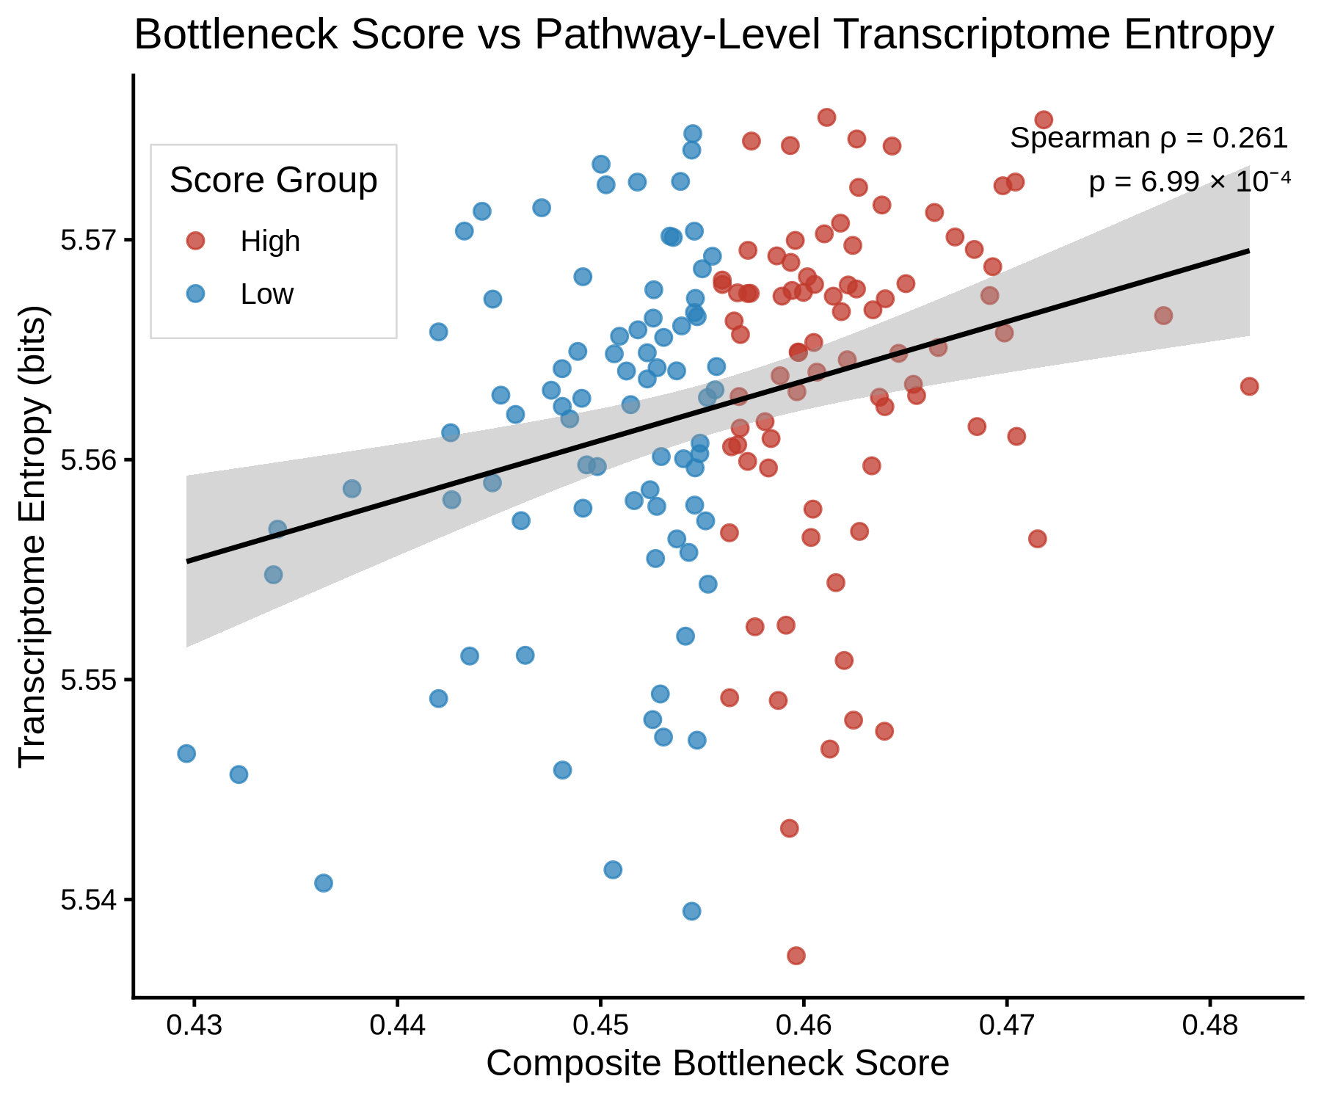
Figure 3. Scatter plot of per-patient Shannon entropy (computed over 50 MSigDB Hallmark pathway ssGSEA enrichment scores, normalised to [0, 1]) versus the mirBottleneck patient risk score (n = 167 TCGA-PAAD patients). Each point represents one patient, coloured by score group (high = red, low = blue). Spearman ρ = 0.261, p = 6.99 × 10⁻⁴. The modest positive correlation indicates that higher patient risk scores associate with marginally greater pathway-level transcriptome heterogeneity.
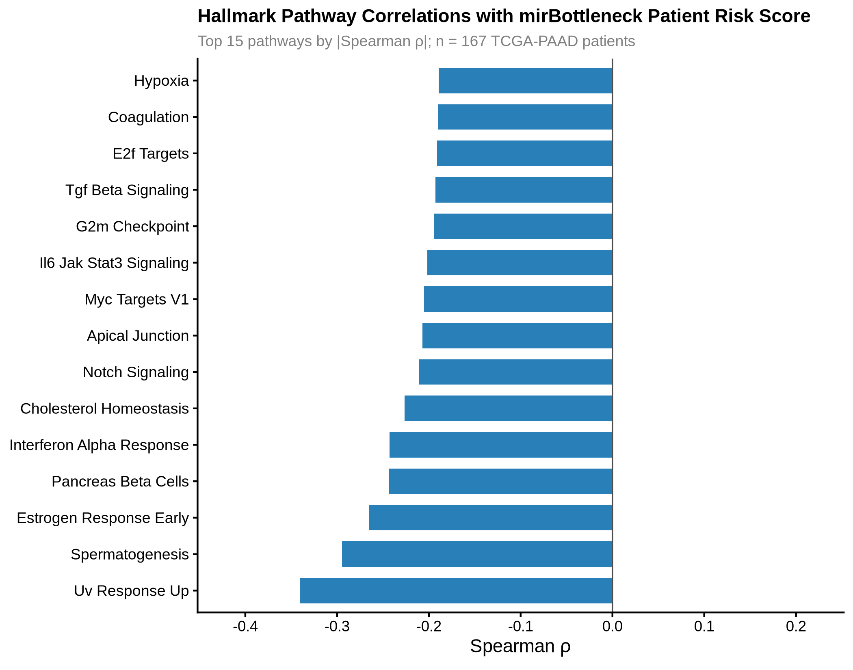
Figure 4. Hallmark pathway correlations with the mirBottleneck patient risk score (n = 167 TCGA-PAAD patients). Horizontal bars show Spearman correlation coefficients between per-patient pathway ssGSEA enrichment scores and the mirBottleneck patient risk score for the 15 pathways with the largest absolute correlations. Positive values indicate pathways more active in high-score patients; negative values indicate pathways more active in low-score patients. Among these 15 pathways, UV_RESPONSE_UP shows the strongest negative correlation (ρ = −0.341). PROTEIN_SECRETION shows the strongest positive correlation across all 50 pathways (ρ = 0.153) but does not appear in this plot as it did not rank in the top 15 by absolute value. All associations are exploratory and require external validation.

4. Discussion
mirBottleneck reframes miRNA biomarker discovery from a gene-centric to a network-centric perspective. The central question shifts from which miRNAs correlate with survival to which miRNAs impose measurable order on the transcriptome by suppressing target variance and inducing coordinated expression. The mirBottleneck patient risk score derived from this framework showed a statistically robust independent association with overall survival in TCGA-PAAD (HR = 6.55, p = 1.43 × 10⁻⁸; naive Harrell's C-index = 0.699, optimism-corrected 0.595), which is a stronger signal than most individual miRNA biomarkers reported in the PDAC literature. The large hazard ratio reflects pronounced risk stratification between extreme score groups in a surgically resected discovery cohort rather than strong individual-level prediction; the optimism-corrected C-index is the more appropriate measure of discrimination.
The biological validity of the framework is supported by the positions of well-characterised miRNAs in the classification space. hsa-miR-155 and hsa-miR-21, arguably the two best-validated oncomiRs in PDAC, ranked highest in the silencer class, meaning they suppress target variance without inducing coherent co-expression. This is biologically coherent: both miRNAs target diverse, functionally unrelated genes (SHIP1, SOCS1, PTEN, PDCD4, TPM1), suppressing noise across a broad target ensemble rather than coordinating a single programme. By contrast, hsa-miR-217, a highly pancreas-specific miRNA that is consistently silenced in PDAC and targets KRAS and SIRT1, appeared in the conductor class (Colamaio et al., 2011). This distinction has functional implications: restoring hsa-miR-217 may reactivate coherent pancreatic differentiation programmes, while targeting hsa-miR-21 primarily reduces transcriptome noise.
hsa-miR-802, the top conductor by bottleneck index, is a documented tumour suppressor in gastrointestinal cancers that targets MACC1 and is reduced in PDAC relative to normal pancreatic tissue. Its highest coherence induction score in the dataset (0.190) suggests it coordinates differentiation-related programmes whose loss contributes to transcriptome disorganisation in PDAC. It is worth distinguishing the VSS and coherence scores from classical network centrality metrics such as degree or betweenness centrality. Degree centrality counts the number of edges a node holds in a static network; betweenness centrality measures how often a node lies on shortest paths between other nodes. Neither captures what mirBottleneck measures: the degree to which a miRNA's expression, varying across patients, empirically accounts for variance and co-ordination in its target ensemble. The VSS is a patient-level R-squared quantity derived from observed expression data, not from network topology alone. The coherence induction score is computed from actual pairwise correlations across patient groups, not from graph structure. This distinction is critical: two miRNAs with identical network degree could have opposite VSS values depending on whether their expression actually explains target variance across the cohort. mirBottleneck therefore measures functional regulatory dominance as observed in patient data, not structural network position.
The proportional hazards assumption was formally verified using Schoenfeld residuals (global p = 0.44; composite score p = 0.96), and the optimism-corrected C-index of 0.595, modestly exceeding the clinical-only model (0.580), indicates that the score captures genuine biological signal beyond age and stage. Replication in ICGC-PACA, which has matched RNA-seq and clinical annotations, remains the clearest path to establishing whether the index has genuine clinical utility beyond TCGA-PAAD.
I acknowledge several limitations. The miRNA-target interaction network is drawn from miRTarBase, a literature-based resource with ascertainment bias toward well-studied miRNAs; poorly characterised miRNAs likely have deflated VSS and coherence scores as a result. The VSS is computed from bulk RNA-seq, which conflates cell-type composition with transcriptional regulation. The VSS averages across all validated targets per miRNA; although target count and VSS are only weakly correlated (ρ = 0.18, p = 0.08), miRNAs with very few targets (minimum 5 in this cohort) should be interpreted cautiously. The liberal Cox inclusion threshold (p < 0.15) is intentional for discovery but will absorb some noise, particularly at this sample size; note also that age and stage covariates used in the miRNA selection step also appear in the final multivariable model, a known limitation of internally derived composite biomarkers that may modestly inflate the apparent independence of the score. Tumour stage was modelled as a binary covariate (Stage I/II vs Stage III/IV) due to the extreme imbalance in this surgically resected cohort (Stage II: n = 151; Stages III/IV combined: n = 9); the resulting stage coefficient should not be interpreted as a population-level stage effect, and findings should be considered applicable to resectable PDAC only. Because the miRNA weights contributing to the patient risk score are derived from Cox models fitted on the same cohort, the reported HR of 6.55 and naive C-index of 0.699 are in-sample estimates. Bootstrap optimism correction (500 resamples) was applied; the optimism-corrected C-index is reported in Section 3.6. External validation in ICGC-PACA remains the definitive next step.
The entropy analysis in Section 3.7 reinforces this interpretation: the mirBottleneck patient risk score captures regulatory signal orthogonal to bulk pathway entropy, arguing against it being a proxy for general transcriptome noise. The positive direction of the entropy-score correlation is unexpected under a simple noise-suppression model and may reflect compensatory upregulation of regulatory miRNAs in transcriptomically disordered tumours, though this interpretation is speculative and requires experimental follow-up.

Several directions follow naturally. External validation in ICGC-PACA is the most immediate priority; run_mirBottleneck_project() accepts any user-supplied expression matrices, so the dataset download is the only barrier. Applying the framework across TCGA cancer types will establish how broadly the archetype system generalises. If externally validated, mirBottleneck could serve as a general framework for quantifying regulatory dominance across multiple classes of gene regulators, extending beyond miRNAs to transcription factors and lncRNAs with validated target sets. Future work will also evaluate penalized multivariable selection strategies such as LASSO-Cox as alternatives to the current univariable screening approach, to further reduce signature instability. The unexpected positive entropy-bottleneck correlation motivates a more refined investigation of transcriptome disorder metrics, ideally using cell-type-aware decomposition from matched single-cell data.

5. Conclusions
mirBottleneck is a systematic framework for classifying miRNAs by their network-level influence on transcriptome organisation in cancer. By combining variance suppression and coherence induction into a unified scoring system, the package identifies miRNAs that act as genuine transcriptome stabilizers, a property that conventional expression-correlation approaches cannot detect. Applied to TCGA-PAAD, the mirBottleneck patient risk score independently predicts overall survival (HR = 6.55, p = 1.43 × 10⁻⁸, Harrell's C-index = 0.699, optimism-corrected 0.595), and the classification of top-ranked miRNAs into biologically interpretable archetypes is consistent with established knowledge of their functional roles in pancreatic cancer. The package is submitted to Bioconductor (under review) with a one-command HTML report, a reproducible toy dataset, and a Zenodo-archived full dataset, making it immediately accessible to other researchers.

Data and Code Availability
The mirBottleneck R package (v0.99.0) is freely available on GitHub (https://github.com/MarkBarsoumMarkarian/mirBottleneck) under an MIT license and has been submitted to Bioconductor (currently under review; installable via BiocManager::install("mirBottleneck") after acceptance). It can be installed now via devtools::install_github("MarkBarsoumMarkarian/mirBottleneck"). The source code and the harmonized TCGA-PAAD expression and clinical dataset (53 MB) are jointly archived in a single Zenodo deposit (DOI: 10.5281/zenodo.19121116); the dataset can be downloaded programmatically via fetch_mirBottleneck_data(). Raw TCGA-PAAD RNA-seq and miRNA-seq data are publicly available from the NIH Genomic Data Commons (https://portal.gdc.cancer.gov) under open-access data use conditions. All R scripts required to reproduce the results in this paper are included in the package repository under inst/scripts/.

Acknowledgements
Funding: No external funding was received for this work.
I thank the TCGA Research Network for making the TCGA-PAAD data publicly available. I also thank the Bioconductor core team for their review of the mirBottleneck package submission.

Claude (Anthropic) was used as an AI writing assistant for manuscript editing and grammar correction; all scientific content, analyses, interpretations, and conclusions are solely my own.

Author Contributions
M.B.M.: Conceptualization, Data curation, Formal analysis, Investigation, Methodology, Software, Validation, Visualization, Writing - original draft, Writing - review and editing.

Conflict of Interest
The author declares no competing interests.

Supplementary data
Supplementary data: None.

References
Bartel DP. (2009) MicroRNAs: target recognition and regulatory functions. Cell. 136(2):215–233.
Bloomston M et al. (2007) MicroRNA expression patterns to differentiate pancreatic adenocarcinoma from normal pancreas and chronic pancreatitis. JAMA. 297(17):1901–1908.
Colamaio M et al. (2011) miR-217 regulates the KRAS oncogene during pancreatic ductal adenocarcinoma development. Oncotarget. 2(12):1247.
Colaprico A et al. (2016) TCGAbiolinks: an R/Bioconductor package for integrative analysis of TCGA data. Nucleic Acids Res. 44(8):e71.
Durinck S et al. (2009) Mapping identifiers for the integration of genomic datasets with the R/Bioconductor package biomaRt. Nat Protoc. 4(8):1184–1191.
Rachagani S, Kumar S, Batra SK. (2010) MicroRNA in pancreatic cancer: pathological, diagnostic and therapeutic implications. Cancer Lett. 292(1):9–16.
Rahib L et al. (2021) Projected changes in cancer incidence and death for 2030. JNCI Cancer Spectr. 5(2):pkab012.
Ru Y et al. (2014) The multiMiR R package and database: integration of microRNA-target interactions along with their disease and drug associations. Nucleic Acids Res. 42(17):e133.
Siegel RL, Miller KD, Wagle NS, Jemal A. (2023) Cancer statistics, 2023. CA Cancer J Clin. 73(1):17–48.
Therneau TM, Grambsch PM. (2000) Modeling Survival Data: Extending the Cox Model. New York: Springer. (survival R package: https://CRAN.R-project.org/package=survival)
[dataset] Markarian MB. (2025) mirBottleneck: Harmonised TCGA-PAAD multi-omics dataset for miRNA bottleneck analysis. Zenodo. https://doi.org/10.5281/zenodo.19121116
[software] Markarian MB. (2025) mirBottleneck: A dual-score framework for identifying transcriptome-stabilising miRNAs in cancer (v0.99.0). GitHub. https://github.com/MarkBarsoumMarkarian/mirBottleneck

