Questionnaire

Installation instructions are in the readme file.

To create a survey, you need to click "add survey" in the "Surveys" section

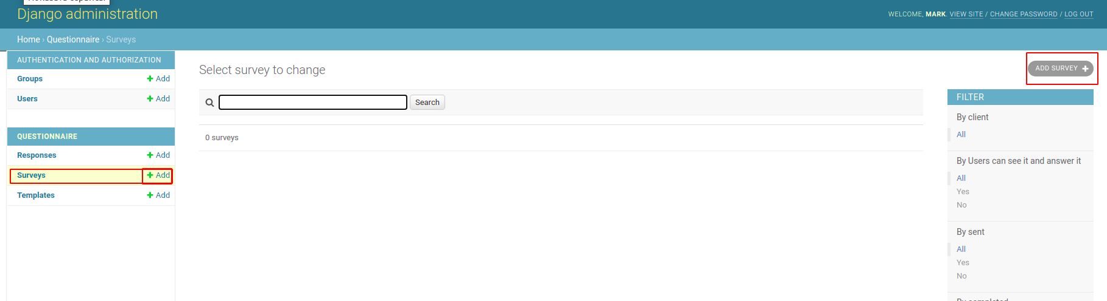

Survey fields:

* - obligatory to filling

name - survey name *

description - description

users can see it and answer it - the survey is available for passing

only authenticated users can see it and answer it - only authenticated users can take the survey.

users can edit their answers afterwards - whether users can edit their answers after completing a survey

display_method - how the survey is displayed (everything on one page or one question per page)

publish_date - the date after which the survey will be available for passing

expire_date - the date after which the survey will not be available for passing

client - the client to which the poll is addressed *. The URL will be formed from this field (as well as from the title field)

title - title. The field can be used for the project name / short description / or other information identifying the survey data. The URL will be formed from this field (as well as from the client field)

URL - the identifier of this survey *. Must be unique. It is generated automatically when filling in the client and title fields. Can be edited manually.

survey_template - The survey template. It is necessary to create it in advance. When choosing a ready-made survey template, data will be taken from it (including questions). But it is needed to fill in the following fields - name, client, title, URL.

sent - shows the status whether the survey was sent to the client. It is needed to change it manually after sending the survey to the client.

completed - shows the status of the test. Cannot be changed manually. If the client passes the survey, the status will automatically change.

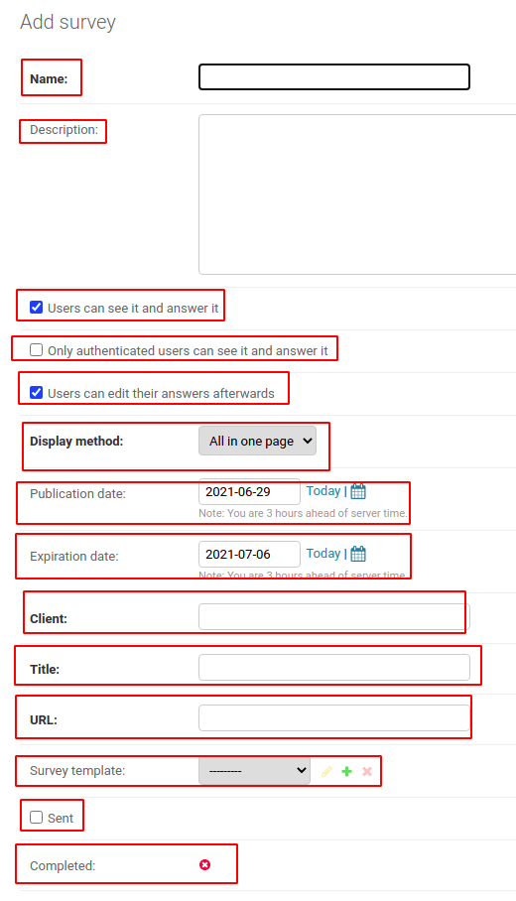

In order to add questions to the survey, you need to click "Add another Question"

Question fields:

Text - the text of the question *

Order - the number of the question in the list of questions *

Required - whether the question is required or can be skipped

Type - the type of answer to the question. It can be one of text, short-text, radio, select, select-multiple, integer, float, date

Choices - The choices field is only used if the question type is 'radio', 'select', or 'select multiple' provide a comma-separated list of options for this question.

After adding all the questions, you can click "SAVE"

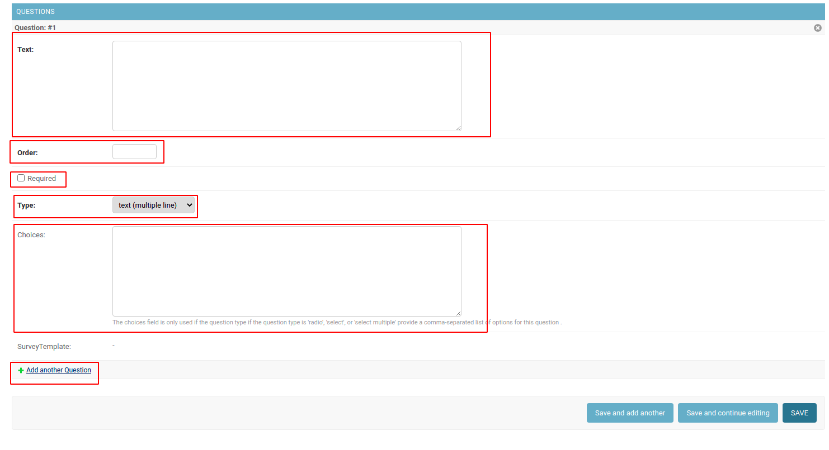  
  
  
  
  
  
  
The survey will be available in the survey list. A link to this survey will be generated and can be sent to the client.

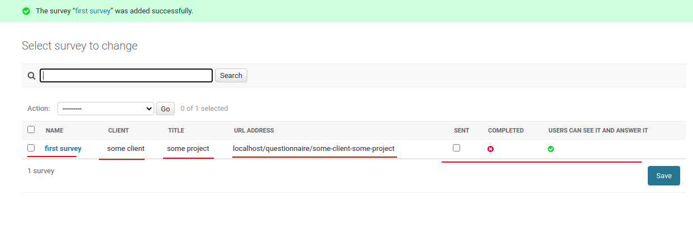  
  
  
Templates.

It is possible to create survey templates in advance. To do this, go to the "templates" section and click "ADD TEMPLATE". The main fields of the template are the same as for the survey, but there are no client, title, URL fields. Questions are created in the same way as in a regular survey.

After creating a template, a regular survey can be created on its basis.

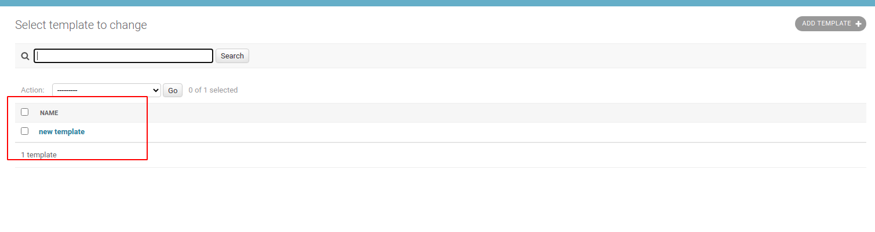

When taking a survey, it will look like this.

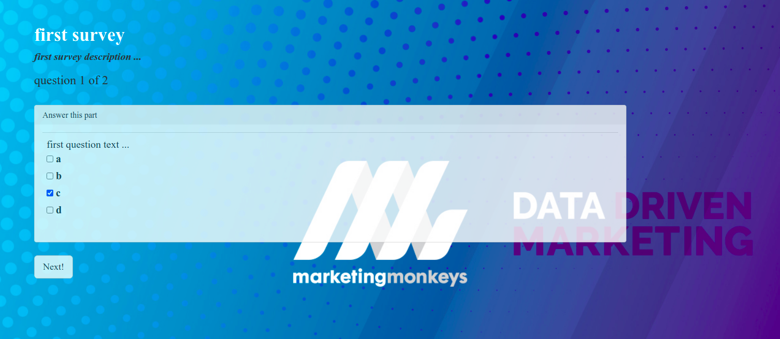



When the client completes the survey, the answers will be available in the list of answers. There you can also see or download a pdf file with the client's answers.

