1. Selected and installed ubuntu 24.04 lts as my operating system:

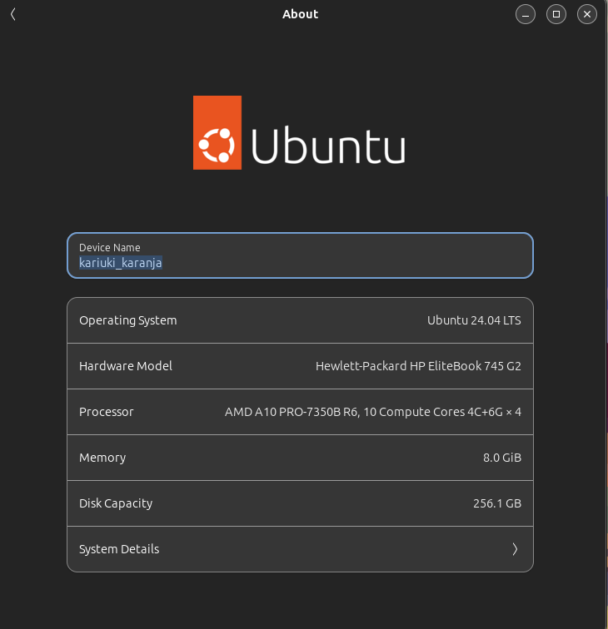

2. Installed visual studio code as my preferred IDE

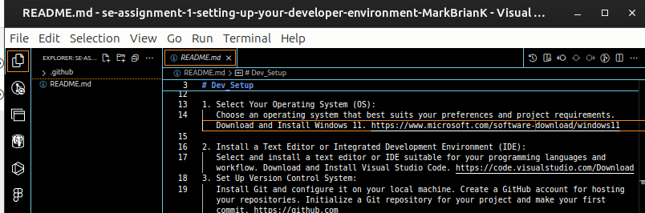

3. Installed git as my version control

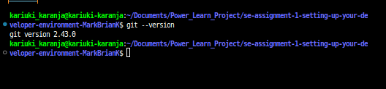

4. Installed python3 and node

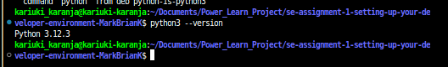

5. Installed pip as my python manager

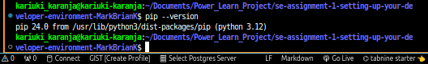

6. Configured and installed postgresql for my database

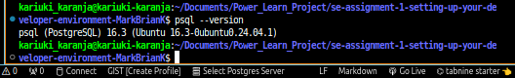

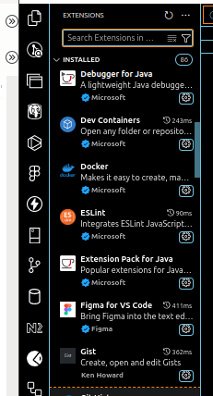7. Installed extensions in my visual studio code IDE to help in certain tasks like formating and version contol

Github respository <https://github.com/MarkBrianK/Label>

**Challenges faced:**

1. Conflicts in configuration packages and versions such as node.

2. Use of various package managers for a certain package during installation especially when reseacrhing in the internet.

**OverCome strategies:**

**1.** Use the latest version of packages by adding lst tag in intallation commands.

2. Installing just the well defined and approved package managers only such as pip.