# Lecture notes: consensus

**Abstract**

In a post-covid world of people connected through devices, establishing sources of trust for the content that we consume and the resources that we use to work and study has become increasingly important. My project will focus on the design and creation of a community mediated resource sharing platform. Through the process of assigning trust levels to users based on their contributions to the platform and the evaluation of these contributions by the community. The platform will provide a measured and unbiased suite of resources and guides for students in the domain of higher education courses. This report will identify the current work being done in this area and highlight the features that the platform will improve upon. A requirement driven, Agile approach will be taken to create a user-friendly platform that provides a system for the community to self-moderate, thus ensuring that content benefits every single user.

There is a wealth of information online from a variety of sources. However, it is often the case that there is not an adequate method to verify the quality of the material being communicated, and often we are likely to trust an online resource with very little objection. This motivates the development of a platform which is unbiased and direct when representing the trustworthiness of users and the usefulness of the resources that they contribute. One initial consideration when developing this idea is that, while a platform of useful content produced by trusted sources is attractive from a consumer perspective, there may be a lack of motivation for contributors to create the content which flows through the system. An answer to this is a model for the application in which a user that has made no contribution to the platform can experience limited access to its functionality, and this access level increases with the submission of quality assets. Therefore, when a user has made a valuable and tangible suite of contributions to the site, they are rewarded with unrestricted access to the library of useful resources from trustworthy creators.

The second deliberation core to the effectiveness of the platform is devising a method to quantify the trustworthiness of a creator and the usefulness of a resources. Intuitively, this will be done through community mediation: assets that are shared will be able to be reviewed and these reviews will be analysed to create an overall rating of the usefulness of the resource. Furthermore, reviews themselves will have the option to be reviewed by other consumers of the resource, these reviews-of-reviews become an important factor in computing a numeric measure of a user’s trustworthiness. This system of reviewing creates meaningful community moderation that is beneficial to all stakeholders. As the system will be designed for the domain of higher education, the main stakeholders are students that would benefit from a high quality and trustworthy materials for revision and other insights into their university course – both as consumers and contributors. Lecturers and other department faculty could also be considered stakeholders, as they are concerned with the reduction of misinformation within the courses that they provide and manage. One aim of this project are to reduce misinformation by ensuring that appropriate emphasis is placed on the trustworthiness of an online material, and that this trust level can be presented to the consumer as readily as the material itself.

Other aims of the project are to provide a platform promoting community engagement such that users on the platform internally mediate content, and to compute accurate numeric representations of both trust and usefulness, therefore simplifying the process of understanding the context and reliability of an information source.

**2. Research**

In order to develop my project, I must first be aware of the current state of the art that relates the system I design and build. This awareness will come from two places. Firstly I will analyse existing systems which offer similar functionality or a subset of the functionality of the application I will build. This will allow me to understand how similar systems have been designed, and note the areas that differentiate my system from others. Secondly, I will review academic works concerned with the details and theory of the salient aspects of my application. My main focus for this review will be computations and representations of trust. Reviewing these cutting-edge theories and practices will be paramount for the implementation of community mediated trust ratings in my system.

**2.1 Existing Systems**

Resource sharing platforms exist and have been proposed across many domains. Figshare is an example of such a platform which offers users the opportunity to share resources in the scientific research community. Users can upload a range of content including papers, images and data sets to the web-based repository, and usage statistics like views, downloads and citations are displayed. This is a model of a general repository, encapsulating resources from several disciplines, and with a feature set limited to essential functions such as search, upload, download. It is not clear whether a general repository of this type can be as successful as more specialised sites that target specific groups of users and implement more complex features (Thelwall and Kousha, 2016).

This implementation of a sharing platform is useful in demonstrating the relative popularity of a source; however, it gives little other information on its usefulness or reliability. For a domain as broad as scientific research, a general repository of information provides an adequate solution to finding the latest content. However, when we focus this domain to higher education, or even further to a specific higher education course, this solution seems lacking in the ease of finding relevant and useful information that will benefit the consumer.

Shreic is a web application designed to enable resource sharing between students of a higher education course. Shreic focusses on two principal areas, the first of which is an e-commerce system in which students can sell or donate required textbooks for a university course. The second functionality of the application is resource sharing. Students can upload class notes and question papers related to a specific course, and other students taking the course can use a search bar to find resources relevant to their interests. Shreic also offers a private messaging system. The system adequately implements resource sharing, with basic functionality of enabling users to upload and download resources and to group them by course (Shyam and Mukesh, 2020). However, questions could be raised about users’ motivation to upload resources onto the site, as there is no extra benefit to users that frequently contribute their notes. Furthermore, there is a lack of descriptive information associated to uploaded assets. When there are a small number of resources being shared, a user could open each resource and decide whether the information is relevant and useful, however when there is a large volume of assets associated with one course, this process is impractical, and it soon becomes difficult to find beneficial material.

Another existing system concerned with resource sharing amongst students in higher education courses is Studocu. Studuco is web application in which students can use search filters to find specific courses that they are enrolled in at their university. The students can view, share, and download shared resources. This application implements an upvote and downvote system for reviewing resources and displays the proportion of upvotes as a percentage when viewing the library of resources for a module. There is a paywall in place so that the application shows only a preview of documents before signing up to a ‘premium’ account. Furthermore, this application incorporates an AI chatbot that allows students to ask questions or set tasks for the AI related to their studies. This demonstrates a specialised resource sharing platform with more complex features. However, the rating system is simplistic, students can see whether a source has been helpful or unhelpful quantitatively, however there is no further detail to the review process. Overall, this application could be improved through a more nuanced approach to the usefulness of a resource, and through the inclusion of evaluation how trustworthy a contributor is. Moreover, this application shares a common issue among works in this area, there is a lack of incentive for users to contribute to the site and review other users’ contributions.

**2.2 Related Work**

There have been several works analysing the concept and properties of trust, and how this can be modelled computationally. Artz et al. in ‘A survey of trust in computer science and the semantic web’ discusses the importance of Trust on the Web, specifically when making trust judgements regarding multiple varying sources of information. They highlight the trust judgements that humans constantly make when they interact with sources of information on the web. In the process of automating trust there will invariably be a decrease in the nuances and practical knowledge that humans use when making trust decisions, therefore modelling trust between users has been approached in many ways(Artz and Gil, 2007).

For trust to be represented computationally, a quantitative model must be achieved. In ‘Formalising trust as a computational concept’ Marsh proposes one of the first models of computational trust. Marsh represents trust as a continuous value in the interval [-1,1] where -1 represents absolute distrust in another party, 0 represents neither trust nor distrust, and 1 represents absolute trust. However, they also argue that there cannot exist an absolute trust, or absolute distrust between parties (Marsh, 1994). An alternative model discussed by Guha et al. in ‘Propagation of Trust and Distrust**’** in which they argue that a range of trust values including negative values could lead to computational difficulties, given that if this range of trust values is used in probabilistic calculations, a negative probability would be possible, and would cause logical inconsistency. Therefore Guha et al. describes a model with trust values in the range [0,1]. (Guha, 2004). A representation also requires some level of aggregation. In ‘Trustworthiness of Data on the Web’, Hartig proposes two methods of aggregating a trust value taken from a quantitative and continuous model. The first of these methods is to take a minimum value, this is the concept that a user is only as trustworthy as their least trustworthy rating or contribution. Taking a minimum value as an aggregate is a pessimistic approach however would ensure that high trust ratings correspond to high quality resources. The second approach raised by Hartig is a median aggregate, this is a more lenient approach and may give a more realistic view of a user’s trustworthiness, as it considers every contribution that they have made (Hartig, 2008).

Once a representation for trust values is established, these can be applied to users in a community. A web of trust is one method of implementation, based on the concept that not all users will interact with each other, therefore propagation of trust is used to ensure that for any two users, a trust relationship can be obtained. Trust propagation describes a situation that for three users: A, B and C; if A trusts B, and B trusts C, then A is said to trust C(Guha, 2004).

This transitivity is applied to predict trust to ensure no trust relationships between users are uncharacterised, however because A has not with C, this method is an approximation, and for applications where a full web of trust is not a requirement, there may be more suitable methods of modelling trust. In ‘Trust Strategies for the Semantic Web’, O’Hara et. al describes five strategies for computationally modelling trust:

* Optimistic System – This strategy is to assume that every user in the system is trustworthy, providing the benefit of intense collaboration between users, however containing a greater risk of misinformation and betrayal.
* Pessimistic System – This strategy assumes that every user in the system is untrustworthy, protecting the integrity of the system, at the cost of collaboration.
* Centralized Trust System – This strategy proposes a central institution that certifies the trustworthiness of a user; however, a question remains as to how trustworthy the central institution is.
* Trust Investigation Systems – This strategy aims to reduce the risk of trust by investigating or evaluating other users to determine details of their operation.
* Transitive Trust Systems – This strategy involves one user communicating to its acquaintances whether a potential user is trustworthy, and these acquaintances either replying with their own opinion of the potential user or propagating the initial user’s opinion in turn to their acquaintances. This aims to increase the scope of knowledge of a user.

O’Hara et al. suggests that many systems use a combination of Transitive Trust and Investigation(O’Hara, 2004) . This combination is logical and results in users communicating the trustworthiness of others yet verifying this with quantitative data based on user actions.

A method of a user giving their opinion of another user, or a resource on the platform is through a review. Reviews have a substantial impact on the users that observe them, Banerjee et al. discusses this is in ‘Whose online reviews to trust? Understanding reviewer trustworthiness and its impact on business’. In this paper, Banerjee et al. proposes a method for classification of users as trustworthy or untrustworthy a linear regression model. To perform this analysis, they used six variables: positivity, experience, sociability, reputation, competence, and involvement. This analysis classified users’ reviews correctly 83% of the time.(Banerjee, Bhattacharyya and Bose, 2017) Such an approach is effective in making this binary judgement. However, these six variables are somewhat subjective, and could be hard to characterise for users without a large amount of previous data relating to their reviews or other activity. Furthermore, classifying users as either trustworthy or untrustworthy does not fully capture the complexity of a trust model, and may not be suitable for applications aiming to assign a quantitative, continuous trust rating to a user.

These discussions regarding trust, user reviews, and strategies to implement trust models will be beneficial in informing the design and implementation of the computational representation of trust that I implement in my project.

**3. Testing and Success Measurement**

Throughout my project, I am going to conduct testing and I will evaluate which areas of the project are successful, as well as whether the project is a success as a whole. I will make use of unit testing to test the functionality of self-contained features, this will ensure that the code produced is robust and that the features function correctly according to my acceptance criteria. The criteria that I will analyse the project against are the functional and non-functional requirements that will be defined at the beginning of the project. If these requirements are met, the project can be considered to be successful. Another form of testing that I will conduct is user acceptance testing. The target audience of the project, higher education students, will test the system and feedback their experience and whether their needs are met. If user acceptance testing shows that users value the system, then it can be considered a success. Finally, I will conduct a holistic review of the system, in which I analyse its intended purpose. This will be done using a combination of the project requirements and the more nuanced initial view of the final system’s ideal state that is articulated in the project proposal. If the project aligns with its intended purpose relating to providing a community mediated resource sharing platform with a computational representation of trust, then the project can be considered successful.

# **4. Project Management**

The Timeline for the development of the project is shown in Figure 1.

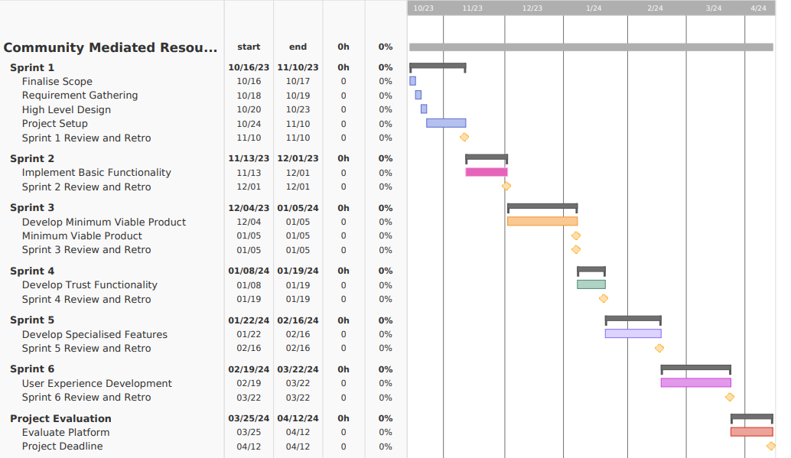**Figure 1.** Project Management timeline Gantt Chart

Throughout the design and implementation of my project, I will use an Agile development methodology, this is demonstrated in the timeline of my project through Sprints. Sprints are short periods of time in which I will work towards completing tasks, developing features and meeting milestones. The end of each sprint is marked by a sprint review and retrospective (retro). A sprint review is a process in which I will evaluate the product work that I have completed during the sprint. I will analyse the initial goals for the sprint, and evaluate whether these goals have been met, how they have been met, and what could have been done more effectively to maximise the quality of the product. The sprint review also offers an opportunity to perform code reviews, therefore ensuring robust and high-quality code. The sprint retrospective will be focussed on the processes that took place during the sprint; the purpose of these sessions will be to ensure continuous process improvement throughout the project.

I will also use the Agile methodology’s requirement driven, prototype-based approach to ensure that every feature that I develop is implemented in line with the functional and non-functional requirements that are gathered at the start of the project, this will allow the application to effectively meet the needs of users. At every stage of development, I will develop a prototype covering a wide range of functionality of the application, at the start of the development process these prototypes will be simplistic, with limited functionality, and this will progressively become more complex over the lifestyle of the project.

Figure 1, above, demonstrates all key milestones for the project. Some key dates to highlight are:

* + Project Setup Complete: 10th November.
  + Minimum Viable Product: 5th January.
  + Trust Mechanism Complete: 19th January.
  + Project Complete: 12th April.

The combination of implementing the Agile methodology in the development of the project and producing deliverables to align with these key dates will ensure that development code is robust and the solution that I create is high quality.

**5. Conclusion**

In conclusion, my project is the design and implementation of a community mediated resource sharing platform for higher education courses, with a mechanism to compute the trustworthiness of users. I have discussed other systems that have similar functionality, and highlighted the ways in which my project is differentiated from others. I have also reviewed various related academic works discussing the implementation of a trust system, these insights will be useful when I come to develop the trust system for this project. I have also discussed the methods that I will use to test and measure the success of individual functions of the system, as well as the project as a whole. Finally, I have created a plan for the management of the project, outlining key dates, sprints, and milestones within an Agile development framework.

**6. References**

Alani, H., Kalfoglou, Y. and Shadbolt, N. (2004) *Trust Strategies for the Semantic Web*. Available at: http://iswc2004.semanticweb.org/.

Artz, D. and Gil, Y. (2007) ‘A survey of trust in computer science and the Semantic Web’, *Web Semantics*, 5(2), pp. 58–71. Available at: https://doi.org/10.1016/j.websem.2007.03.002.

Association for Computing Machinery. (2004) *The thirteenth International World Wide Web Conference : proceedings.* Association for Computing Machinery.

Banerjee, S., Bhattacharyya, S. and Bose, I. (2017) ‘Whose online reviews to trust? Understanding reviewer trustworthiness and its impact on business’, *Decision Support Systems*, 96, pp. 17–26. Available at: https://doi.org/10.1016/j.dss.2017.01.006.

Hartig, O. (2008) *Trustworthiness of Data on the Web*. Available at: https://www.researchgate.net/publication/228985691.

Marsh, S.P. (1994) *Formalising Trust as a Computational Concept*.

Shyam, A. and Mukesh, N. (2020) ‘A Django Based Educational Resource Sharing Website: Shreic’, *Journal of scientific research*, 64(01), pp. 138–152. Available at: https://doi.org/10.37398/jsr.2020.640134.

Thelwall, M. and Kousha, K. (2016) ‘Figshare: A universal repository for academic resource sharing?’, *Online Information Review*, 40(3), pp. 333–346. Available at: https://doi.org/10.1108/OIR-06-2015-0190.