**Research/UI/UX**

* Based on feedback from our presentations from the Team CA1 presentations and a Q & A it was recommended to our team that the audio message for users performing a lift should not notify them that they are making an error or mistake in a way that would put the user off continuing to try and learn and progress. The language used has to be important to not dissuade them from attempting the lift again. The language has to be helpful, encouraging and have no negative feedback or give the user a negative perception of themselves such as telling them you are doing this wrong or you are making a mistake.
* PT’s when training clients they need to give off a positive message not just through their body language but also with the language that they use when speaking to clients. As SetStats has an audio voice instructing the client it is more likely to need to have an encouraging voice speaking to the user. A monotone voice does not fit this criteria. The audio messages cannot be angry either or change in tone to a negative one. Positive energy will come from it to lift the client up and encourage them to continue and not give up.
* Being on the team as the user works so using words like we, us and our can build a bond with the user and give them confidence in themselves.
* 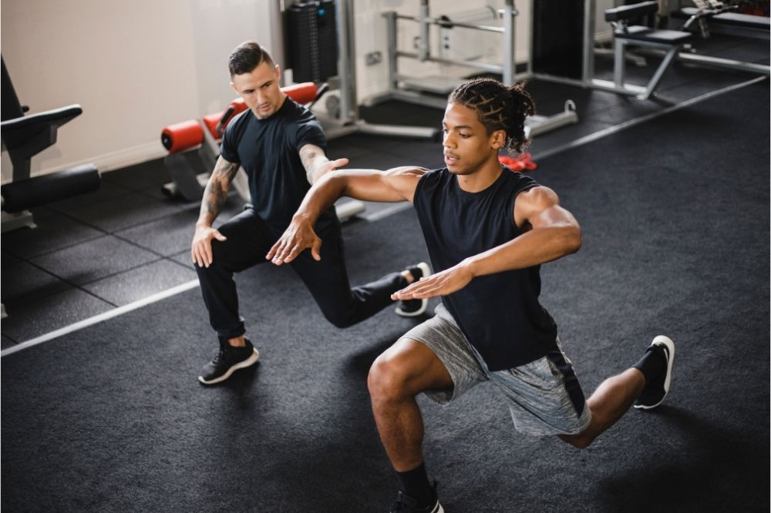
* Positive reinforcement works to not only motivate the client but also to install confidence in them with each different lift.
* The audio we use with SetStats can be a collection of different phrases and terms prebuilt into the system to match up with each lift and cover all of the different variations in movements with each lift.
* Based off of my own personal experiences in the gym with a trainer I personally believe that one of the best ways to start a client or user in this case is to give them an explanation of the correct way to perform an exercise without them causing themselves injury or the client feeling bad about themselves. To convey this our audio can explain how to perform each lift the correct way before the user attempts the lift. Then should the user perform it correctly the audio message returns positive feedback such as great progress, well done, good job etc. Should they do the opposite then the message can instruct them on what they did wrong but in a nice way and tone.
* As our application SetStats is for people lifting weights in their home or local gym there is many different users. One way users can feel assured when training is to hear their own name being used in the messaging. People respond more positively to their own voice as it makes them feel acknowledged and can help them to build a rapport with others. Using the name of the person makes them more likely to listen to do the exercise correctly and they will appreciate the attention they feel from hearing their own name being used.

***References used***

[***https://fitness.edu.au/the-fitness-zone/communication-skills-for-personal-trainers/***](https://fitness.edu.au/the-fitness-zone/communication-skills-for-personal-trainers/)

[***https://www.instituteofpersonaltrainers.com/blog/5-communication-tips-personal-trainers***](https://www.instituteofpersonaltrainers.com/blog/5-communication-tips-personal-trainers)

[***https://www.futurefit.co.uk/blog/top-5-skills-to-strengthen-communication-with-personal-training-clients/***](https://www.futurefit.co.uk/blog/top-5-skills-to-strengthen-communication-with-personal-training-clients/)