**SETSTATS**

Mark Byrne Richard Collins Liam Denning Florian Scheunert

Table of Contents

Contents

Team Members 3

What is SetStats? 3

What are our goals? 3

Hardware Required 4

What we did - 5

Data the device will be collecting: 6

How the data will be gathered: 6

How we are going to be processing the data collected: 6

How the device and data are going to be secured: 6

Frequency with which each sensor can record a value and how the sensors work: 6

How cron will be used to process the data, listing the cron jobs that will be run 6

Paper Prototype 9

Paper prototype page descriptions: 11

Connection: 12

User Profiles 13

**About Us**

# Team Members

**Mark Byrne: Liam Denning:**

**Role:** Database developer **Role:** Web Developer

**Richard Collins Florian Scheunert**

**Role:** IoT Developer **Role:** Tester/ Designer

# What is SetStats?

SetStats is an application created to help everybody improve their form in the gym. Whether you are a new user or a 20-year veteran, SetStats will surely help you. Trainers can use it to see how their trainees are doing and trainees can use it to find a trainer to watch them.

# What are our goals?

* We want to create a platform where you can track progress and improve your form.
* Beginners will have a platform to watch and learn from more experienced lifters through our tutorial section.
* SetStats hope to avoid injury by making sure lifters are not lifting too heavy or with incorrect form.
* Trainers should be able to see all of their trainees’ stats and with the help of SetStats they will have a better idea of how the trainee can improve their training

**Hardware**

# Hardware Required

1. R**aspberry Pi Zero** – this is being used as it is the more compact option whilst also having low power consumption.
2. **Accelerometer (MPU-6050)** – used to measure the displacement on the x-axis.
3. **Ultrasonic Sensor (HC-SR04)** – is being used to measure the distance from the ground, very accurately.
4. **Power Bank (5000 mAh)** – the power source which will be connected via micro-USB.

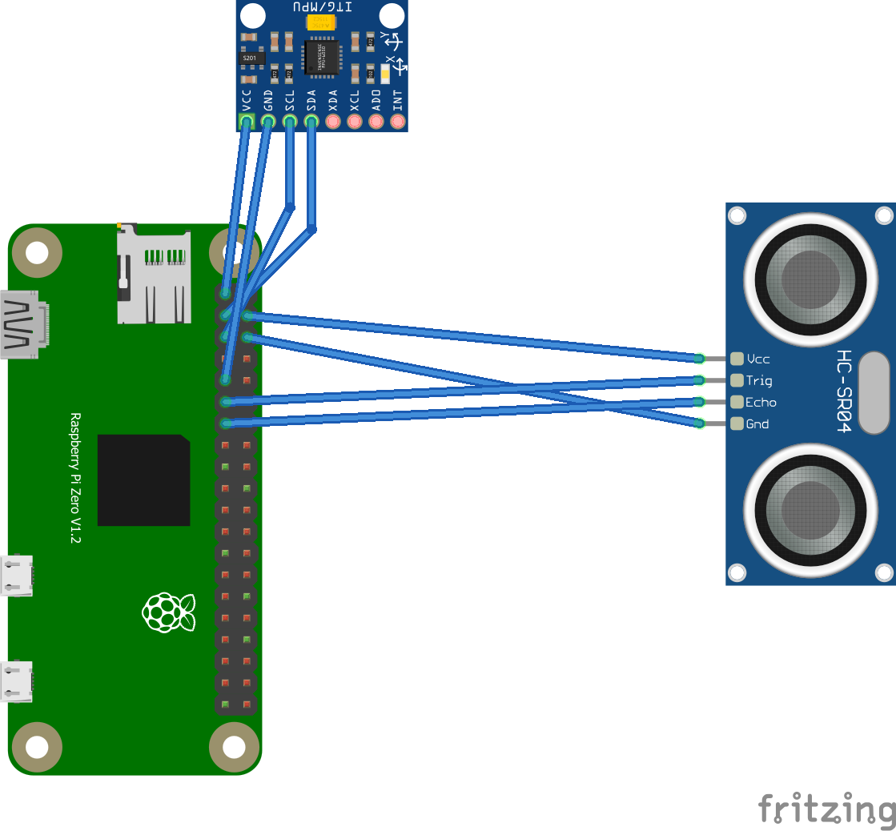

**Detail how we will power it and how we will connect it to the internet Is it mobile?**

The system will be connected to an external rechargeable battery source (Power Bank), which will give long lasting life due to the low power consumption of the Pi. It will be connected to the gym’s Wi-Fi or your phone’s hotspot. It would be mobile as long as you’re connected to a phone’s hotspot.

# What we did -

**Florian** Researched what modules would best suit our needs for the project, and found that an accelerometer would do the job.

**Mark** bought the accelerometer off Amazon and tested it out. He ran into a problem that we wouldn’t be able to track the movement of the bar on the x-axis(sway).

**Richard** found an alternative option, which would be by using an ultrasonic distance sensor in tandem with the accelerometer.

**Liam** then bought ultrasonic sensor to make sure it works by testing code from the internet.

**Richard** wrote code to collect data from both sensors at the same time and to display it for a prototype.

**Data**

# Data the device will be collecting:

* Height of the bar (y co-ordinate)
* Sway of the bar (x co-ordinate)
* Time
* Number of reps and sets
* Highest point (in which bar was lifted)

# How the data will be gathered:

The data will be sent from the device to a database hosted on a server. Every 0.75 seconds the sensor picks up a change in distance/sway etc the data will be sent to the database and stored in a table for that lift.

# How we are going to be processing the data collected:

The data collected will be send to a database and then further pulled/displayed onto a website using chart.js. The data will be shown as a line graph.

# How the device and data are going to be secured:

Certain data will be encrypted such as user’s login information when sent to the database.

# Frequency with which each sensor can record a value and how the sensors work:

Both sensors will collect data every 0.75 seconds.

**Accelerometer (MPU-6050) –** converts mechanical energy into electrical energy, it measures change in motion(acceleration)

**Ultrasonic Sensor (HC-SR04) –** Sends out a soundwave at a frequency of 40KHz and it travels through the air and if there is an object it will bounce back to the sensor.

# How cron will be used to process the data, listing the cron jobs that will be run

**Database**

**Trainee Table:**

The trainee table contains all the information of the regular user who uses the application. They have their own id and linked to them is a trainer id, but they don’t necessarily have to have a trainer. Their password will be hashed for security.

**Trainer Table:**

The trainer table contains all of the data of a trainer who uses the app. The trainer can have multiple trainees and we can use sql to grab them uses the foreign trainer_id in the trainee table.

**Lift Details Table:**

The lift details table will contain the data for a specific trainees current lift, the x and y will be updated a lot as the user moves the bar, while the rep, set and time will change on a slower pace but still quickly enough. The data will help us for the history page of the trainee so they can see when they trained.

**History Table:**

The history table will be used for the trainee to be able to look at their progress overtime by looking at previous sessions. This will be able to grab the users best lift of the session and the rest of the data like reps and sets and how long the session was. The trainer can use this data also to be able to observe their trainee’s improvements.

**User Interface**

# Paper Prototype

# Paper prototype page descriptions:

**1. Login Page**

User uses this page to login by entering their username and password that they registered with.

**2. Register Page 1**

User will use this page to begin their registration by entering their details like their username, password, and email. They will use these details to log into their account.

**3. Register Page 2 (About You)**

The second register page is to get the users physical details such as their height, weight and age. This data can be used for trainers and for the user to track their progress.

**4. Main Menu Page**

The main menu page contains the links to most of the applications pages, this is where the user will be able to navigate the app.

**5. Before Lift Page**

This screen is where the user has setup the device and is getting ready to lift, the user can click the start button to begin the session.

**6. During Lift Page**

This is what the user see’s while they are lifting, the graph displays the position of the bar compared to the optimal form line, the user can also see details such as the time of the session, what rep they are on and what set they are on.

**7. Lift Summary Page**

This is what the user can see after their session is finished or when they click on this session from their history. The summary page shows the users best lift of the session, their max weight lifted and time of session, along with the reps they done and sets.

**8. Session History Page**

This is where the user and their trainer can see the trainee’s session history, click one of the days and you will be linked to the lift summary page of that session.

**9. Side Bar Menu**

This is where the user can sign out and view other links to parts of the application which are not displayed on the main men u page and this side bar can be accessed from any page on the app.

**10. Trainees Page**

This is the page where the trainer can see their trainees and once they click on their name, they can see the trainee’s session history page.

# Connection:

Connection to the device and app is through a Wi-Fi connection where the device is connected either to your hotspot/gym Wi-Fi. If there is no connection, a message should be displayed on the app telling the user that there is no solid connection and that they need to setup the device correctly.

**Users**

# User Profiles

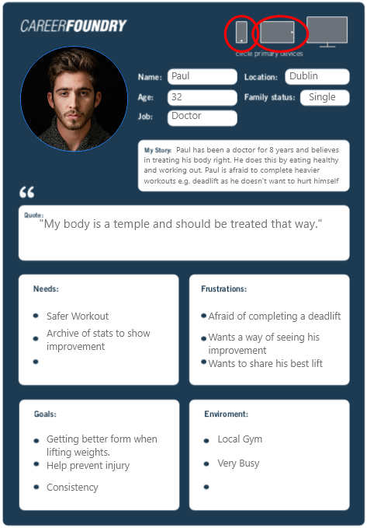

**Testing**

Test is going to be divided in two parts.

First the code and the hardware need to be tested individually and secondly the actual usage and functionality of the measurement needs to be tested as well.

The code of the application can and will be tested by JUnit-Tests to make sure the functions work as intended and to make resolving problems as easy as possible in the future

Testing the functionality of the app is done by people in the gym trying out the application. We ask strangers or friends to take a part in our testing program and let them use the application on their own. This not only helps to test the functionality, but it also helps to figure out if the layout and design of the app is easy to understand for everybody. To test all use-cases of the app we need to have people from different ages and different experience levels in lifting. For example, there should be users who have never lifted before, some with a bit experience and some professionals.

The users are asked to give feedback regarding everything related to the usage and functionality of the application. It helps to find bugs, missing features we might have not considered and the overall user experience. The collected data from the sensors helps to improve the measurements and to make sure our data is not too far off from the actual values.