ganache-cli -m "smart fun man behind sea joke split cherry force season once pair"

Truffle tests – 181 passing
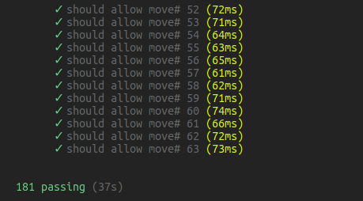

Close the ganache instance and run – note ERC20 not tested as I intend to hook into existing ERC20 tokens
./node_modules/.bin/solidity-coverage
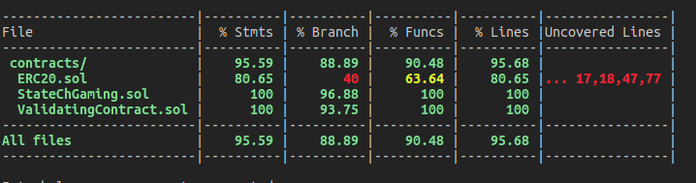
See the html files
truffle run verify
