Economy Changes

The economic play of Lost Colonies so far has had a few rough spots. So we are working on an update and I want to take a moment to share some of our thinking and then what the updates are. First of all, thank you to everyone who gave us feedback during and after the March event. We listened and I hope you like what we have changed.

Our goal with all rules is to make sure that they provide for the most fun, the most trust,the most player to player interaction as possible, and the least mindless bookkeeping. We also try to minimize staffing requirements so that you aren’t left hanging hoping for a storyteller to walk by.

What we found was that Appraise, Import Export, and Smuggling specifically were not working out to be as cool as we wanted them to be. We also found that our pricing structure on component cards was fundamentally broken. So we are changing things up, hopefully for the better.

*NOTE: If you feel like any of this is directed at you specifically, please know that it is not. But also if you feel like any of this has caused you in game financial problems because of the change, please come talk to us and we will make it up to you. None of this is because anything was being exploited or leveraged in a funny way. We just think that what we had wasn’t achieving the goals we wanted to achieve. Some of this was based on feedback, some on observations, and we felt that we could, and should, do better.*

## Component Card Changes

We are going to remove the Price and Research lines from Component Cards. No more tables to look up. No more Rarity multiplied by Price math to do. No more filling out “Known” for every Component.

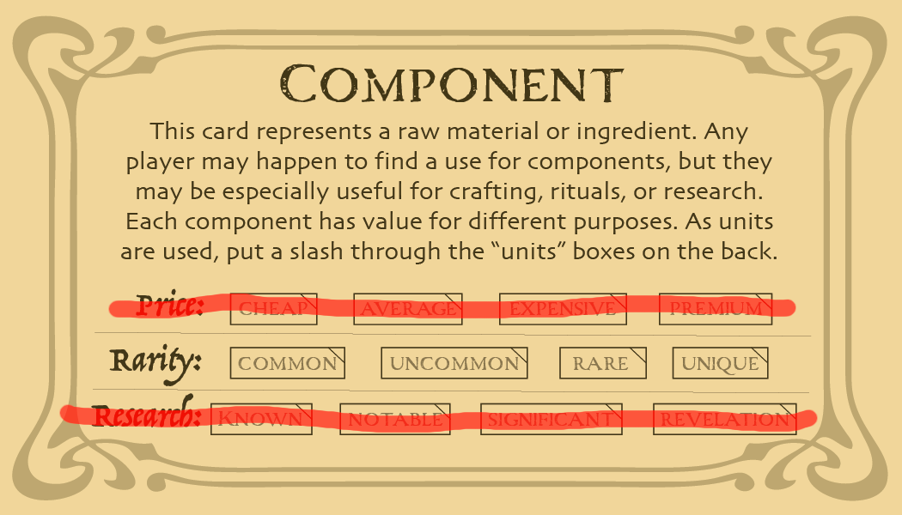

A Component’s Rarity value determines what recipes it can be used in and also how easy it is to gather it. Going forward it will also be the main function of how much people will value it. Note that we are not setting a price tied directly to Rarity anymore though certainly Rarity will factor into the price that gets set for components and for the items made from components.

The gathering rules, the transmutation rules, and probably a few other rules, all are based on the idea that a Rare component is three times more rare than an Uncommon component. Similarly an Uncommon component is three times more rare than a Common one. Rare then would be nine times more rare than a Common is. This might mean that prices will settle down along those same multiples. For example, if a Common component were to sell for 5 Par then an Uncommon component might be worth 1 Unum and 5 Par to the same person. However, the Rarity of a Component is not quite the same as its availability in the current economy, not perfectly anyway. Since supply and demand can fluctuate as time goes on we will not be listing exact prices for each Component or each Rarity. Just know that we will be writing rules under the 1, 3, 9 pattern to make things consistent within the rules and that it is a pretty good rule of thumb that everyone should be aware of.

## 

## Item Card Changes

We will also be dropping Price and Rarity from Item cards, though they will retain the Research value. This requires less explanation that Component card changes. The cost of making an item should influence the price of the Item. If you make an Item for someone you are encouraged to charge them money to cover your expenses plus make a profit. If you use an item on someone, perhaps to heal them, you should be encouraged to ask them to repay you in some fashion. Quid pro quo is a perfectly valid exchange if all parties are happy with it.

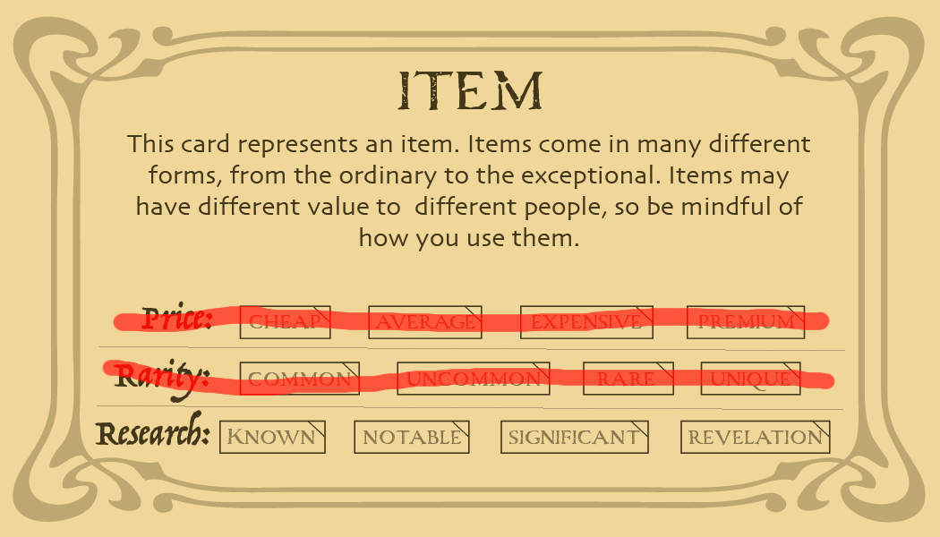

## Quartermaster Changes

The Quartermaster will still be selling some Components, but will no longer have everything available all the time. As we mature our Gathering Systems we will reduce the amount of things the Quartermaster has to sell as the intention is to make this a player driven economy as much as possible. But until we get gathering fully ironed out we will maintain the Quartermaster as a means of players getting the things they need for crafting.

Going forward the Quartermaster is going to have some secret information:

1. Their price list
2. What they are willing to buy
3. What they are willing to sell
4. How much of each thing they have at any given time
5. The full list of which Commerce Quests are currently available

A couple of notes about this information.

* We do NOT want to have the Quartermaster be a system that can be manipulated.
* We do NOT want to encourage or allow players to rush straight to the Quartermaster first thing Friday night and buy up all the stock
* The Quartermaster is not a get rich quick scheme
* We DO want Merchants to be able to do business with each other, with crafters, and with other players in a free and fair fashion.
* We do NOT want people to be cut out from using their skills simply because they were last in line at the Quartermaster. So, if the Quartermaster limits you to buying 2 Steel in one transaction, and then sells 2 Steel to the next person, and the next person, know that we are metering the supply of this commodity so that everyone can get a fair shake.
* We DO NOT want, or encourage, “Cornering the Market”. This is fun for only one person and it can break other systems.
* We DO want to be sure that the New Player who just arrived in town can get the things they need to make their craft using the starting money they have been given.
* Fake Economies have lots of edge and corner cases that can lead to weird things happening. If you find one, please notify us. Exploiting a loophole is not the game we are trying to promote, please resist the urge to get rich quick because of a flaw in our systems.

The intent of our system is to have players go to other players first for things and that the Quartermaster is recommended as a stopgap, or a transaction of last resort. The Quartermaster will also do trades following the 1, 3, 9 rule assuming that the Quartermaster has supplies. The Quartermaster can also be seen as a way for the game to have a way to avoid players price gouging each other. Profits are good and fun and valid. Economic griefing will not be tolerated.

## Skill Changes

Appraise is being renamed to Commerce and being completely re-written as a skill. If you already had Appraise on your character sheet you now have Commerce. Here are the new skill write ups for Commerce, Import / Export, Smuggle, and also the new skill Tycoon!

**Commerce**

**Reqs:** Wits 3

*Quartermaster’s Connection*  [Always, Quest] You gain the ability to obtain and complete Commerce Quests from the Quartermaster. Commerce Quests reward you financially for completing them, and also reward build to a number of participants including yourself, as listed on the card. You must complete your current Commerce quest to obtain a new one.

*Market Watch* [Once Per Event] You will gain rumors and insight into supply and demand of the resources of the Colony on your rumors sheet at Check-in.

**Import / Export**

**Reqs:** Resolve 3

*Port Connections* [Always] You gain access to a special Goods selection, of large purchase of commodities and other items that are independent of the normal Quartermaster Supply. See the Quartermaster to see what is for sale.

*Trading Partners* [One Per Event, Quest] You may return an Unfinished Commerce Quest to the Quartermaster and select a new Quest instead.

**Smuggle**

**Reqs:** Resolve 7, Import Export

*Black Market* [Always] You gain access to a limited Goods selection of rare items, finished goods, and other rarities for a very high price. See the Quartermaster for the list of available items.

*Perfectly Legitimate Business* [Always, Quest] You may complete specialized Smuggling Commerce Quests. These will require strange, rare, and unusual items to complete, and will reward you with build now, and a reward next Event you attend. The form of your reward is unknown but you are guaranteed to receive a payment. You may only have one of these Quests at a time, and it counts as a Commerce Quest.

**Tycoon**

**Reqs:** Focus 11, Inventory

*Special Order* [Once Per Rest] - You may contact supplies through the Quartermaster to obtain an Item Card called “Bundle for X” where X is the name of a single Ritual or Recipe. The Item Card counts as all of the required Components to complete that single Ritual or Recipe once. The price for this item will be at a significant premium. Within the next 15 minutes, you will gain the item.

*Credit Line* [Always, Quest] You may have two Commerce Quests active at the same time.

## Commerce Quests

Commerce Quests will come in three general levels, small, medium, and large. They won’t be labeled as such, but that is how we are designing them and we will use that terminology in this explanation of intent.

A Commerce Quest represents an order placed by the Colony, a Guild, or another entity, for supplies. If you have the Commerce or Smuggle skill you can report to the Quartermaster to get one Commerce Quest at a time. Once you have Tycoon you can have two at a time. Import Export also lets you “trade in” a commerce quest by essentially passing the contract off to an outside supplier so that you can get a better opportunity to complete a different Commerce Quest yourself.

Small commerce quests might ask for a list of Components that need to be gathered and what compensation completing the quest comes with. You complete a Commerce Quest by turning in all of the matching Component or Item cards to the Quartermaster. To simplify the process and reduce the number of Item cards written simply to turn in to the Quartermaster, the Commerce Quest will have spaces for crafters to fill in their information.

So… the Merchant who picks up the Commerce Quest from the Quartermaster will find all of the necessary Items, or Crafters and Components, necessary to complete the contract. They can turn in either Item cards or have the Crafters sign the Contract. This is easier to explain with an example….

Here is a link to one example:

<https://docs.google.com/document/d/1jmjxD6PKF9rZJkho-rMVr_jDoB5rpw7QslWXHWeUdbI/edit?usp=sharing>