Mark Capka

VR & Data Visualization – Assignment 3:

Default run (code as submitted) has isosurface = .75

To change the value edit the line skinExtractor->SetValue(0, #value<1);

Comment out aRenderer->AddActor(skin); if you only want to see probing.

Probing: saggital: 4,4 , axial: 4,4 , coronal: 3,3

Comment out the SetDisplayExtent line and replace with the segment area that you would like to use. You can have all 3 display at once or can limit to displaying just one by commenting out

aRenderer->AddActor(#nameOfAxis);

ISO-SURFACE EXTRACTION:

**Part A:**

Iso-Surface Extraction: 0.1

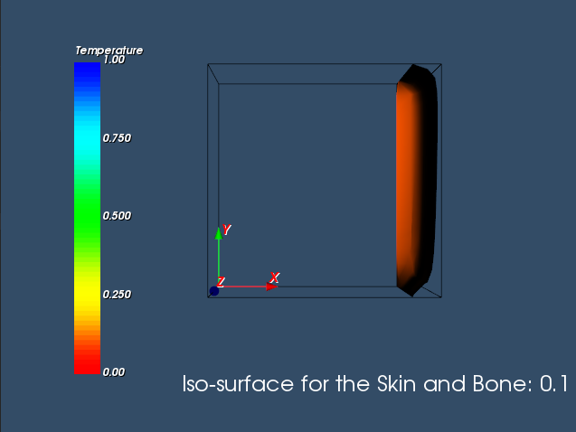

Iso-Surface Extraction: 0.2

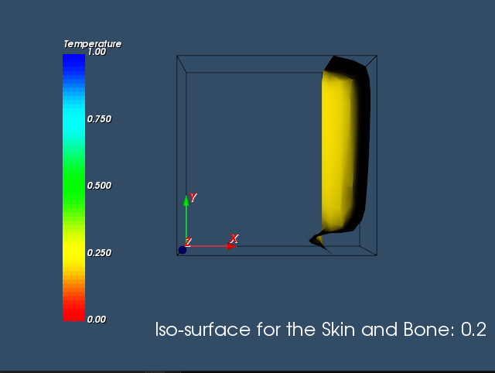

Iso-Surface Extraction: 0.3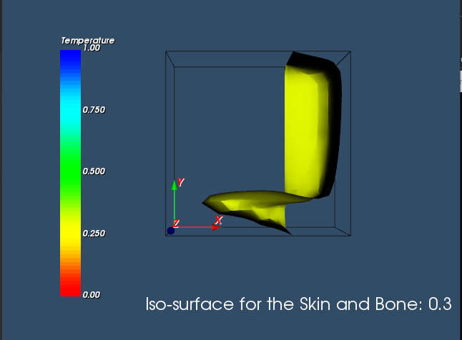

Iso-Surface Extraction: 0.5

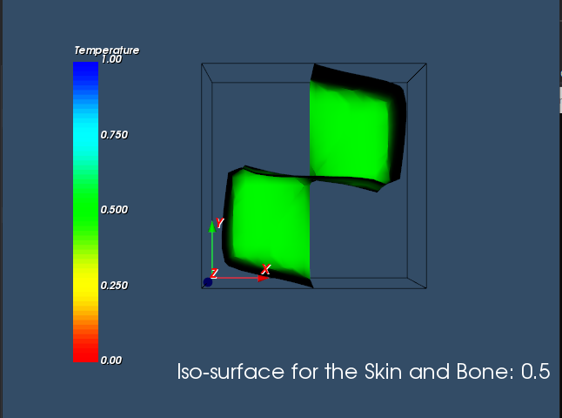

Iso-Surface Extraction: 0.75

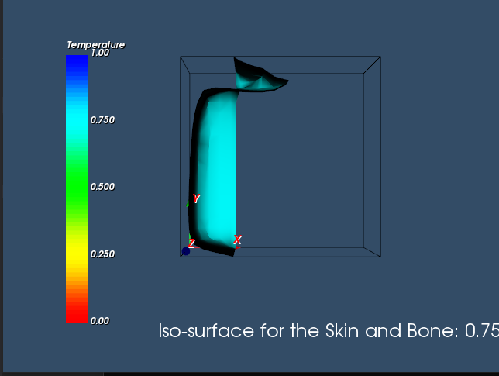

**PROBING: Sagittal Only** (0,0, 0,17, 0,9)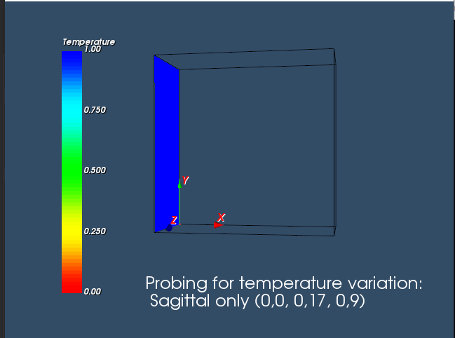

Sagittal Only: (4,4, 0,17, 0,9)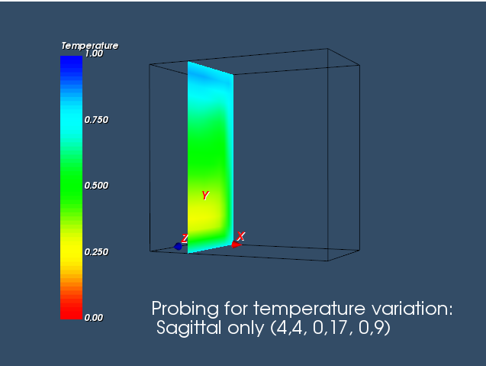

Sagittal only: (9,9, 0,17, 0,9)

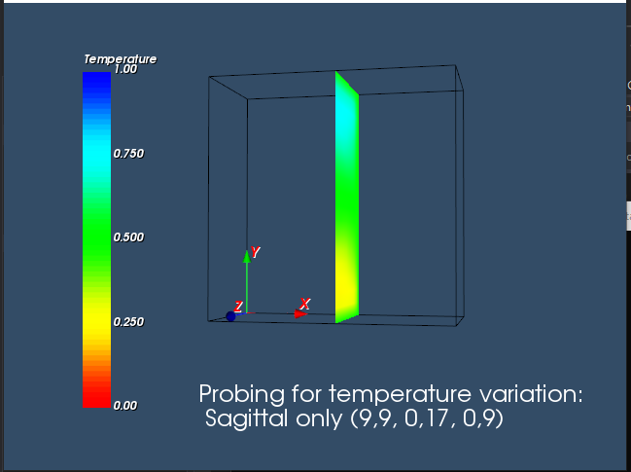

Sagittal only: (13,13, 0,17, 0,9)

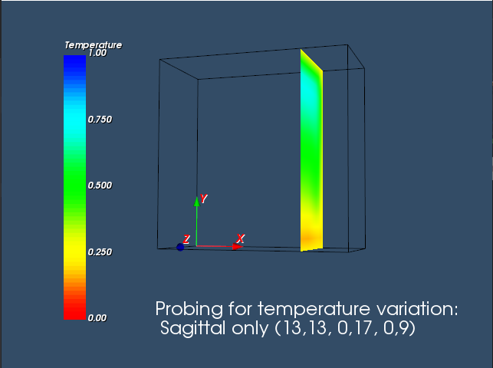

Sagittal only: (17,17, 0,17, 0,9)

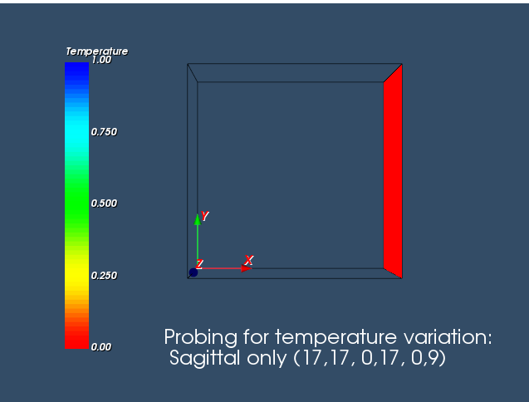

**Axial only: (0,17, 0,0, 0,9)**

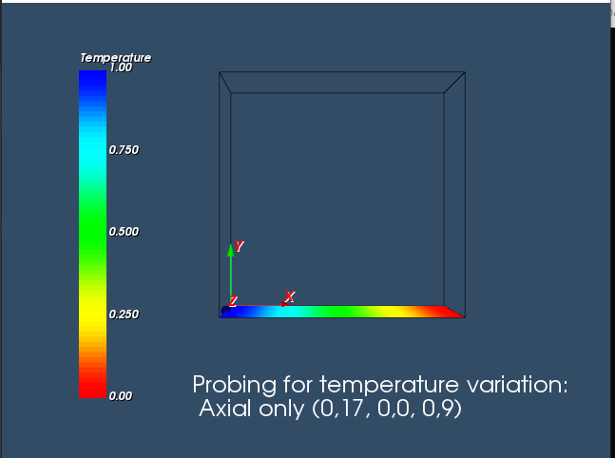

Axial only: (0,17, 4,4, 0,9)

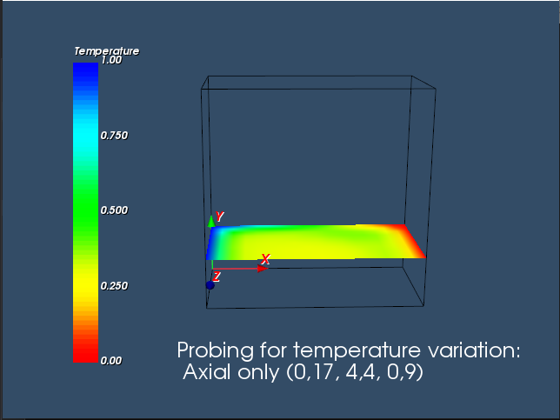

Axial only: (0,17, 9,9, 0,9)

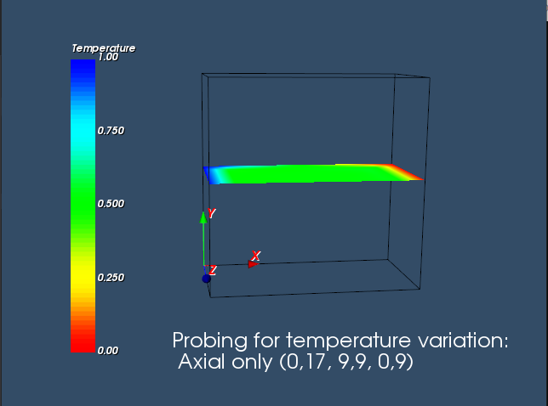

Axial only: (0,17, 13,13, 0,9)

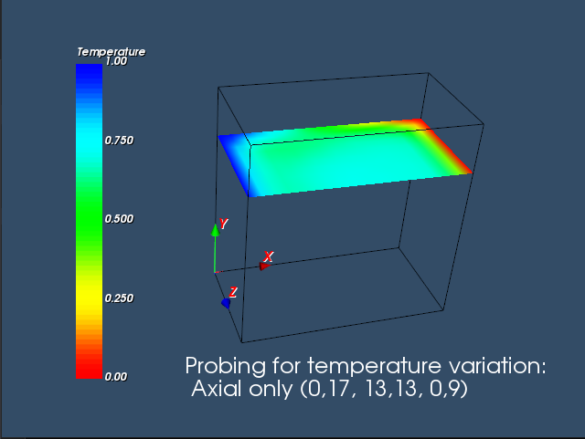

Axial only: (0,17, 17,17, 0,9)

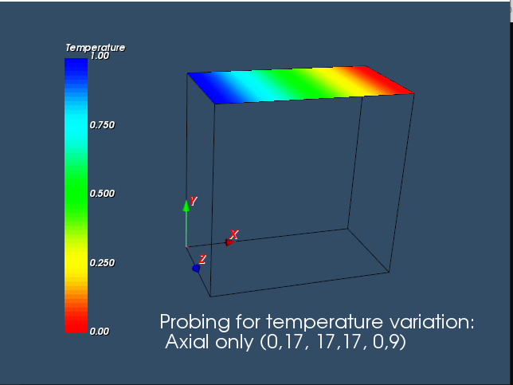

Coronal only: (0,17, 0,17, 0,0) 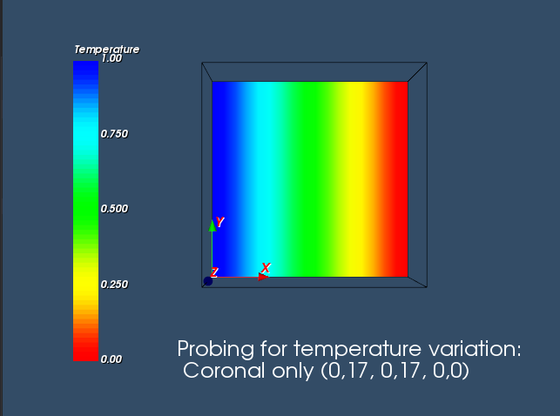

Coronal only: (0,17, 0,17, 3,3)

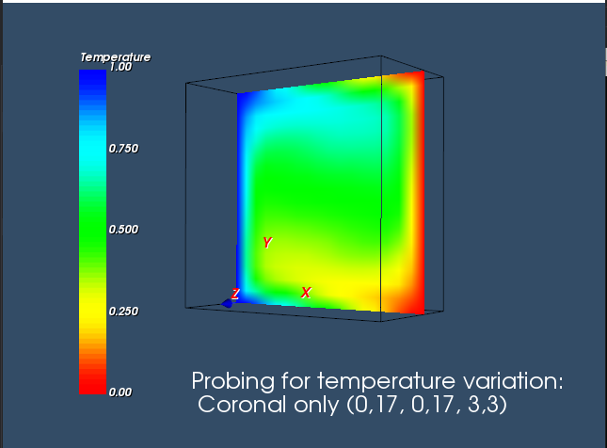

Coronal only: (0,17, 0,17, 6,6)

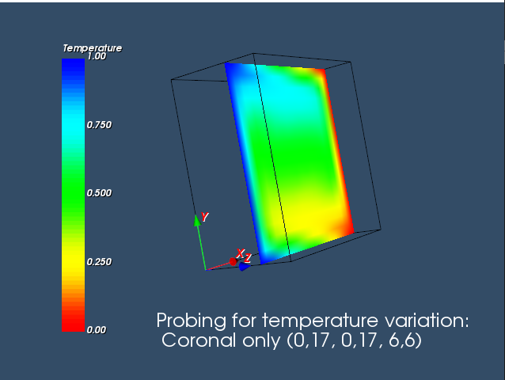

Coronal only: (0,17, 0,17, 9,9)

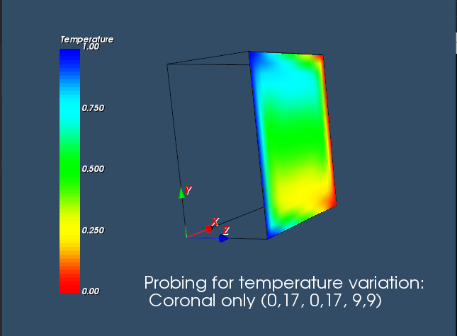

All 3 probing intersections:

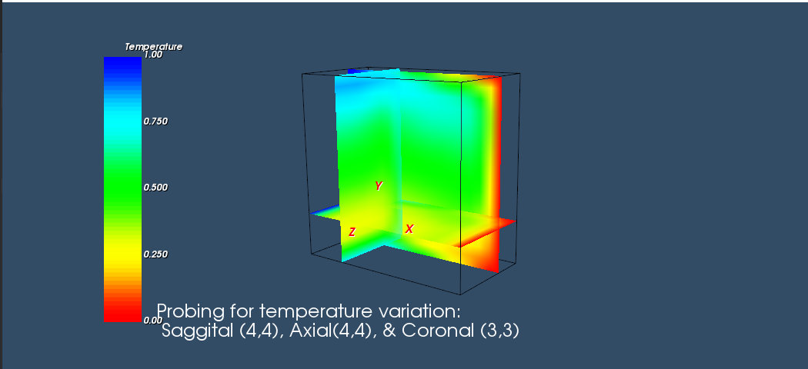

Submission: leaves both isosurface and Probing information in so will look like this when loaded:

