# Lab 4 Systems Database

Select part

Explain select part

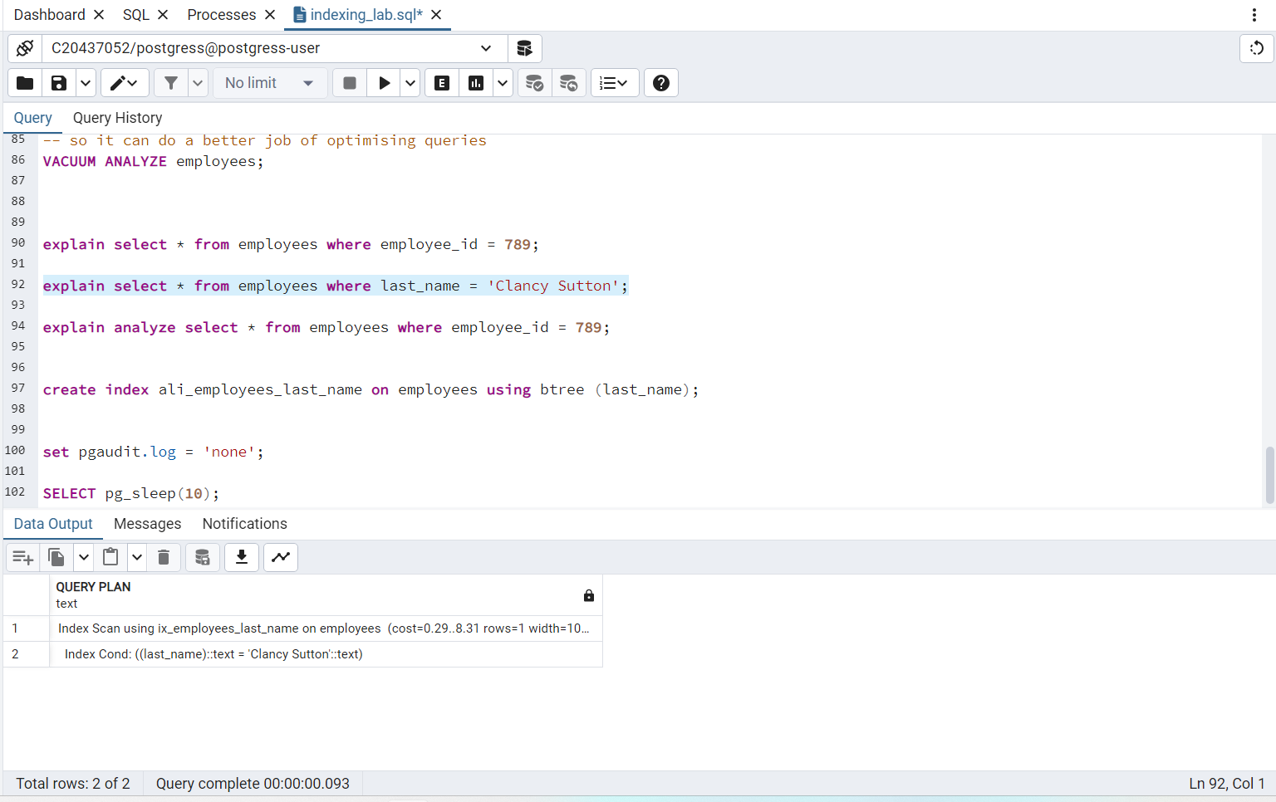

Explain analyse part

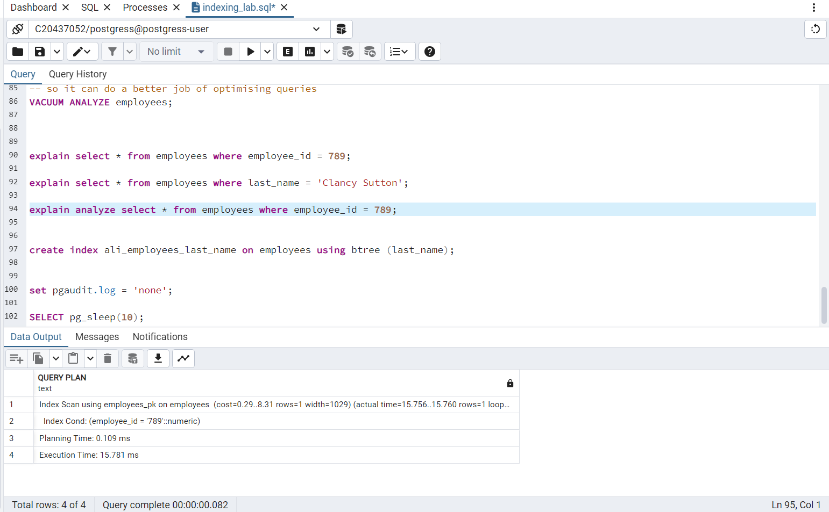

Cat part in 3 different images



