Invoice Processing Automation
for Marshall’s Tailoring

Final Project Documentation (GT6B)
A Project Submitted to the College of Information Technology and Engineering
in partial fulfillment of the requirements for the course
APPDEVT (Applications Development and Emerging Technologies)
Submitted by:
Serrano, Mark Cyrus
Umila, Alejandro
De Guzman, Ergio Rafael
Mendoza, Matt Gabriel
Ceneta, Stephanie
Section: C3A
Submitted to: Balita, Arabelle
Date submitted: October 29, 2026

I. Company Profile
Company name | Marshall’s Tailoring | Year started | 2002
Type of business | Local tailoring shop | Size | Small business (family-owned)
Owner / manager | Marcial F. Serrano | Number of employees | 4 (including the owner)
Location | 2nd Floor, Bldg. 1, Lipa City Public Market, Lipa City, Batangas | Operating hours | Tuesday to Sunday, 9:00 AM to 4:00 PM
Nature of business | Made-to-measure garments, uniforms, coat and suit rental, alterations, and repairs. Products and services: school, corporate, and organizational uniforms; custom suits and made-to-measure formal wear; Barong Tagalog; coat and suit rental; and alterations.
Typical customers | Schools, companies, and organizations needing uniforms; individuals (men and women) needing suits, formal wear, and Barong Tagalog.
Invoice volume | Average of 3 to 4 invoices per week.
Marshall’s Tailoring serves Lipa City and nearby areas of Batangas, from single pieces to bulk uniform orders. Orders arrive by phone, through the inquiry form on the shop’s website, or in person. The client’s garment type, occasion, and timeline are discussed, followed by a fitting and consultation to take measurements and agree on the fabric and styling. Each job then requires the owner to determine the fabric and materials needed, compute their cost, and bill the client. Billing is still done manually by the owner, and this billing step is the process addressed by this project.
II. Functional Area
A. Identified Functional Area
The study focuses on the Sales and Billing (Invoicing) function of Marshall’s Tailoring. This function computes the cost of materials for each client order and issues the invoice. The owner, Marcial F. Serrano, performs the whole function; the shop’s other employees are not involved in invoicing. Client intake, fitting, and measurement take place before this function and are out of scope.
B. Current Process Flow (As-Is)
Table 1. As-Is invoicing process (seven manual steps of the owner, with one decision point at step 2; Figure 1 shows the same flow)
No. | Who | Activity | Input | Output / decision | Tool used | Problem
1 | Owner | Receives the client order and notes the materials and yards needed. | Client request (phone, website inquiry, or walk-in) and agreed fabric and garment | Handwritten or mental notes of the order | Notebook / memory | Details may be incomplete or noted inconsistently.
2 | Owner | Mentally checks the details. | Order notes | Decision: complete? If not, asks the client for the missing details. | Memory | No fixed checklist; mistakes are found late.
3 | Owner | Looks up the price per yard of each material. | Fabric and garment names | Price per yard and labor fee | Price list on paper / Excel | Time-consuming; prices may be outdated.
4 | Owner | Multiplies price by yards for each item and adds the totals. | Prices and yards | Invoice total | Calculator | Computation errors.
5 | Owner | Writes or types the invoice. | Line amounts and client name | Invoice document | Handwritten / Word / Excel | Inconsistent format; repeated retyping; no automatic invoice numbering.
6 | Owner | Sends the invoice to the client. | Invoice document | Invoice received by the client | Chat / SMS / email / in person | Sent separately; delays.
7 | Owner | Records the invoice. | Invoice details | Logbook entry | Logbook | No organized or searchable record.

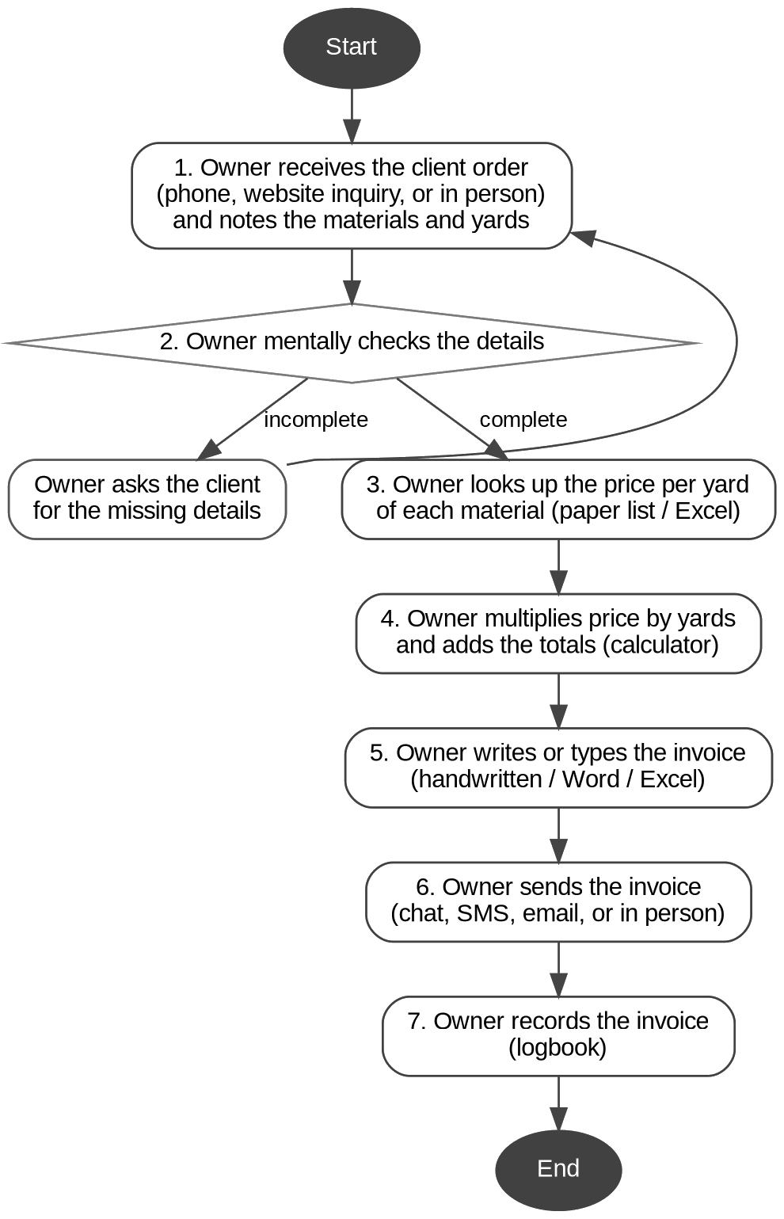  Figure 1. As-Is invoicing process of the owner: seven manual steps with one decision point. | Problems and Opportunities  The manual process is repetitive (the same steps for every order), rule-based (a price is looked up and multiplied by the yards), and digital in nature (inputs, price list, and outputs can all be handled in files and email). It is also error-prone by hand. This leads to:  - Computation errors when prices are multiplied and added by hand, which affect revenue and client trust.  - Slow turnaround between a client request and a received invoice.  - Inconsistent invoice formats and no automatic invoice numbering.  - No organized, searchable record of the invoices issued and sent.  Opportunity: every step after the input of materials and yards can be done by a bot. This makes the process a good candidate for RPA.
III. Organizational Chart
Figure 2. Organizational chart of the Sales and Billing function
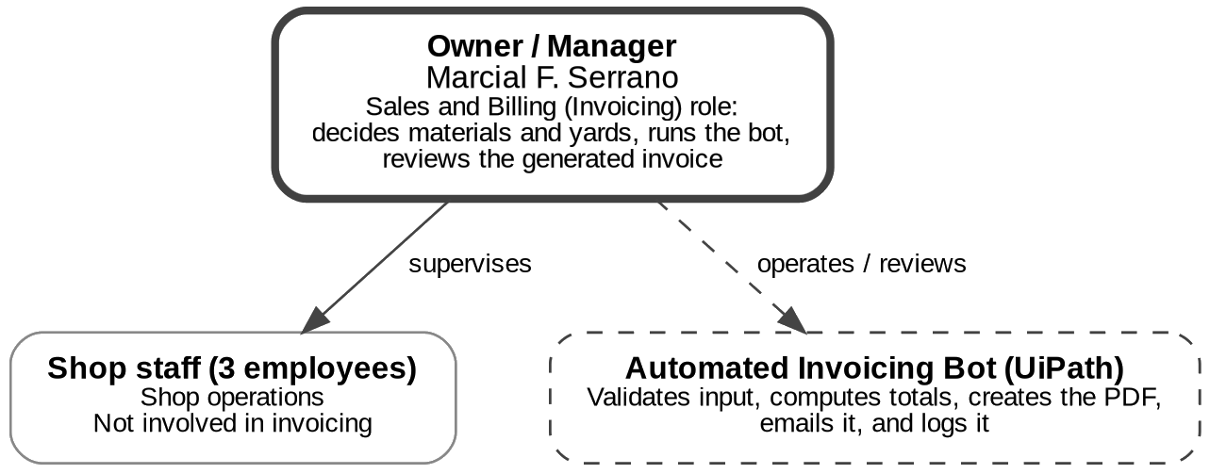
Figure 2. The owner (highlighted) performs the invoicing role and operates the bot; the three other employees are not involved in invoicing.
Owner / Manager (Marcial F. Serrano, highlighted): receives orders, decides the materials and yards, enters the invoice details in the form, starts the bot, and reviews the generated invoice.
Shop staff (3 employees): shop operations; not involved in invoicing.
Automated Invoicing Bot (UiPath): validates the input, reads the price lists, computes the totals, creates the invoice PDF, emails it, and records it in the Invoice Log.
IV. Process Description
A. Objectives and Scope
General objective: to automate the invoice processing of Marshall’s Tailoring using UiPath, from material input to the delivery of the invoice to the client.
Specific objectives: read the price lists and settings from an Excel workbook and compute line totals and the invoice total (Excel automation); generate a formatted invoice PDF (PDF automation); email the PDF to the client (Email automation); record every invoice with its sending status in an invoice log; and handle invalid input with clear messages instead of crashing.
In scope: input of client and order details through a form (order type, fabric, garment, yards, uniform sizes, or alteration service); price lookup and computation; invoice PDF generation and emailing; invoice logging and error handling.
Out of scope: payment collection, inventory management, taking measurements, and customer ordering.
Automation types used: Excel, PDF, and Email.
B. Automated Process (To-Be) and System Architecture
For each invoice, the owner starts the bot and fills in the New Invoice form. The bot then validates the input, reads the price lists, computes the amounts, builds and saves the PDF, emails it, and logs the result. Figure 3 shows the flow, Figure 4 the components, and Table 2 maps each manual step to its automated step.
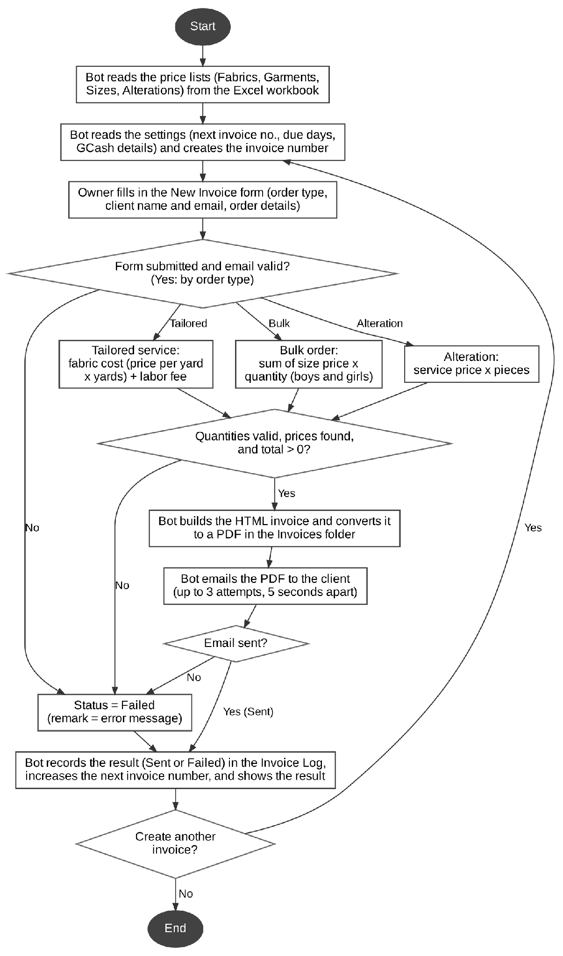  Figure 3. To-Be flowchart of the invoice bot, including the validation decisions and the email retry. | 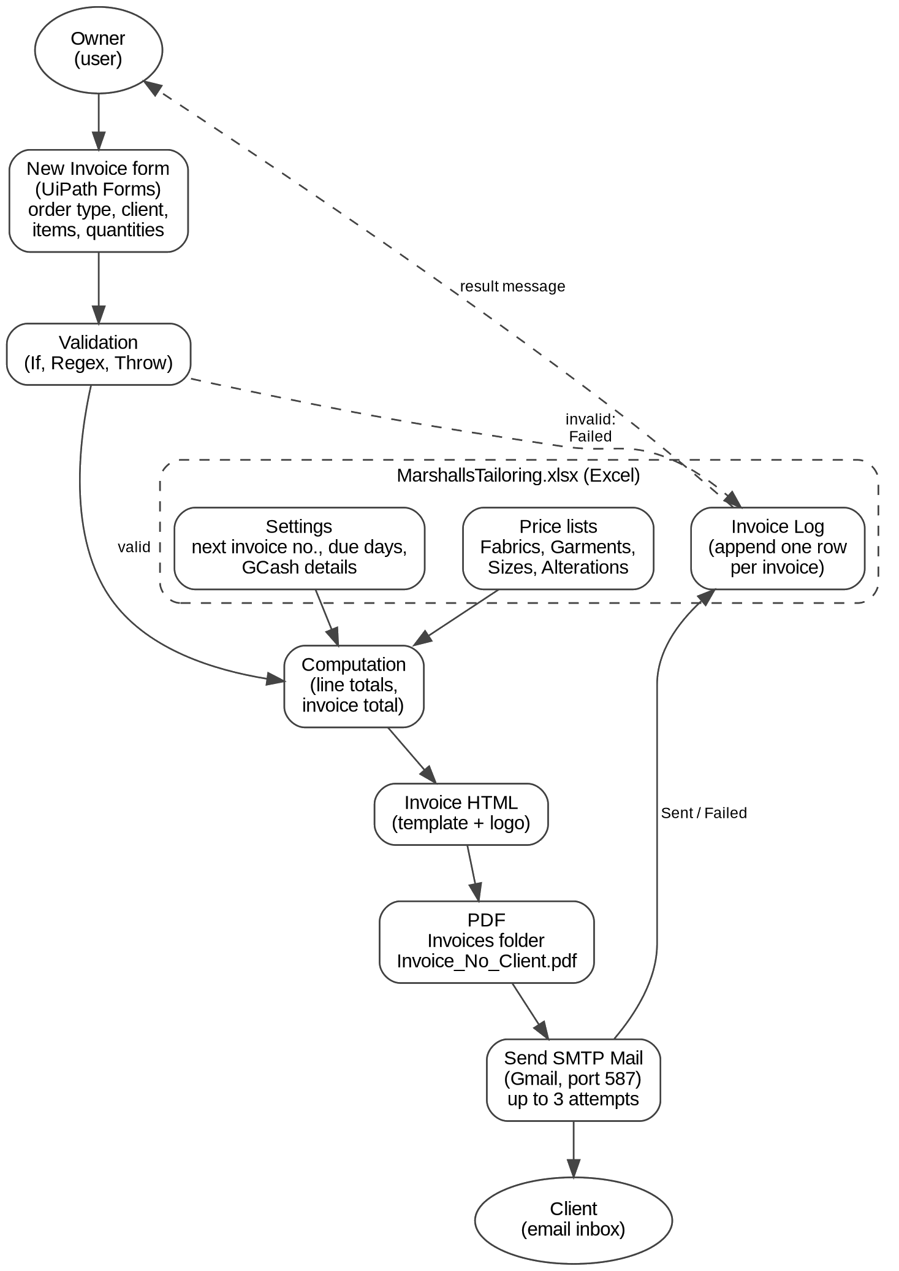  Figure 4. System architecture: components of the invoice bot and the data that moves between them.
System architecture. The system has no server or database. The owner works through the New Invoice form (UiPath Forms). The UiPath workflow validates the input, then reads prices and settings from MarshallsTailoring.xlsx and computes the amounts. It fills an HTML invoice template (with the shop logo), converts it to a PDF in the Invoices folder, and sends the PDF through Gmail SMTP (smtp.gmail.com, port 587, STARTTLS). The outcome of every run, Sent or Failed, is appended to the Invoice Log sheet of the same workbook, and the result is shown to the owner in a message box.
Table 2. How each manual step became an automation
No. | Manual step (As-Is) | Automated step (To-Be) | Main UiPath activities | Type
1 | Owner notes the order details. | Owner enters the order type, client name, client email, and the order details in the New Invoice form (up to four garments with fabric, yards per piece, and pieces; boys and girls quantities per size; or up to four alteration services with pieces). | Show Form, Do While | Form
2 | Owner mentally checks the details. | Bot validates: form submitted, valid email format, yards per piece greater than 0, at least 1 piece, and a total greater than 0. | If, Regex.IsMatch, Throw | Validation
3 | Owner looks up each price. | Bot reads the price lists (Fabrics, Garments, Sizes, Alterations) and the Settings sheet, then finds the price, labor fee, or unit price of each item. | Excel Process Scope, Use Excel File, Read Range, Assign | Excel
4 | Owner computes with a calculator. | Bot computes by order type: for each garment, fabric cost (price per yard x yards per piece x pieces) plus labor fee x pieces; size price x quantity for each size; or service price x pieces for each service. It then sums the invoice total. | If, Assign, For Each, For Each Row in Data Table | Excel
5 | Owner writes or types the invoice. | Bot builds the invoice in HTML and converts it to a PDF named Invoice_<No>_<Client>.pdf in the Invoices folder. | Assign, Invoke Method (CreateDirectory), Convert HTML to PDF | PDF
6 | Owner sends the invoice separately. | Bot emails the PDF as an attachment with a standard message, trying up to 3 times. | Send SMTP Mail Message, Do While, Try Catch, Delay | Email
7 | Owner records the invoice, if at all. | Bot appends a row to the Invoice Log with the status, increases the next invoice number, shows the result, and asks whether to create another invoice. | Add Data Column, Add Data Row, Write Range, Message Box, Input Dialog | Excel
Table 3. Summary of improvements (As-Is vs To-Be)
Aspect | As-Is (manual) | To-Be (bot)
Input | Order notes in a notebook or from memory; no checklist. | One form with required fields, dropdown lists, and minimum values.
Price lookup and computation | Prices looked up on a paper list or in Excel, then multiplied and added with a calculator. | Prices read from the Excel price list at every run and computed by order type.
Invoice | Handwritten or typed; inconsistent format; no automatic invoice number. | One HTML template converted to PDF; automatic number INV-<year>-<running number>.
Delivery | Sent separately by chat, SMS, email, or in person. | Emailed as a PDF attachment, with up to 3 attempts.
Record | Logbook entry, not searchable. | Invoice Log sheet with status and remarks for every run.
Error checking | Mistakes found late. | Invalid input blocked by the form and checked again by the bot, with a clear message.
In short, the owner only fills in the form and reviews the result; the bot performs steps 2 to 7 of Table 1.
C. Data Specifications
Price list and settings (input). The invoice contents and the Invoice Log columns are described under Figures 9 and 12.
Sheet / column | Description | Example
Fabrics: Fabric, Unit, Price per Yard | Name and current price per yard of each fabric (8 fabrics). | Cotton Twill, Yard, 180
Garments: Garment, Labor Fee | Name and labor charge per piece of each garment (7 garments). | Pants, 600; Polo Shirt, 450
Sizes: Size, Boys, Girls | Unit price of each uniform size, XS to 3XL. | Size XS: Boys 330; Girls 350
Alterations: Service, Price | Name and price per piece of each alteration service (5 services). | Hemming, 150
Settings: Setting, Value | Next Invoice Number, Payment Due (days), GCash Number, and GCash Account Name, in that order. | Payment Due (days): 7; GCash 0917 000 0000
D. Exception and Error Handling
The form blocks some invalid entries before the bot starts, and the bot repeats the checks. When an order reaches the bot with a problem, it stops that invoice, shows a FAILED message with the reason, and writes a Failed row with the reason in Remarks. The last column of Table 4 shows where each case is demonstrated.
Table 4. Exceptions and bot responses
Scenario | How it is detected | Bot response | Shown in
Yards per piece below 0.1 or pieces below 1 | The form sets minimum values; the bot checks again (If) and throws “The fabric length must be greater than 0.” or “The number of pieces must be at least 1.” | The form shows an error under the field and Create Invoice does not proceed. | T4, Figure 13
Client email blank or invalid format | The form checks the email; the bot repeats it with a Regex check on the trimmed email. | The form shows “must be a valid email” and blocks the entry. If it reached the bot, it would stop with “The client email address is not valid.” | T5, Figure 13
Form closed without submitting | Order type or client name is empty. | The message shows “FAILED: The form was closed without submitting an order.” No invoice or PDF is created; a Failed row is logged. | T7, Figures 12 and 13
No items ordered (all uniform quantities 0) | Total amount is 0 or less. | The message shows “FAILED: No items were ordered, so there is nothing to invoice.” No invoice or PDF is created; a Failed row is logged. | T6, Figures 12 and 13
Email cannot be delivered | Exception on the Send SMTP Mail Message activity. | The bot tries up to 3 times, waiting 5 seconds between attempts. The PDF is already saved in the Invoices folder. | Figure 10
E. Tools, Environment, and Development Process
- UiPath Studio 2026.0 with the Excel, Mail, PDF, Forms, and System activity packages; Microsoft Excel 2024 for the price lists, settings, and invoice log (MarshallsTailoring.xlsx); Windows 11.
- Email: Gmail SMTP (smtp.gmail.com, port 587, STARTTLS). During development and testing, mail is sent from the team’s school account, alejandro_umila@dlsl.edu.ph. The shop’s own address is marshalls.tailoring@gmail.com; for live use, the sender must be changed to the shop’s address with an app password.

Phase | Activities | Owner
Analysis | Interview the owner, map the current process, and identify pain points. | Mark Cyrus Serrano and Alejandro Umila
Design | Design the To-Be flow, input method, invoice template, and data layout. | Ergio Rafael De Guzman and Matt Gabriel Mendoza
Development | Build the Excel, PDF, and Email workflows in UiPath Studio. | Alejandro Umila and Mark Cyrus Serrano
Testing | Run normal and error scenarios (see Table 5). | Matt Gabriel Mendoza and Stephanie Ceneta
Documentation | Compile the documentation, and prepare the files | Ergio Rafael De Guzman and Stephanie Ceneta
F. Setup and User Guide
Prerequisites. A Windows computer with UiPath Studio and the activity packages above, Microsoft Excel, an internet connection, an email account for sending, and the project folder containing MarshallsTailoring.xlsx and logo.png. The Invoices folder is created by the bot when it is missing.
Updating the price list. Open MarshallsTailoring.xlsx and edit the Fabrics, Garments, Sizes, or Alterations sheet, then save and close the file. The bot reads the current prices at every run. A new fabric, garment, or service must also be added to the matching dropdown of the New Invoice form (TailoringOrder), because the dropdown options are maintained separately. Do not edit the next invoice number in Settings during normal use.
Creating an invoice.
- Close MarshallsTailoring.xlsx, then open the project in UiPath Studio and click Run file.
- In the New Invoice form, choose the order type, then enter the client name and client email.
- For a Tailored Service, fill in up to four garments (garment, fabric, yards per piece, and pieces); leave unused rows empty. For a Bulk Order, enter the boys and girls quantities per size (leave unused sizes at 0). For an Alteration, choose up to four services and their pieces.
- Click Create Invoice. The bot validates the input, computes the totals, saves the PDF in the Invoices folder, emails it, and logs the result.
- Read the Invoice result message. It shows Sent or the reason for failure. If the email was not delivered, the PDF is still in the Invoices folder and can be sent manually.
- Answer Yes to “Create another invoice?” to start a new invoice, or No to end the run.
- Check the PDF in the Invoices folder and the new row in the Invoice Log sheet.
G. Testing
Table 5 lists the nine test cases run on October 29, 2026 with sample client data. The workbook started with INV-2026-001 to 004 and Next Invoice Number 5, so the three valid orders (T1 to T3) were logged as INV-2026-005 to 007, and the two failed runs (T6 and T7) as INV-2026-008 and 009. The large order (T9) was logged as INV-2026-011. INV-2026-010 is an additional Failed run (Alteration, “The number of pieces must be at least 1.”) that is not one of the listed cases.
Table 5. Test cases
ID | Scenario | Input | Expected result | Actual | Result
T1 | Valid tailored order | Tailored Service (1:1); Alejandro Umila; alejandro_umila@dlsl.edu.ph. Cotton Twill, Pants: 3.2 yd x 3 pieces; Poplin, Polo Shirt: 1.7 yd x 2 pieces. | Total = fabric + labor for each garment (1,728.00 + 1,800.00 + 408.00 + 900.00 = PHP 4,836.00); PDF created, email sent, log shows Sent. | INV-2026-005, total PHP 4,836.00. Message “Invoice INV-2026-005 was sent to alejandro_umila@dlsl.edu.ph.” appeared; PDF saved, email arrived with the PDF, log shows Sent (Figures 5, 9, 11, 12). | Pass
T2 | Valid bulk order, all sizes | Bulk Order (School Uniforms); Alejandro Umila. Boys XS to 3XL: 3, 4, 5, 6, 7, 8, 9. Girls XS to 3XL: 9, 8, 7, 6, 5, 4, 3. | Fourteen line items; each line = unit price x quantity; total PHP 36,120.00; PDF created, email sent, log shows Sent. | INV-2026-006, total PHP 36,120.00 with fourteen lines. Message, PDF, email, and log row Sent as expected (Figures 5, 9, 11, 12). | Pass
T3 | Valid alteration order | Alteration; Alejandro Umila. Waist Adjustment x 3, Hemming x 3, Zipper Replacement x 2. | Price x pieces for each service (750.00 + 450.00 + 400.00 = PHP 1,600.00); PDF created, email sent, log shows Sent. | INV-2026-007, total PHP 1,600.00. Message, PDF, email, and log row Sent as expected (Figures 5, 9, 11, 12). | Pass
T4 | Zero or negative entry | Tailored Service; Pedro Reyes. Pants, Denim; yards per piece: 0; pieces: -2. | Entry rejected: the form blocks it, or the bot throws “The fabric length must be greater than 0.” | The form marked yards per piece 0 (“cannot be less than 0.1”) and pieces -2 (“cannot be less than 1”). Entry blocked; nothing created (Figure 13). | Pass
T5 | Invalid email | Tailored Service; Ana Lopez; email: abc@. Poplin, Skirt, 1.5 yd x 1 piece. | Entry rejected before any invoice is created. | The form showed “Client Email … must be a valid email.” and blocked the entry (Figure 13). | Pass
T6 | Bulk order with all quantities 0 | Bulk Order; Sample High School; all boys and girls sizes: 0. | No invoice or PDF; message shows FAILED with the reason; log shows Failed. | Message “Invoice INV-2026-008 FAILED: No items were ordered, so there is nothing to invoice.” appeared. No PDF; log row INV-2026-008 shows Failed with that reason in Remarks (Figures 12, 13). | Pass
T7 | Form closed without submitting | Open the New Invoice form, then close it without clicking Create Invoice. | No invoice or PDF; message shows FAILED with the reason; log shows Failed. | Message “Invoice INV-2026-009 FAILED: The form was closed without submitting an order.” appeared. No PDF; log row INV-2026-009 shows Failed with that reason in Remarks (Figures 12, 13). | Pass
T8 | Several invoices in a row | Run T1, T2, and T3 one after another, answering Yes to “Create another invoice?” after T1 and T2. | Invoice numbers increase by 1; all are logged. | INV-2026-005, 006, and 007 were created in sequence and logged at 15:53, 15:55, and 15:57 (Figure 12). | Pass
T9 | Extreme input: very large bulk order | Bulk Order (School Uniforms); De La Salle Lipa; mark_cyrus_serrano@dlsl.edu.ph. All boys and girls sizes XS to 3XL: 500 each. | Fourteen line items; total = (2,940 + 3,080) x 500 = PHP 3,010,000.00; PDF created, email sent, log shows Sent. | INV-2026-011, total PHP 3,010,000.00 with fourteen lines. Message, PDF, email, and log row Sent as expected (Figure 14). | Pass
V. Screenshots of the Automated Process
Figures 5 to 14 follow the To-Be steps in Table 2. All screenshots use sample client data and were taken on October 29, 2026.
Figure 5. Input of client details, materials, and yards (To-Be step 1)
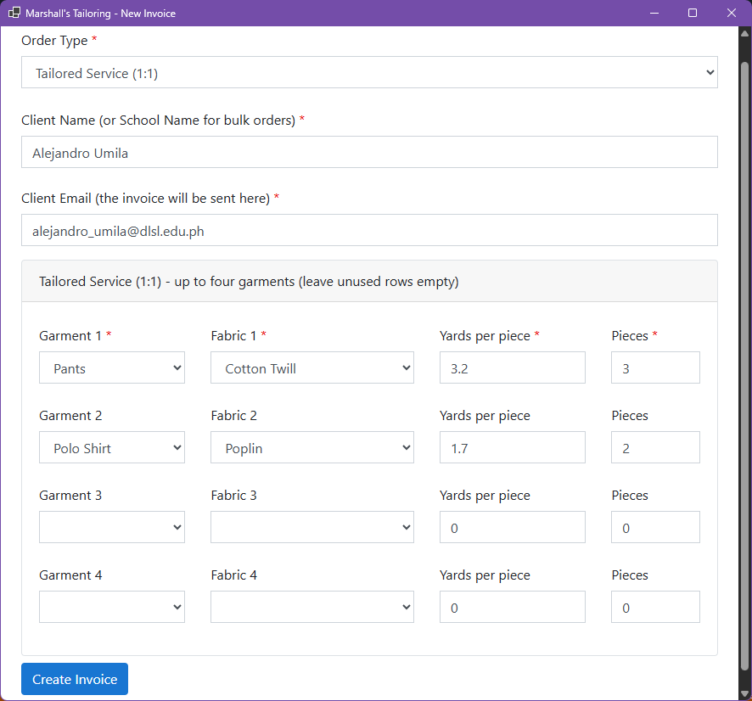  5a. New Invoice form, Tailored Service (1:1), as filled in for T1: Pants in Cotton Twill (3.2 yd x 3 pieces) and Polo Shirt in Poplin (1.7 yd x 2 pieces). | 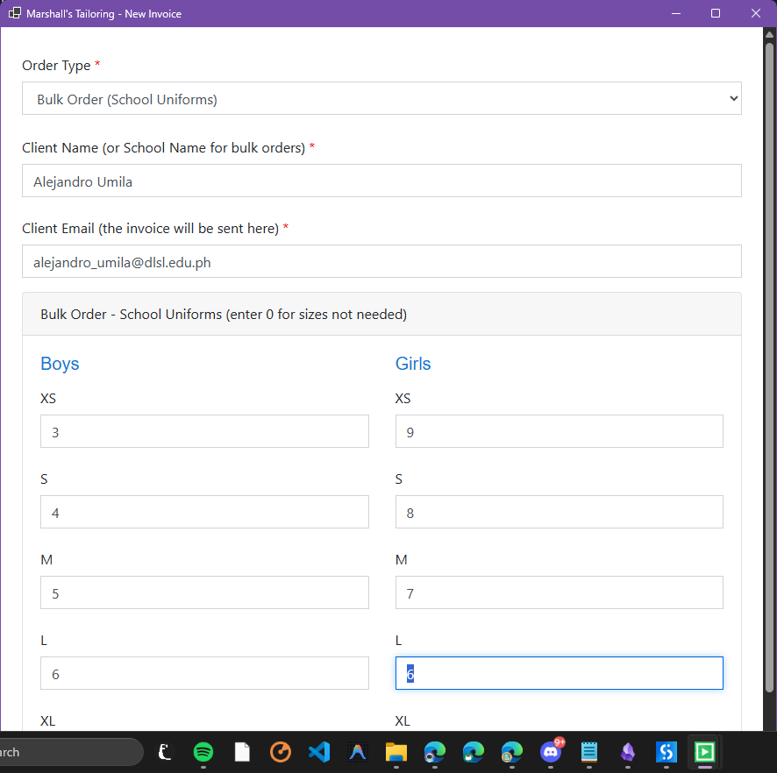  5b. New Invoice form, Bulk Order (School Uniforms), as filled in for T2: boys and girls quantities per size (first sizes).
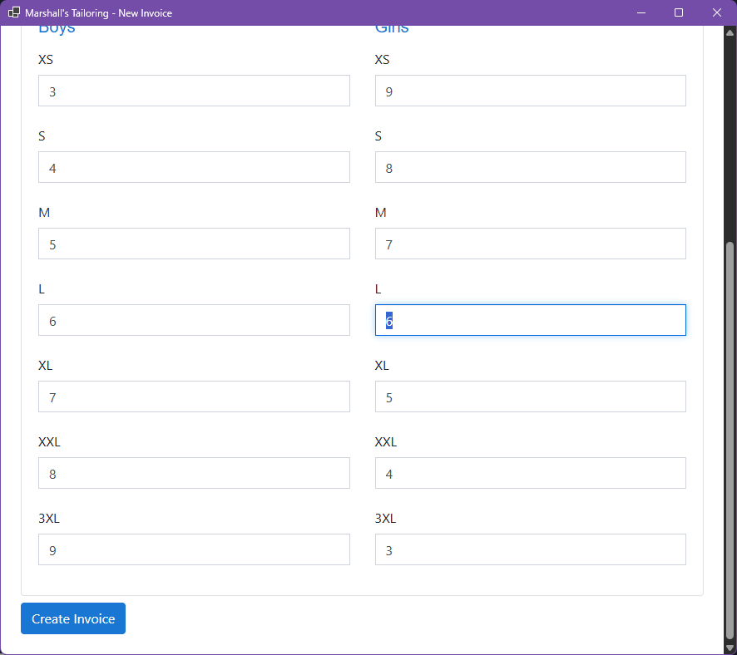  5c. Bulk Order form, remaining sizes (L to 3XL) and the Create Invoice button. | 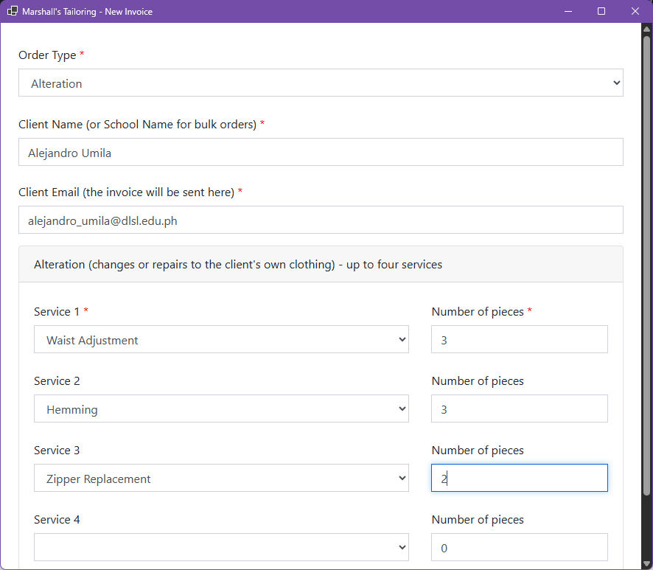  5d. New Invoice form, Alteration, as filled in for T3: Waist Adjustment x 3, Hemming x 3, Zipper Replacement x 2.
Discussion. The owner enters the order type, client name, and client email, followed by the details for that order type: up to four garments (garment, fabric, yards per piece, and pieces) for a tailored service; boys and girls quantities per size (XS to 3XL) for a bulk school uniform order; or up to four alteration services with their number of pieces. Required fields, dropdown lists, and minimum values prevent typing mistakes, and only the fields needed for the selected order type are shown. The bot receives these values as variables, trims and validates them, and uses them to look up prices and compute the invoice.
Figure 6. Price list and settings in Excel (To-Be step 3)
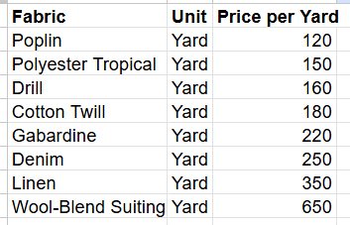  6a. Fabrics sheet: 8 fabrics with the price per yard.  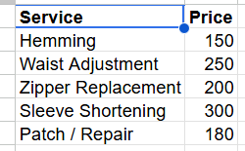  6d. Alterations sheet: price per service. | 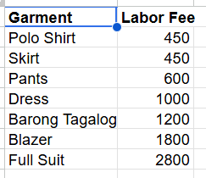  6b. Garments sheet: labor fee per piece.  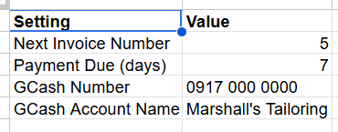  6e. Settings sheet before the test runs (Next Invoice Number 5, payment due in 7 days, GCash details). | 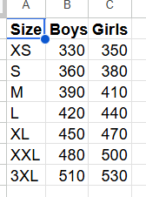  6c. Sizes sheet: boys and girls unit prices, XS to 3XL.
Discussion. The price list workbook (MarshallsTailoring.xlsx) has sheets for fabrics (price per yard), garments (labor fee), sizes (boys and girls prices), alterations (price per service), and settings (next invoice number, due days, GCash details). The Fabrics sheet lists 8 fabrics. The bot reads this file at every run, so prices are always current and the owner updates only the file, not the bot. The Settings screenshot was taken before the tests; after the test runs (INV-2026-005 to 011: four Sent and three Failed) the next invoice number is 12, because failed runs also use an invoice number.
Figure 7. UiPath workflow overview (To-Be steps 1 to 3)
Stage 1 loads the price lists (7a to 7c). Stage 2 prepares each invoice (7d to 7h): at the start of every loop, the bot resets the form values and reads Settings. Stage 3 handles input and validation (7i).
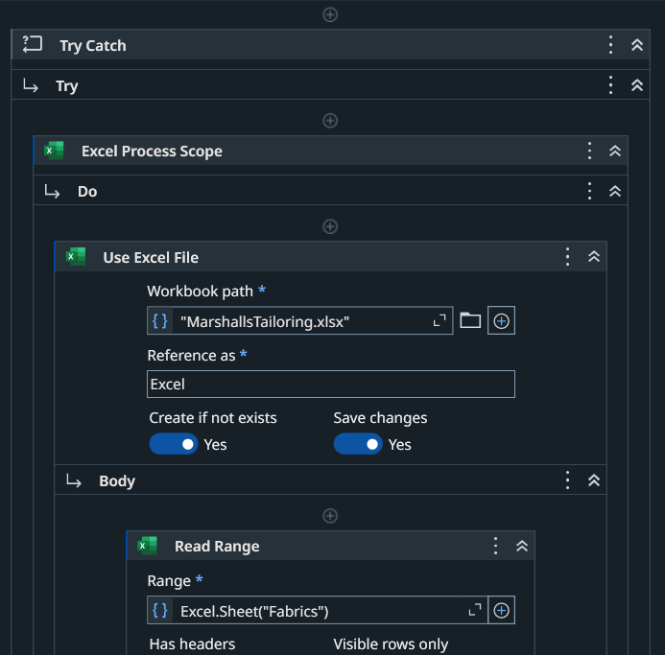  7a. Stage 1: Try Catch wraps the process; Use Excel File opens MarshallsTailoring.xlsx and Read Range loads the Fabrics sheet. | 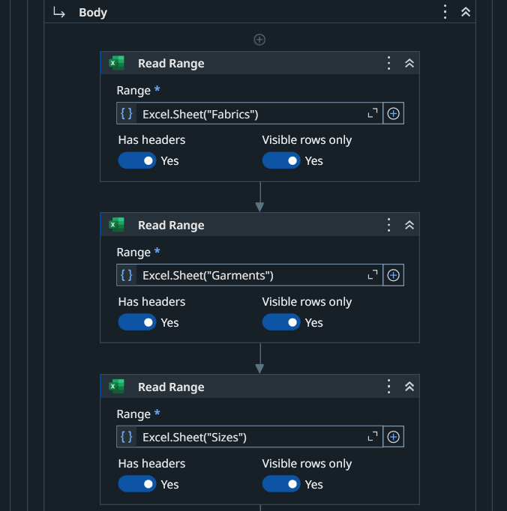  7b. Stage 1: Read Range loads the Garments and Sizes sheets.
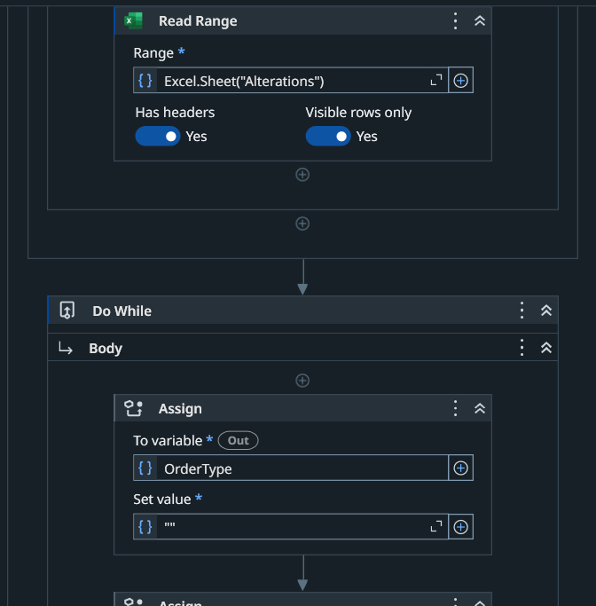  7c. Stage 1: Read Range loads the Alterations sheet; the Do While loop that repeats for each invoice begins. | 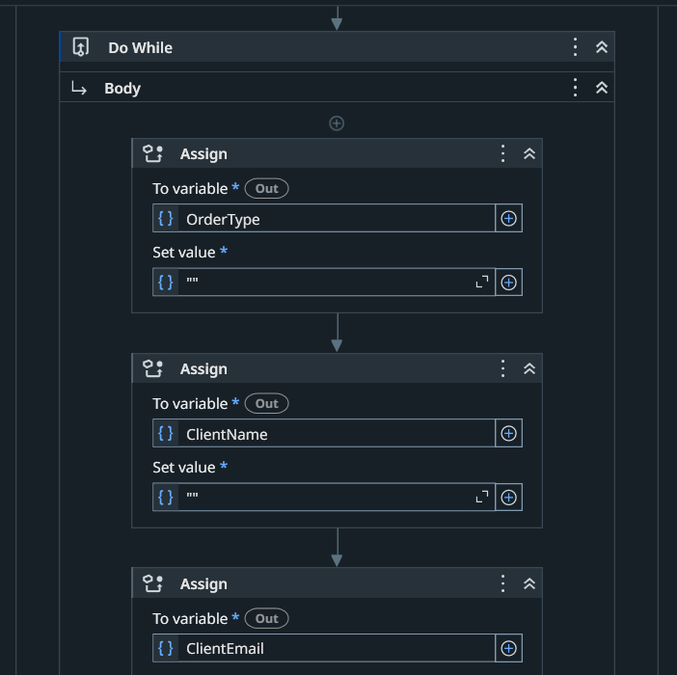  7d. Stage 2: form values are reset at the start of each loop (order type, client name, and client email shown; the other fields are reset the same way).
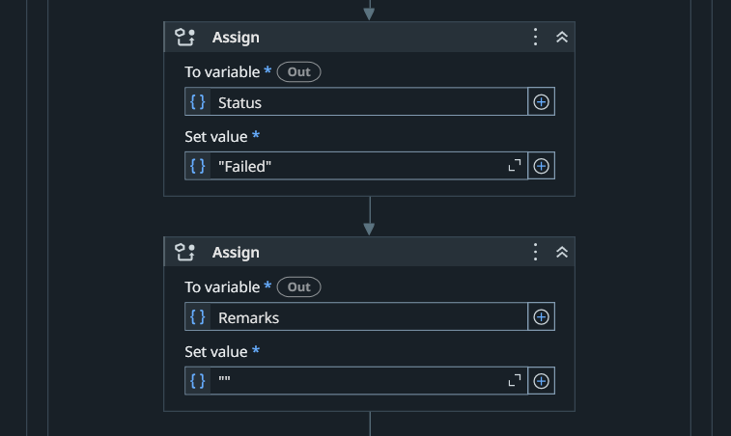  7e. Stage 2: Status defaults to Failed and Remarks to empty until the invoice succeeds. | 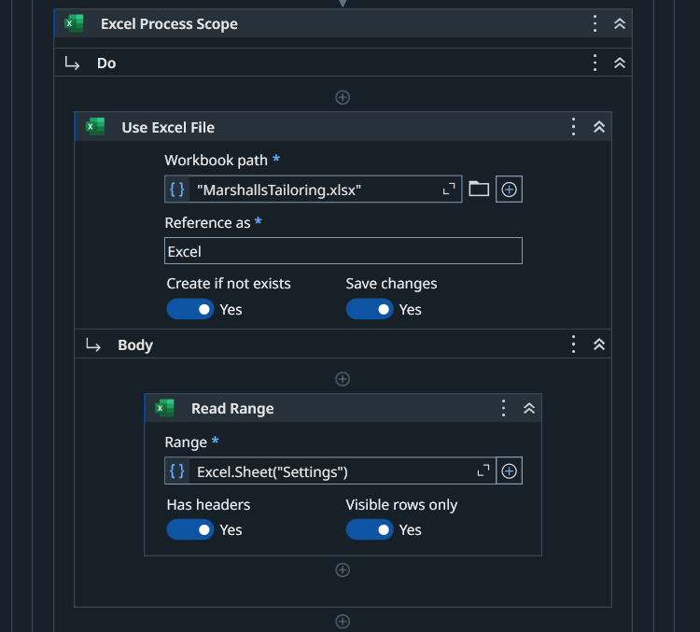  7f. Stage 2: the Settings sheet is read.
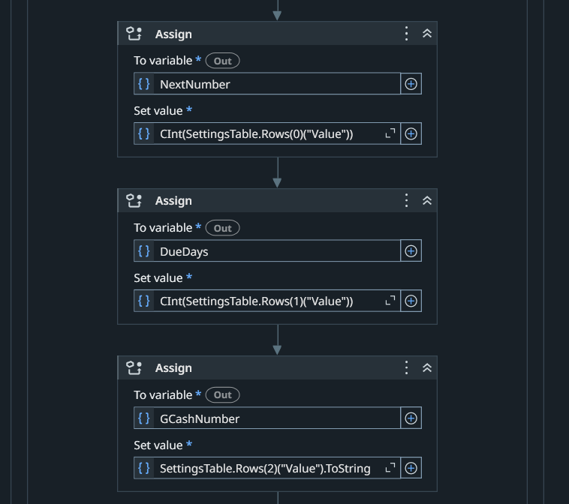  7g. Stage 2: next invoice number, due days, and GCash number are taken from Settings. | 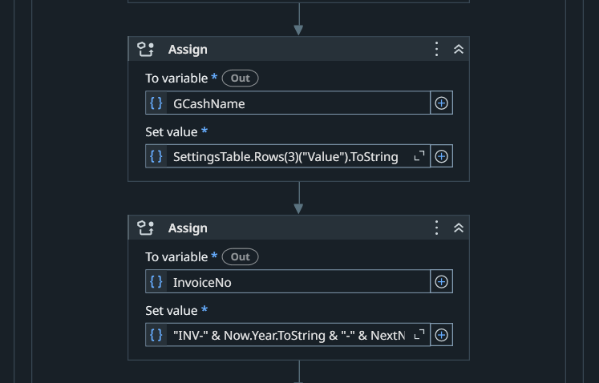  7h. Stage 2: GCash name is read and the invoice number (INV-year-number) is built.
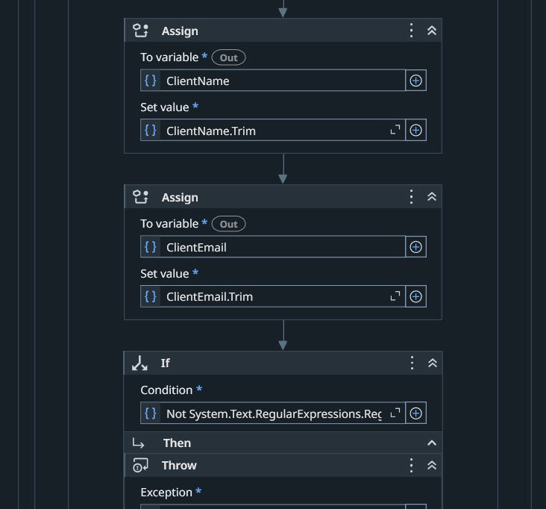  7i. Stage 3: client name and email are trimmed, and a Regex check tests the email format. | Discussion. The workflow is organized into seven stages: loading the price lists, preparing each invoice, input and validation through the form, price lookup and computation by order type, PDF generation, email sending with retries, and logging with the result message. The whole process is one sequence wrapped in a Try Catch, with a Do While loop that repeats for each invoice. The New Invoice form (TailoringOrder) is shown with Show Form, and an If check throws an error when the form is closed without an order. The logging stage is shown in Figure 12.
Figure 8. Price lookup and computation (To-Be step 4)
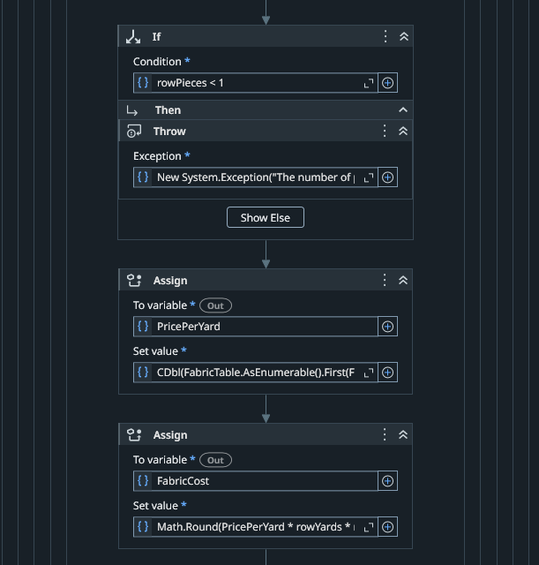  8a. Tailored branch, one pass of the garment loop (up to four garments): pieces below 1 raise an error; the price per yard is looked up; fabric cost = price per yard x yards per piece x pieces. | 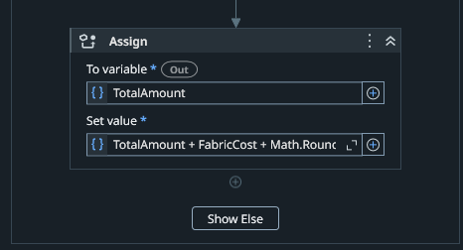  8b. The garment total is added: TotalAmount = TotalAmount + fabric cost + labor fee x pieces.
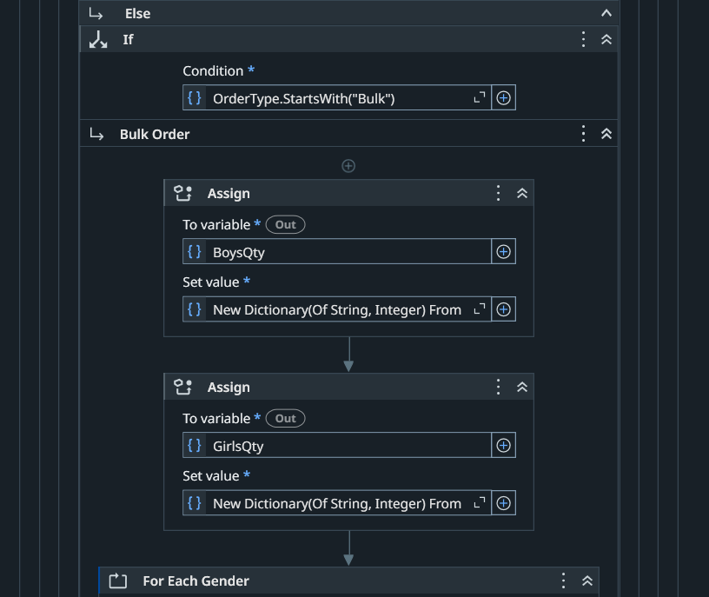  8c. Bulk Order branch: a quantity dictionary is created for boys and girls. | 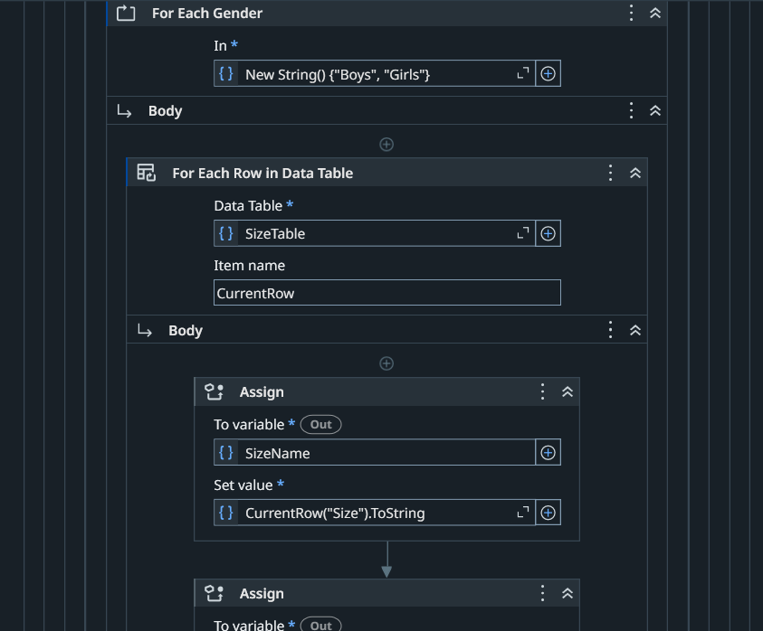  8d. For Each gender and For Each Row in the Sizes table loop through every size.
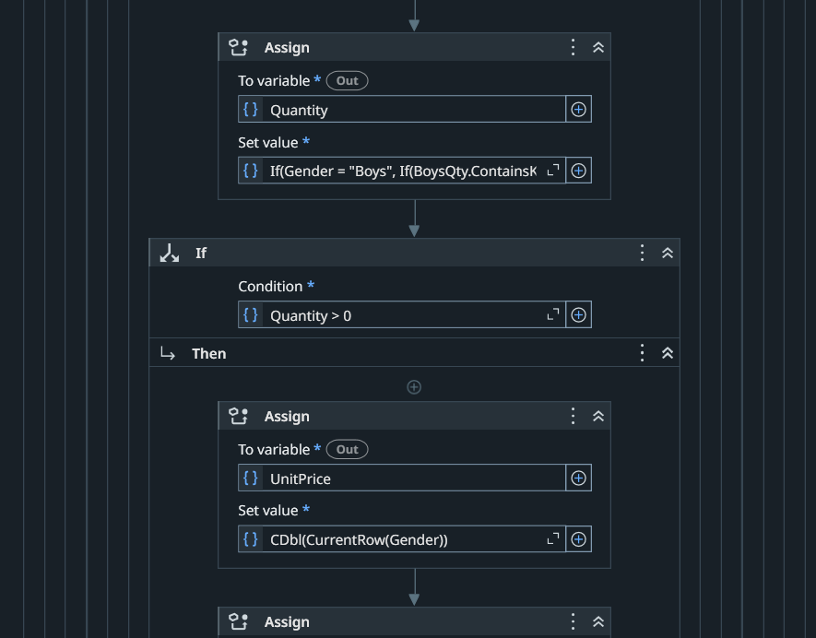  8e. The quantity for each size is read; only quantities above 0 continue. | 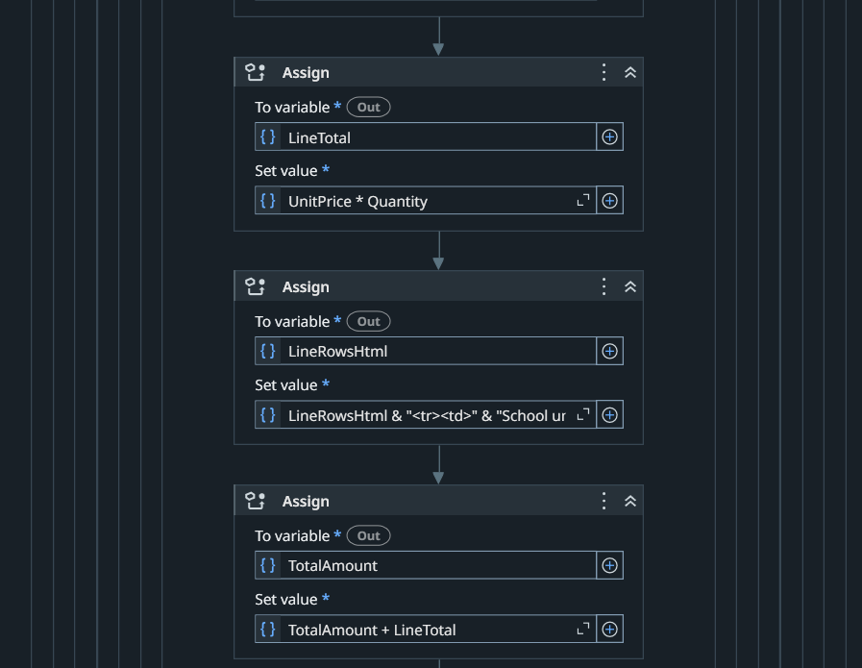  8f. Line total = unit price x quantity, added to the invoice and the total.
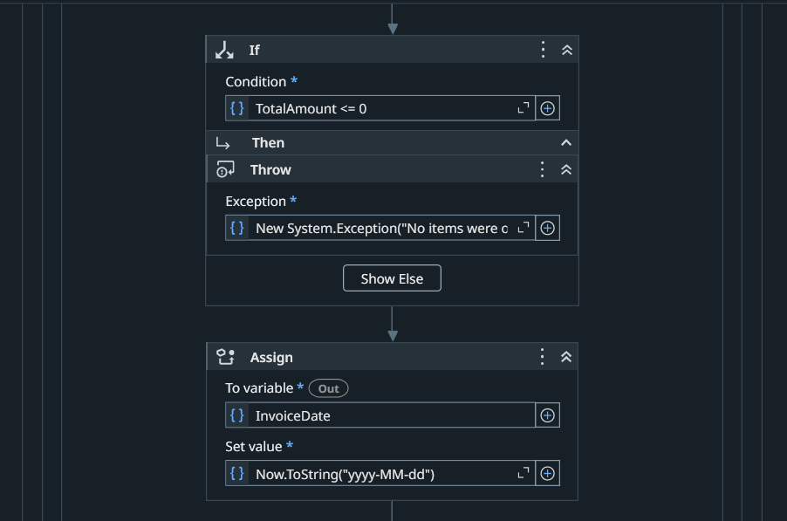  8g. Final check: a total of 0 or less throws “No items were ordered”. | Discussion. The bot reads the price lists into data tables and looks up the price of each selected item. For a tailored service, it goes through up to four garment rows: the fabric cost is the price per yard x yards per piece x pieces, and the labor fee of the garment x pieces is added. For a bulk order, each size with a quantity above 0 is computed as the boys or girls unit price x quantity. For an alteration, it goes through up to four service rows, and each amount is the service price x pieces. The invoice total is the sum of these amounts, and a total of 0 stops the invoice.
Figure 9. Invoice template and generated PDF (To-Be step 5)
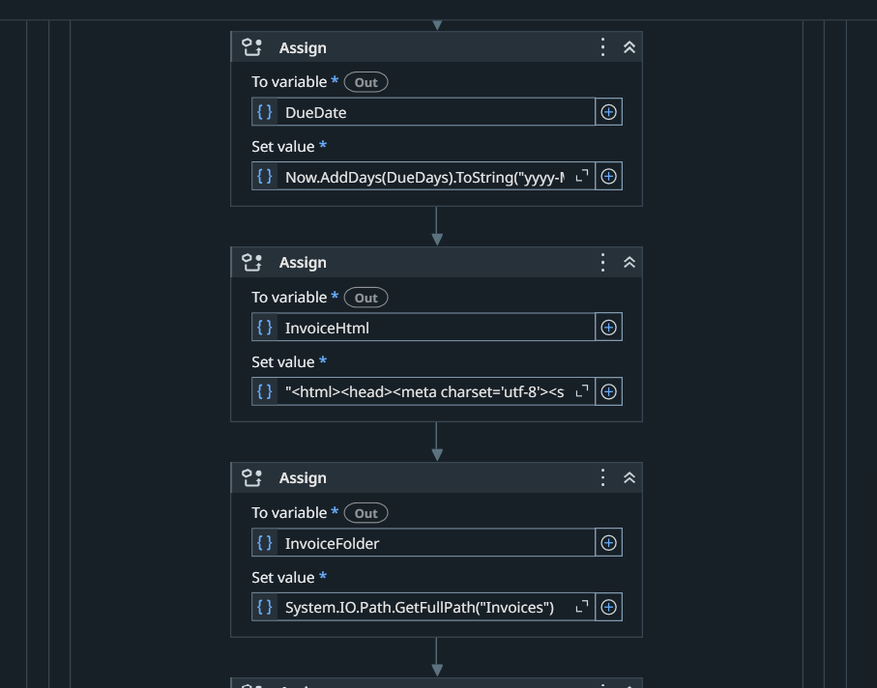  9a. Due date, the HTML invoice template, and the Invoices folder path are assigned. | 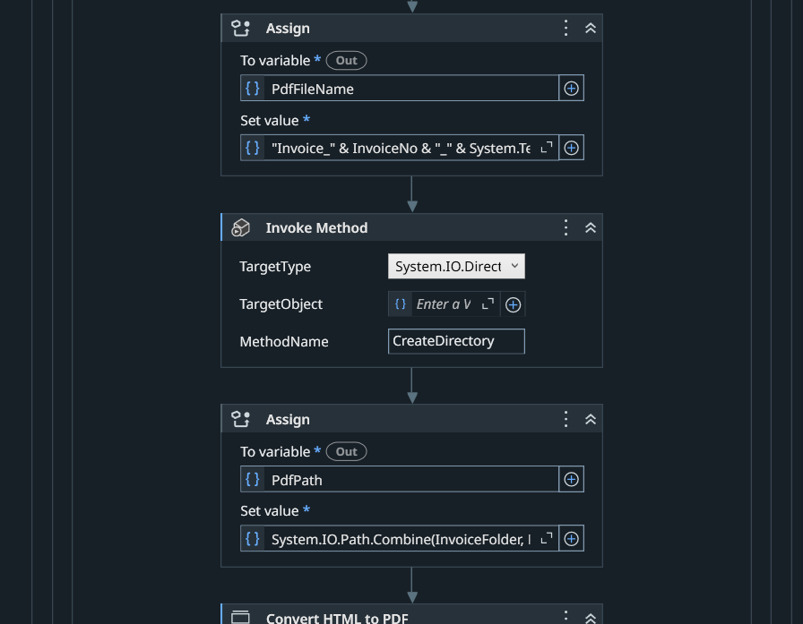  9b. The PDF file name is built, the Invoices folder is created if missing, and the PDF path is set.
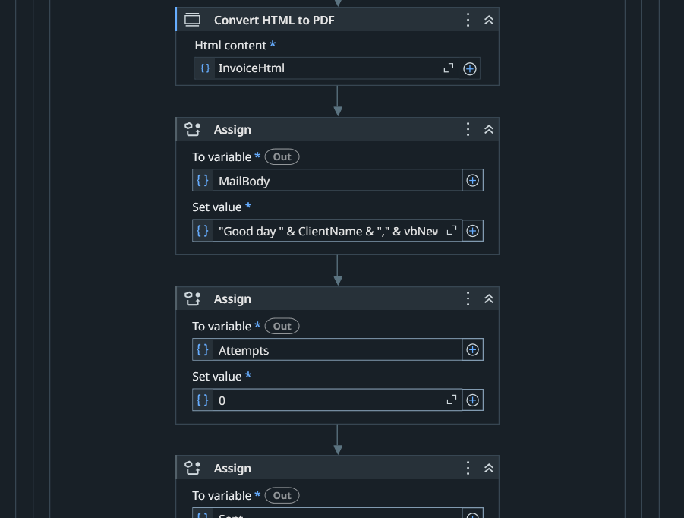  9c. Convert HTML to PDF creates the file; the email body and retry counter follow. | 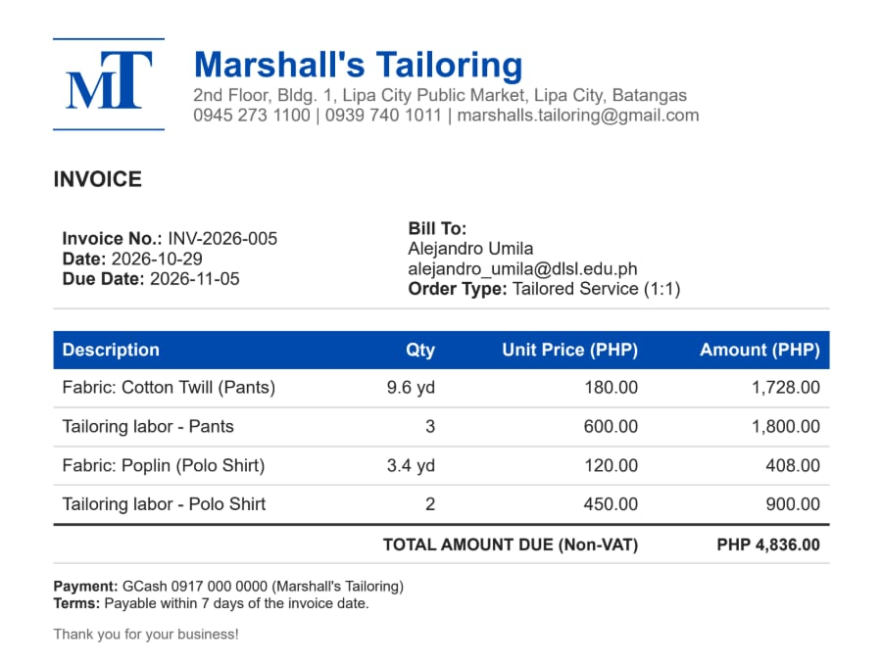  9d. Generated invoice INV-2026-005, Tailored Service: fabric and labor lines for each garment, total PHP 4,836.00.
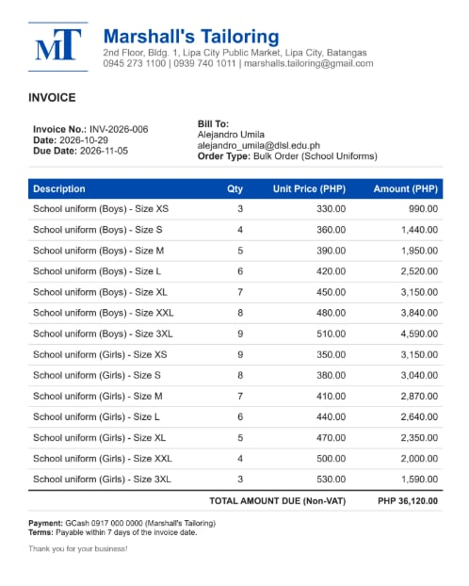  9e. Generated invoice INV-2026-006, Bulk Order: one line per size with a quantity above 0, total PHP 36,120.00. | 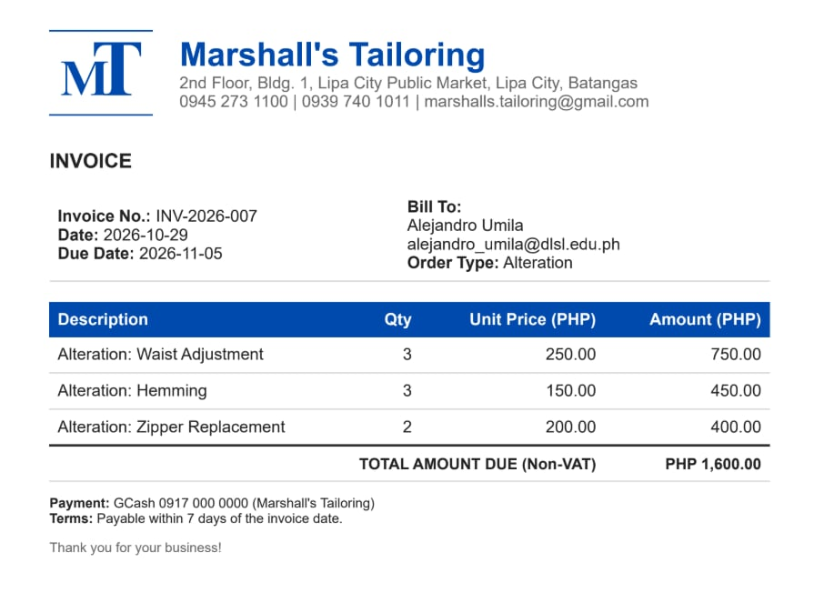  9f. Generated invoice INV-2026-007, Alteration: three services, total PHP 1,600.00.
Discussion. The template contains the shop logo, name, address, and contact numbers; the invoice number, date, and due date; the Bill To details; a table of line items (description, quantity, unit price, and amount); the total amount due (Non-VAT); and the GCash payment details and terms. The bot fills this HTML template with the values and converts it to a PDF named Invoice_<No>_<Client>.pdf in the Invoices folder. The due date is 7 days after the invoice date (2026-10-29 and 2026-11-05 in these samples). The three samples show a tailored service, a bulk order, and an alteration, and each total matches the sum of its lines.
Figure 10. Email workflow (To-Be step 6)
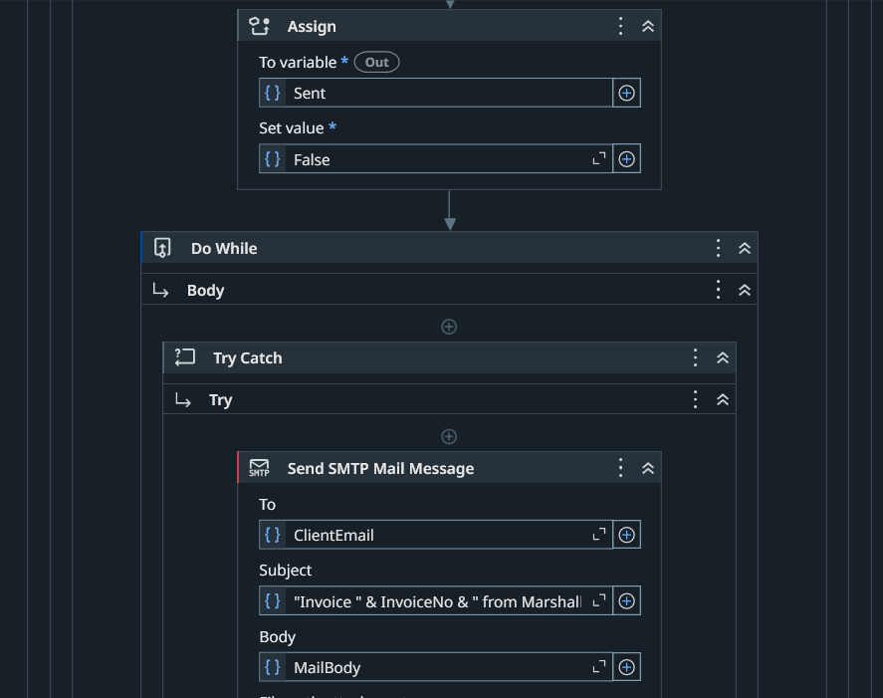  10a. The Sent flag is set to False and a Do While loop starts the retry. | 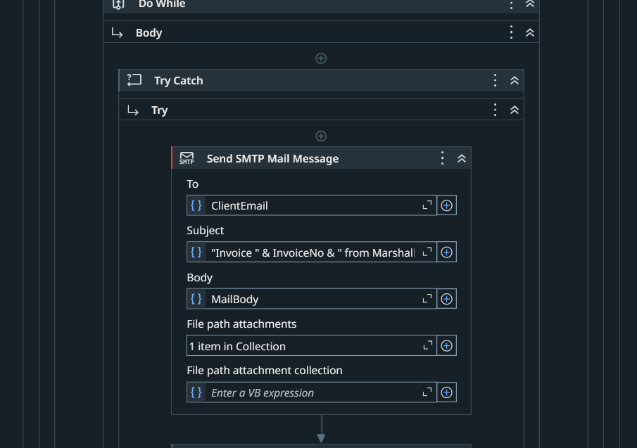  10b. Send SMTP Mail Message: To (client email), Subject, Body, and the PDF as a file attachment.
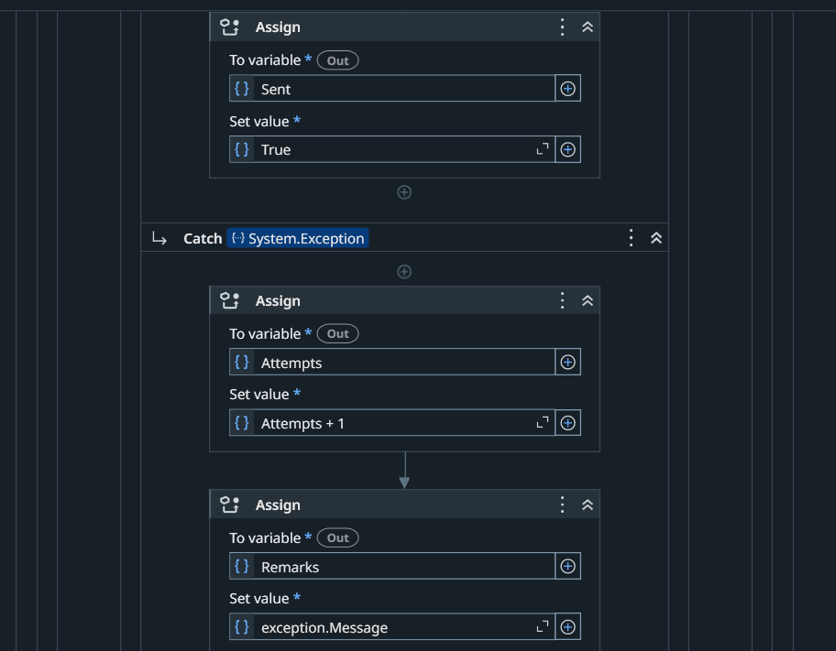  10c. On success Sent is set to True; a Catch counts the attempt and keeps the error message. | 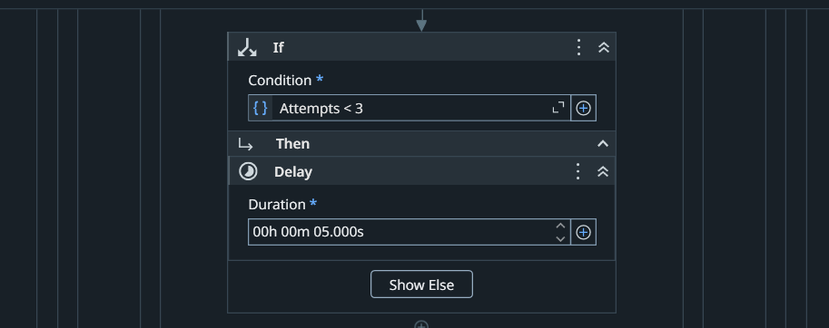  10d. While attempts are fewer than 3, a Delay of 5 seconds precedes the next try.
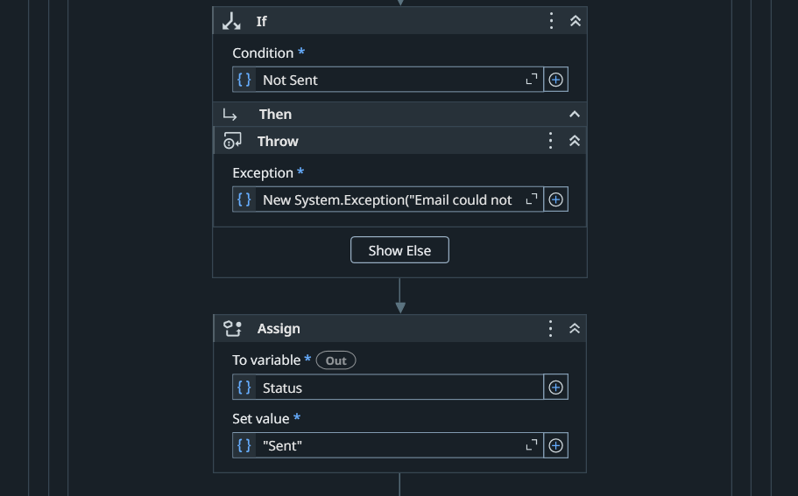  10e. If the email was not sent after the loop, an error is thrown; otherwise Status is set to Sent. | Discussion. The bot sends the PDF to the client with a standard message. The subject is “Invoice <No> from Marshall’s Tailoring”, and the body greets the client by name, states the invoice number, total amount, and due date, and gives the GCash payment details and the shop contact numbers. The attachment is the PDF built in the previous step. If sending fails, the bot waits 5 seconds and tries again, up to 3 attempts.
Figure 11. Email received by the client (To-Be step 6)
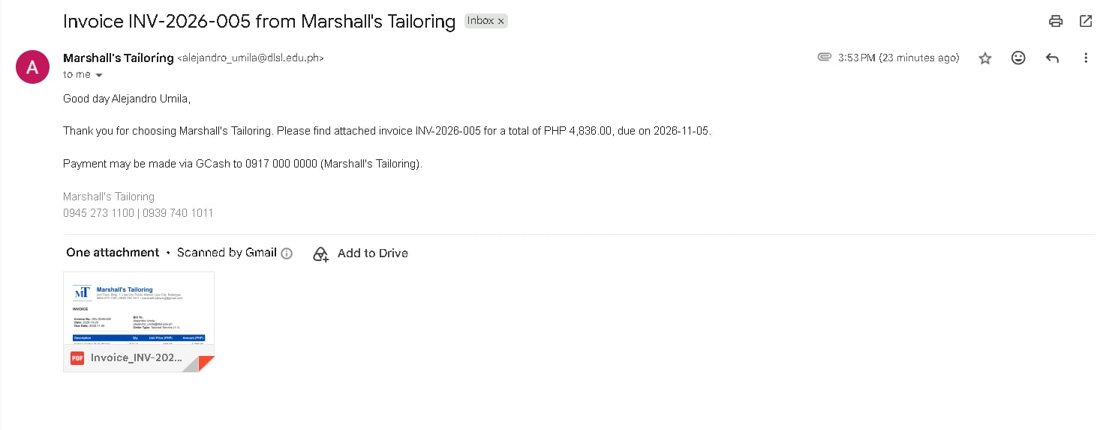
11a. Email for INV-2026-005 (PHP 4,836.00) with the invoice PDF attached.
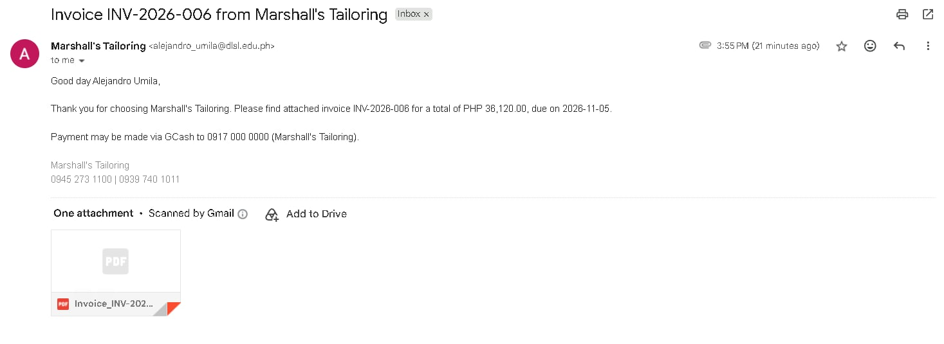
11b. Email for INV-2026-006 (PHP 36,120.00) with the invoice PDF attached.
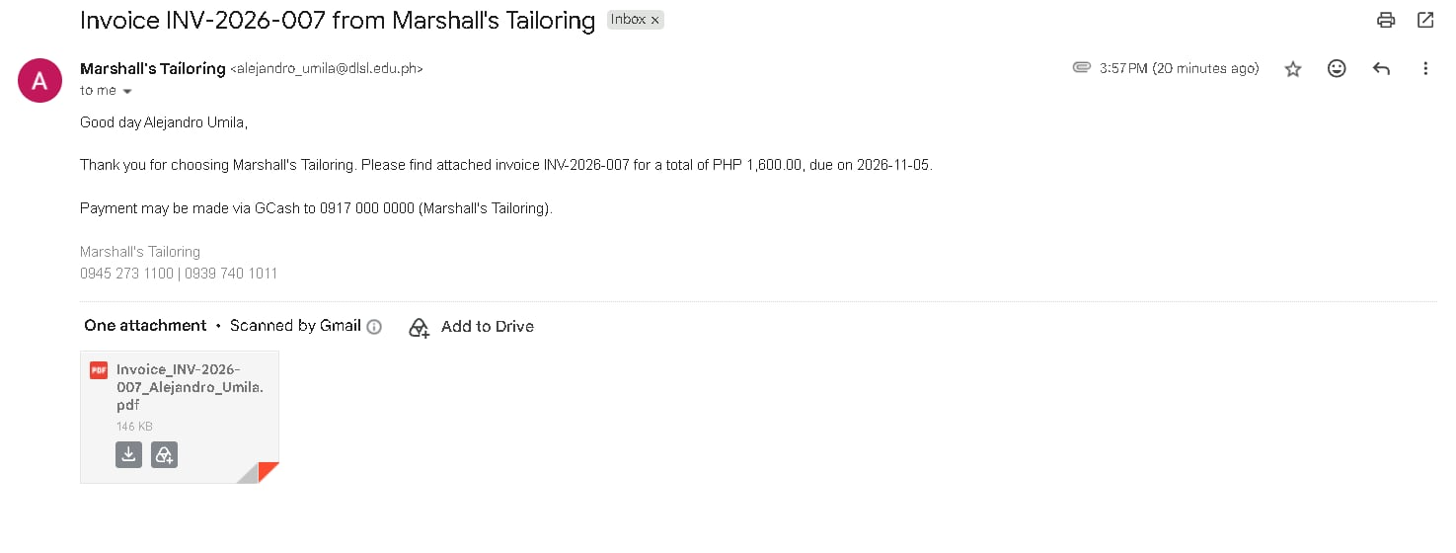
11c. Email for INV-2026-007 (PHP 1,600.00) with the invoice PDF attached.
Discussion. Each email arrived in the client’s inbox with the subject “Invoice <No> from Marshall’s Tailoring”, a greeting to the client, the total and due date (2026-11-05), the GCash details, the shop contact numbers, and the invoice PDF attached. The sender shown is the development account described in Section IV.E.
Figure 12. Logging, result message, and Invoice Log (To-Be step 7)
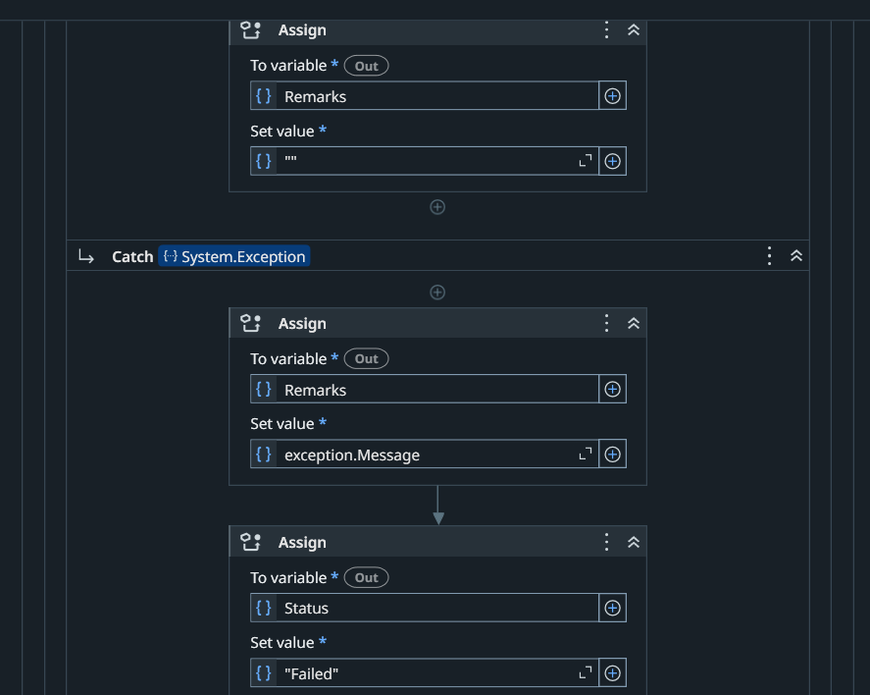  12a. When an invoice fails, Status is set to Failed and the error message is kept in Remarks. |  | 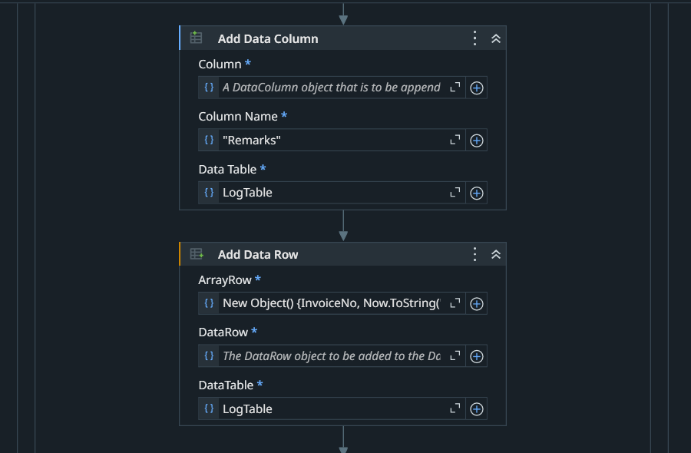  12b. Column Remarks is added and Add Data Row builds the log row (the other log columns are added the same way).
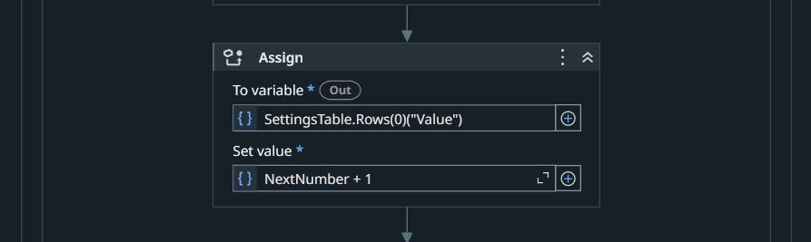  12c. The next invoice number is increased by 1. |  | 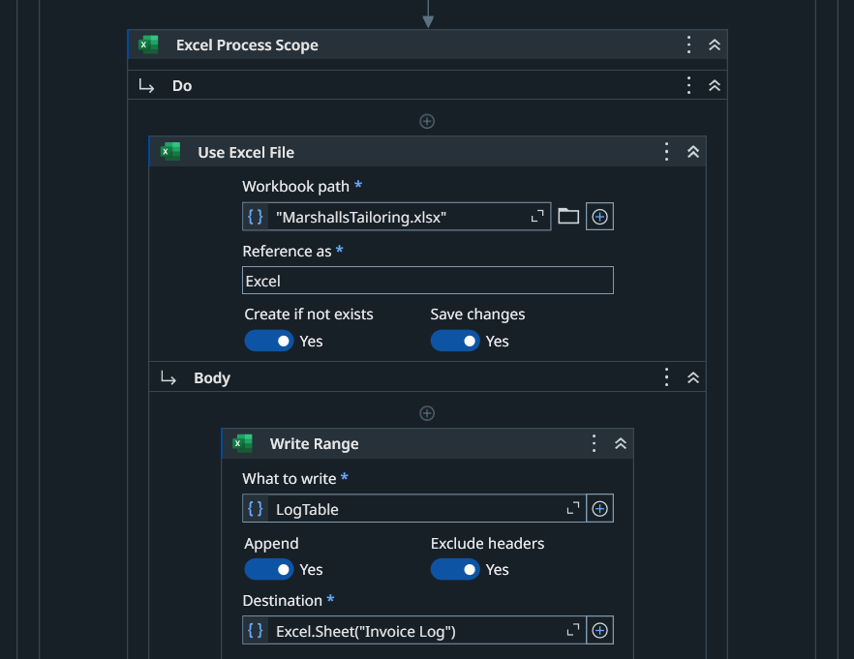  12d. Write Range appends the row to the Invoice Log sheet.
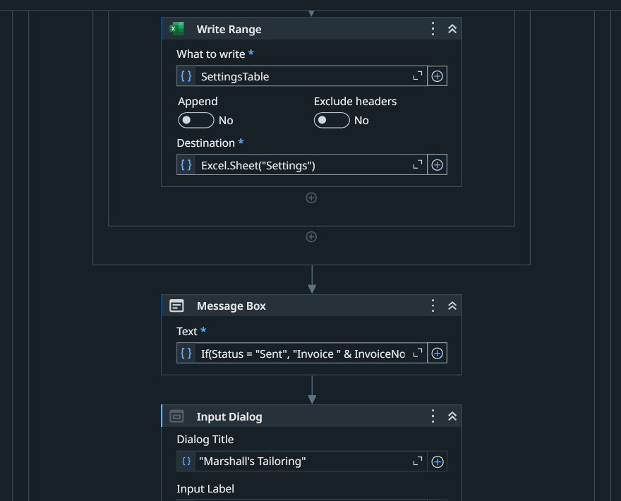  12e. Settings is written back; a message box shows the result, and an Input Dialog follows. |  | 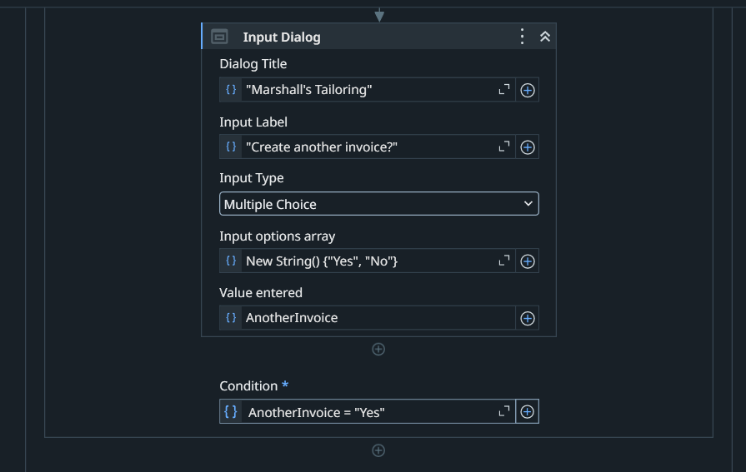  12f. “Create another invoice?” Yes/No dialog; the loop repeats while the answer is Yes.
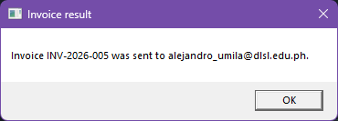  12g. Result message for INV-2026-005 (T1). | 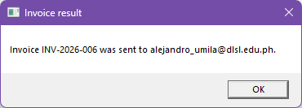  12h. Result message for INV-2026-006 (T2). | 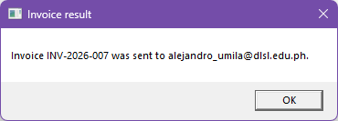  12i. Result message for INV-2026-007 (T3). | 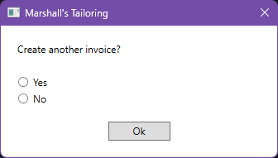  12j. The “Create another invoice?” dialog that follows every result message.
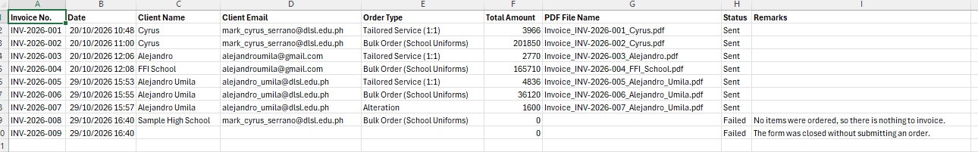
12k. Invoice Log after the tests: INV-2026-001 to 004 from earlier use; INV-2026-005 to 007 from T1, T2, and T3 (Status Sent); INV-2026-008 and 009 from T6 and T7 (Status Failed, with the reason in Remarks and no PDF file name).
Discussion. Every run adds a row with the invoice number, date and time (yyyy-MM-dd HH:mm), client name and email, order type, total, file name, status, and remarks, which gives the shop a complete record. When this screenshot was taken the log held nine entries; Figure 14 shows it after T9. The three valid orders carry consecutive numbers 005 to 007 with the totals shown in Figure 9, and the two failed runs are recorded as Failed with the reason in Remarks (INV-2026-008 and 009). The result message appears before the “Create another invoice?” dialog and tells the owner whether the invoice was sent.
Figure 13. Error handling in action
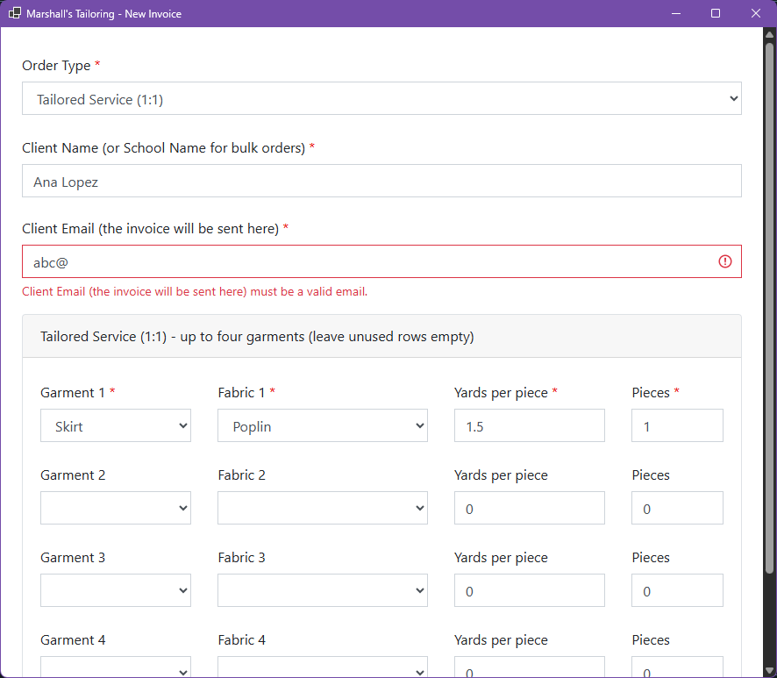  13a. T5: typing abc@ as the client email makes the form show “must be a valid email” and blocks the entry. | 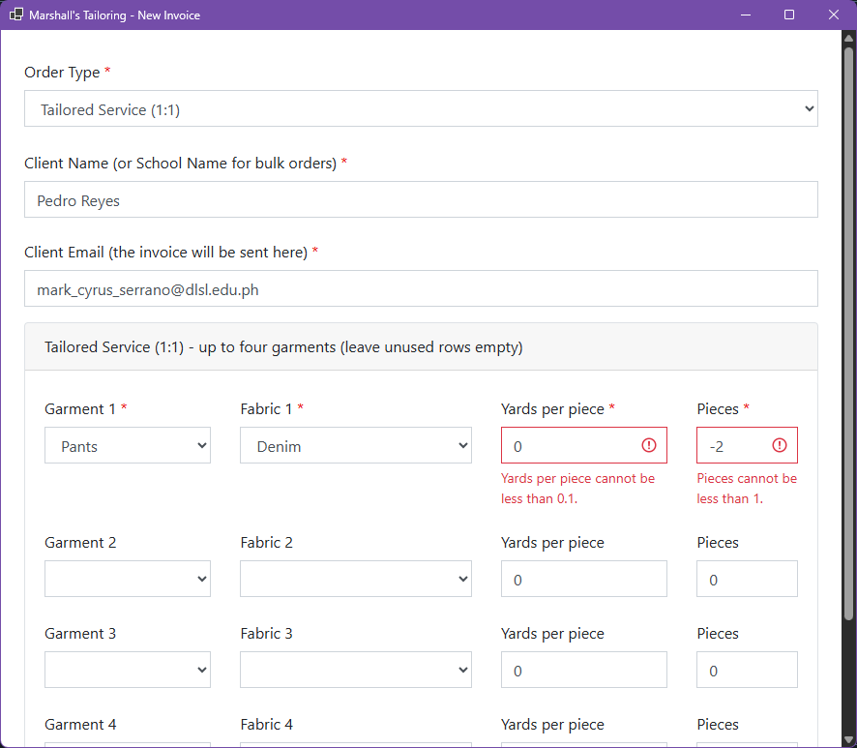  13b. T4: yards per piece 0 and pieces -2 are flagged (“cannot be less than 0.1” and “cannot be less than 1”).
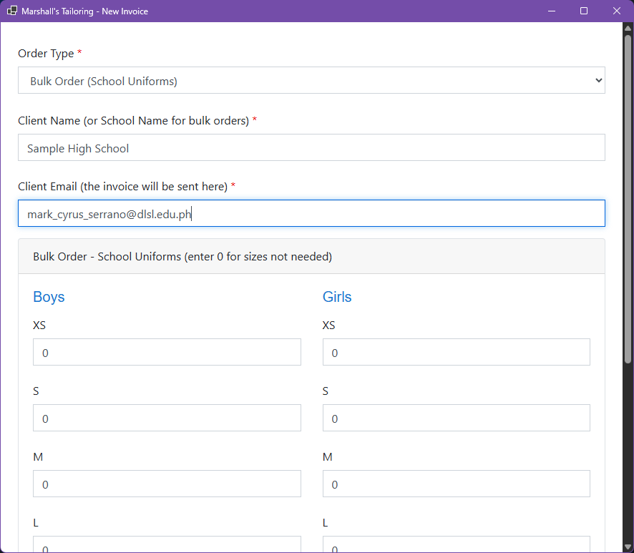  13c. T6: Bulk Order for Sample High School with every size left at 0. | 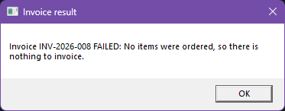  13d. T6: the result message “Invoice INV-2026-008 FAILED: No items were ordered, so there is nothing to invoice.”  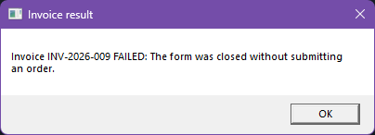  13e. T7: closing the form without submitting shows “Invoice INV-2026-009 FAILED: The form was closed without submitting an order.”
Discussion. Invalid entries are caught at two levels. The form blocks a bad email, a yards value below 0.1, and pieces below 1 before the bot starts (T4, T5). If an order reaches the bot with nothing to invoice, or the form is closed, the bot stops that invoice, shows a FAILED message with the reason, and writes a Failed row with the reason in Remarks; no PDF is created and no email is sent (T6, T7, and the log in Figure 12).
Figure 14. Large-volume order (T9)
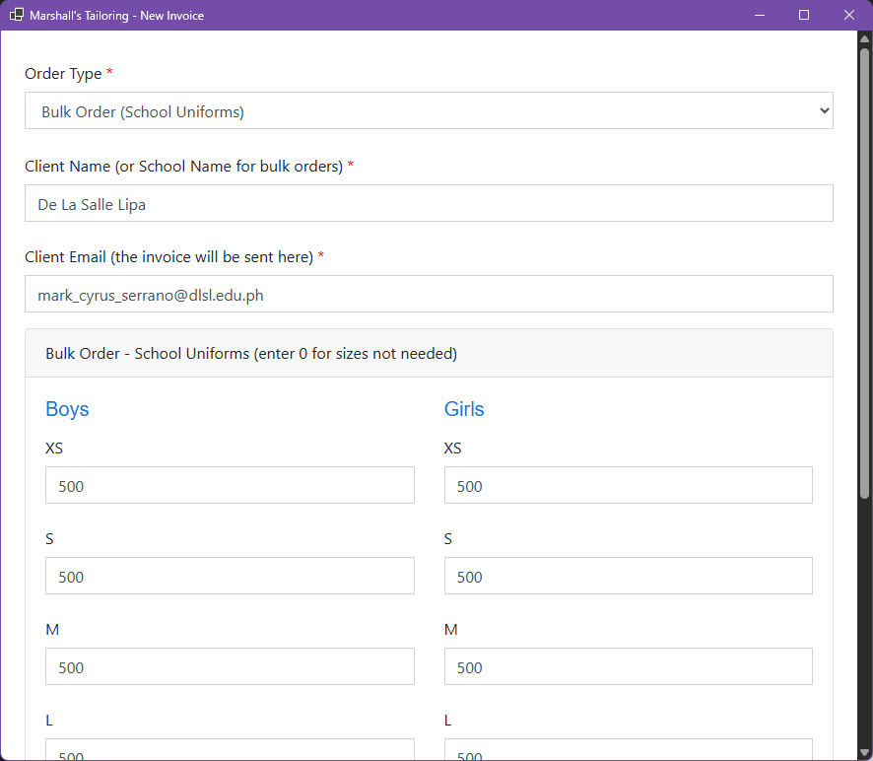  14a. Bulk Order form for De La Salle Lipa with 500 pieces entered for every boys and girls size (first sizes). | 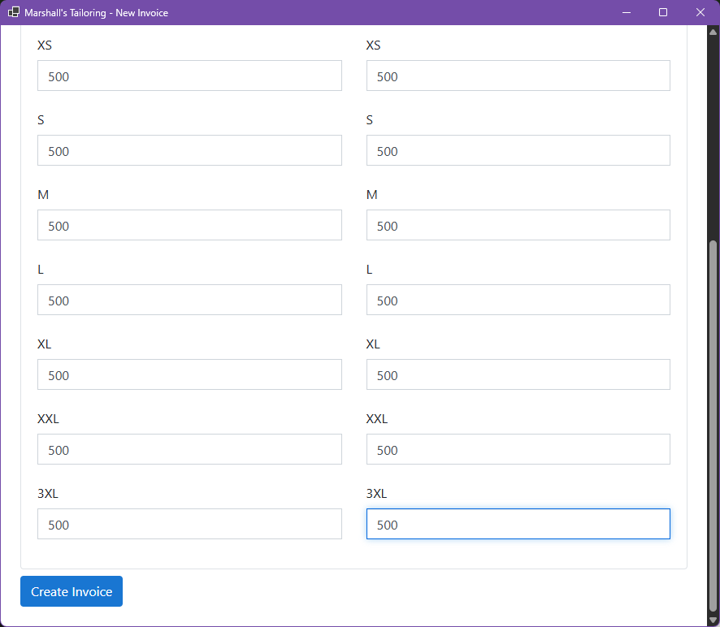  14b. Remaining sizes (XS to 3XL) at 500 each and the Create Invoice button.
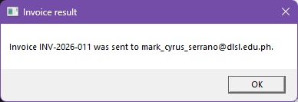  14c. Result message: Invoice INV-2026-011 was sent to mark_cyrus_serrano@dlsl.edu.ph.  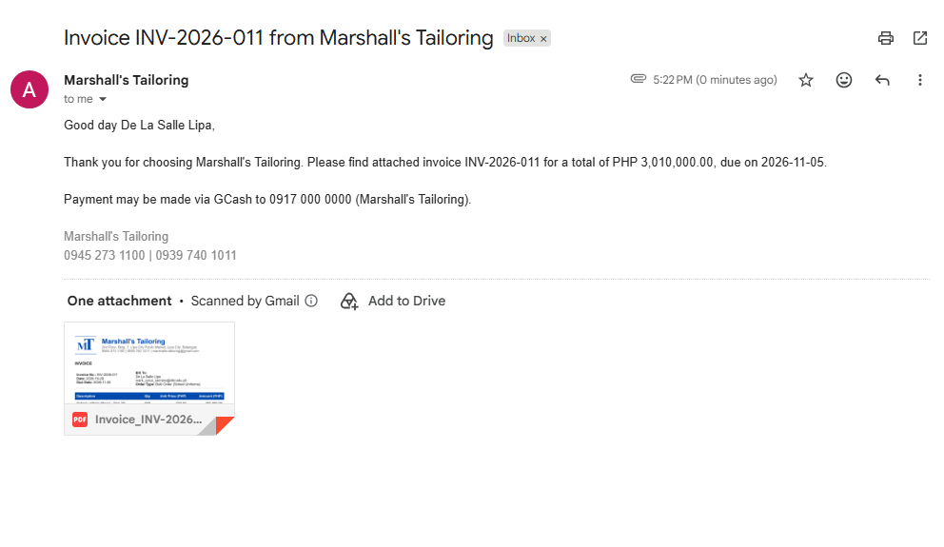  14d. Email received with the invoice PDF attached; total PHP 3,010,000.00. | 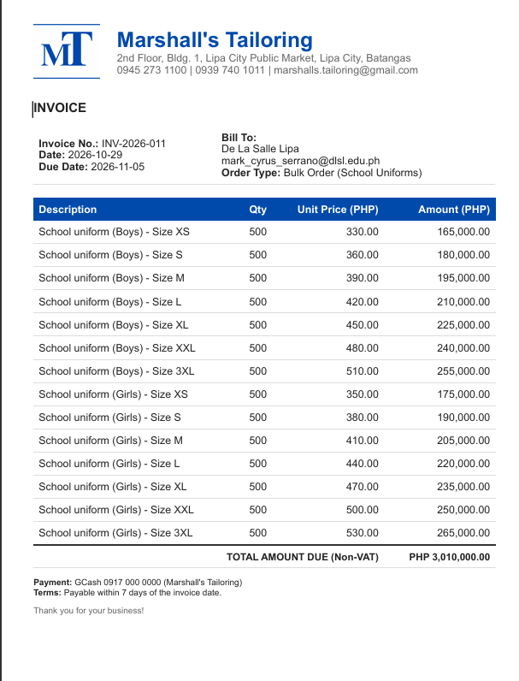  14e. Generated invoice INV-2026-011: fourteen lines of 500 pieces each, total PHP 3,010,000.00.
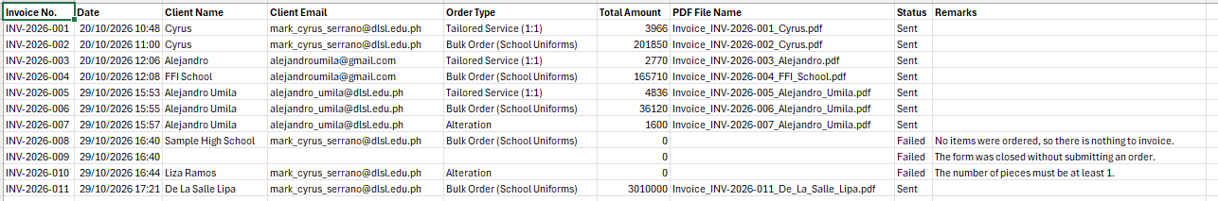
14f. Invoice Log after T9: INV-2026-011 (Bulk Order, total 3010000, Status Sent) follows the earlier entries.
Discussion. To test a high-volume input, every boys and girls size was set to 500 pieces. The form accepted the values, and the bot computed fourteen lines and a total of PHP 3,010,000.00, which matches the hand computation of (2,940 + 3,080) x 500, where 2,940 and 3,080 are the sums of the boys and girls unit prices. The PDF was created and emailed without any error, and the log row shows Sent.

