Estimating a flood inundation probability map

Your assignment is to build a spatial predictive model in R that estimates ‘the probability that an area will be inundated by a flood”. The flood you are modeling is based on one that took place in Calgary, Alberta (Canada) in 2013 (https://www.calgary.ca/water/flooding/history-calgary.html). It was the worst flood there in over 100 years, and the Director of Disaster Planning in CITY X has asked you to try a machine learning approach to estimate what would happen if a Calgary-type weather event took place there.

Train and validate a spatial predictive model using data from Calgary. Deploy model to predict a flood in a CITY X. Write a report to the "Director of Disaster Planning" with your findings. You get to choose which City X you'd like to use for your model (more on that below).

To be clear, to do this analysis, you will copy the code from the land conservation markdown (predicting the probability of land conservation) and create new independent variables for a model that predicts probability of flood inundation. You can wrangle data in ArcGIS or R, it’s your choice, but your modeling will take place in R. You must stick to "glm" logistic regression only.

This is a team project - you will work in groups of 2. Sign up for a team in the teammate signup sheet below. If you have a person you’d prefer to work with, sign up as a team, otherwise just put your name on the sheet – either as Team Member 1 on a new team, or as Member 2 next to another solo student. If you can’t find a team by the end of the week this is assigned, let our teaching team know and we will help you find one. We will be spending a significant in-class time doing "workshop" sessions on the assignment with your teaching team present.

Basic procedure
- Choose City X. Choose a city with similar hydrology, topography, and climate, with available data comparable to Calgary's. Don't choose a city on the ocean, or a city in a desert.
- Gather open data from Calgary’s open data site (https://data.calgary.ca/) and City X's open data site as well as other internet sources. Build a fishnet grid for each city with the same sized cells. Calgary flood extents and other data are hosted on canvas in Module 5, they are called midTermProject_Data.zip
- Using what we’ve learned about feature engineering, build as many useful variables describing the natural, hydrological and built environment factors that might help explain flood inundation. Form a hypothesis to motivate your search for data. You must include at least one feature from the watershed analysis. You need to build the exact same features for Calgary AND City X. We will have a feature engineering workshop in class.
- Join your features to the vector Fishnet.
- Move your Fishnet datasets into R and set up your model workflow based on our Preservation markdown.
- Build logistic regressions for Calgary. Make a training set and test your model by predicting on a test set. Set up a workflow with goodness of fit metrics - a confusion matrix for example. Experiment until you find a model with decent predictive performance.
- Using the predict function, feed the exact same independent variables from City X into your model object. Output a prediction for each cell in that city.
- Visualize and communicate your results.

Deliverables
A technical report - maximum of 4 pages - in pdf form (or knitted R Markdown document html) due on Canvas.
The audience for your report is the Director. Assume they are technically savvy - they were the ones who asked you to do regression modeling for this task! Use clear language, good organization and simple interpretation.
Your report should contain:
- An introduction framing the planning motivation for your algorithm and presenting the top-line results. How does this modeling approach work? Why are we doing it this way? What was the result of the analysis?
- A section outlining your feature selection. This should contain maps or plots related to four of your model features. Annotate with some commentary about why these are useful or un-useful features. This must include at least one watershed feature (even if it’s not significant).
- A section on your model. This should contain your final logistic regression model summary table, your ROC curve plot, and a table of confusion metrics (True Positives, False Positives, etc). Please discuss the modeling process, the training and testing process, comment on the accuracy of the model, and make a table that uses simple statements to describe the four model outcomes ("A True Positive is...").
- Support your modeling section with three maps:
  - One showing true positives, true negatives, false negatives and false positives for the training set in Calgary.
  - Second, your inundation predictions for Calgary (entire dataset);
  - Third, predictions for your comparable city.
- A conclusion section commenting on the quality of your model, its usefulness in your comparable city, and your opinion about the utility of this modeling approach.

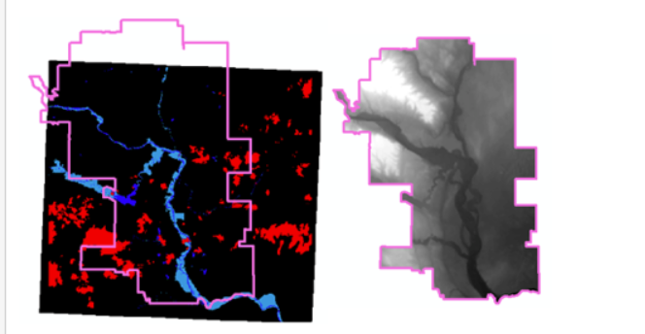

There are three files as illustrated above in Module 5 on Canvas (midtermdata.zip). There is the satellite image with flood inundation in light blue and cloud cover in red. You will have to reclassify into a raster of 0=no inundation and 1=inundation. The pink polygon is the study area which you will note has a greater area than the raster. You can 1) create a fishnet at the study area extent in ArcGIS with this toolLinks to an external site., or in R with sf::st_make_grid.Links to an external site. You will then have to 2) create an unique id field in the fishnet shapefile and 3) use zonal statistics as table to get the raster values into the fishnet. Finally 4) remove the grid cells to the north for which we have no raster data from the fishnet. You also have a DEM raster as above. For your comparison city, look to their open data site for Digital Elevation Map (DEM). Otherwise, go to EarthExplorerLinks to an external site. and download Shuttle Radar Topography Mission data (SRTMLinks to an external site.) data.

Project management
You and your partner need to collect the same features (with the same variable names) for both cities. To make a model work – your comp city needs to have the exact same features with the exact same variable names so that the predict function can run using your model. Keep in mind that your model has specific parameters – if you can’t collect the same data for City X as you can for Calgary (and for your model), it won’t work!
I suggest you split your cities by teammate and create a shared table on google docs for data tasks. This 'data matrix' will help you keep track of what data is being collected by whom.

A note about time management – if you have not done a project of this nature before (in MUSA 508 for instance), you might not realize that it is very hard to predict when and how things might go wrong with your code. It is imperative that you start early.

Assignment 3 Rubrics
Criteria | Ratings | Pts
This criterion is linked to a Learning OutcomeIntroduction and Planning Motivation  The Planning motivation for your algorithm and an overview of the modeling process and outcomes. |  | 5 pts
This criterion is linked to a Learning OutcomeAnnotated Maps  Four of your more original (as you deem it), yet statistically significant features. Annotate as you see fit. |  | 5 pts
This criterion is linked to a Learning OutcomeModels & Feature Engineering  Model outputs and basic goodness of fit with annotations, annotations and plots associated with feature engineering. |  | 5 pts
This criterion is linked to a Learning OutcomeError Metrics & Comp City  Maps of your predictions in training/testing and your "challenge" city |  | 5 pts
This criterion is linked to a Learning OutcomeCompleteness  Was it on time? Does it contain all of the key elements specified on the list of deliverables? Is it the specified length? |  | 5 pts
Total Points: 25

