1.



imp

2.



User: bicmd@bjcmd1608

Psd: 123456

3.



Yes

4.



O:\dmp\2016.09.18\ITF_6A_20160601_08302.dmp

5.



819200

6.

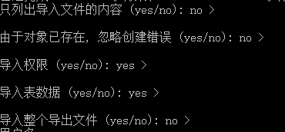

Enter

7.



Bjcmd

8.



Enter

9.

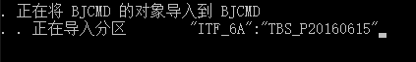

waiting