# AutoPlait

## 【故障】20161103-所有轴温报错_1日_axleTempFault

文件夹：

E:\Data_Lab\20161103-所有轴温报错_1日_axleTempFault

### 结果

231_6092_2016-04-06重采样对比

位置：E:\Data_Lab\20161103-所有轴温报错_1日_axleTempFault\out

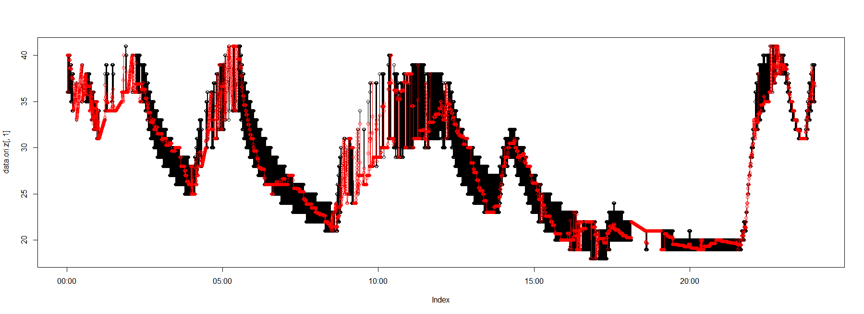

### Autoplait

处理方式：

采样间隔10s

231_1510_2016-04-06_axleTempFault_3_merge2_1_ri_10.csv

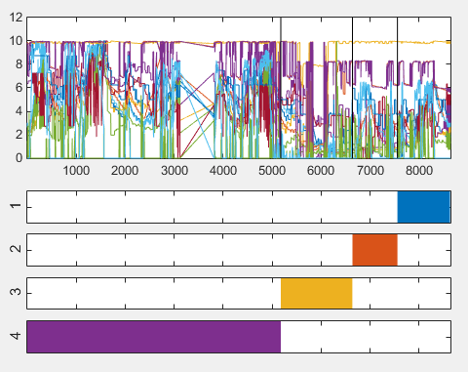

231_6075_2016-04-21_axleTempFault_11_merge2_1_ri_10.csv

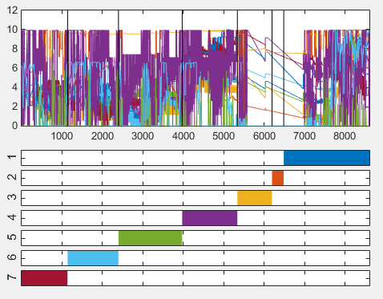

231_6075_2016-04-22_axleTempFault_12_merge2_1_ri_10.csv

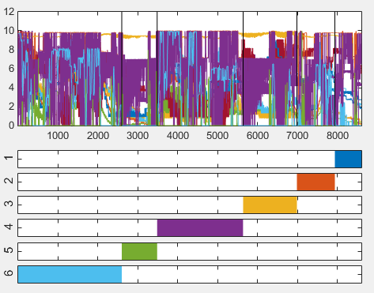

231_6075_2016-04-23_axleTempFault_13_merge2_1_ri_10.csv

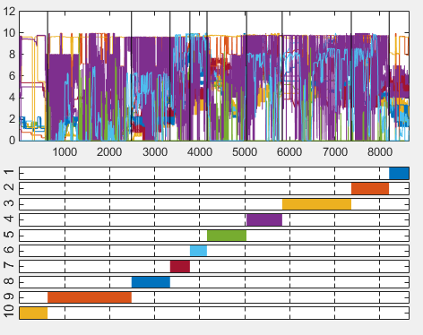

231_6097_2016-04-26_axleTempFault_15_merge2_1_ri_10.csv

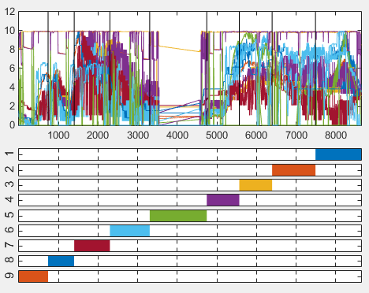

231_6101_2016-04-16_axleTempFault_16_merge2_1_ri_10.csv

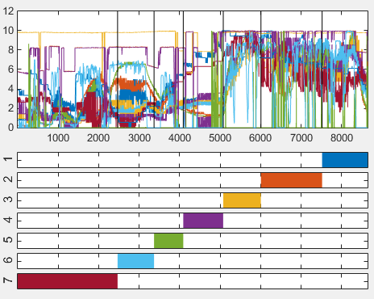

231_6113_2016-04-19_axleTempFault_18_merge2_1_ri_10.csv

