A&J Luxury Mobile App: Step-by-Step App Flow
This guide follows the app in the order a user experiences it: first a customer, then A&J staff. Each step has one screen and a short explanation. The steps are numbered 1 to 22, and each one names the step that comes next.

About the pictures
- Source: every picture is a screenshot of our own clickable Prototype 2 (Classic Boutique), shown inside its phone frame. All 22 screens were captured, so no placeholder frames were needed.
- Item pictures: items are shown with temporary placeholder drawings labelled "PLACEHOLDER IMAGE". No pictures from the A&J Luxury website are used.
- Sample data: item names, brands, prices, people, orders and all dashboard and report figures are invented for the prototype. They are not A&J data.

Differences from the requested flow
- Steps 7 and 8: the prototype has no cart, checkout or in-app payment. The closest screens, Inquire to buy and Inquiry sent, are shown instead. A&J then confirms the item and arranges payment.
- Step 11: the review summary is part of the last consignment step (Hand-over). Only the submission confirmation is pictured.
- Steps 10 and 12: tapping a photo slot adds a drawn sample instead of uploading a real photo, and the consignment status does not move past Submitted.

Flow diagram
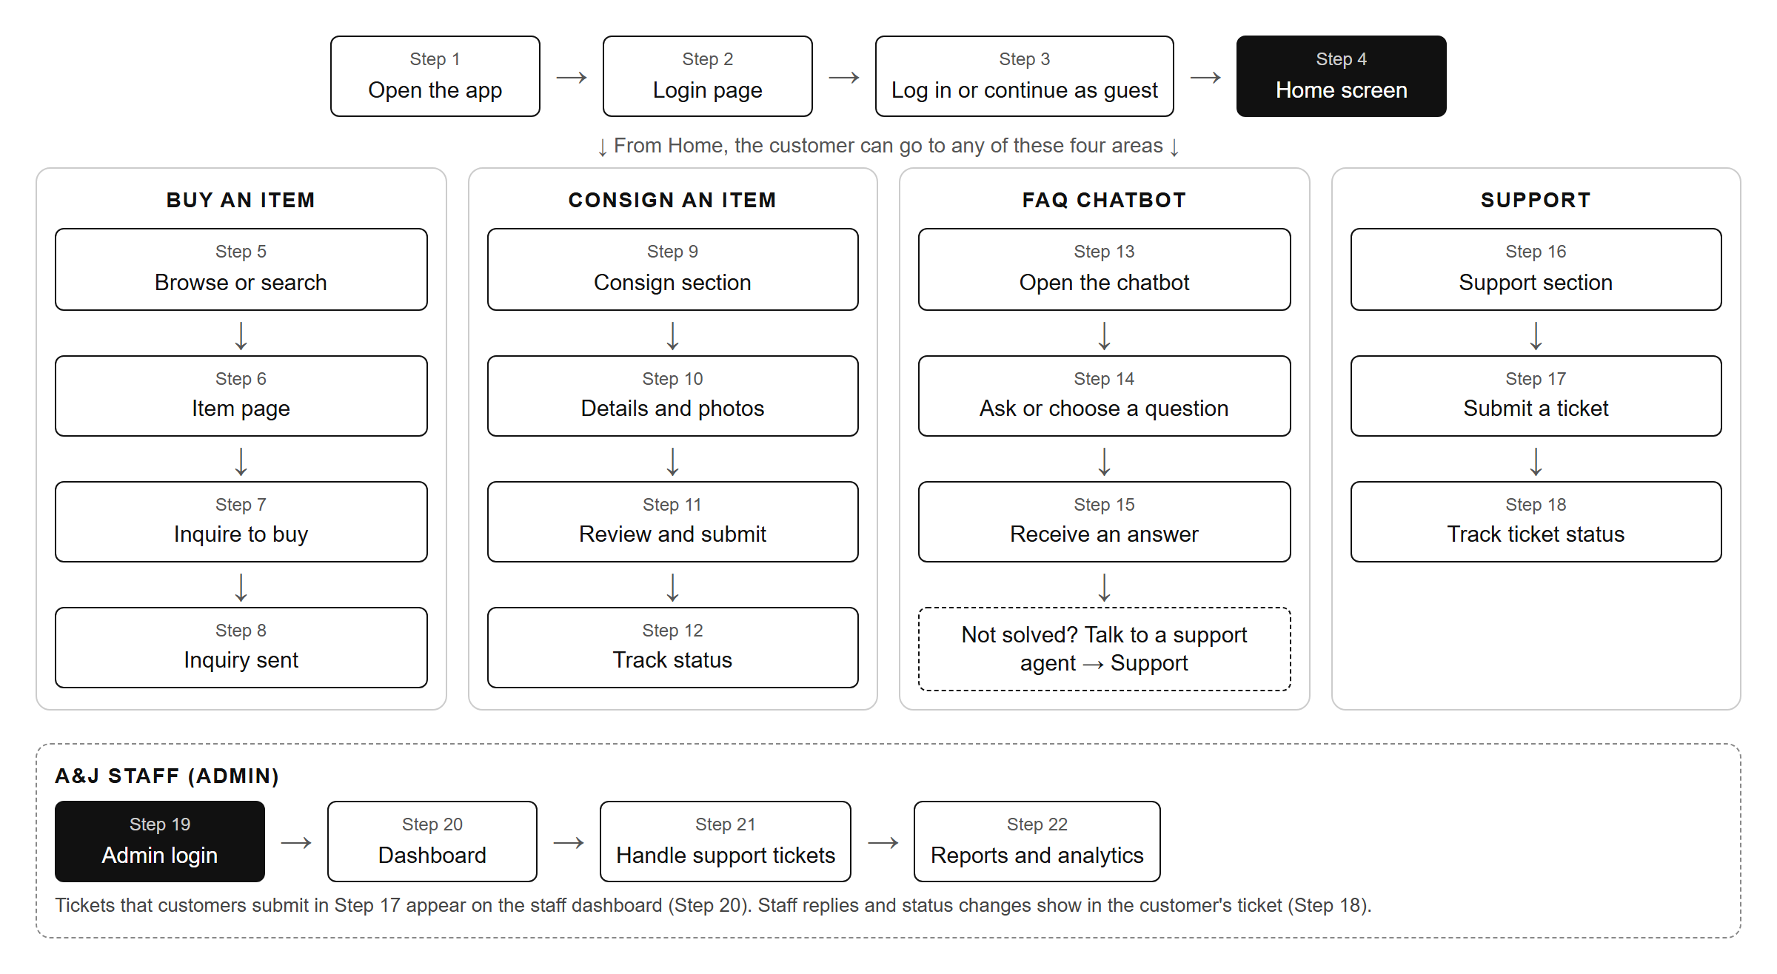

Flow 1: Opening the app and logging in
Steps 1 to 3.
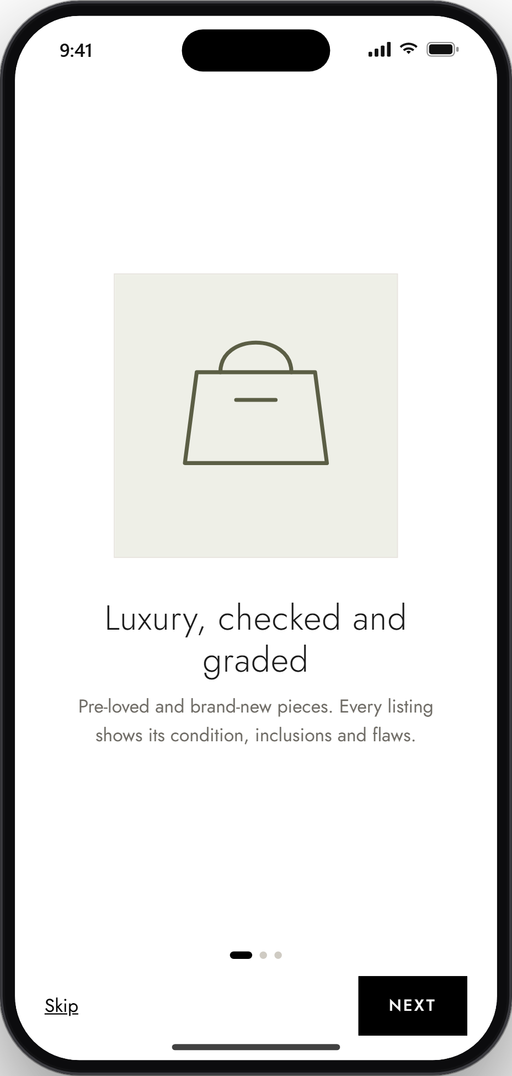 | STEP 1 OF 22  1. Open the app  The app opens with three short intro slides about buying, consigning and condition grading. The user taps Next to continue, or Skip to go straight to the login page.  Next: Step 2, Login page ↓
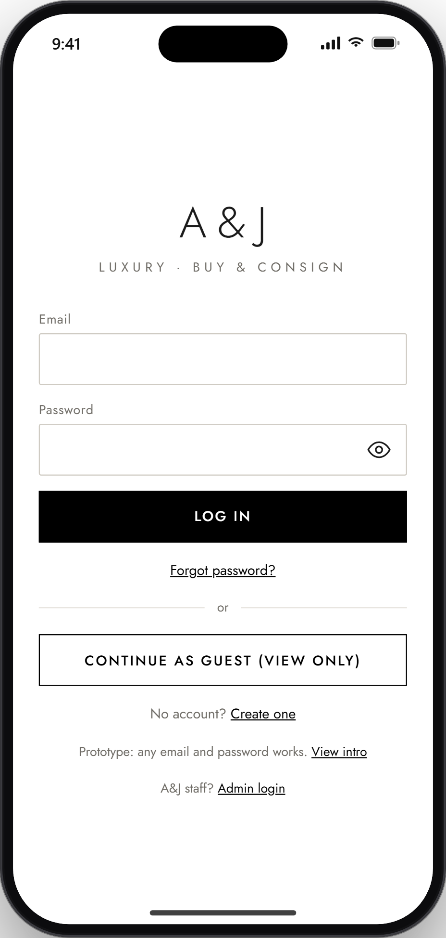 | STEP 2 OF 22  2. Login page  The login page asks for an email and password. It also offers Create one (sign up), Forgot password, Continue as guest (view only), and a separate Admin login for A&J staff.  Next: Step 3, Log in or continue as guest ↓
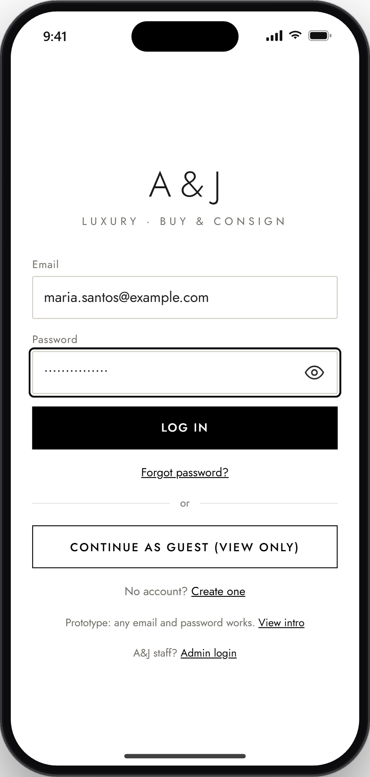 | STEP 3 OF 22  3. Log in or continue as guest  The user enters their email and password and taps Log in. Or they tap Continue as guest to browse, search and use the chatbot; saving, inquiring, consigning and support tickets will then ask them to log in.  End of this flow. Next: Flow 2, Browsing and buying an item, starting at Step 4.

Flow 2: Browsing and buying an item
Steps 4 to 8.
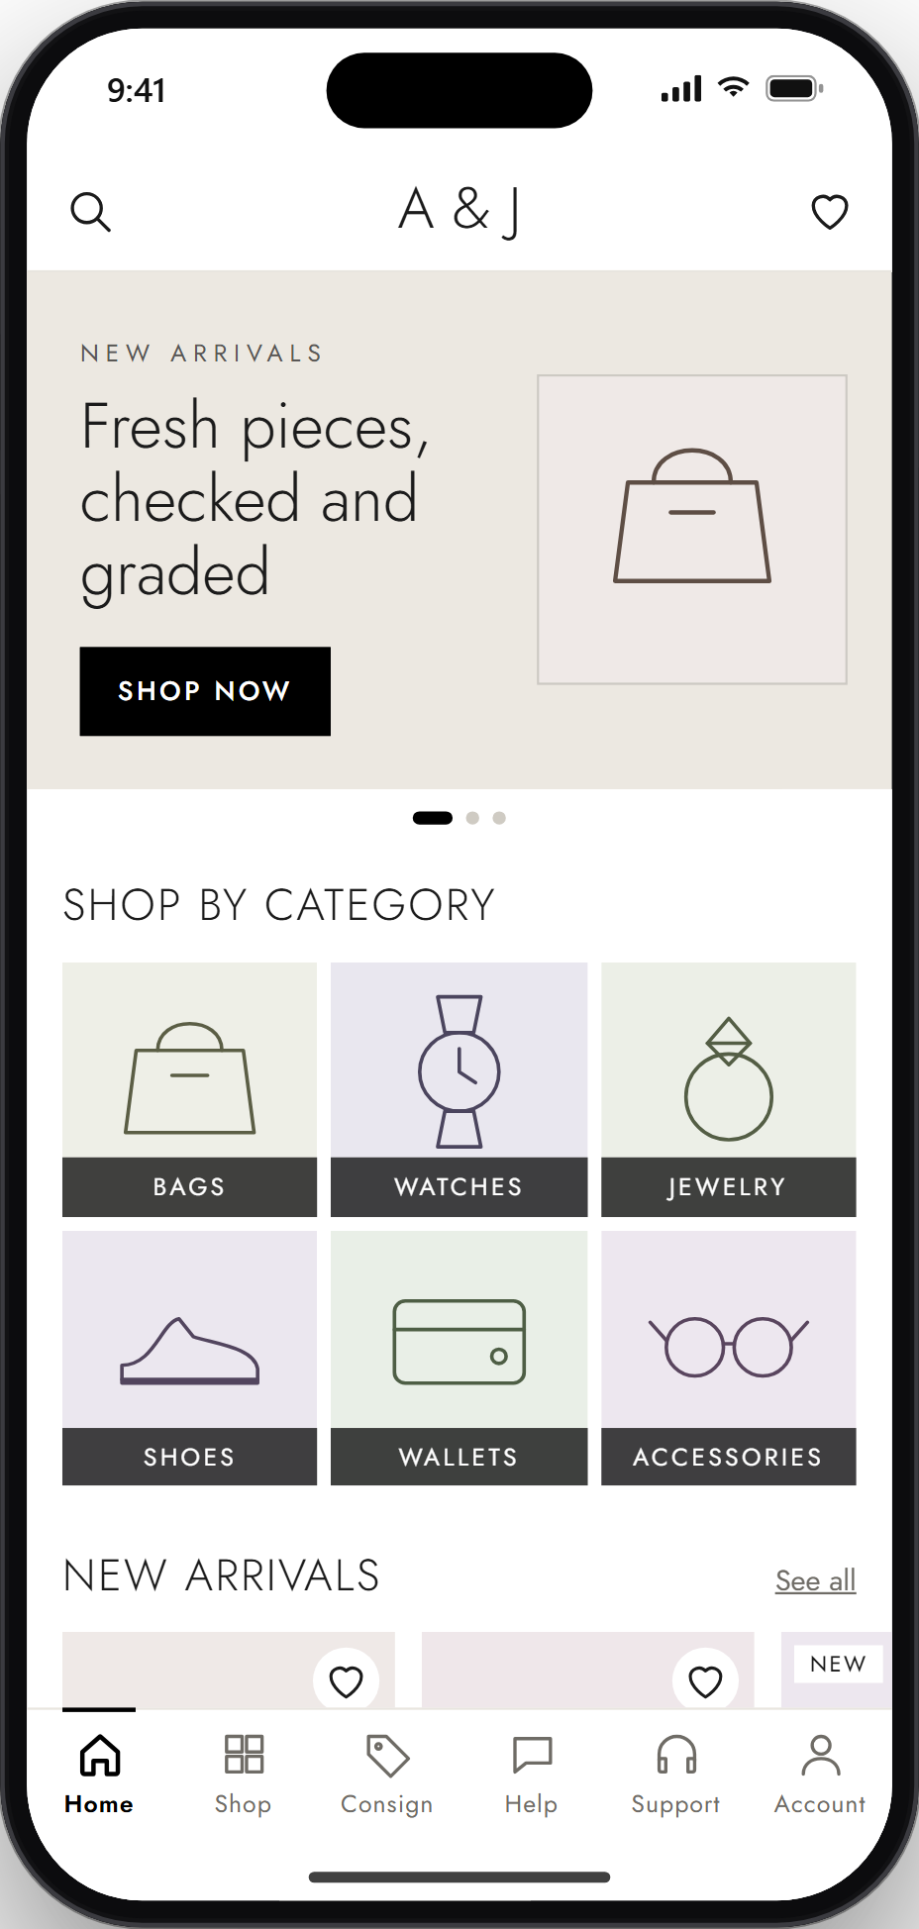 | STEP 4 OF 22  4. Home screen  Home shows new arrivals and Shop by category tiles. The tab bar at the bottom leads to Home, Shop, Consign, Help, Support and Account.  Next: Step 5, Browse or search items ↓
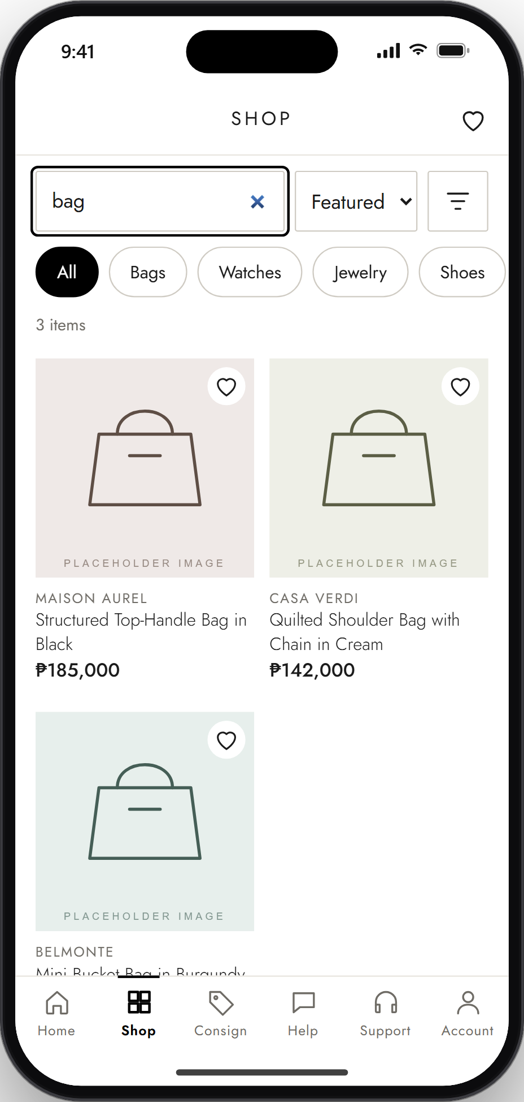 | STEP 5 OF 22  5. Browse or search items  In Shop, the user types a search word (here, "bag"), picks a category, sorts the list, or opens the filters for brand, condition and price. Each card shows the brand, title and price.  Next: Step 6, Item detail page ↓
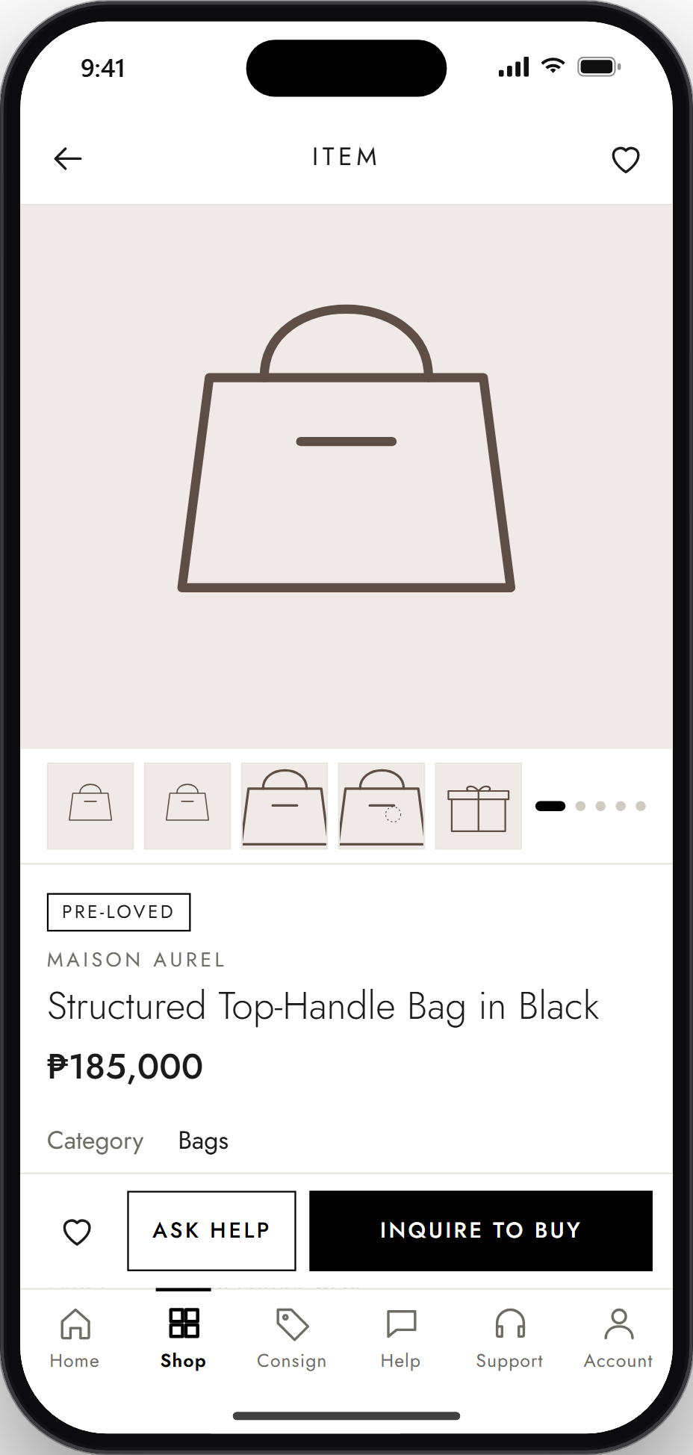 | STEP 6 OF 22  6. Item detail page  The item page shows a swipeable photo gallery, the condition label, brand, title, price and category, with more details further down. The user can save the item with the heart, tap Ask Help, or tap Inquire to buy.  Next: Step 7, Add to cart or checkout (in the prototype: Inquire to buy) ↓
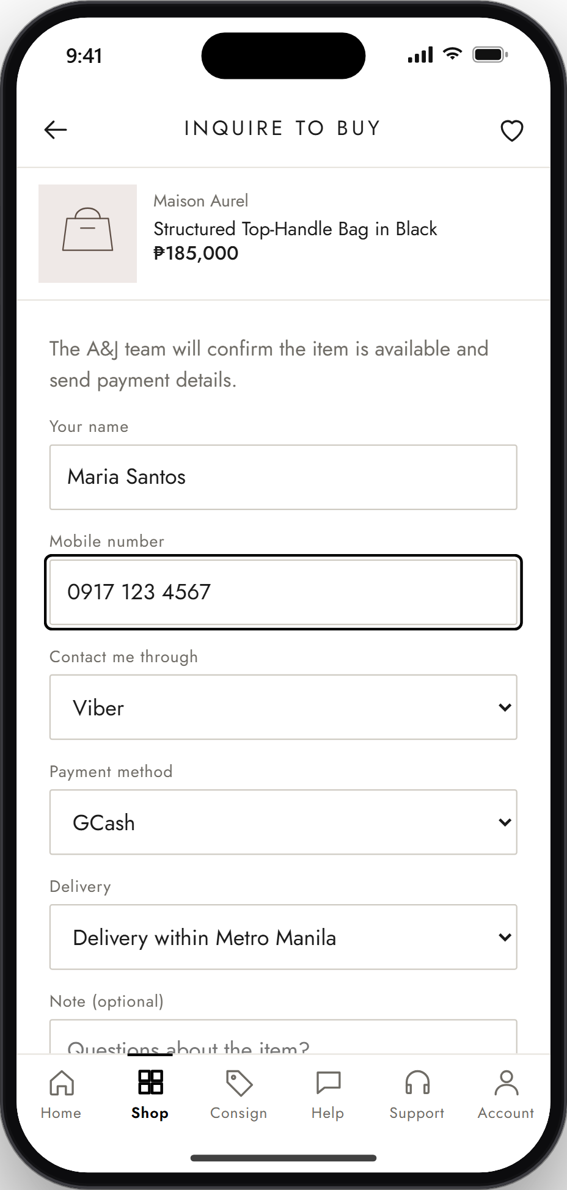 | STEP 7 OF 22  7. Add to cart or checkout (in the prototype: Inquire to buy)  The prototype has no cart or in-app payment yet. Instead, the user fills in the Inquire to buy form: name, mobile number, how to be contacted, payment method (here, GCash) and delivery option, then taps Send inquiry.  Next: Step 8, Order confirmation (in the prototype: Inquiry sent) ↓
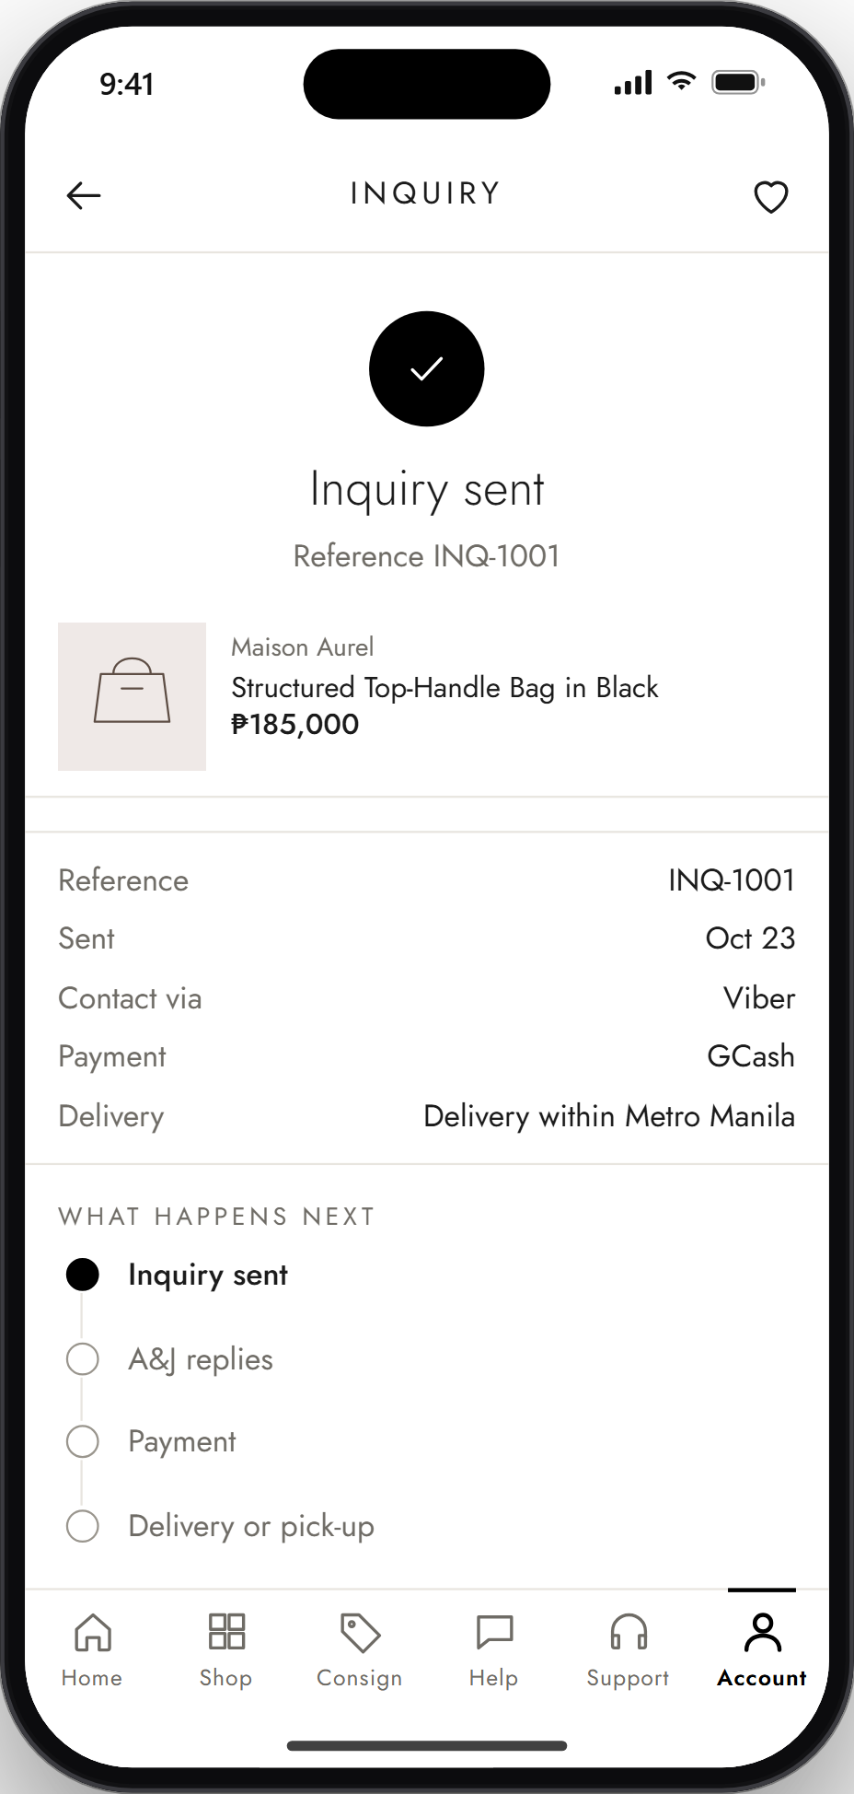 | STEP 8 OF 22  8. Order confirmation (in the prototype: Inquiry sent)  A confirmation shows the inquiry reference and the chosen details. What happens next lists the stages: Inquiry sent, A&J replies, Payment, then Delivery or pick-up.  End of this flow. Next: Flow 3, Consigning an item, starting at Step 9.

Flow 3: Consigning an item
Steps 9 to 12.
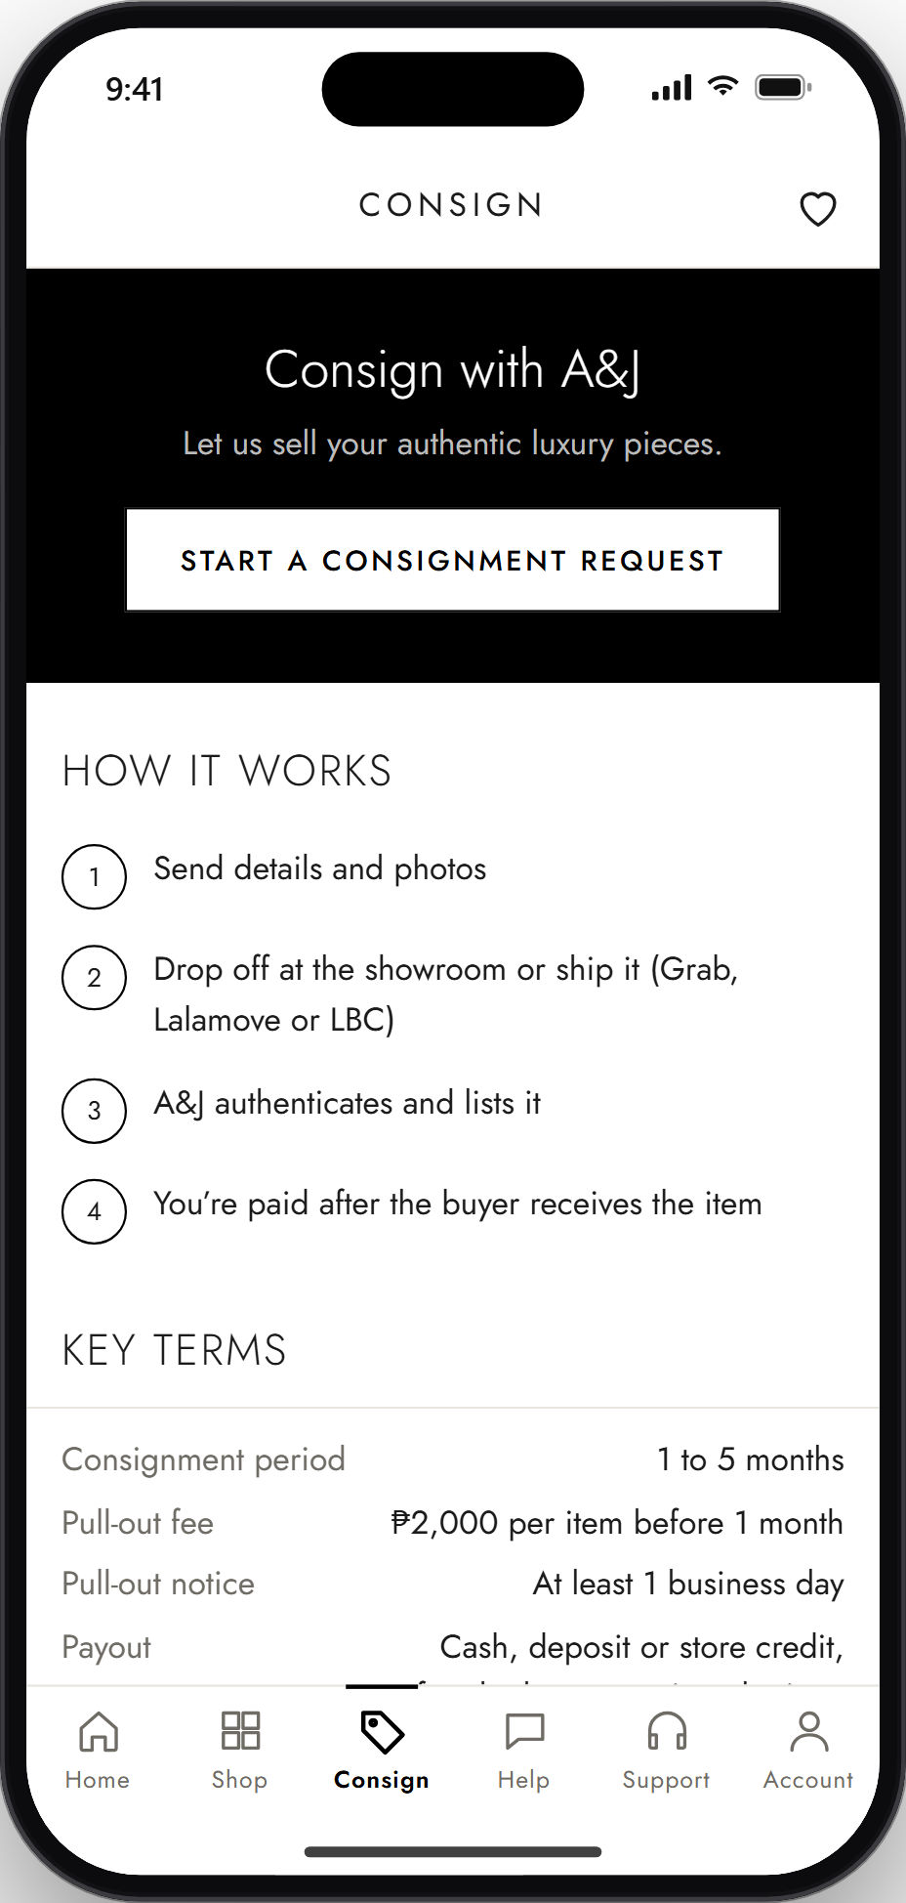 | STEP 9 OF 22  9. Open the consignment section  The Consign tab explains how consignment works and lists the key terms, which are paraphrased from A&J's public website and not yet confirmed by A&J. The user taps Start a consignment request.  Next: Step 10, Submit item details and photos ↓
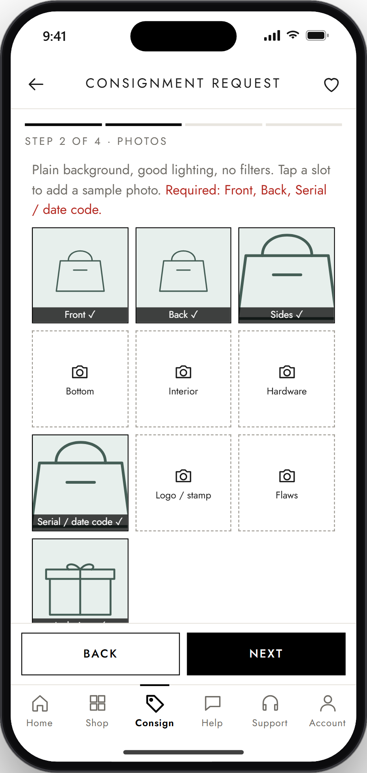 | STEP 10 OF 22  10. Submit item details and photos  The request has four short steps: Item, Photos, Details and Hand-over. After entering the item details (consign or sell, category, brand, name, condition), the user adds photos; Front, Back and Serial / date code are required.  Next: Step 11, Review and submission confirmation ↓
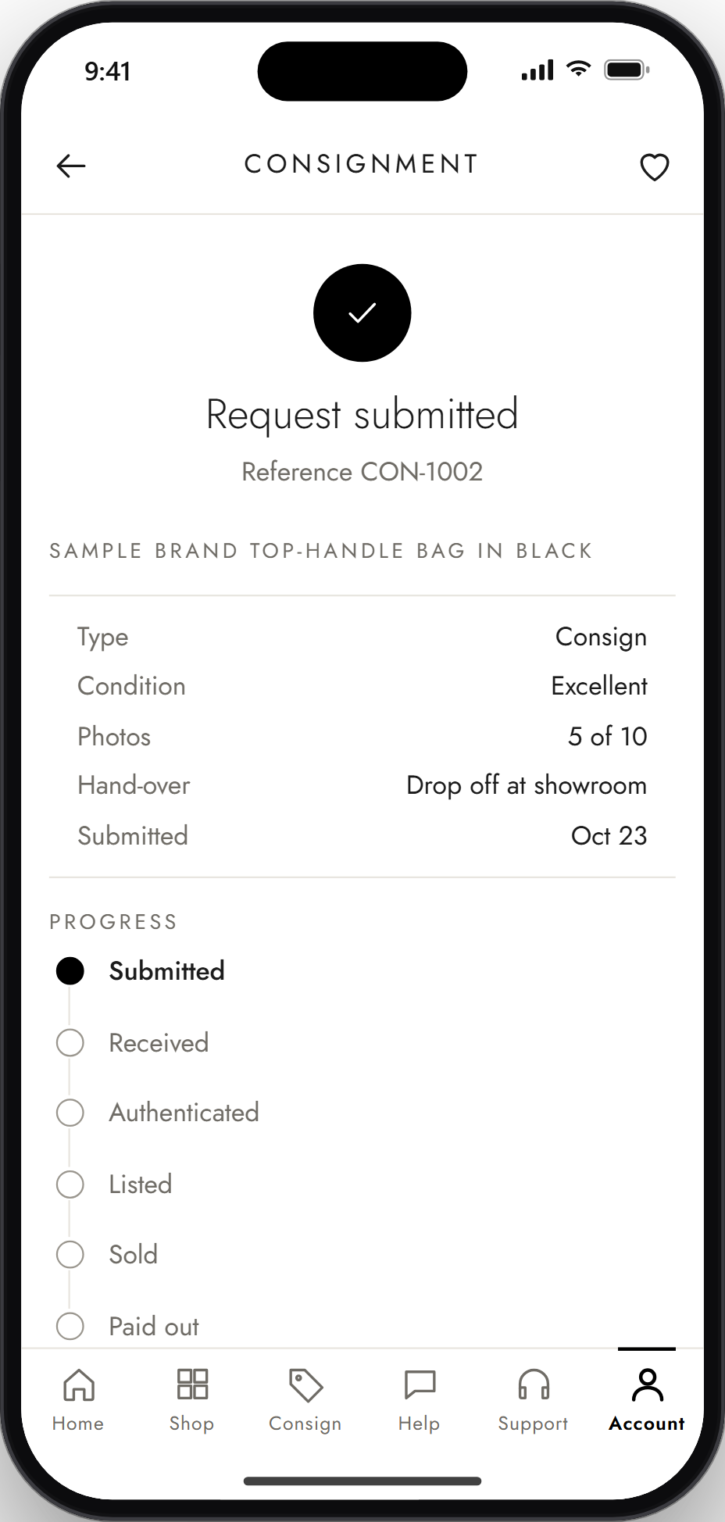 | STEP 11 OF 22  11. Review and submission confirmation  The last step, Hand-over, shows a summary of the request to review before the user taps Submit request. The confirmation shown here gives the reference number and the request details.  Next: Step 12, Track consignment status ↓
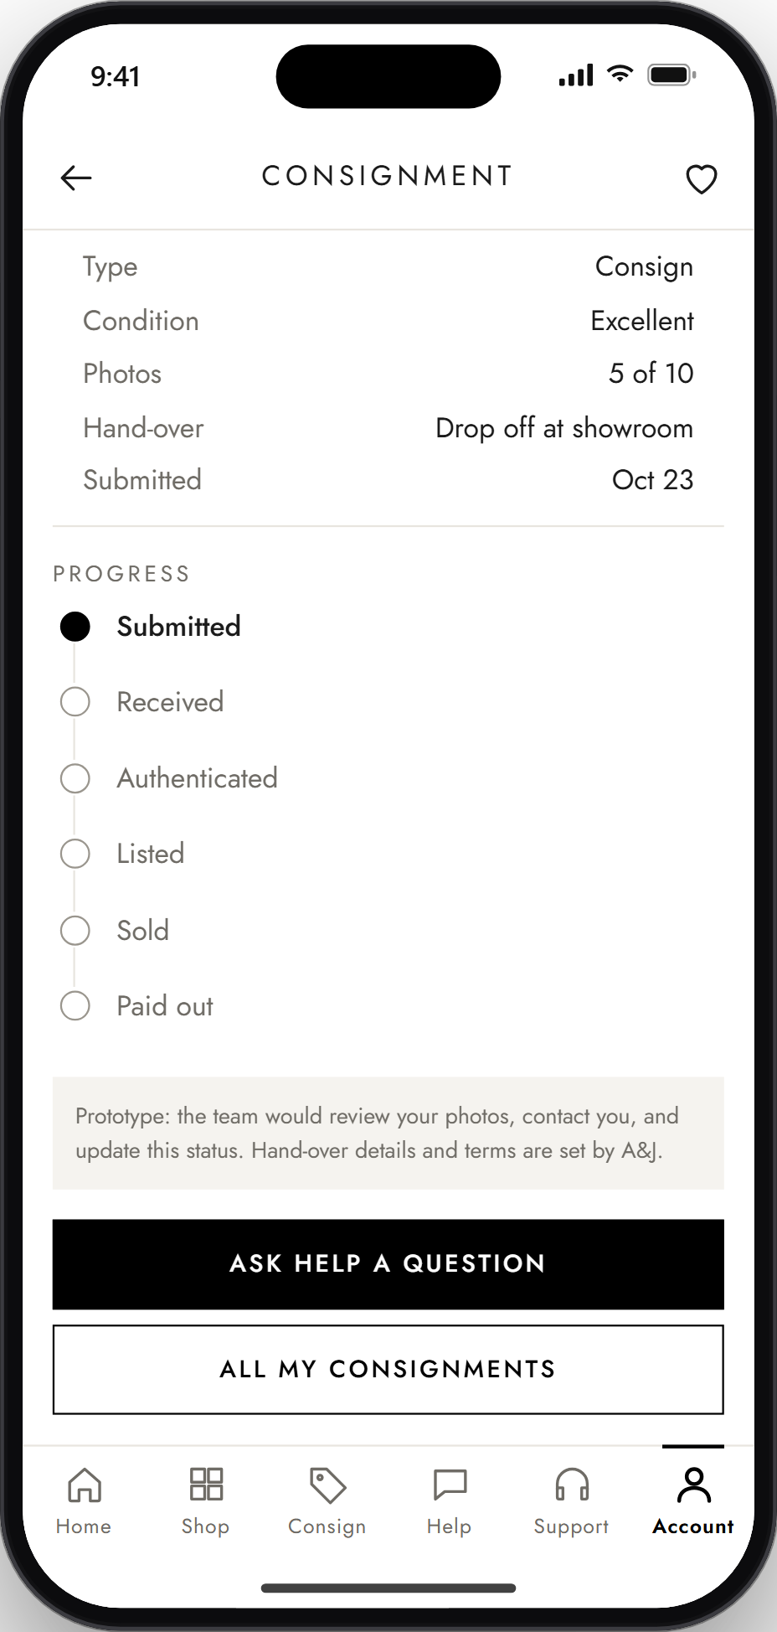 | STEP 12 OF 22  12. Track consignment status  From Account > My consignments, the user opens the request to see its progress: Submitted, Received, Authenticated, Listed, Sold, Paid out. In the prototype the status stays at Submitted, because staff cannot update it yet.  End of this flow. Next: Flow 4, FAQ chatbot, starting at Step 13.

Flow 4: FAQ chatbot
Steps 13 to 15.
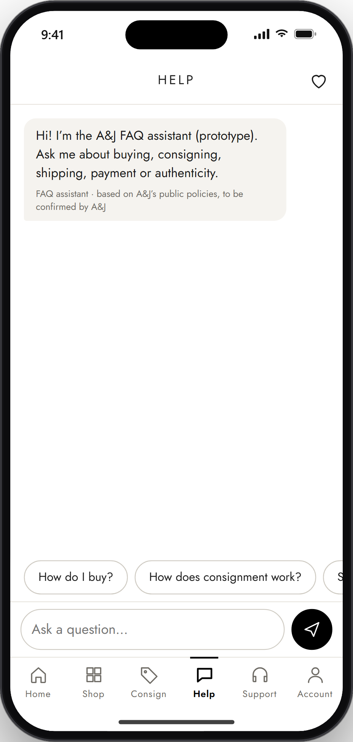 | STEP 13 OF 22  13. Open the chatbot  The Help tab opens the FAQ assistant with a greeting. Suggested questions appear as buttons above the message box.  Next: Step 14, Ask or choose a question ↓
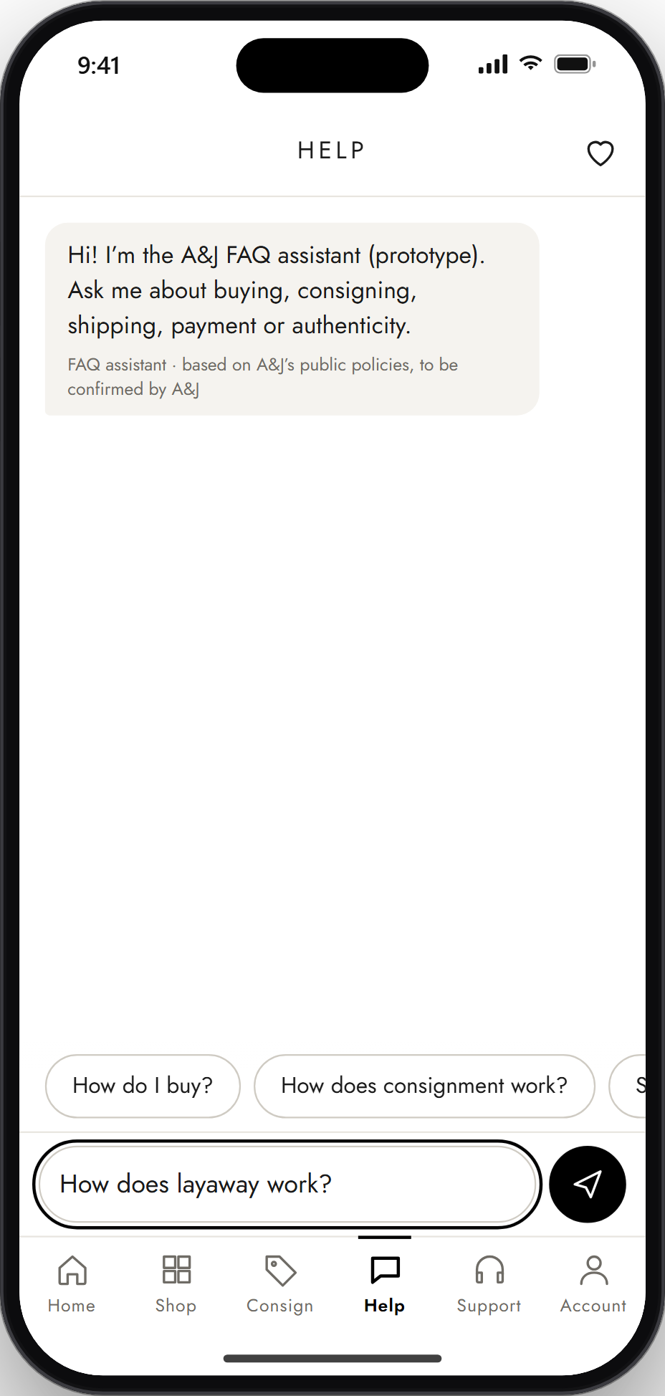 | STEP 14 OF 22  14. Ask or choose a question  The user types a question (here, "How does layaway work?") or taps one of the suggested questions.  Next: Step 15, Receive an answer ↓
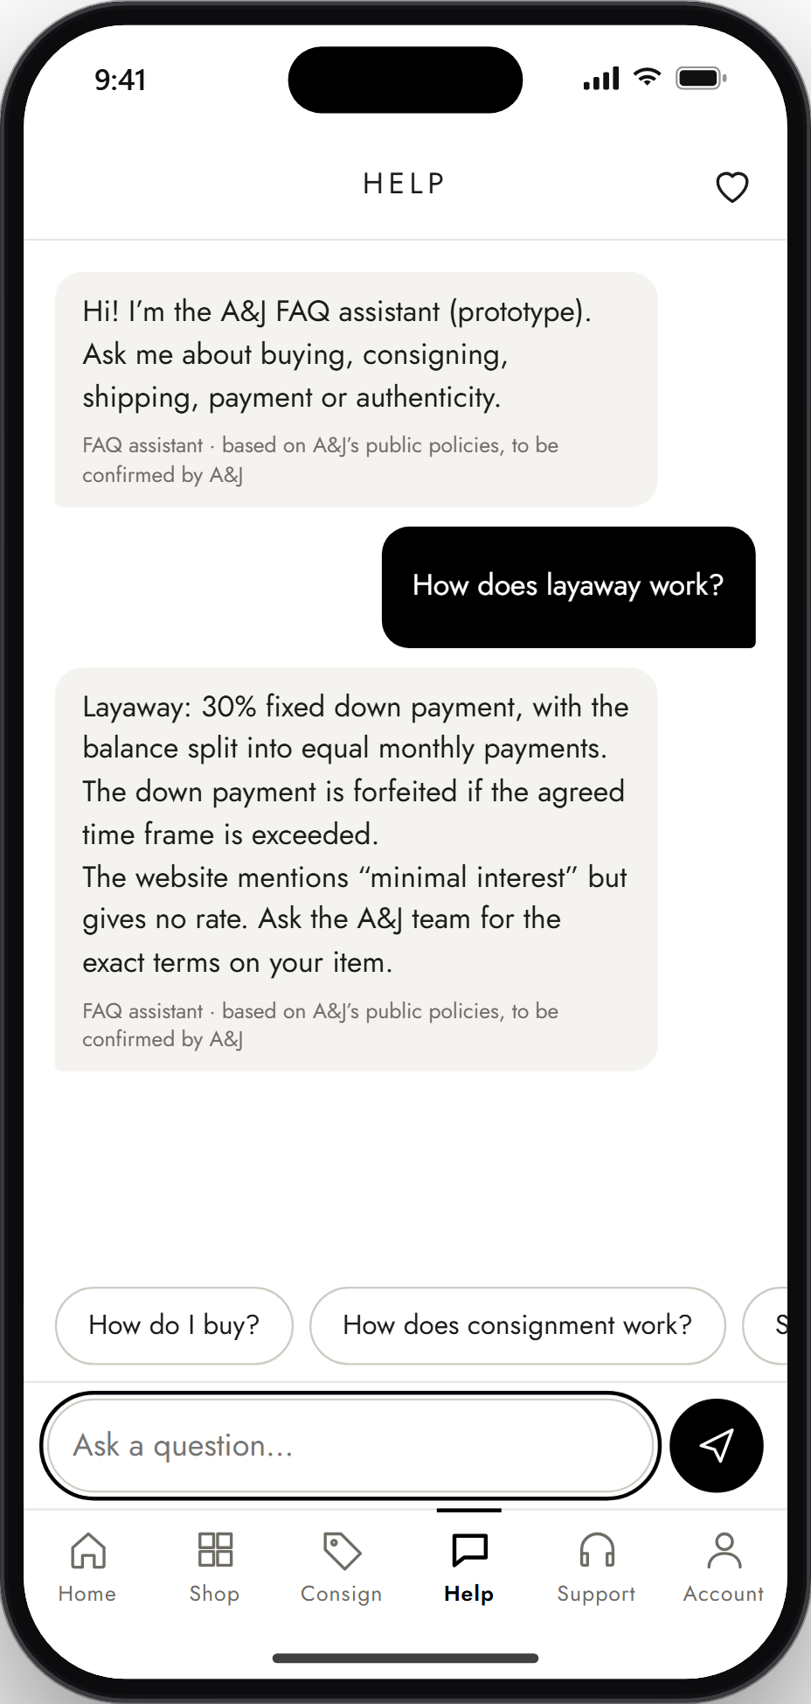 | STEP 15 OF 22  15. Receive an answer  The assistant answers from the approved FAQ text, labelled as based on A&J's public policies and still to be confirmed by A&J. If it cannot help, it offers Talk to a support agent, which opens a support ticket with the chat attached.  End of this flow. Next: Flow 5, Technical support and after-sales support, starting at Step 16.

Flow 5: Technical support and after-sales support
Steps 16 to 18.
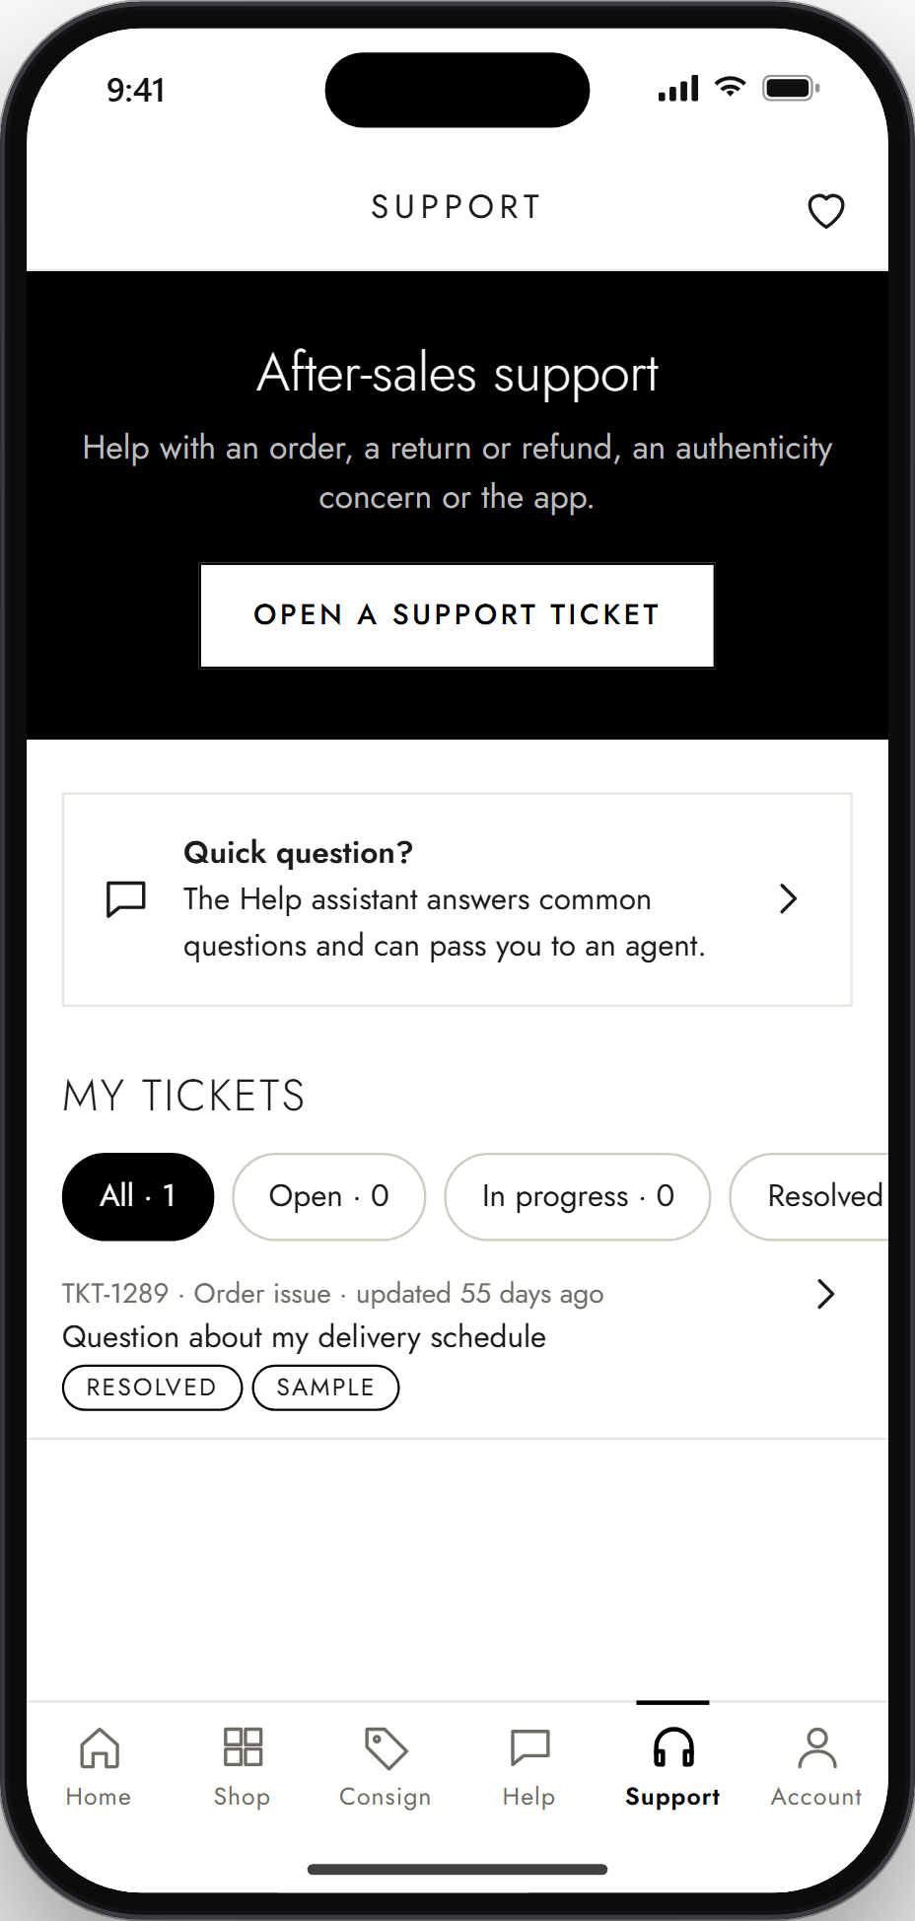 | STEP 16 OF 22  16. Open the support section  The Support tab offers Open a support ticket, a shortcut to the Help assistant for quick questions, and My tickets with status filters. Each customer starts with one sample resolved ticket.  Next: Step 17, Submit a support ticket ↓
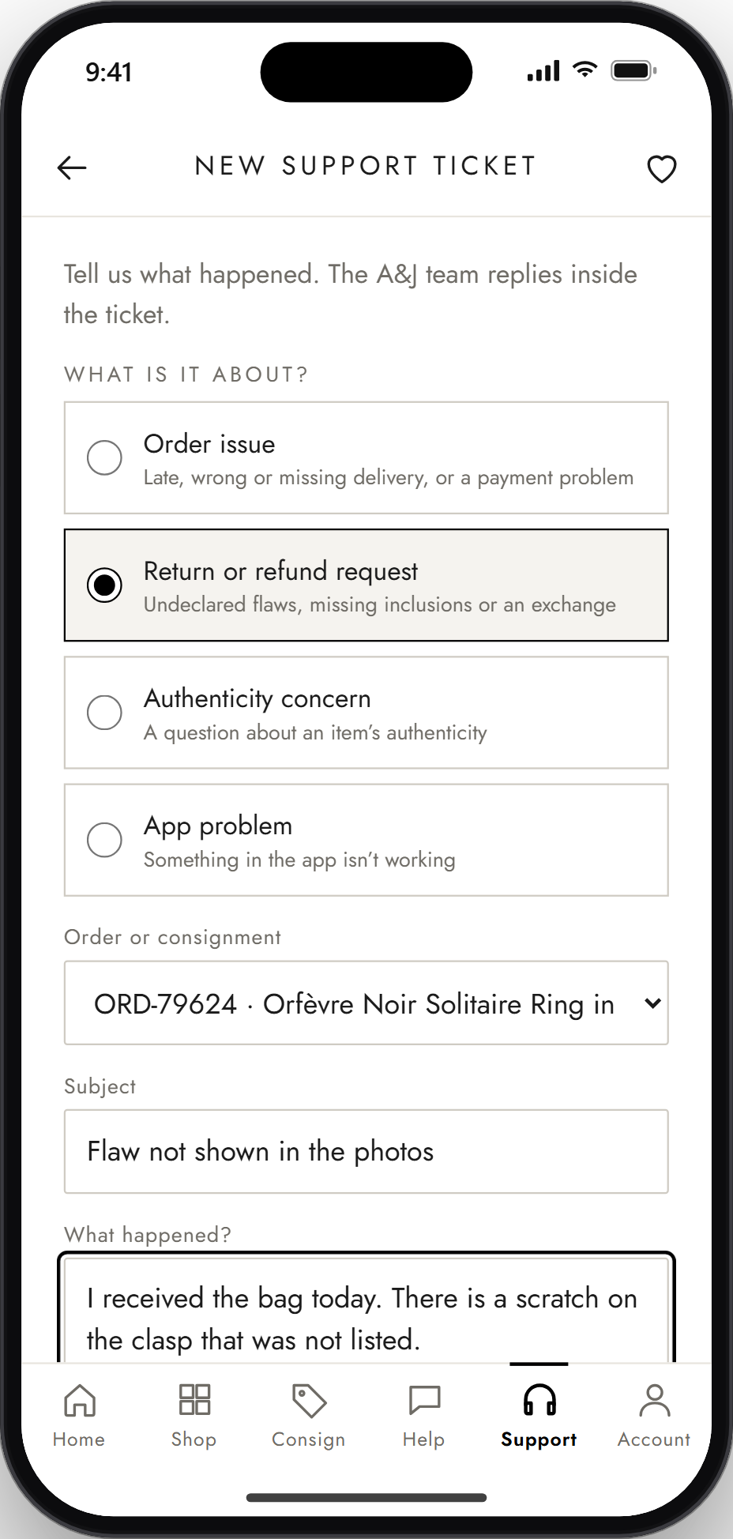 | STEP 17 OF 22  17. Submit a support ticket  The user chooses what it is about (here, Return or refund request), picks the related order, adds a subject and describes the problem, then taps Submit ticket.  Next: Step 18, Track ticket status ↓
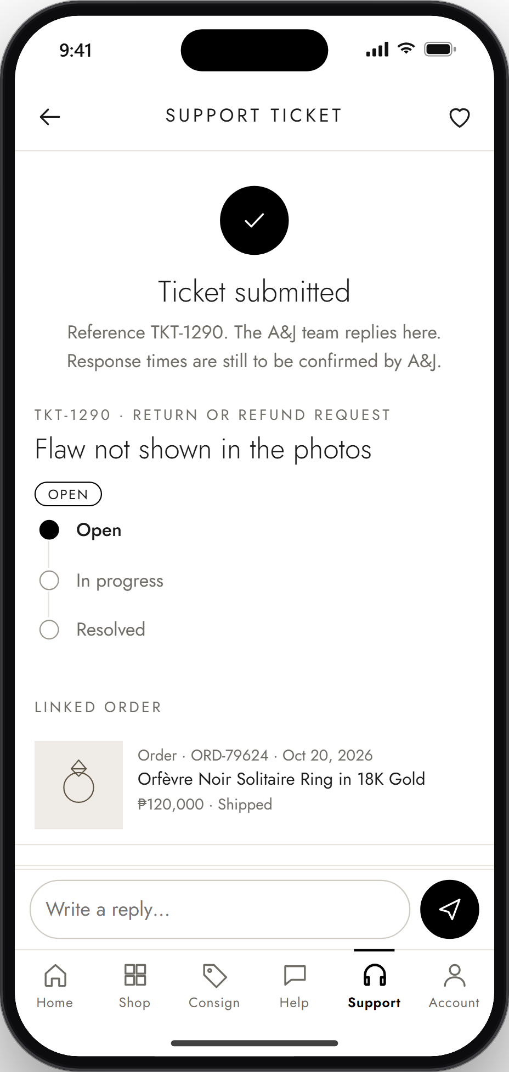 | STEP 18 OF 22  18. Track ticket status  The confirmation shows the ticket reference, the status timeline (Open, In progress, Resolved), the linked order and a reply box. The customer comes back here to read staff replies and see status changes.  End of this flow. Next: Flow 6, Admin flow (A&J staff), starting at Step 19.

Flow 6: Admin flow (A&J staff)
Steps 19 to 22.
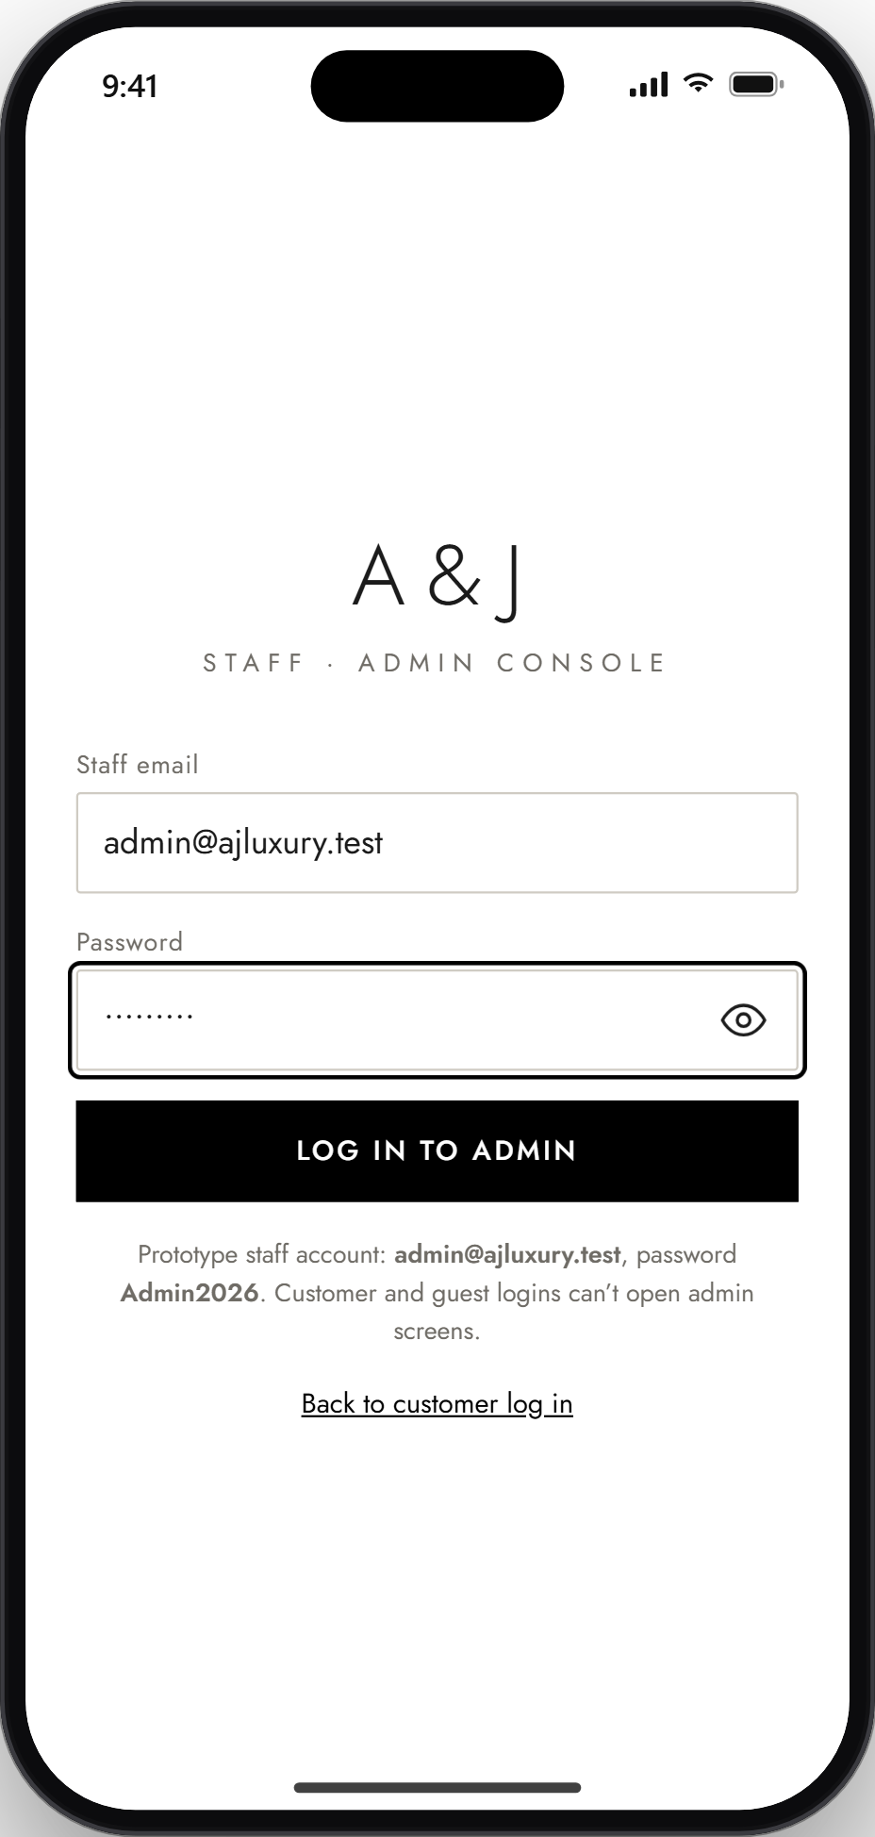 | STEP 19 OF 22  19. Admin login  Staff sign in through a separate Admin login, linked from the bottom of the login page. Customer and guest accounts cannot open admin screens. The prototype shows its sample staff account.  Next: Step 20, Dashboard ↓
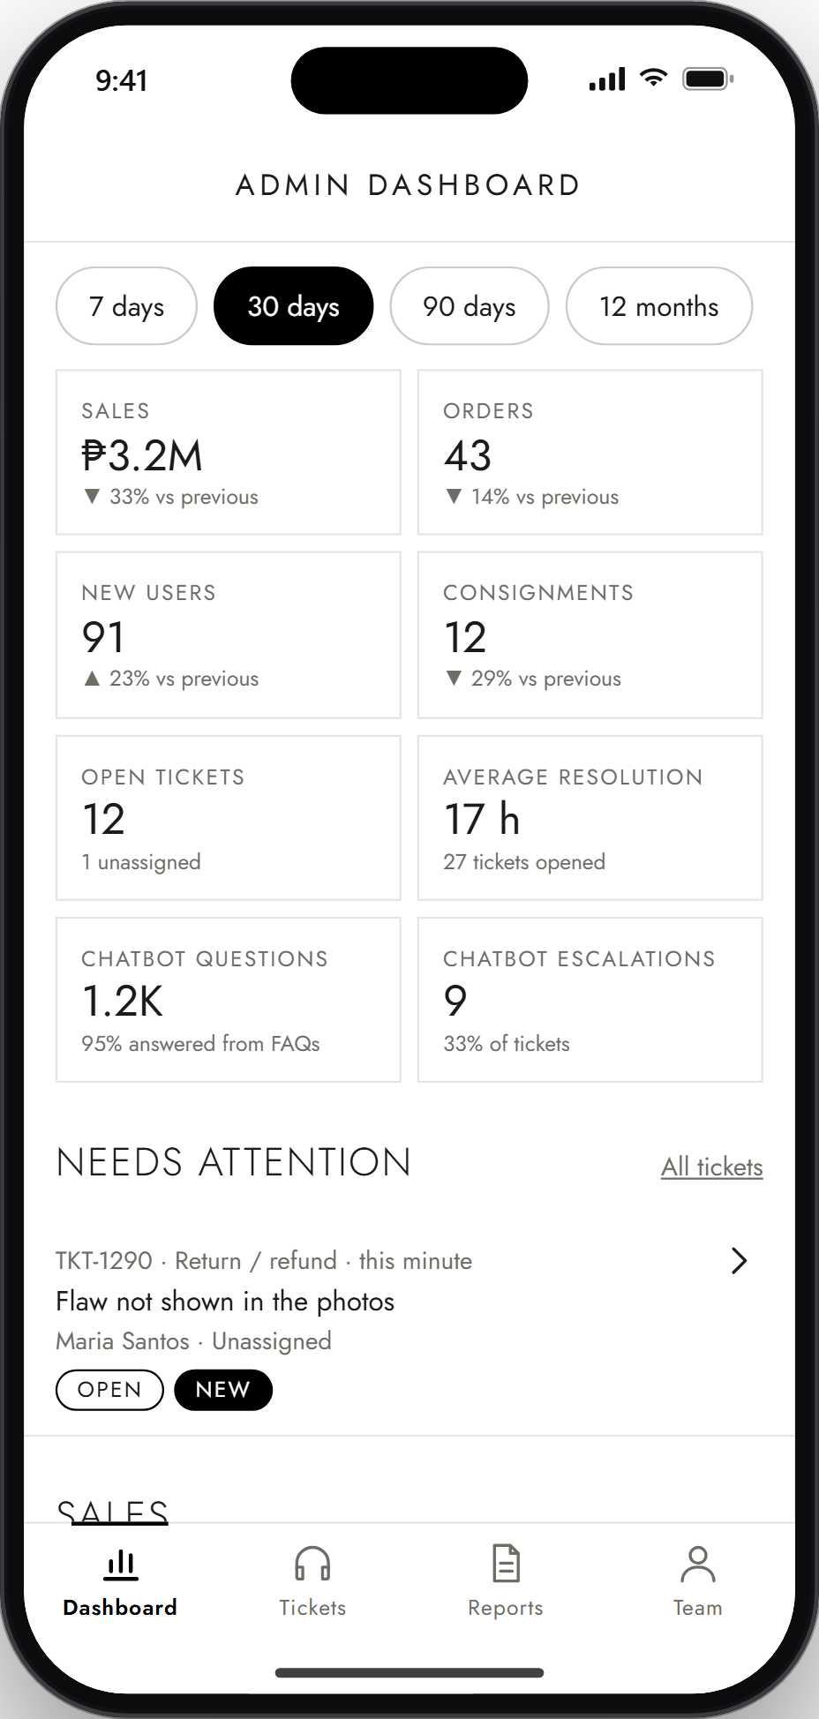 | STEP 20 OF 22  20. Dashboard  The dashboard shows totals for the chosen period (7 days to 12 months): sales, orders, new users, consignments, open tickets, average resolution time and chatbot activity. Needs attention lists new or unassigned tickets, including the one submitted in Step 17, and charts follow further down.  Next: Step 21, Handle support tickets ↓
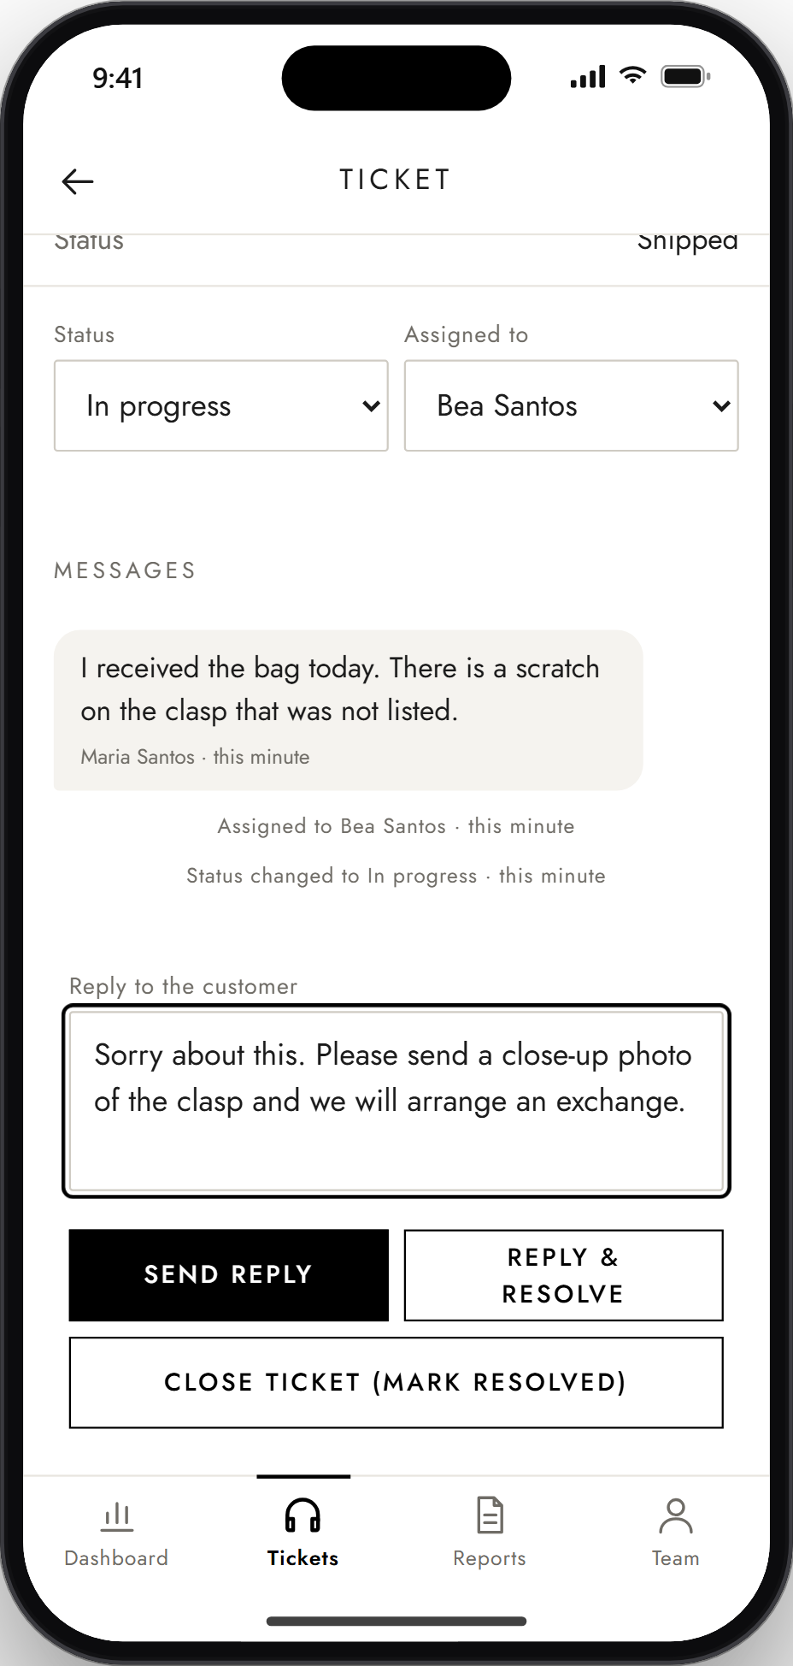 | STEP 21 OF 22  21. Handle support tickets  Staff open the ticket, assign it (here, Assign to me), change the status to In progress and write a reply. Every change appears in the customer's ticket from Step 18.  Next: Step 22, Generate reports and view analytics ↓
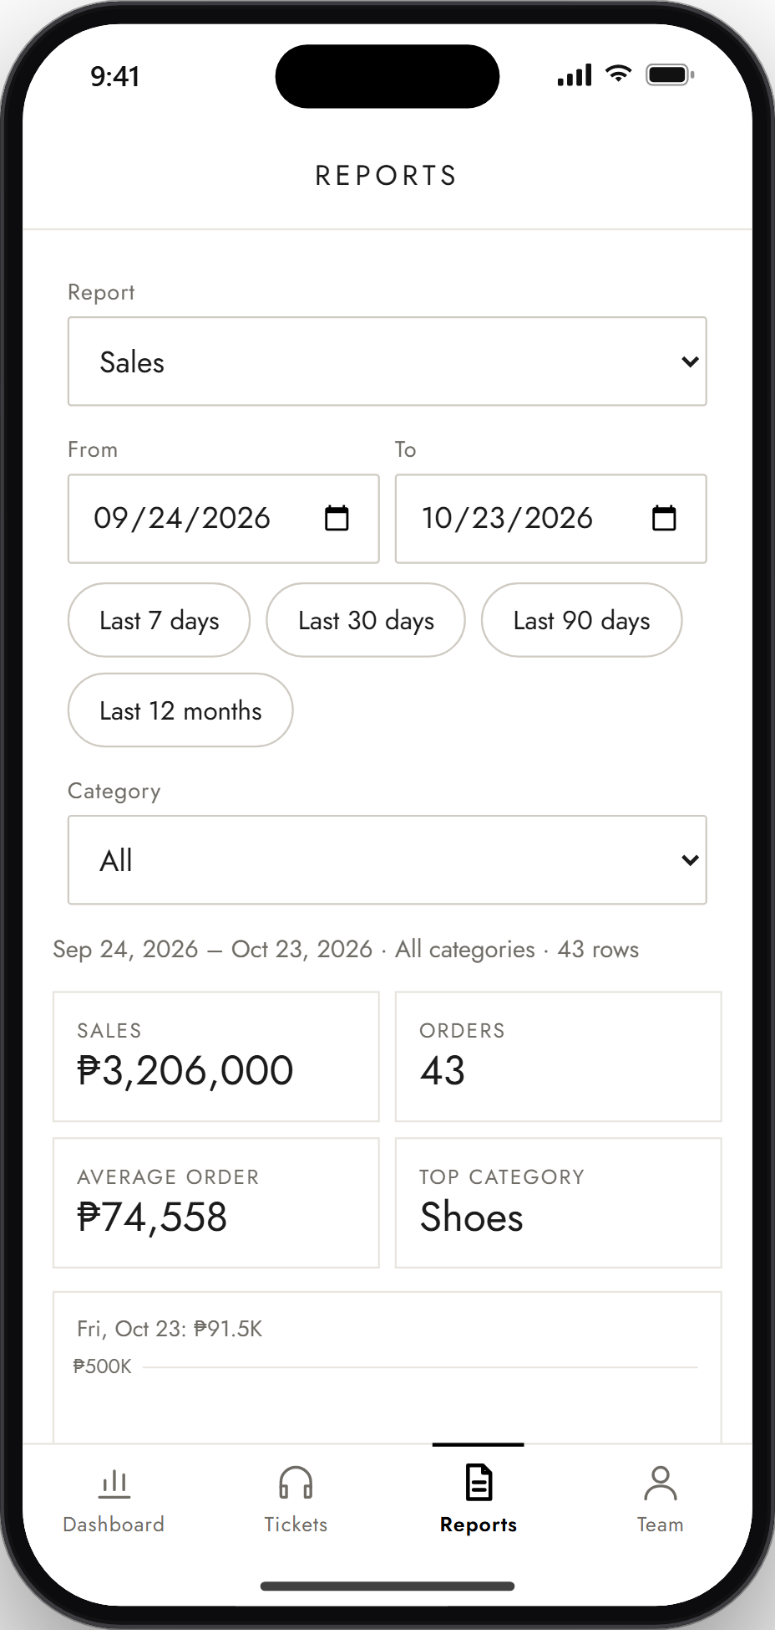 | STEP 22 OF 22  22. Generate reports and view analytics  In Reports, staff choose a report (sales, consignments, support tickets or users), a date range and a category. Totals appear first; further down are a chart, CSV and PDF download buttons, and a table of results.  End of the guide.

