# Gain/loss asymmetry in time series of individual stock prices

# SPY 1994 – 2014

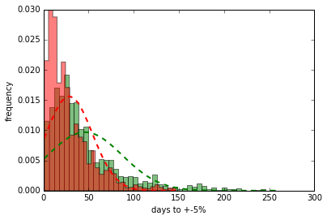

# Random walk

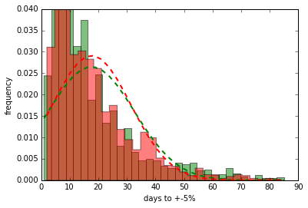

# Correlation with out of sample sources

# Anscombe's quartet

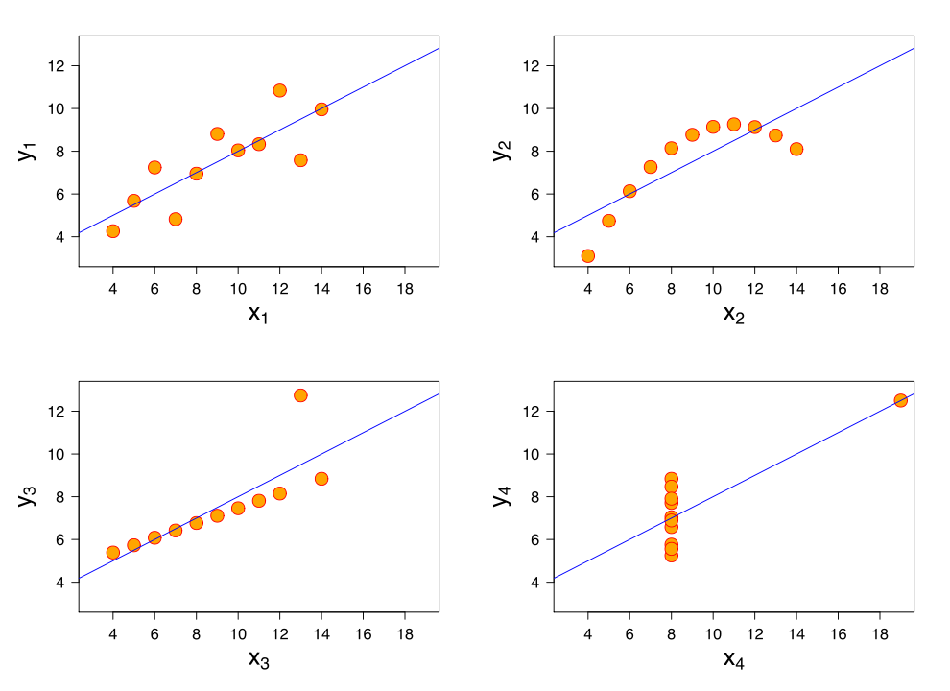

# No exchange rate factored

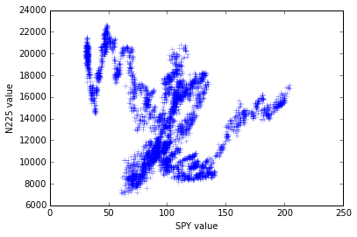

# Exchange rate factored

