Date | Research Firm | Action | From | To
13-Nov-14 | Deutsche Bank | Initiated |  | Hold
14-Jun-13 | Barclays | Downgrade | Overweight | Equal Weight
13-Jun-13 | Oppenheimer | Initiated |  | Perform
20-Dec-10 | Stifel Nicolaus | Downgrade | Buy | Hold
5-Nov-10 | Argus | Upgrade | Hold | Buy
26-Jan-10 | Ladenburg Thalmann | Upgrade | Sell | Neutral
26-Oct-09 | Stifel Nicolaus | Upgrade | Hold | Buy
19-Oct-09 | FBR Capital | Upgrade | Underperform | Mkt Perform
25-Sep-09 | William Blair | Initiated |  | Outperform
24-Aug-09 | Barclays Capital | Upgrade | Equal Weight | Overweight

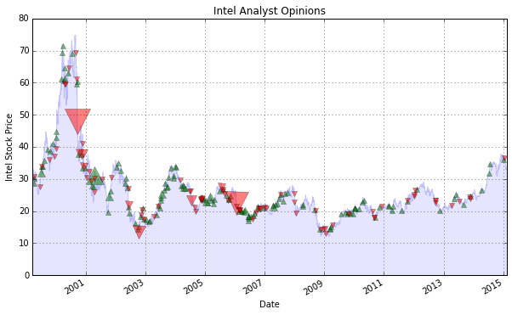
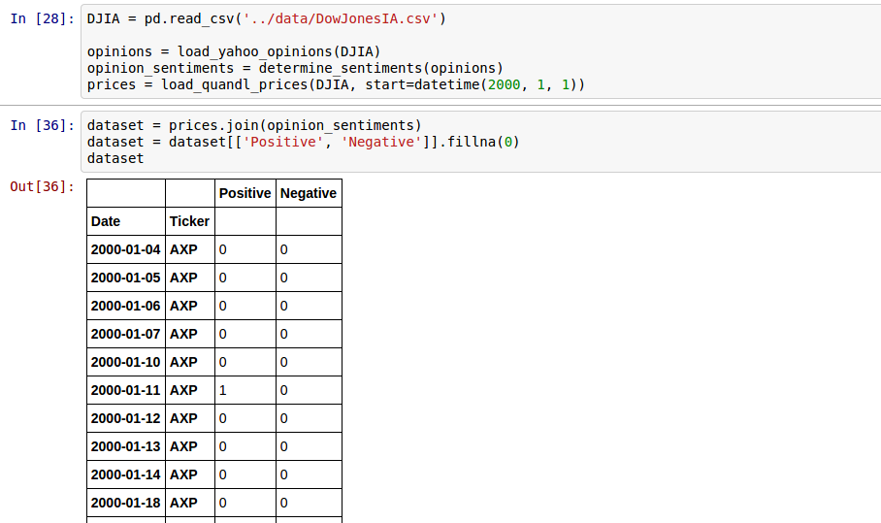

Your algorithm will be measured on these performance criteria:

- Sharpe Ratio: The gold standard of performance metrics. Penalizes an algorithm if it takes excessive risk to achieve its return. Higher Sharpe is better.
- Annualized volatility: Lower volatility is better.
- Annualized returns: The algo has to make money.
- Max Drawdown: The greatest loss suffered from a peak in equity to its subsequent trough. By minimizing drawdown, your algorithm can better compound gains.
- Stability of Return: This measures how consistently an algorithm generates its profits over time. (Mathematically, the R-squared of the linear regression line drawn through the algorithm's equity curve based on log-returns).
- Calmar Ratio: Annual Return / Maximum Drawdown. This is a quick way to compare across algorithms how long it might take to get back above its high-water mark after suffering a loss equal to its historical max drawdown.

