# Distribution of capital

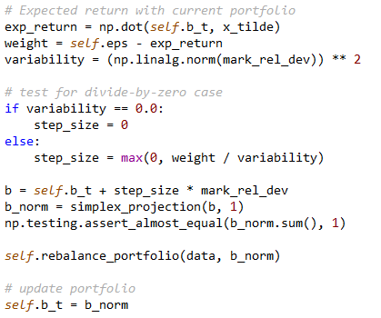

* x_tilde is the expected delta of portfolio components
* mark_rel_dev = x_tilde – mean(x_tilde) (center around 0)
* Step is proportional to total expected return and (1 / variance of mark_rel_dev )
* Algorithm will make larger changes to individual component if the entire portfolio is moving together

Simplex Projection

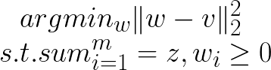

* V = portfolio weights
* Z = 1
* Method of normalization
* Find the closest point (w) on the square of size z to the point v

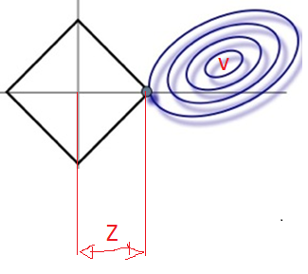

# Stock Groups

* NASDAQ: 2917
* NYSE: 3293
* AMEX: 413
* DJIA: 30
* Etc..

# Basic classifier

* Moving average crossover
  + If short crossed over long, indication of upward trend
  + If short crossed under long, indication of downward trend
* Stochastic oscillator
  + Prices tend to close near the extremes of the recent range before turning points
  + Compare current price to high/low of price window
* Bollinger bands
  + Detect when prices are n stddevs away from mean
* Average True Range
  + Measure of volatility
  + Based on maximum difference between highs/lows/current price
* MACD
  + Divergence of moving averages