Unisys Consultancy Services
Design Specification
for an EPoS Keymap Maintenance Application for Compass In-Unit Trading Project (Reference CDD/EDS)

Unisys Project Manager Signature Date

Compass Project Manager Signature Date

Effective Date:
Change Summary

Version | Date | Section | Description of Change
Draft A | 10/4/96 | All | Initial Version, technical sections incomplete
Draft B | 15/4/96 | Technical & File Definition | Sections added
Draft C | 24/4/96 | All | Changes as per discussions at Redditch on 17th April 1996. Flow Diagrams Section added.
Draft D | 2/5/96 | File Definition | Configuration File - Terminal Type field added.
 |  | Technical Operation | Batch Processes flow diagram changed. Directory Structures changed.
 |  | Flow Diagrams | Flow diagrams updated.
 |  | Appendices | Directory structure diagram added.
Version 1.0 | 29/5/96 |  | Issued for review/sign-off
Version 1.1 | 13/6/96 | Technical Operation, File Definition & Communications. | OMCOM.BAT operation/requirements added. Colour, Local PLU and Help File Layouts added/changed. All references to Control Centre changed from 999 to XX (Change Request dated 21/5/96)

Reference Documentation

- OmCom PI Developer’s Manual for use with Release 1.13
- RS4601 Hospitality Pad Programming Manual (Version Number 6.0)

Contents

Contents
Introduction
Functional Requirements
Entry Screen
The Main Screen
The Search Function
Context Sensitive Help
Save and Exit
Technical Operation
General
Omron 4602/4603
Batch Processes
File Definition
General
Omron 4602/4603
Communications
Omron (OmCom)
Flow Diagrams
Appendices
Directory Structure

Introduction

This document was produced by Terry Boldick, Unisys Systems Architect for the Compass In-Unit Trading Project, and is the result of a meeting at Compass, Birmingham on 25th and 26th March 1996 with Geoff Ingram, Scott Nelson, and Rob Watkins, to determine the best method of maintaining EPoS keymaps at the unit level. A number of existing methods were evaluated; Fretwell Downing, Catabyte, and OmCom. The systems evaluated were considered either too complex for a unit manager to operate (OmCom), or having a ‘look-and-feel’ that was incompatible with ReMACS (Fretwell Downing). Although the ‘look-and-feel’ of the Catabyte system was considered acceptable, close inspection of the file structures and programming language introduced some major concerns concerning the ability to integrate the product with ReMACS.
Furthermore, in the medium term, it will be necessary to maintain multiple EPoS terminal types, and none of the systems evaluated offered this functionality. Therefore, it was decided that Unisys should specify and develop a keymap maintenance application that could co-exist, and complement the ReMACS back office system.
The purpose of this document is to define the functional and technical requirements for an EPoS keymap maintenance application to be included within the ReMACS back office system for the Compass In-Unit Trading Project.
The purpose of the keymap maintenance application is to allow the management of a pre-determined section of the EPoS keymap at the unit. The application will be incorporated into the overall ReMACS menu structures, and will support multiple EPoS types. The first version of the keymap maintenance application will support the Omron RB46 EPoS terminal, and this version (1.0) of the specification is concerned only with the functional and technical requirements necessary for this purpose. This document is a working document, and will change to incorporate support for other terminal types over time.

Functional Requirements

This section of the document describes the ‘look-and-feel’ and functional requirements of the keymap maintenance application

Entry Screen
On entry, the user will be prompted for the control centre and terminal id of the EPoS terminal to be maintained. The basic entry screen is shown below:
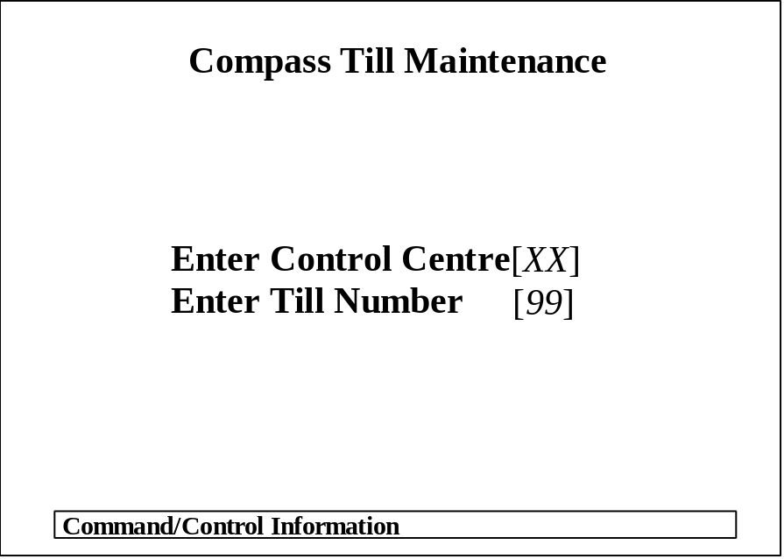
The following functions will be available in this screen:
F1 - Search, this will display a ‘pop-up’ containing a list of valid Control Centres
and Terminal Numbers (from the configuration file, see General File
Definitions Section of this Specification).
ESC - Cancel, this cancels the current action.
TAB - Next Field, allows the user to navigate between fields.
ENTER - Enter, accepts the current item from the ‘pop-up’ window described above.
On completion and acceptance of this screen, the user will be presented with the Main Screen (see below), display for the EPoS terminal specified.

The Main Screen
The layout of the screen provides a good indication of the functionality required of the system. The screen must be character based, to reflect the ‘look-and-feel’ of the ReMACS back office system. Any graphical representation (e.g. of the keymap to be configured) must be consistent with this requirement. This effectively limits the application to the use of the extended ASCII character set, including basic DOS graphical characters and colours. The application should allow for the support of international characters within the extended ASCII character set, for use across Europe.
The basic layout of the main screen is shown below, this is consistent with the ‘look-and-feel’ of the existing Catabyte system:
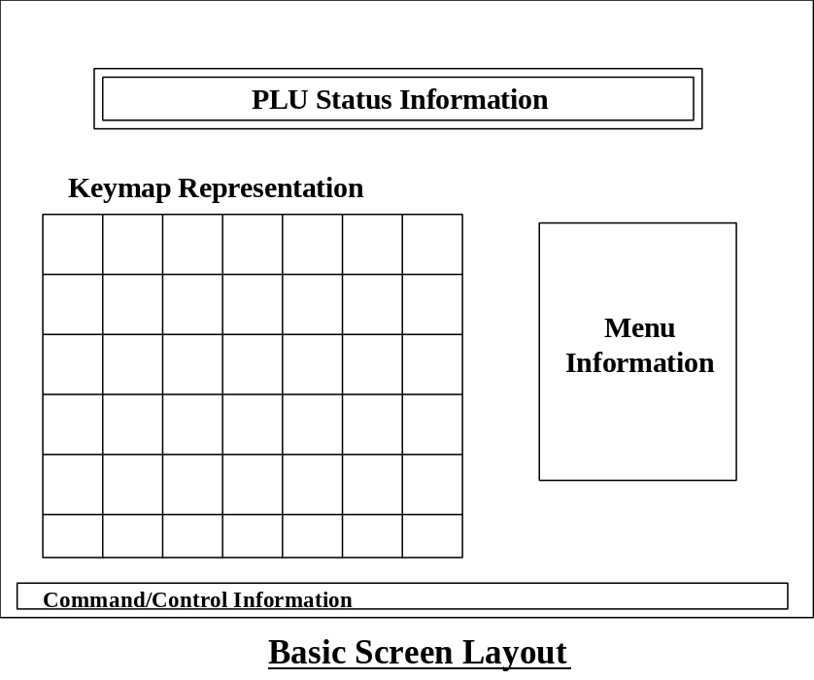

- Keymap Representation
This is the most important area of the screen. It provides a simple graphical representation of the keymap currently under configuration. As most keymaps will be too large to fit into this area, it should be a scrolling area of the screen, to allow users access to any key. The item description, as it will appear on the EPoS terminal template, should be clearly displayed.
When run, the application should automatically position the cursor in the top left-hand corner of the keymap (i.e. the first key). The position of the cursor should be identified using flashing inverse video on the keymap. The user should be able to move from key to key, within the keymap display, using the standard keyboard arrow keys or the TAB key.
- PLU Status Information
This a two-line display that provides the user with detailed information on the configuration of the key currently highlighted by the cursor within the Keymap Representation as described above. When the key is defined as a ‘single-shot’ key, the information displayed on the first line comprises; PLU Code, ReMACS Description, and Selling Price 1 through 6; and that on the second line comprises; Key Description, Kitchen Printer (Y/N), the kitchen printer flag will have a default value of ‘N’. The second line of the display is editable; the key description refers to the actual description to appear on the keymap, if no value is input by the user, then the first twelve (12) characters of the ReMACS description should be used as the keymap description. The kitchen printer flag can only accept Y (Yes) or N (No). When the key is defined as a menu, the first line of the display will comprise Menu Descriptor information.
The user should be able to move from the Keymap Representation to the PLU Status Information line by pressing the F2 function key to allow configuration of the key at which the cursor is positioned within the Keymap Representation. The key being configured should remain highlighted, as described previously. The user will only be able to modify the PLU Code field when ‘active’ in the PLU Status Information line.
The PLU Code field will have three conditions:
- Blank, indicates that the current key position is not configured;
- Valid PLU Code displayed (refer to File Definition section of this specification), indicates that the current key position is configured with the single PLU item as displayed;
- ‘**MENU**’, indicates that the current key position is configured as a MENU or Window (see Menu Information below).
The user is able to toggle the type of key, between a single PLU Item key and a MENU or Window key by pressing the F5 key. When the user wishes to define a key as a MENU key, they should be prompted to enter a valid 12-character description for the menu on line 2 of the display. The process to change the PLU items within a MENU is described within the Menu Information description, below.
For keys defined as single PLU Item keys, entering an alternative, valid (refer to File Definition section of this specification), PLU Code, will cause the highlighted field within the Keymap Representation to change as necessary. The user will be able to enter a PLU Code manually, using the numeric keypad, or execute a search for a PLU Code (this procedure is defined separately below). The user will accept the PLU Code, and the key configuration by pressing the ENTER key. This action will return the user to the cursor position highlighted on the Keymap Representation.
- Menu Information
When the key highlighted within the Keymap is a menu, the full contents of the menu should be displayed within the Menu Information display. The number of items displayed is dependent on the type of EPoS terminal under configuration, and the Menu Information display should change to accommodate the menu requirements of the specific EPoS terminal being configured.
The process of changing the PLU items to be displayed within a MENU is similar to that described above for keys defined as single PLU Item keys, except that the user is not returned to the Keymap Representation after the selection of a single PLU Code, but remains within the PLU Information display until the F2 function key is pressed. Whilst in the PLU Information display, the user is able to enter valid PLU Codes as necessary, either manually, or using the search procedure defined below, and accept PLU Codes using the ENTER key. As changes are made to the menu, these should be displayed in the Menu Information section of the screen. Pressing the F2 function key returns the user to the current cursor position within the Keymap Representation.
- Command/Control Information
This area of the screen displays the function keys valid at any particular time. The use of function keys should be consistent with the use of function keys within ReMACS, that is:
F1 - Search, this initiates the search process as defined below.
ALT-F1 - Toggles Keyboard Level. Where applicable (e.g. for Omron) this allows the user to toggle between keyboard levels available on the EPoS terminal.
F2 - Jump to PLU Status Information.
F5 - Menu/’Single Shot’ Toggle.
Shift F9 - Help, this provides the user with ‘context-sensitive’ help, as defined below.
F10 - Save and Exit, this saves the current configuration in the manner defined below.
ESC - Cancel, this cancels (aborts) the current action. Confirmation by pressing ESC again.
TAB - Next Field, allows the user to negotiate the screen as defined above.
ENTER - Enter, accepts the current item, as defined above.
DEL - Delete, deletes the current PLU from Window/Keymap.
INS - Insert, inserts PLU in Menu.
The use of other functions keys are explicitly defined within the functional requirements themselves.

The Search Function
When in the PLU Status Information field, the search function allows the user to search for a particular PLU by description. The search function is initiated by pressing the F1 function key. This action will cause the screen display to change as shown below:

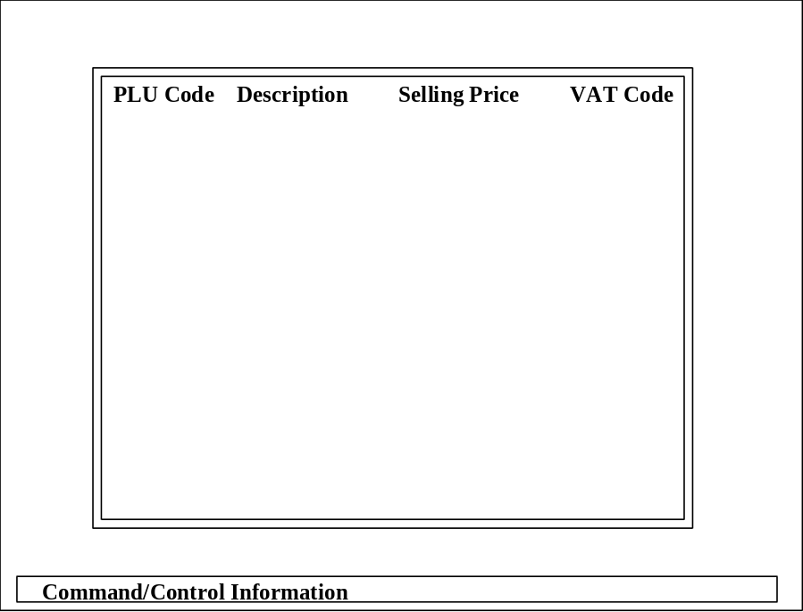

The screen will display a scrolling item list of PLU Codes, Descriptions, Selling Prices and VAT Codes from the PLU File (this is defined within the File Definition section of this specification). The cursor will be positioned at the first item on the list, and the row at which the cursor is positioned will be highlighted using reverse video. The user will be able navigate within the item list by the following actions:
- Up Arrow Key, moves the cursor up a single row (item);
- Down Arrow Key, moves the cursor down a single row (item);
- Page Up Key, scrolls the item list up a full display;
- Page Down Key, scrolls the item list down a full display;
- Entering a Single Alphabetic Character, this positions the cursor at the first PLU Code whose Description Field begins with the character entered. PLU list to be sorted by Description Field (i.e. Alphabetically);
- Entering a Single Numeric Character, this positions the cursor at the first PLU Code starting with the numeral entered. PLU list to be sorted by PLU Code;
- ENTER Key, selects the PLU Code at the cursor position and returns the display to the main screen.

Context Sensitive Help
Pressing the F9 Function Key will cause the display of ‘context-sensitive’ help, where available. Where the help is simple, e.g. ‘Enter the PLU Code’, this should be displayed within the Control/Command Information section of the main screen. Where the help is more extensive, the screen display should change to be consistent with the help display within the DOS environment i.e. white text on a blue background. Pressing the ESC Key (Cancel) will return the display and cursor position to that immediately prior to the F9 Key depression.

Save and Exit
Pressing the F10 key will clear the main screen display (refer to File Definition section of this document for file details relating to the specific EPoS terminals) and the following options will be offered to the user:
1 - Transmit to EPoS Now
2 - Transmit to EPoS at End-of -Day
3 - Transmit to EPoS on Specific Date
4 - Save Layout to File
5 - Print Layout
6 - Exit
These options have the following functions:
- Transmit to EPoS Now
This option causes all amendments to be saved to a file (refer to Technical Operation of the System for naming conventions, etc.) for onward transmission to the EPoS terminal(s) immediately. The method of transmission and initiation of the transmission process is dependent on the EPoS terminal being configured, and is detailed within the Communications section of this specification.
- Transmit to EPoS at End-of-Day
This option causes all amendments to be saved to a file (refer to Technical Operation of the System for naming conventions, etc.) for onward transmission to the EPoS terminal(s) as part of the ReMACS end-of-day procedure.
- Transmit to EPoS on Specific Date
This option causes the system to prompt the user for a date on which the amendments should be effective. After the user has entered a valid date (must be equal or greater than the current date) and pressed the ENTER key, all amendments are saved to a file (refer to Technical Operation of the System for naming conventions, etc.) for onward transmission to the EPoS terminal(s) as part of the ReMACS end-of-day procedure on a specific date.
- Save Layout to a File
This option causes the system to prompt the user to enter a filename. The system will then save the keymap configuration to the file specified by the user (refer to Technical Operation of the System for naming conventions, etc.).
- Print Layout
This option allows the user to print the keymap layout to a printer. The print routine will not produce coloured, graphical output, but will print black ASCII text on a pre-printed keymap.
- Exit
This option exits from the Keymap Maintenance application, and returns control to ReMACS. The application will prompt the user to confirm their decision to exit.
Note:
All changes, together with current date and time, and decisions made by the user as part of the ‘Save & Exit’ process, will be written to the Audit Trail (see ‘File Definitions’ section).

Technical Operation

In general, the system provides the user with a simple interface for the definition and maintenance of keymap configuration files for multiple EPoS terminal types. This section describes the EPoS specific requirements, together with the different types of files, and the processes for creating and maintaining these files. The file definitions themselves are detailed in the next section of this specification.

This section also describes the keymaps and programming requirements specific to each EPoS terminal model/manufacturer.

It should be noted that this system will not provide the ability to fully program the EPoS terminal, but will provide the mechanism to allow users to allocate PLUs (or sales items) to a key on the EPoS keymap; or to define a key as having a ‘WINDOW’ or ‘MENU’ and allow users to allocate PLUs (or sales items) to the ‘WINDOW’ or ‘MENU’.

General
File and Directory Structures
The Keymap Maintenance Application uses the following file and directory structure (refer to File Definition Section of this specification for file naming conventions):
\
ISS\
POSUPDT\
POScrXX.flt (PLU File exported by ReMACS)
KEYMAINT\
KEYMAINT.AUD (the audit trail file)
KEYMAINT.CFG (the configuration file)
XX\ (This directory relates directly to the control centre i.e. one directory will exist for each control centre connected to the PC).
KEYMAP99.XXX
PLU99.XXX
STORE.DAT (This is an Omron specific file)
TEMP\ (This contains temporary file area for PLU files to be transmitted on certain dates).
YYMMDD99.PLU
YYMMDD99.OSP (created when user selects transmit on specified date from ‘Exit’ options).
XMT\ (This directory contains all files for transmission to EPoS terminals)
YYMMDD\ (Files are held in sub-directories indicating the transmission date).
PLUcrXX.flt (The PLU file to be exported).
OSPcrXX.flt (The Omron Department file to be exported).

Application Initiation
The Keymap Maintenance Application will comprise three (3) separate .EXE files:
- A PLU File Update and Conversion Routine (XXXPLUCN.EXE). There will be a separate PLU File update and conversion program for each type of EPoS terminal. The purpose of this routine is to convert the data within the PLU file exported by ReMACS, to update the Keymap Maintenance PLU File, and produce the EPoS Terminal specific PLU file for transmission to terminal itself.
- A PLU Comparison Routine (XXXPLUCP.EXE). This will compare the updated PLU file created by the PLU File Update and Conversion Routine, above, with the original PLU file and identify any changes. The routine will produce a report of all changes, classified by new PLUs, deleted PLUs, and price changes.
- The Keymap Maintenance Application (COMPKEY.EXE) itself.
All programs will be initiated from the ReMACS ‘Rmenu’ system, either directly, or from within batch (.BAT) files.

Omron 4602/4603
Note: The information contained within this sub-section has been derived from the Omron programming documentation for OmCom and the 4601 EPoS terminal, together with conversations with Omron and Compass. Some of the information may not be accurate, and will require thorough testing. Specifically, where asterisks and question-marks appear in the text, these areas should be confirmed prior to implementation.
The Omron 4602/4603 programming specification is designed to meet the specific requirements of B&I.
The Omron 4602/4603 is a compact footprint terminal with a membrane keypad of 11 x 15 keys (165 keys in total). Of these, 69 keys are pre-programmed, and should not be maintainable via the Keymap Maintenance Application. The remaining 96 keys should be totally maintainable at site. A diagram of the keymap is provided below; the pre-programmed areas are un-shaded, whilst the programmable areas are shaded grey.

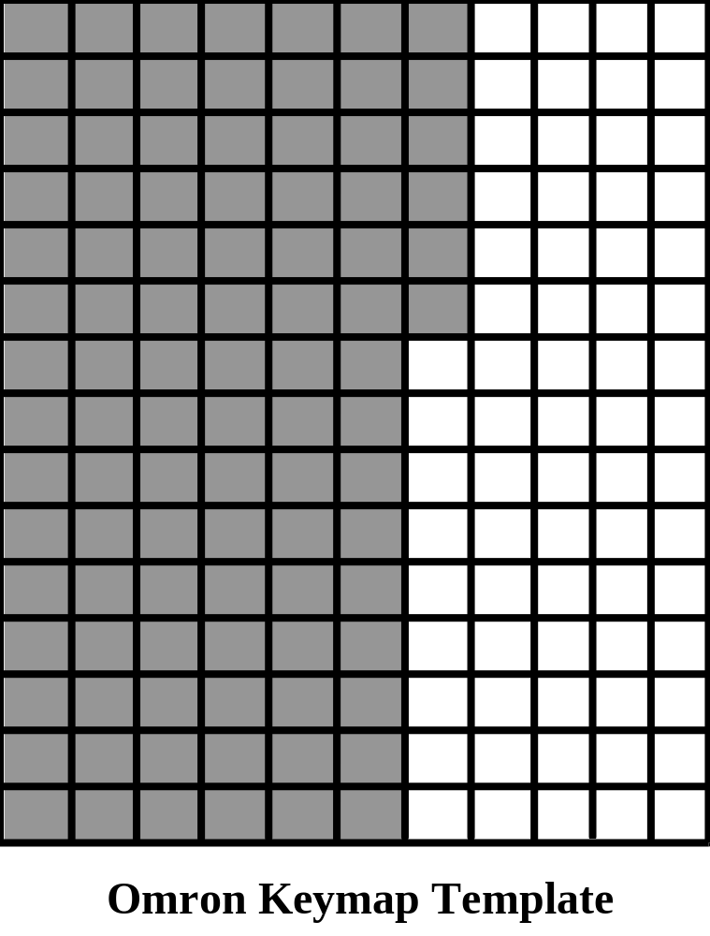
For the Omron 4602/4603, the Keymap Representation section of the screen, described in the ‘Functional Requirements’ section of this specification, will represent the shaded area of the keymap as shown above.
The Omron 4602/4603 has 3 levels of keymap (each level is selectable using the ALT-F1 key sequence within the main screen of the keymap maintenance application), which are selectable from the pre-programmed area of the keypad. This effectively allows three different keymap configurations per terminal. However, the individual keys remain ‘single-shot’ (i.e. a key to which a single PLU is assigned), or ‘window’ (i.e. a key to which multiple PLUs are assigned) keys regardless of level; that is, keys defined at one keymap level as a ‘single-shot’ key cannot change to a ‘window’ key on a different level, and vice-versa. The PLU assignments for each level are configured within the Omron Department File (see ‘File Definition’ section of this specification).
To simplify the programming of the 4602/4603 keymap, each key is configured as a ‘department’. A ‘single-shot’ key is defined by inserting a valid PLU Code into the relevent OSP Code field of the Department Record relating to the key for which the item is to be configured (see Department File). A ‘window’ (or ‘menu’) key, is defined by leaving the OSP Code field blank, setting the ‘Closed Department’ flag within the Department Status Table to closed (1) and by assigning more than one valid PLU Code within the Associated Dept field of the Omron PLU File. (For further details about status bit settings, see below).
For completeness, where a key is defined as ‘single-shot’, the Description field of the Department Record within the Department File should be blank. Where a key is defined as a ‘window’, the Description field should have a valid description; and where a key is undefined, the Description field should be left blank.

Update and Change Process
The process for updating and changing the PLU File and Department File on the EPoS terminal is based on the following status requirements:
- New PLU Item
All updates to the PLU file on the EPoS terminal will be via a replace, i.e. Action set to 4 in Omron PLU file.
- Delete PLU Item
All updates to the PLU file on the EPoS terminal will be via a replace, i.e. Action set to 4 in Omron PLU file.
- Description or VAT Code Change to PLU Item
All updates to the PLU file on the EPoS terminal will be via a replace, i.e. Action set to 4 in Omron PLU file.
- Price Change to PLU Item
All updates to the PLU file on the EPoS terminal will be via a replace, i.e. Action set to 4 in Omron PLU file.
- Key configured as ‘Window’ (Menu)
Data formatted as Department File requirements; Active set to ‘00’ (Active); Description must have a value; Closed Department (Status File) set to ‘1’ (Closed); Display pop-up menu (status file) set to ‘1’ (Yes). PLUs attached to ‘Window’, have the Department No. of the ‘Window’ configured in the Associated Department field of the PLU File.
- Key configured as ‘single shot’
Data formatted as Department File requirements; Active set to ‘00’ (Active); Description should be blank; the PLU code valid for levels 1, 2 and 3 of the keymap should be in fields OSP Code 1, OSP Code 2, OSP Code 3; the VAT Code should be set in the Department Status File; Closed Department (status file) set to ‘0’ (open) *****??????****; Display pop-up menu (status file) set to ‘0’ (No).

Batch Processes
The batch processes initiate the .EXE files developed for the Keymap Maintenance Application, when the applications are not called directly from ReMACS.

Batch Process to Initiate PLU Update
This process is called by ReMACS to update the Main PLU file, and prepare the EPoS specific PLU file for transmission to the terminal. The basic flow is shown in the diagram below:

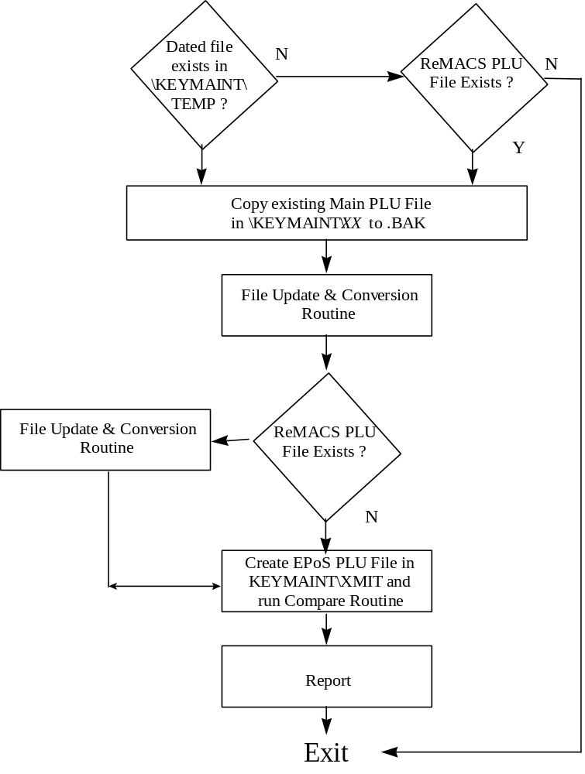

OmCom
The PC to 4602 update process is handled by OmCom, Omron’s communication application. OmCom will be initiated using the OMCOM.BAT process described in the Omron Polling Software Developer’s Manual. See the Communications section of this Design Specification for further details.

File Definition

This section details the file layouts of all files referenced in the previous section, ‘Technical Operation’, of this specification. The file definitions are listed as general (e.g. the main PLU file, and therefore independent EPoS terminal type), or EPoS specific (i.e. Omron, Counter Solutions, Checkout, etc.).

General

ReMACS PLU File
This file is output by ReMACS, and provides the base PLU information for the Keymap Maintenance Application. A ReMACS PLU file is produced by control centre number, and contains dates on which the PLU information becomes valid.

File Name: POScrXX.flt
where, POS denotes PLU update file
cr indicates the type of PLU table (i.e OM=Omron, CS=Counter Solns, etc.)
XX indicates the control centre
Directory: \ISS\POSUPDT
Format: ASCII
Record Length: 77 bytes

Field Description | Beginning Position | Field Length
Record Type* | 0 | 1
PLU Code | 1 | 15
Description | 16 | 25
Effective Date (YYMMDD) | 41 | 6
Serving Location** | 47 | 10
Meal Period | 57 | 10
Menu Item Price | 67 | 10
* Record Type (P = Price Update); In general, all records will have a ‘P’ record type.
** For Omron 4602/4603, this field indicates the Price Level.

Audit Trail
This file is used by the Keymap Maintenance Application to record all changes, along with dates and times. The record length will be variable, and dependent on the information stored.

File Name: KEYMAINT.AUD
Directory: \KEYMAINT
Format: ASCII Text
Record Length: Variable

Configuration File
This file contains the site configuration details (i.e. the control centres, terminal ids per control centre, descriptions, etc.). This file is configured at install time and maintained manually (i.e. using EDIT).

File Name: KEYMAINT.CFG
Directory: \KEYMAINT
Format: ASCII Text
Record Length: 38 bytes

Field Description | Beginning Position | Field Length
Control Centre | 0 | 2
Description | 2 | 15
Terminal ID | 17 | 2
Description | 19 | 15
Terminal Type* | 34 | 3
*Terminal Type = OMR (Omron)

Omron 4602/4603

Main PLU File
This file is maintained by the PLU File Update and Conversion Routine, and is used by the File Maintenance Application to maintain keymaps for the connected EPoS terminals. A Main PLU file is valid for all terminal ids within the control centre.

File Name: PLU99.XXX
where, 99 = the terminal id
XXX = the terminal type (i.e. OMR = Omron, etc.).
Directory: \KEYMAINT\XX
where, XX = the control centre
Format: ASCII
Record Length: 99 bytes

Field Description | Beginning Position | Field Length | Comments
Header | 0 | 8 | Zero Filled
PLU Code | 8 | 6
Status | 14 | 10 | Refer to PLU Status Table Definition Below
ReMACS Description | 24 | 25 | The description from the ReMACS PLU File
Keymap Descriptor | 49 | 12 | Input by user within Keymap Maintenance Application
Price Level 1 | 61 | 6
Price Level 2 | 67 | 6
Price Level 3 | 73 | 6
Price Level 4 | 79 | 6
Price Level 5 | 85 | 6
Price Level 6 | 91 | 6
Associated Dept | 97 | 2 | This field contains the Department No. (i.e. the key/window) to which the PLU belongs.

LOCALPLU File

This file is used by the KeyMap Maintenance Application to manage valid PLUs and pricing, and dated PLU information.
File Name: LOCALPLU.XXX
where, XXX = the terminal type (e.g. OMR=Omron)
Directory: \KEYMAINT\XX
where, XX = the control centre
Format: ASCII
Record Length: 101 bytes

Field Description | Beginning Position | Field Length | Comments
Header | 0 | 4 | Zero Filled
PLU Code | 4 | 6
Description | 10 | 25
Date | 35 | 6 | Date on which pricing becomes valid (YYMMDD)
Price Level 1
Price Level 2
Price Level 3
Price Level 4
Price Level 5
Price Level 6

Layout File

This file provides the KeyMap Maintenance Application with information concerning the EPoS terminal keyboard layout.

File Name: LAYOUT.XXX
where, XXX = the terminal type (e.g. OMR=Omron)
Directory: \KEYMAINT
Format: ASCII
Record Length: Variable

The first line of the file contains the basic information concerning the layout of the keyboard:
No. of keys ?????? No. of levels
The remainder of the file contains the layout of the keymap, and (in the case of the Omron 4602/4603 EPoS terminal) the department numbers of each key position.

Help File
This file contains the help text associated with each level of the KeyMap Maintenance Application. It is editable using any standard Windows edit application.

File Name: HELPFILE.XXX
where, XXX = the terminal type (e.g. OMR=Omron)
Directory: \KEYMAINT
Format: ASCII
Record Length: 80 bytes

Each line starts with a number (1 to 5) which identifies the section of the KeyMap Maintenance Application to which the text applies, i.e.
1 Help for Search Function
2 Help for Start Screen Search
3 Help for Start Screen
4 Help for Main Screen
5 Help for PLU Input Area,
followed by a space and the required text.
The text for each area should not exceed one screen of text.

Colours File

File Name: COLOURS
Directory: \KEYMAINT
Format: ASCII

This file is used by the KeyMap Maintenance Application to identify the colours required to display various fields within the application. The layout of the file is self-explanatory, and detailed within the text of the file itself. An example of this file is contained within the Appendices of this specification.

Omron PLU File
This file is transmitted to the EPoS terminal by OmCom. It is created by the File Update and Conversion Program from the data held within the Main PLU File (see above).

File Name: PLUcrXX.flt
where, cr = the terminal type (i.e. OM = Omron)
XX = the control centre
Directory: \KEYMAINT\XMIT\YYMMDD
where, YYMMDD = the transmission date
Format: ASCII
Record Length: 111 bytes

Field Description | Beginning Position | Field Length | Comments
Header | 0 | 8 | Zero Filled
PLU Code | 8 | 6
Status | 14 | 10 | Refer to PLU Status Table Definition Below
Keymap Descriptor | 24 | 12
2nd Line Descriptor | 36 | 12 | For Message PLUs Only (Not used in this application)
Price Level 1 | 48 | 6
Price Level 2 | 54 | 6
Price Level 3 | 60 | 6
Price Level 4 | 66 | 6
Price Level 5 | 72 | 6
Price Level 6 | 78 | 6
IOSM* Table 1 | 84 | 2 | Not Used in this application
IOSM* Table 2 | 86 | 2 | Not Used in this application
IOSM* Table 3 | 88 | 2 | Not Used in this application
IOSM* Table 4 | 90 | 2 | Not Used in this application
IOSM* Table 5 | 92 | 2 | Not Used in this application
IOSM* Table 6 | 94 | 2 | Not Used in this application
Associated Dept | 96 | 2 | This field contains the Department No. (i.e. the key/window) to which the PLU belongs.
Action* | 98 | 1 | Indicates to Omcom what action to take at terminal (see below).
Trailer | 99 | 10
CR/LF | 109 | 2 | Carriage Return/Line Feed to Complete Record
*IOSM = Inclusive Option Set Menu
*Action:
0,1 - Do not process.
2 - Create
3 - Delete
4 - Replace
5 - Price Change

Department File
This file is used by Omcom to update the keymap configuration. It is created by the Keymap Maintenance Application when a keymap is modified by a user.

File Name: KEYMAP99.XXX
where, 99 = the terminal id
XXX = the terminal type (i.e OMR = Omron)
Directory: \KEYMAINT\XX
where, XX = the control centre
Format: ASCII
Record Length: 59 bytes

Note: This file is the format of the Department File required for transmission to the EPoS terminal. When requested by the user as part of the Keymap Maintenance Application Exit routine, this file should be copied to \KEYMAINT\XMIT\YYMMDD\OSPcrXX.flt for onward transmission to the EPoS terminal.

Field Description | Beginning Position | Field Length | Comments
Header | 0 | 8 | Zero Filled
Department Number | 8 | 2 | Refers to a Key Position
Status | 10 | 8 | Refer to Department Status Table Definition Below
Active/Inactive | 18 | 2 | 00 = Active  80 = Inactivate the Department
Description | 20 | 8 | Description of Dept.
OSP Code 1 | 28 | 6 | For a ‘one-shot’ key, the PLU for Keyboard Level 1
OSP Code 2 | 34 | 6 | For a ‘one-shot’ key, the PLU for Keyboard Level 2
OSP Code 3 | 40 | 6 | For a ‘one-shot’ key, the PLU for Keyboard Level 3
Action | 46 | 1 | 0 = Hide (Do not process)  1 = Replace
Trailer | 47 | 10 | Zero Filled
CR-LF | 57 | 2

PLU Status Table
The PLU Status Table is part of the Omron specific PLU File (see above).

Digit | Part | Programming Item | Bit Selection | APL
1 |  | Preparation Area (0-8) | No Print : 0
2 |  | Kitchen printer single/double ticket | Double : 4  Single : 0
3 |  | PLU Type | Preparation : 4  Message : 2  SD : 1  Normal : 0
4 |  | PLU Type | Change Plate : 4  Set Menus : 2  Inclusive Option : 1
5 |  | VAT Applicable (Rate 1 - 3)  Rate 3  Rate 2  Rate 1 | : 3  : 2  : 1 or 0
6 | 2  3 | Change Plate Type  PLU | Side Order : 2  Add Portion : 0  Inactive : 1  Active : 0
7 | 1  2  3 | Preparation Required  Multiple Preparation Required  Allow in change plate option | Yes : 4 No : 0  Yes : 2 No : 0  Yes : 1 No : 0
8 |  | Always
9 | 1  2  3 | Applicable to Service Surcharge  Transmit in Previous Item to KP  Print Ticket | Yes : 4 No : 0  Yes : 2 No : 0  Yes : 0 No : 1
10 | 1  2  3 | Applicable to selective subtotal  discount  Force Compulsory Guest Check  Option  Allow as substitute in set menu | Yes : 4 No : 0  Yes : 2 No : 0  Yes : 1 No : 0
11 - 12 |  | Associated department code (0-99)  (not applicable for Preparation PLU)

Department Status Table
The Department Status Table is part of the Departments File (see above).

Digit | Part | Programming Item | Bit Selection | APL
1 |  | Department group number report (0-9) for group by Department report and Guest Check | : 0-9 | 0
2 |  | Closed Department | Closed : 1  Open : 0 | 1
3  4 |  | Highest Value Allowed (Note 1)  Trailing number of zeros  Most significant digit | : 0-6  : 0-9 | 4  1
5 |  | VAT applicable rate 1, 2 or 3  Rate 3  Rate 2  Rate 1 | : 3  : 2  : 1 or 0 | 1
6 |  | Hotel/SSD/Service Group | (0 - 3) | 0
7 | 1  2  3 | Selective subtotal discount applicable  Print format of guest check  Display pop-up menu (Note 2) | Yes : 4 No : 0  Group : 2  Own Line : 0  Yes : 1 No : 0 | 0
8 | 1  3 | Service Charge Applicable  Print Ticket | Yes : 4 No : 0  Yes : 1 No : 0

Note 1: The highest value allowed digits (3 and 4) are entered as in the following example
e.g. 50000 is entered as
digit 3 -> 4
digit 4 -> 5
Note 2: For the pop-up menu to be displayed, the department must be closed.

Communications

Omron (OmCom)
In general, the communications process to the terminals will be controlled by the ReMACS end-of-day process. Furthermore, the configuration of OmCom will be part of the hot-stage and installation process at each site.
However, the user may wish to initiate an immediate transfer of changes to connected terminal(s).
When this is necessary, configuration files (i.e. PLU File and Department File) for transmission to an Omron 4602/4603 terminal using OmCom are written to the \OMRON\OMRONXMT directory. The process is defined within the OmCom PI Developer’s Manual.
Note:
OmCom can only be configured to communicate with one control centre at any one time. Therefore, the communications process must include overwriting the OmCom configuration file, STORE.DAT with control centre specific STORE.DAT in \KEYMAINT\999 prior to initiating the OmCom transmission routine.

OMCOM.BAT
The OmCom Polling Software Developer’s Manual contains a sample OMCOM.BAT file and OC01.BAT file. However, whereas the OC01.BAT (a process that requests manual input) process works correctly, the OMCOM.BAT example does not.
The process should comprise the following:
CD \OMRON
DEL POST.DAT
DEL \OMRON\OMRONDAT\POST.DAT
COPY OMRONSEQ\Required_sequence.SEQ OMRONSEQ\LAST.SEQ
OC09A
OC01D
If reports are to be initiated (not required as part of the KeyMap Maintenance Application), OC041 and OC04A should be executed. If communications log is required, OC06A should be executed.
The programmer should be responsible for including error checking and handling within the batch process initiating the transfer process.

Flow Diagrams

This section provides several flow-diagrams showing the flow of different parts of the PLU Update and Conversion Routine, Communications process, etc. It is for information only, and does not represent the flow of all the programs and processes described within this specification, nor contain all the logic necessary to implement the applications.

Basic Flow of PLU Conversion and Update Process
This flow diagram shows the basic flow of the PLU Conversion and Update Process (OMRPLUCN.EXE). Note, this flow only relates to Omron, as these terminals do not have automatic dated price update capability.

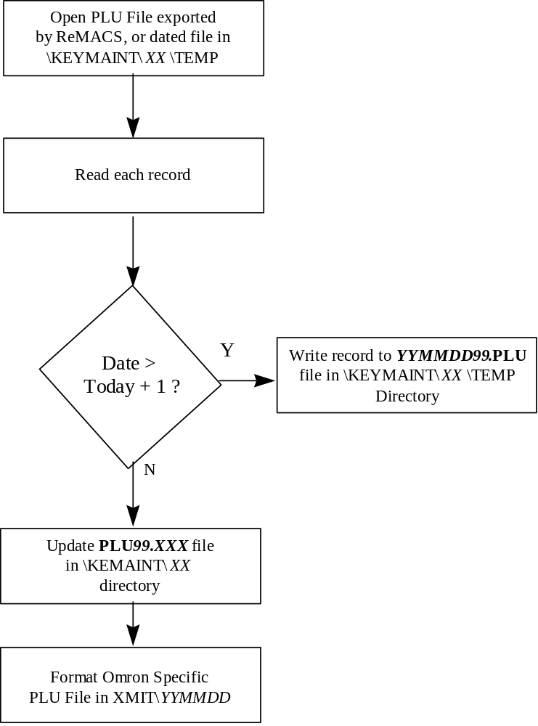

Appendices

Directory Structure
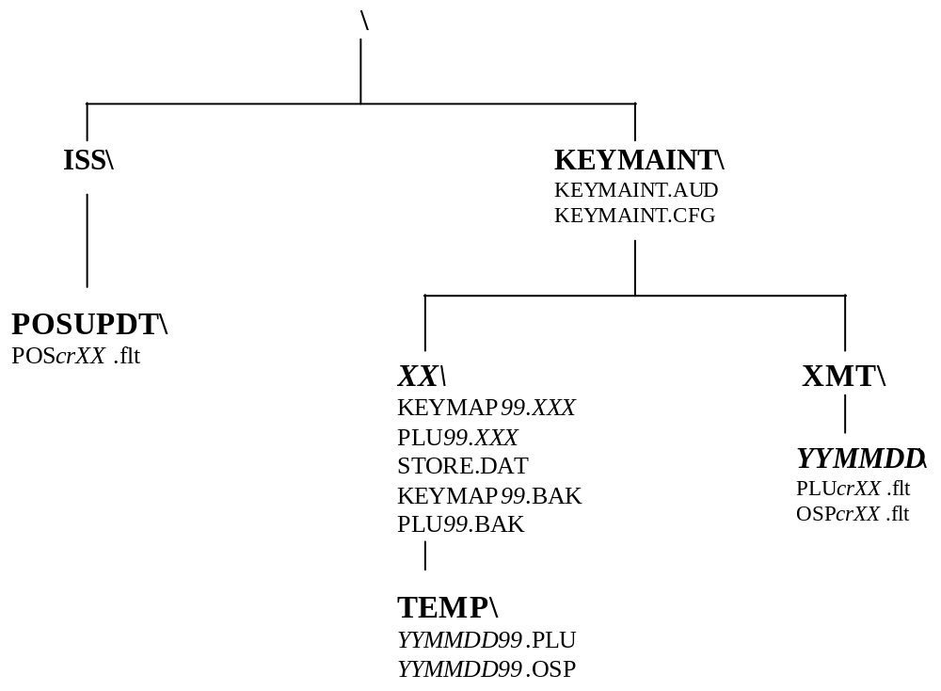

Example COLOURS File

; Enter a two digit hex value for each colour
; DO NOT change the order or ADD or DELETE any lines
; The first nybble is the background colour
; The second nybble is the forground colour
; The colours are:
; 0 Black
; 1 Blue
; 2 Green
; 3 Cyan
; 4 Red
; 5 Magenta
; 6 Orange
; 7 Light Grey
; 8 Dark Grey colours above 7 should not be used for background
; 9 Light Blue colour, if they are, they will flash
; A Light Green
; B Light Cyan
; C Light Red
; D Light Magenta
; E Yellow
; F White
;
61 ; flash attrib - x'ored with grid text colour for flashing key
06 ; grid colour
01 ; grid text colour
06 ; menu colour
01 ; menu text colour
06 ; title box colour
0E ; title plu colour
01 ; title background colour
0E ; title description colour
0A ; title kitchen print words colour
0A ; title kitchen print Y/N colour
01 ; status key colour
01 ; status text colour
00 ; status background colour
06 ; status box colour
0A ; flags colour
01 ; background colour
06 ; search box colour
01 ; search text colour
0E ; search plu colour
01 ; start screen title colour
06 ; start screen text colour
0E ; start screen input colour
01 ; start screen search list text colour
06 ; start screen search list box colour
61 ; start screen search list cursor colour x'ored with text colour
1E ; help border
1E ; help background
1E ; help text

