Building Electron using Windows VM and GIT Repository

**First time users: Follow all steps**

**Return users creating new electron app instance:** search “return users” and note # for order of steps. (i.e., return users #1)

**Git Repo for Electron/R/Shiny to fork to create new Project**

https://github.com/ColumbusCollaboratory/electron-quick-start

**Starting Windows 10 VM**

Windows 10, Chrome, Atom, NodeJS (current ), Python(v2.7) installed.

**Confirm latest NodeJS and NPM version**

node –version (v8.4.0)

npm –version (v5.3)

**Python System Environment Variable**

Updated Windows System Environment Variables to include C:\Python27

**Error MSBuild tools 2.0 running node-gyp for sqlite and node**

For node-gyp Install of npm windows-build-tools

npm install –global –production windows-build-tools

After install – right click and “Run as Administrator

**NPM 5.3 issue July/August 2017**

https://github.com/npm/npm/issues/17781

Had to back peddle on npm version 5.3; and downgrade to 5.2

npm i –g [npm@5.2](mailto:npm@5.2)

**Clone Git Repo (clone the new Project repo)** – return users #1

git clone https://github.com/ColumbusCollaboratory/electron-quick-start

git clone http.sslVerify=false [https://github.com/ColumbusCollaboratory/electron-quick-start]

(*sometimes required if certification issues with https)*

**Electron Shiny Application (library dependencies)** - return users #2

Run R.exe (from R-Portable) and determin if there are any package dependencies that are needed to be installed.

Install packages into R (R-Portable🡪 Bin ) on Windows.

add/commit the new library packages to the new project git repo

(If the library should be included in the original electron shiny repo, you can also add it to the original electron shiny repo by running install on a clone of it and committing/pushing the change; or by doing a pull request for the change from the fork to the original electron shiny repo)

**NPM Install** - return users #2

cd [git electron repo] (i.e., cd electron-quick-start)

npm install

**NPM Start (show it working)** - return users #3

npm start

**Electron Packager Install**

npm i –g electron-packager

clone – npm install and then run package

**Build Electron Windows Executable** - return users #4

npm run package-win

(NOTE::if you wish to change the Application Executable name you need to change that in the package.json package-win script command”)

**Share a directory with the Server Windows VM**

If you need to move files to and from the Windows VM you will need to share a drive. The following directions are how to do that with Microsoft Remote Desktop.

Select the RDP Desktop.

Click Edit

Select Redirection

Check “Enable Folder Redirection”

Click the + to add a new folder redirection.

Browse to the Folder you wish to map to the Windows VM.

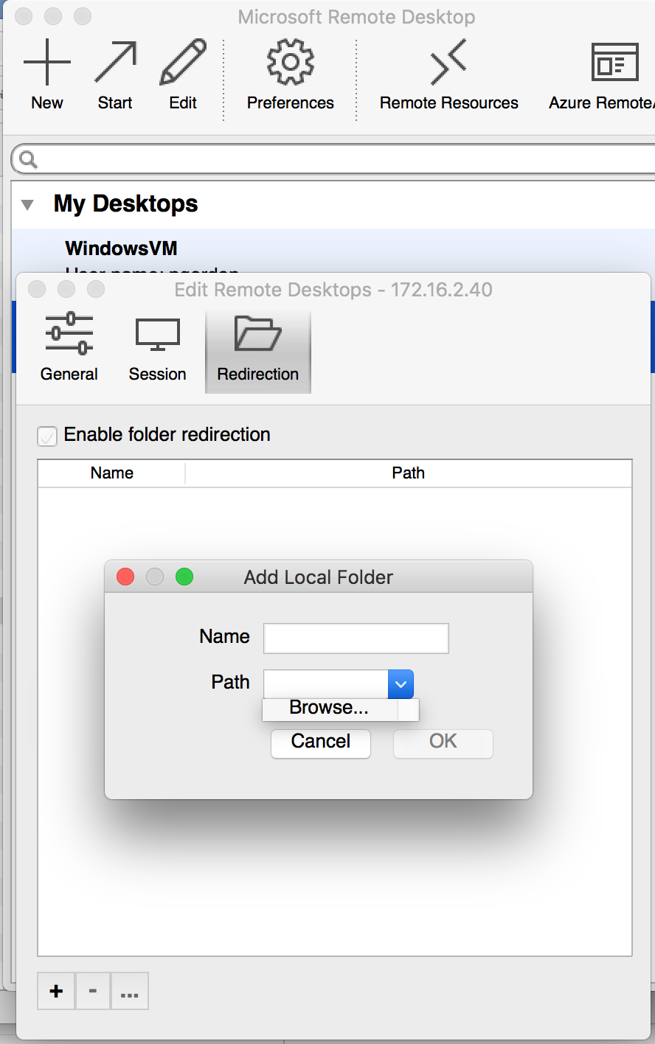

When you login to the Windows VM you should now see a Mapped Drive to the PC that is the directory for which you have created a folder redirection.