CSE 404 Car Price Deal Finder
Sections 5 & 6: Methodology and Initial Results (Daniel Helo)

5. Methodology

5.1 Preprocessing
After merging three data sources (Hugging Face, DVM-CAR, UCI), we removed the 201 UCI rows due to missing year, mileage, and model fields, yielding 276,627 listings with 9 features. Prices were clipped at the 1st and 99th percentiles ($699 to $89,990) to remove outliers. High-cardinality categoricals (make: 86 unique, model: 887 unique) were target-encoded (Micci-Barreca, 2001) to preserve price signal without dimensionality explosion. Low-cardinality categoricals (fuel_type, transmission) were one-hot encoded. Numerical features (year, engine_size, mileage) were z-score standardized. All encoding was fit on training data only. The dataset was split 70/15/15 into train (193,638), validation (41,494), and test (41,495) sets.

5.2 Models
Ridge Regression (Hoerl and Kennard, 1970) serves as our linear baseline, with alpha tuned via 5-fold cross-validation (optimal alpha = 0.02).
K-Nearest Neighbors predicts price as the distance-weighted mean of k nearest neighbors. Vaneesha et al. (2024) found KNN competitive with SVM for car pricing. We tuned k over [3, 30] with 3-fold CV on a 50K subsample (Figure 2).
Support Vector Regression was evaluated in linear (LinearSVR) and RBF-kernel variants. Both were trained on a 30K subsample due to O(n²) memory scaling.
TabNet (Arik and Pfister, 2021) is our complex neural network. It uses sequential sparse attention masks to select features at each decision step, qualifying as an attention-based architecture. [Mark: insert architecture params and training details here.]

5.3 Deal Scoring
We convert regression output to a deal score: (predicted - actual) / predicted. Listings exceeding a threshold tau are classified as deals.

6. Initial Results

6.1 Regression
KNN achieves the lowest MAE of $1,309 (13.5% of median price $9,699), explaining 97.1% of variance. Ridge captures only 82.2%, confirming strong non-linear structure in car pricing. SVR underperforms due to its 30K training subsample.
Table 1: Regression performance on held-out test set (n = 41,495)
Model | MAE ($) | RMSE ($) | R² | Note
KNN (k=10) | 1,309 | 2,512 | 0.971 | Best
Ridge | 3,876 | 6,180 | 0.822 | Baseline
LinearSVR | 4,271 | 6,821 | 0.784 | 30K sample
SVR (RBF) | 5,206 | 8,679 | 0.650 | 30K sample
TabNet* | 23,386 | -- | -- | 3 feats, 1K rows
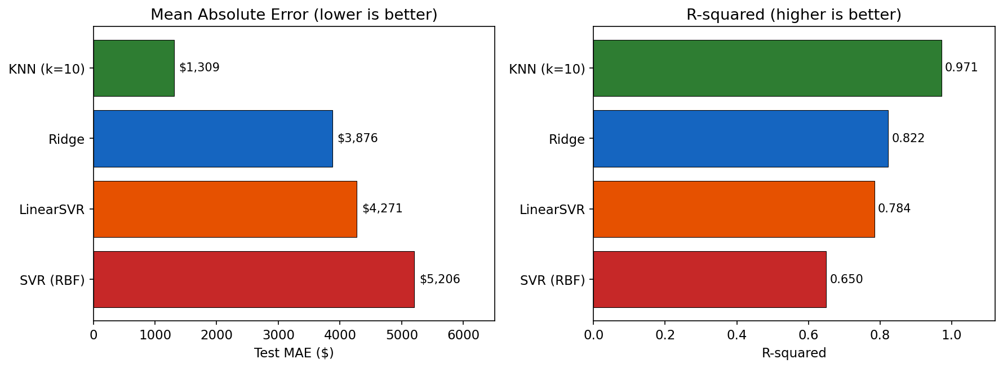
Figure 1: Model comparison on MAE and R-squared
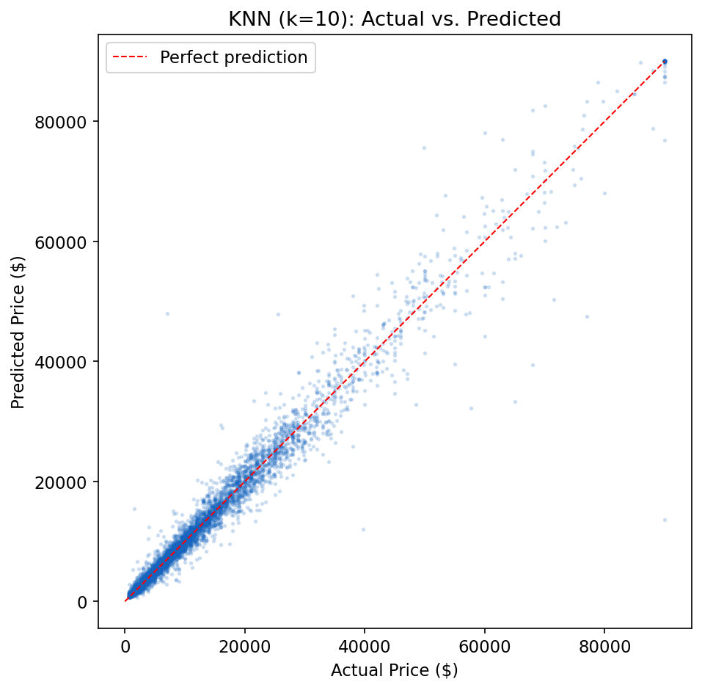
Figure 3: KNN actual vs. predicted price (5K sample)

6.2 Hyperparameter Sensitivity
Figure 2 shows how KNN validation MAE varies with k. The curve shows the classic bias-variance tradeoff: k=1 overfits (MAE=$1,798), performance peaks near k=5 (MAE=$1,588), then degrades as k increases (k=30, MAE=$1,829).
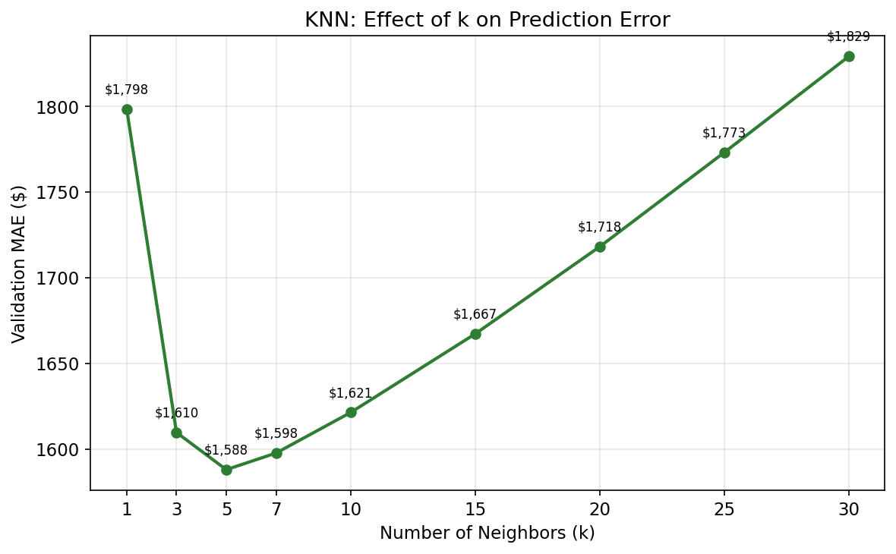
Figure 2: KNN hyperparameter tuning -- effect of k on validation MAE

6.3 Classification Metrics
We discretized prices into Low (<$5K), Mid ($5K-$15K), and High (>$15K) bins to compute required classification metrics.
Table 2: Classification metrics (price-bin, weighted average)
Model | Accuracy | Precision | Recall | F1
KNN (k=10) | 0.929 | 0.929 | 0.929 | 0.929
Ridge | 0.821 | 0.825 | 0.821 | 0.820
LinearSVR | 0.746 | 0.773 | 0.746 | 0.739
SVR (RBF) | 0.692 | 0.706 | 0.692 | 0.687

6.4 Error Analysis
Figure 4 shows KNN residuals are centered near zero. Error magnitude increases with predicted price, which is expected since higher-priced vehicles have more price variation.
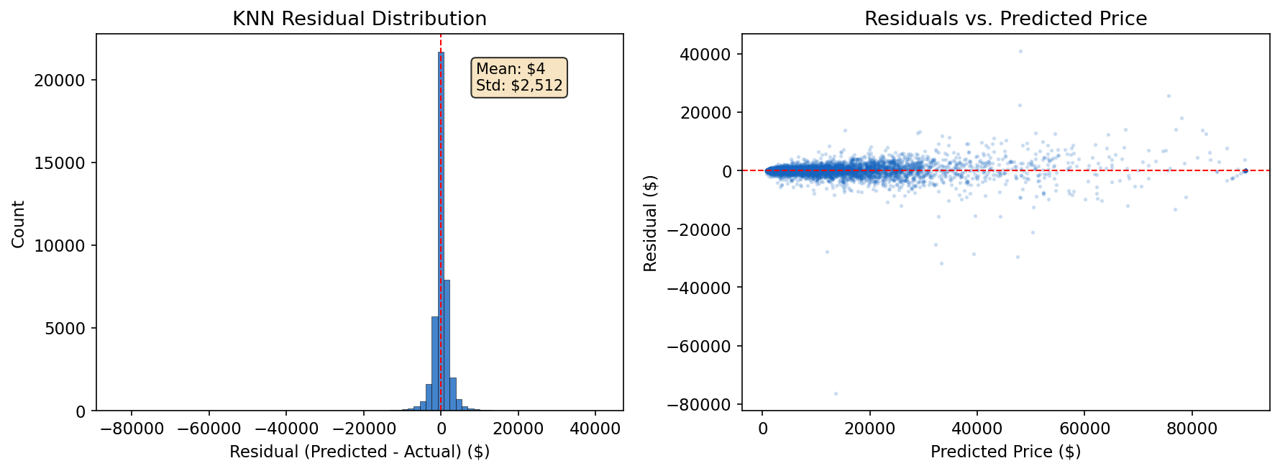
Figure 4: KNN residual distribution and residuals vs. predicted price

6.5 Deal Scoring
At tau = 0.20, KNN flags 8.4% of test listings (3,493 / 41,495) as deals with average savings of $2,309. The inverse relationship between threshold and volume suggests well-calibrated residuals.
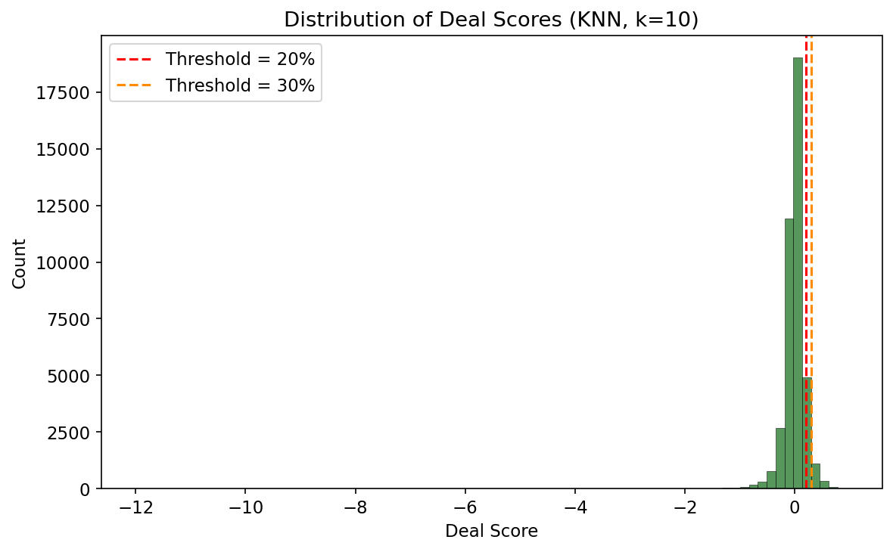
Figure 5: Deal score distribution with threshold markers

6.6 TabNet Training Dynamics
Figure 6 shows TabNet training loss plateaus after epoch 4, with validation MAE spiking after epoch 3, indicating overfitting on the limited 1K-row, 3-feature training set. Full-feature re-run pending.
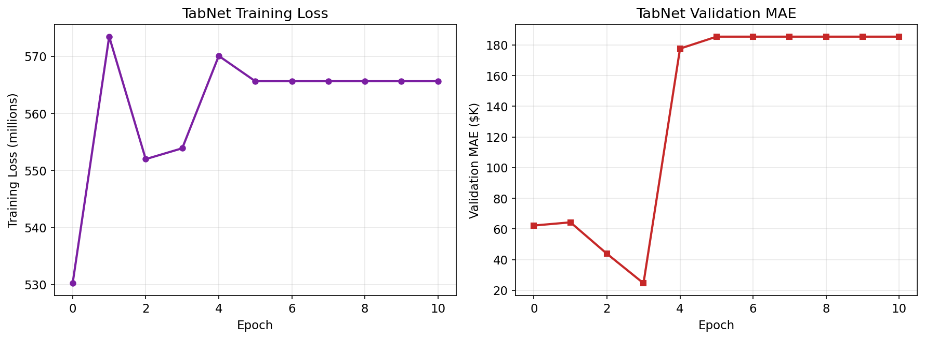
Figure 6: TabNet training loss and validation MAE (initial run)

6.7 Discussion
Feature engineering dominated model choice: adding target-encoded make/model reduced MAE 18x compared to TabNet's initial 3-feature run. KNN's strength is domain-specific, as car pricing is naturally clustered by make, model, year, and mileage.
NOTE FOR MARK ENDICOTT
Please write the TabNet methodology for Section 5.2 (under the TabNet paragraph). Include: (1) architecture details (n_steps, n_d, n_a, gamma), (2) training config, (3) updated results with full features. Frame TabNet as attention-based, not feedforward. Re-run with the target-encoded feature set from helodani_model_comparison.ipynb. Report same metrics (MAE/RMSE/R² + classification on Low/Mid/High bins). Cite: Arik and Pfister (2021), AAAI.

