

|  |  |
| --- | --- |
| Students name: | Zhangir Bayanov, Erasyl Usen, Beibarys Ussenov |
| Group name: | SE-2001 |
| Teacher name: | Zamira Bekish |
| Project name: | Online Book Store |
| Project type: | Group |
| Number of words | 623 |

**INTRODUCTION**

This site was created so that customers can buy books online and all this was convenient. What is meant when you hear convenient. the site was built to select a book by genre, by name, and by rating. Also, visitors to the site can select a book and highlight it . thus, save it to the trash. If you like the book very much, special cells are created. to leave a review. To be honest, the main goal was to help people with the choice of books and convenience.It is believed that a lot of people can not find a suitable online bookstore, and for this purpose the site was created.

**MAIN PART**

Methodology:

To build our website, a necessary number of programming languages were used, such as HTML,CSS,PHP,MySQL and JavaScript.

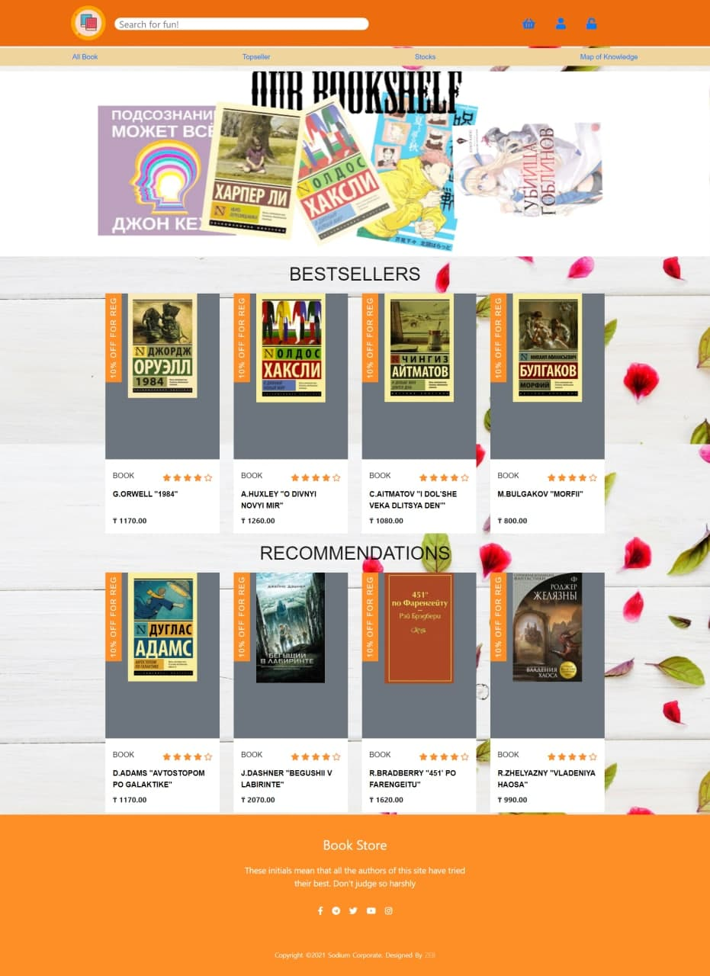

This site has over 40+ pages, 20+ functions with all this languages.

Features:

1. Authorization to our Site

In site you can sign up and then sign in. Cause we have really cool database system, by this system your data is always in our base.

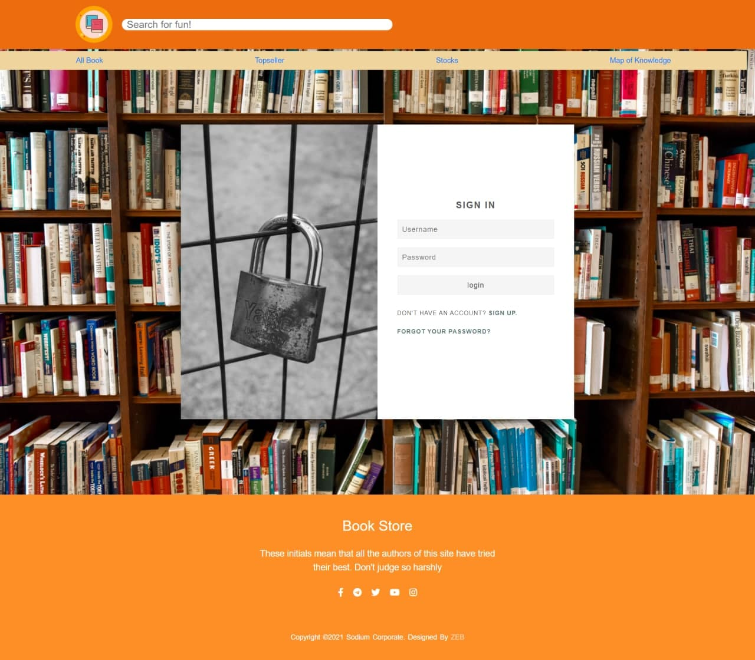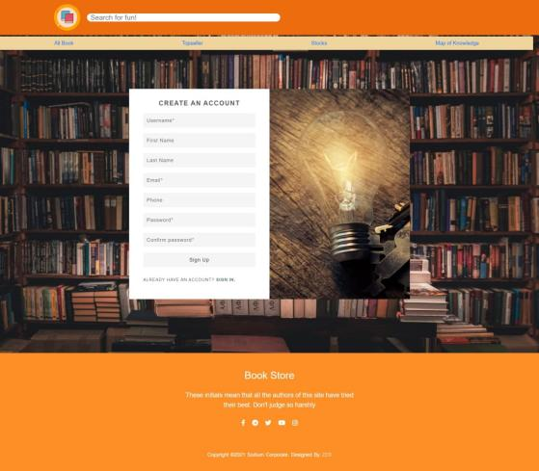

1. Recovering your password

Forgot your password? No problem we can solve it, by your email adress that you give us, when you recover your password we send you mail then you can easily recover it.

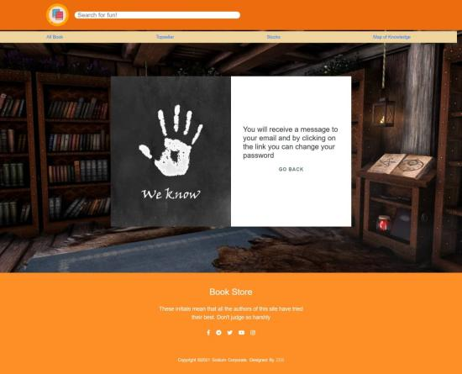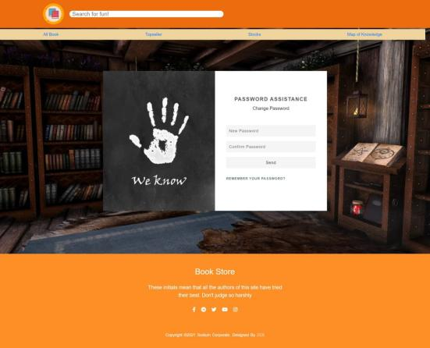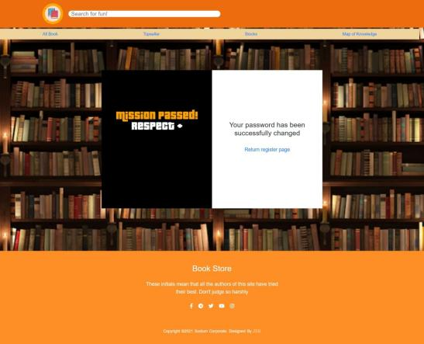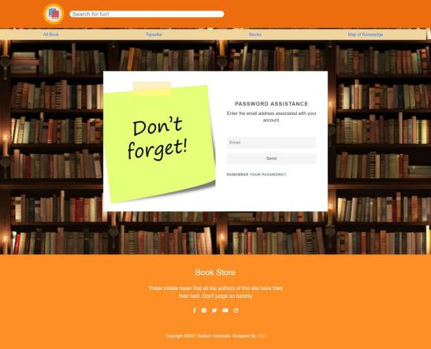

1. Map of Knowledge

We created an interesting function which allows the user to look at the world map and select any country, and in this turn the site shows the authors and books that were written in this country and the person.

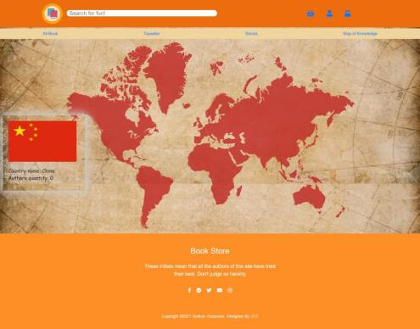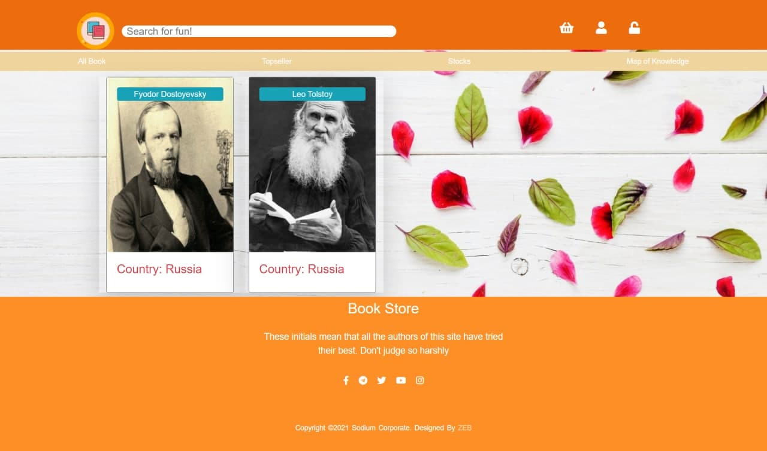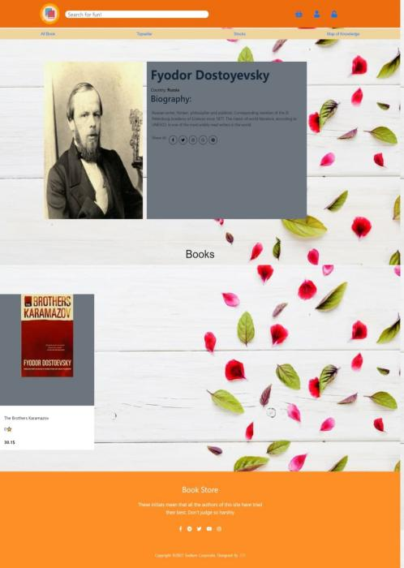

1. Basket

We have created a basket in which the customer can put any product that he liked and wants to buy. Thus, it makes it easier for users to search for their favorite product.

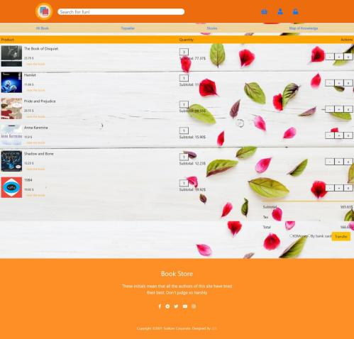

1. Transaction

Now, after a person has selected a product, he will be able to buy it on this site.

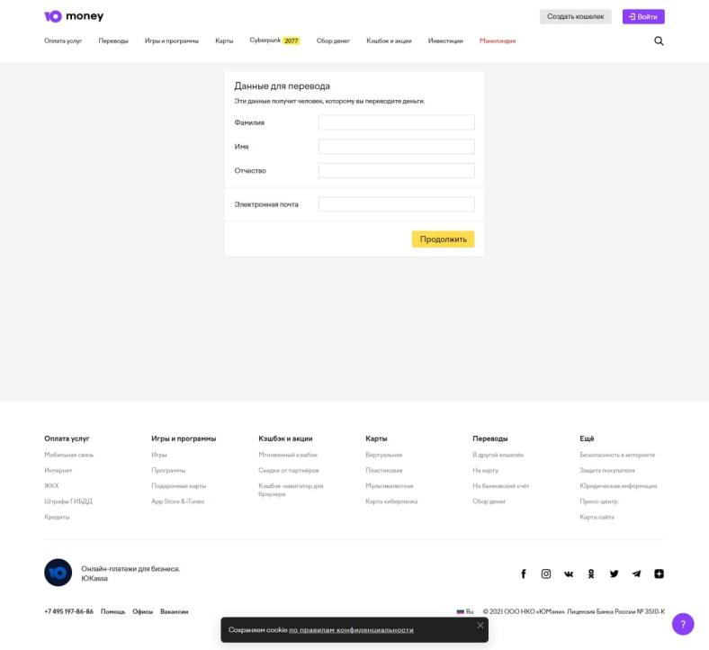

1. Giving a Review

You can also leave feedback on our website. People will have the opportunity to write about their book whether they liked it or not.

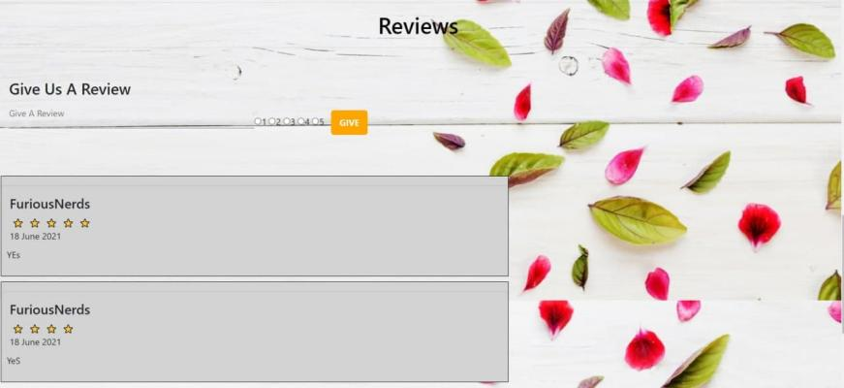

7.Adaptivity

We have done adaptive screen for some pages. To phone Users.



**DAILY PROGRESS**

|  |  |  |  |  |
| --- | --- | --- | --- | --- |
| Week | Tasks | Start date | End date | Responsible team member |
| 1 | Choose the topic | 05.04.2021 | 08.04.2021 | All |
| Write project description | 09.04.2021 | 11.04.2021 | Beibarys and Zhangir |
| Make a Gantt Chart | 09.04.2021 | 11.04.2021 | Yerasyl |
| 2 | Make a general website design | 12.04.2021 | 18.04.2021 | Beibarys and Zhangir |
| Watch tutorials for creating some functions | 12.04.2021 | 18.04.2021 | All |
| Draw ERD | 12.04.2021 | 18.04.2021 | Yerasyl |
| 3 | Create site main page | 19.04.2021 | 25.04.2021 | Beibarys |
| Make registration and authorization | 19.04.2021 | 25.04.2021 | Zhangir |
| Feel the database | 19.04.2021 | 02.04.2021 | Yerasyl |
| 4 |
| Create some functions for admin | 26.04.2021 | 02.04.2021 | Zhangir |
| Make some beautifull animations | 26.04.2021 | 02.05.2021 | Beibarys |
| Create sorting methods | 26.04.2021 | 02.05.2021 | Yerasyl |
| 5 | Start creating personal pages for books | 03.05.2021 | 09.05.2021 | Beibarys |
| Make a map | 03.05.2021 | 16.05.2021 | All |
| 6 |
| Create sections with recommendations | 10.05.2021 | 16.05.2021 | Yerasyl |
| 7 | Create cart | 17.05.2021 | 23.05.2021 | All |
| Creating a personal cabinet | 17.05.2021 | 30.05.2021 | All |
| 8 |
| Create a section with comments | 24.05.2021 | 30.05.2021 | Beibarys and Zhangir |
| 9 | Check and fix some problems | 31.05.2021 | 13.06.2021 | All |
| 10 |
| Prepare for the presentation of the project | 07.06.2021 | 13.06.2021 | All |

**CONCLUSION**

Our team have done a lot of work, and improved a team-working skills. Also all of the members learn how to create a normal, functional site. We have improved not only soft skills , also hard skills like, all members have developed own purposes. Zhangir - Back-End skills, Erasyl - DataBase skills and Beibarys - Front-End skills. This opportunity was good to us an we think that in the future we dedicate ourselves to this way.

**REFERENCES**

<https://fontawesome.com/>

<https://www.w3schools.com/>

<https://www.youtube.com/>

<https://getbootstrap.com/>