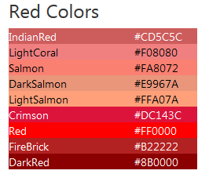
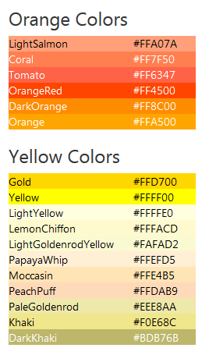
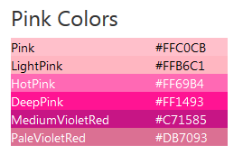
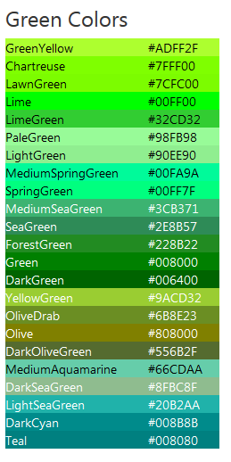
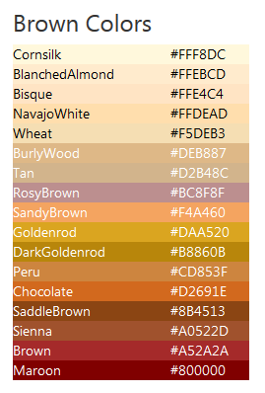
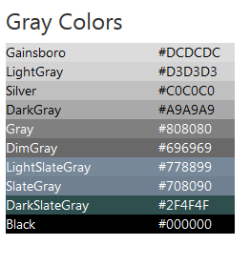
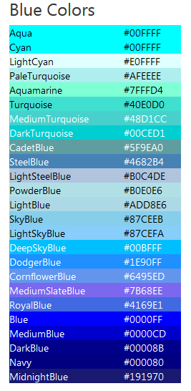
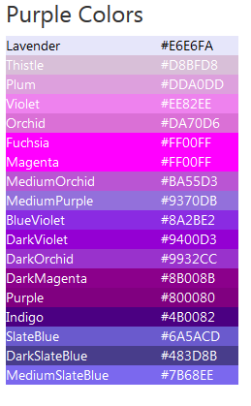

# To bring turtle graphics into your python code:
from turtle import*

# To set the colour of the background screen:
bgcolor('BurlyWood')

# To set the colour of the pen being used:
pencolor(‘IndianRed’)

# To set the colour inside the shape being drawn:
fillcolor(‘Cornsilk’)
begin_fill()
circle(80)
end_fill()

Turtle Graphics Colour Swatch

