Mark Gameng

HW10

# Part 1.1

**9.2.1)**

**a –** cos (theta) = (u * v) / (||u|| * ||v||)

A and B -> cos(theta) = **(3.06*2.68 + 500α*320α + 6β*4β) / (sqrt(3.06^2 + (500α)^2 + (6β)^2) * sqrt(2.68^2 + (320α)^2 + (4β)^2))**

A and C -> cos(theta) = **(3.06*2.92 + 500α*640α + 6β*6β) / (sqrt(3.06^2 + (500α)^2 + (6β)^2) * sqrt(2.92^2 + (640α)^2 + (6β)^2))**

B and C -> cos(theta) = **(2.68*2.92 + 320α*640α + 4β*6β) / (sqrt(2.68^2 + (320α)^2 + (4β)^2) * sqrt(2.92^2 + (640α)^2 + (6β)^2))**

**b –** α = β = 1, theta = arccos(cos(theta)

A and B -> theta = arccos((3.06*2.68 + 500*320 + 6*4) / (sqrt(3.06^2 + (500)^2 + (6)^2) * sqrt(2.68^2 + (320)^2 + (4)^2))) = **0.132 degrees**

A and C -> theta = arccos((3.06*2.92 + 500*640 + 6*6) / (sqrt(3.06^2 + (500)^2 + (6)^2) * sqrt(2.92^2 + (640)^2 + (6)^2))) = **0.175 degrees**

B and C -> theta = arccos((2.68*2.92 + 320*640 + 4*6) / (sqrt(2.68^2 + (320)^2 + (4)^2) * sqrt(2.92^2 + (640)^2 + (6)^2))) = **0.282 degrees**

**c –** α = 0.01, β = 0.5

A and B -> theta = arccos((3.06*2.68 + 500*0.01*320*0.01 + 6*0.5*4*0.5) / (sqrt(3.06^2 + (500*0.01)^2 + (6*0.5)^2) * sqrt(2.68^2 + (320*0.01)^2 + (4*0.5)^2))) = **7.743 degrees**

A and C -> theta = arccos((3.06*2.92 + 500*0.01*640*0.01 + 6*0.5*6*0.5) / (sqrt(3.06^2 + (500*0.01)^2 + (6*0.5)^2) * sqrt(2.92^2 + (640*0.01)^2 + (6*0.5)^2))) = **7.452 degrees**

B and C -> theta = arccos((2.68*2.92 + 320*0.01*640*0.01 + 4*0.5*6*0.5) / (sqrt(2.68^2 + (320*0.01)^2 + (4*0.5)^2) * sqrt(2.92^2 + (640*0.01)^2 + (6*0.5)^2))) = **14.26 degrees**

**d -** α = 1/486, β = 1/5.33

A = [3.06, 500 * 1/486, 6 * 1/5.33] = [3.06, 1.028, 1.125]

B = [2.68, 0.658, 0.75]

C = [2.92, 1.316, 1.125]

A and B -> theta = arccos((3.06*2.68 + 1.028*0.658 + 1.125*0.75) / (sqrt(3.06^2 + (1.028)^2 + (1.125)^2) * sqrt(2.68^2 + (0.658)^2 + (0.75)^2))) = **6.072 degrees**

A and C -> theta = arccos((3.06*2.92 +1.028*1.316 + 1.125*1.125) / (sqrt(3.06^2 + (1.028)^2 + (1.125)^2) * sqrt(2.92^2 + (1.316)^2 + (1.125)^2))) = **5.373 degrees**

B and C -> theta = arccos((2.68*2.92 + 0.658*1.316 + 0.75*1.125) / (sqrt(2.68^2 + (0.658)^2 + (0.75)^2) * sqrt(2.92^2 + (1.316)^2 + (1.125)^2))) = **10.82 degrees**

**9.2.3)**

**a –** A: 4, B: 2, C: 5

Avg = 11/3 -> norm = comp - avg

Normalized: **A: 0.33, B: -1.66, C: 1.33**

**b –** I assume since it normalized the ratings, the components should be normalized as well:

|  |  |  |  |
| --- | --- | --- | --- |
| Feature | A | B | C |
| Processor Speed | 0.17 | -0.21 | 0.03 |
| Disk Size | 14 | -166 | 154 |
| Main-Memory Size | 0.67 | -1.33 | 0.67 |

User Profile:

Processor Speed: (0.33 * 0.17 + -1.66 * -0.21 + 1.33 * 0.03) / 3 = **0.1482**

Disk Size: (0.33 * 14 + -1.66 * -166 + 1.33 * 153) / 3 = **161.223**

Memory-Size: (0.33 * 0.67 + -1.66 * -1.33 + 1.33 * 0.67) / 3 = **1.106**

# Part 1.2

**5.1.1)**

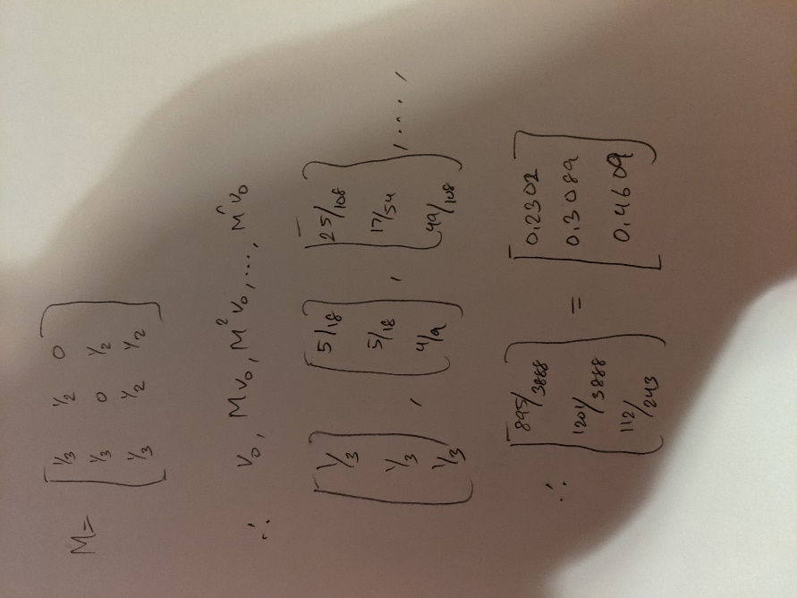  
**PageRank of A, B, C are 0.2302, 0.3089, and 0.4609 respectively**

**5.1.2)**

**PageRank of A, B, C are 0.2608, 0.307, and 0.4322 respectively.**  
  
  
  
  
  
  
  
  
  
  
  
  
  
  
  
  
  
  
  
  
  
  
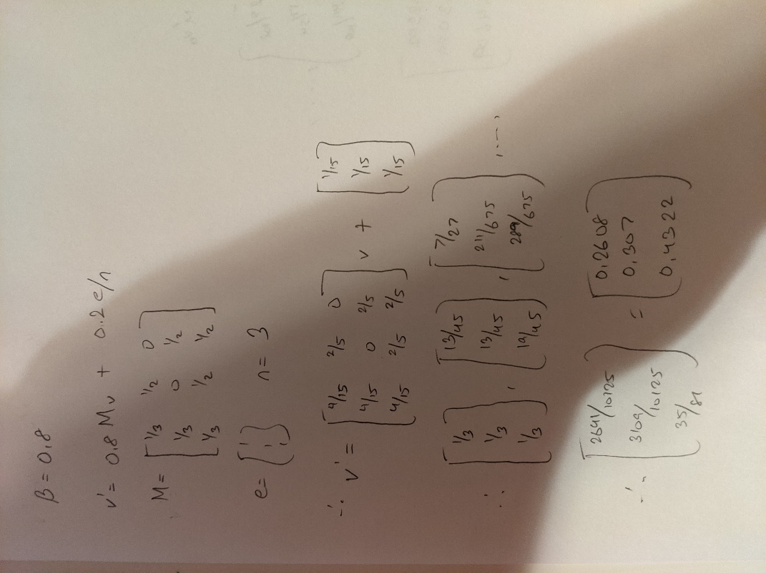

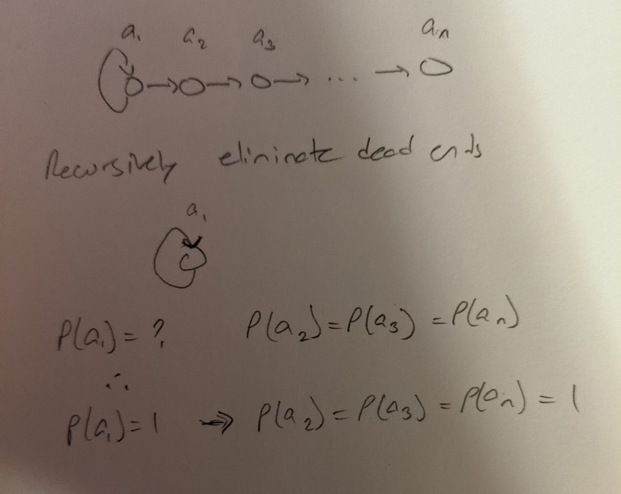**5.1.6)**

**The PageRank for each node would be 1.**

**Part 1.3**

**a)** Normalized degree centralityFor graph a:

Node 1: **1/4**

Node 2: **3/4**

Node 3: **2/4**

Node 4: **4/(5-1) = 4/4 = 1**

Node 5: **2/4**

For graph b:

Node 1: **2/4**

Node 2: **3/4**

Node 3: **2/4**

Node 4: **2/4**

Node 5: **3/4**

**b)** Normalized closeness centrality

Graph a:

Node 1: **4/(1+2+2+2) = 4/7**

Node 2: **4/(1+1+1+2) = 4/5**

Node 3: **4/(1+1+2+2) = 4/6**

Node 4: **4/(1+1+1+1) = 4/4 = 1**

Node 5: **4/(1+1+2+2) = 4/6**

Graph b:

Node 1: **4/(1+1+2+2) = 4/6**

Node 2: **4/(1+1+1+2) = 4/5**

Node 3: **4/(1+1+2+2) = 4/6**

Node 4: **4/(1+1+2+2) = 4/6**

Node 5: **4/(1+1+1+2) = 4/5**

**c)** Normalized betweenness centrality

Graph a:

Node 1: **No shortest path go through node 1, thus: 0*2(undirected) / (2 * (4 choose 2) = 0/12 = 0**

Node 2: **(1)*2/12 = 2/12**

Node 3: **0/12**

Node 4: **(3+1)*2/12 = 8/12**

Node 5: **0/12**

Graph b:

Node 1: **(1)*2/12 = 2/12**

Node 2: **(1+1)*2/12 = 4/12**

Node 3: **0/12**

Node 4: **(1)*2/12 = 2/12**

Node 5: **(2)*2/12 = 4/12**