Mark Gameng

CS 422 – HW 3

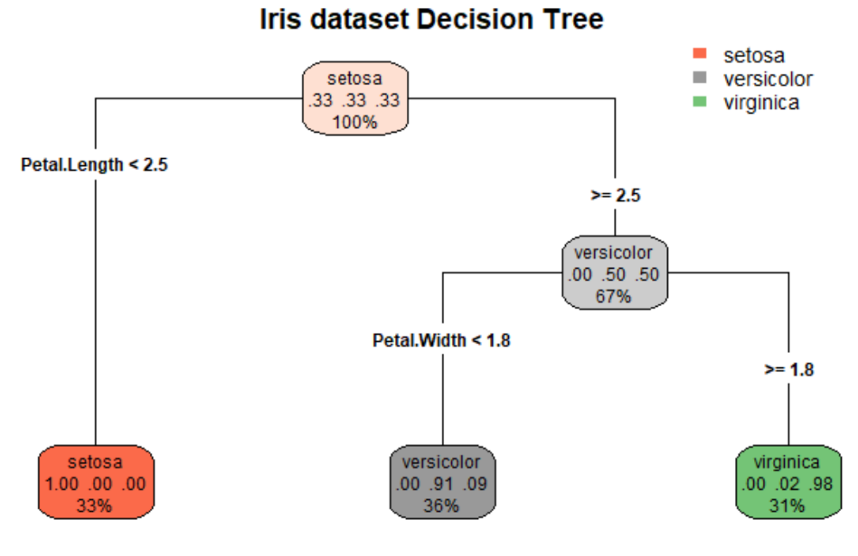

**Part 1.1**

1. **There are 3 levels in the decision tree**
2. **Level 1, Vertex 1: Default class label is setosa**

**Level 2, Vertex 1: Default class label is setosa**

**Level 2, Vertex 2: Default class label is versicolor**

**Level 3, Vertex 1: Default class label is versicolor**

**Level 3, Vertex 2: Default class label is virginica**

1. **Level 1: split on attribute: Petal length**

**< 2.5 left subtree (setosa), >= 2.5 right subtree (versicolor)**

**Level 2: split on attribute: Petal width**

**< 1.8 left subtree (versicolor), >= 1.8 right subtree (virginica)**

1. **The three numbers signify the predicted probability of each class in the order of setosa, versicolor, virginica. For example, versicolor at level 2, the numbers are (.00, .5, .5) which means its 50% chance of versicolor or virginica. The last line signifies the percent of observations in the node.**