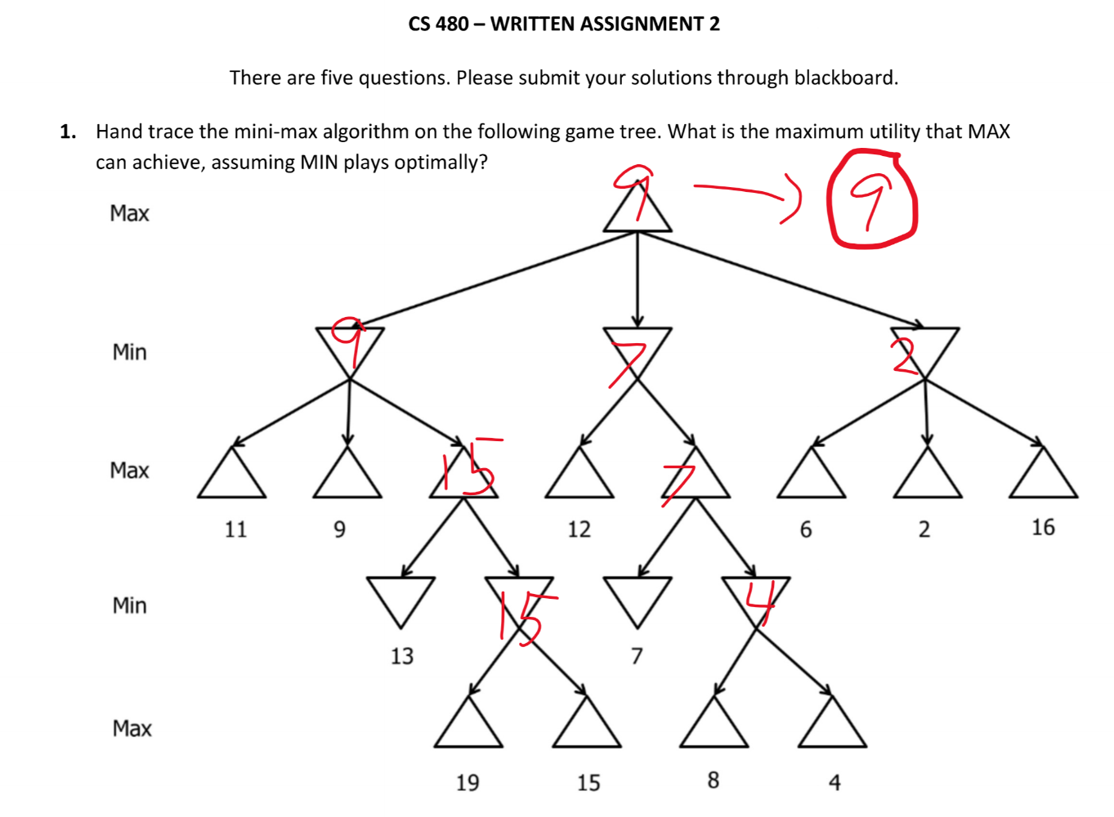

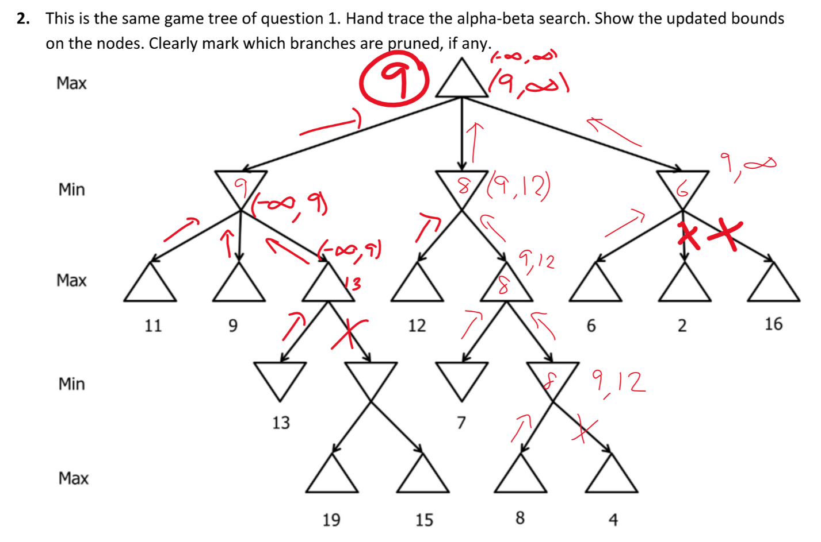

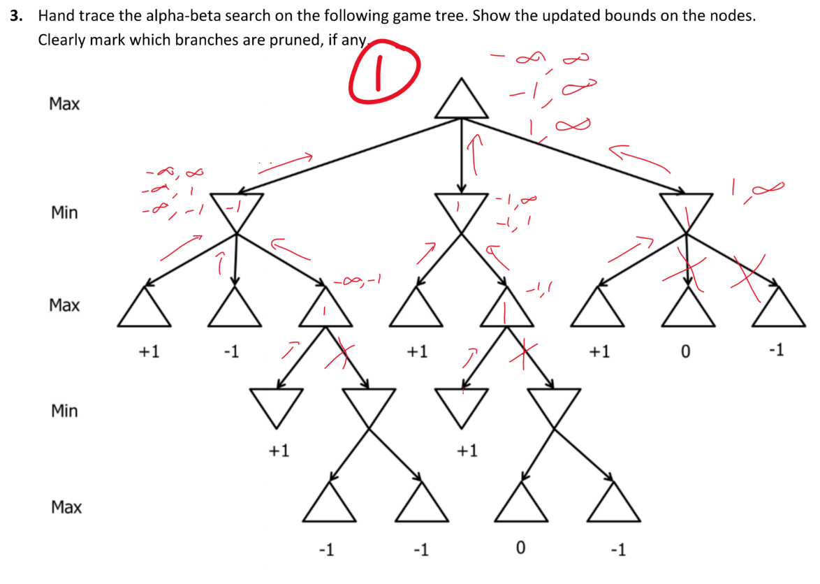

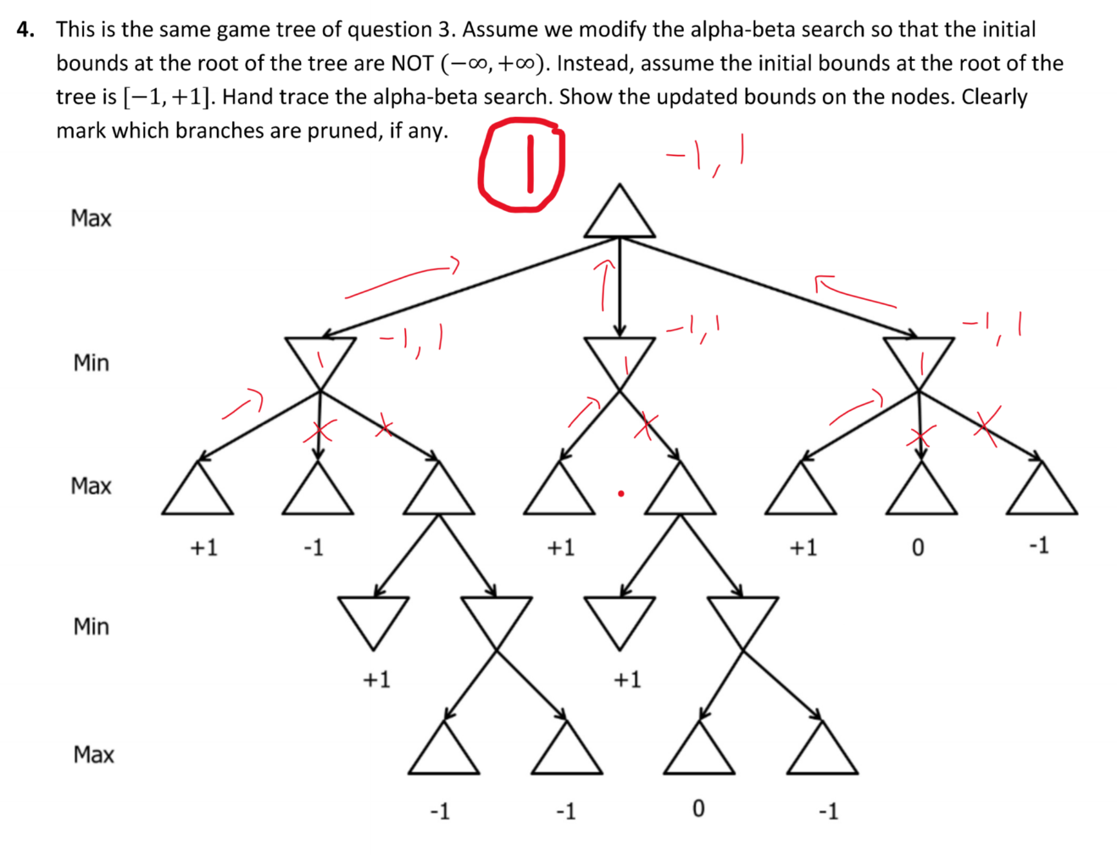

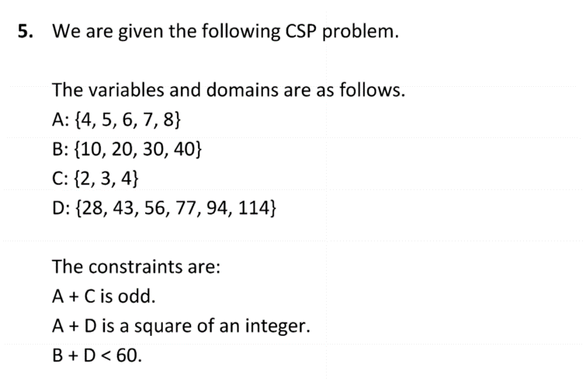

|  |  |  |  |  |
| --- | --- | --- | --- | --- |
|  | C = 2 | A = 5 | A = 7 | D = 114 |
| A: {4,5,6,7,8} | A: {5,7} | A: 5 | A: 7 | A: 7 |
| B: {10,20,30,40} | B: {10, 20, 30, 40} | B: {10,20,30,40} | B: {10,20,30,40} | B: **None - backtrack** |
| C: {2,3,4} | C: 2 | C: 2 | C: 2 | C: 2 |
| D: {28,43,56,77,94,114} | D: {28,43,56,77,94,114} | D: **None - backtrack** | D: {114} | D: 114 |

|  |  |  |  |  |
| --- | --- | --- | --- | --- |
|  | C = 3 | A = 4 | D = 77 | A = 6 |
| A: {4,5,6,7,8} | A: {4, 6, 8} | A: 4 | A: 4 | A: 6 |
| B: {10,20,30,40} | B: {10, 20, 30, 40} | B: {10,20,30,40} | B: **None - backtrack** | B: {10,20,30,40} |
| C: {2,3,4} | C: 3 | C: 3 | C: 3 | C: 3 |
| D: {28,43,56,77,94,114} | D: {28,43,56,77,94,114} | D: {77} | D: 77 | D: {43,94} |

|  |  |  |
| --- | --- | --- |
|  | D = 43 | B = 10 |
| A: {4,5,6,7,8} | A: 6 | **A: 6** |
| B: {10,20,30,40} | B: {10} | **B: 10** |
| C: {2,3,4} | C: 3 | **C: 3** |
| D: {28,43,56,77,94,114} | D: 43 | **D: 43** |

**Next page**



**Answer is A = 6, B = 10, C = 3, D = 43.   
A + C -> 6 + 3 = 9 – odd – satisfied  
A + D -> 6 + 43 = 49 – square of an integer – satisfied  
B + D -> 10 + 43 = 53 – less than 60 - satisfied**