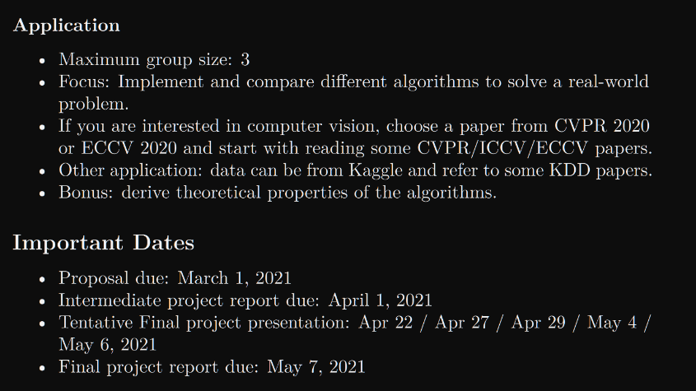

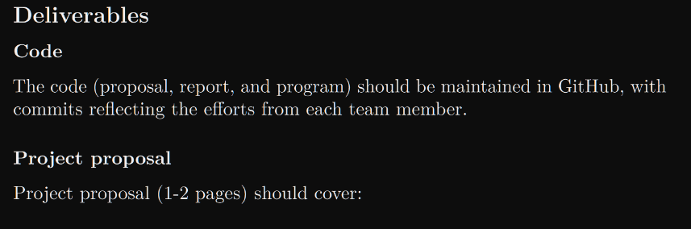

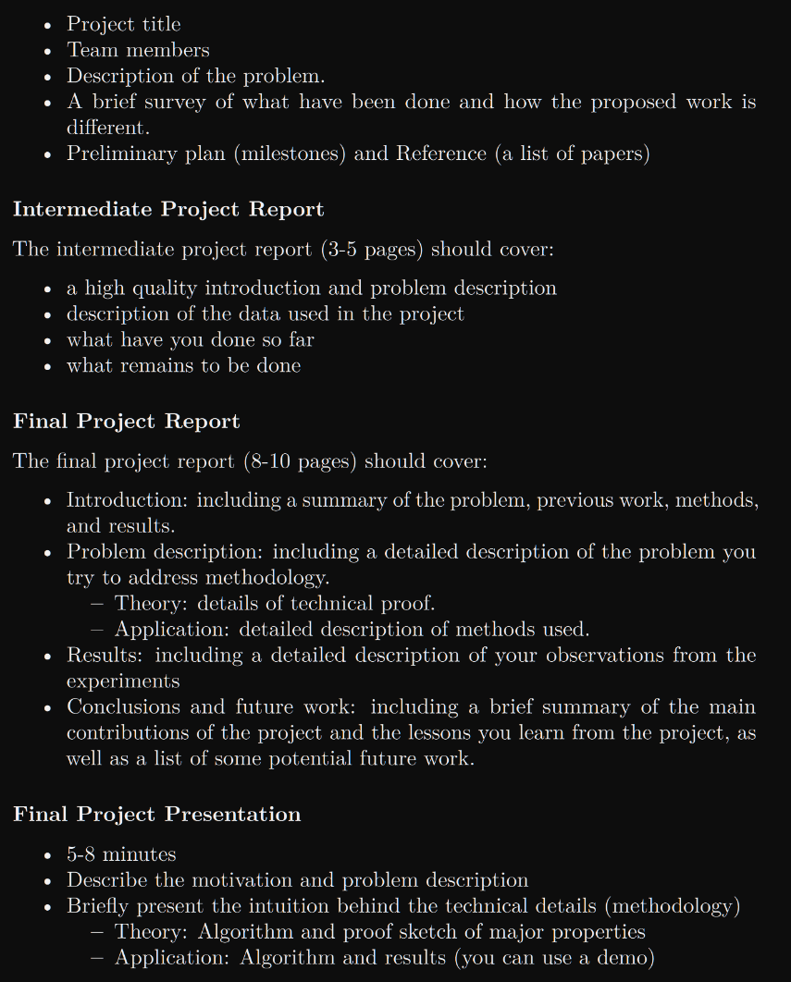

Music Genre classification:

<http://cs229.stanford.edu/proj2019spr/report/3.pdf>

<http://cs229.stanford.edu/proj2018/report/19.pdf>

<http://cs229.stanford.edu/proj2018/report/20.pdf>

<http://cs229.stanford.edu/proj2018/report/21.pdf>

<http://cs229.stanford.edu/proj2017/final-reports/5244969.pdf>

<http://cs229.stanford.edu/proj2017/final-reports/5242682.pdf>

<http://cs229.stanford.edu/proj2017/final-reports/5242092.pdf>

<http://cs229.stanford.edu/proj2017/final-reports/5241796.pdf>

<http://cs229.stanford.edu/proj2016/report/IrvinChartockHollander-RecurrentNeuralNetworkswithAttentionforGenreClassification-report.pdf>

search google scholar for more papers

<https://github.com/Hguimaraes/gtzan.keras>