THE TELETUBBIE EQUATION
By Mark Lagodych, github.com/MarkLagodych, made in 2020
A*B = $A∙B$ A**B = $A^{B}$ abs(A) = $\left|A\right|$
$(abs((441/400 * (x-210)**2 + (y-210)**2)-44100))$
$* (abs((49/64 * (x-210)**2 + (y-20)**2)-49))$
$* (abs(y-35+abs(35-y)) + abs((x-210)**2 + (y-21)**2-225))$
$* (abs(35-y+abs(y-35))+abs(y-40+abs(40-y)) + abs(x-205))$
$* (abs(35-y+abs(y-35))+abs(y-40+abs(40-y)) + abs(x-215))$
$* (abs(y-70+abs(70-y)) + abs((9/25 * (x-210)**2 + (y-70)**2)-900))$
$* (abs(x-160+abs(160-x)) + abs((25 * (x-165)**2 + (y-95)**2)-1225))$
$* (abs(260-x+abs(x-260)) + abs((25 * (x-255)**2 + (y-95)**2)-1225))$
$* (abs(120-y+abs(y-120)) + abs((1 * (x-210)**2 + (y-97)**2)-3025))$
$* (abs(y-80+abs(80-y)) + abs((25/64 * (x-210)**2 + (y-80)**2)-625))$
$* (abs(80-y+abs(y-80))+abs(y-110+abs(110-y)) + abs(x-170))$
$* (abs(80-y+abs(y-80))+abs(y-110+abs(110-y)) + abs(x-250))$
$* (abs(110-y+abs(y-110)) + abs((9/16 * (x-210)**2 + (y-110)**2)-900))$
$* (abs(125-y+abs(y-125)) + abs((1/9 * (x-210)**2 + (y-125)**2)-25$
$+ abs(25-(1/9 * (x-210)**2 + (y-125)**2))))$
$* (abs((25/36 * (x-190)**2 + (y-100)**2)-25+abs(25-(25/36 * (x-190)**2$
$+ (y-100)**2))))$
$* (abs((25/36 * (x-230)**2 + (y-100)**2)-25+abs(25-(25/36 * (x-230)**2$
$+ (y-100)**2))))$
$* (abs(182-x+abs(x-182))+abs(x-198+abs(198-x))+abs(y-(3/64*(x-190)**2+90)))$
$* (abs(222-x+abs(x-222))+abs(x-238+abs(238-x))+abs(y-(3/64*(x-230)**2+90)))$
$* (abs(x-150+abs(150-x)) + abs((9 * (x-150)**2 + (y-95)**2)-900))$
$* (abs(150-x+abs(x-150))+abs(x-158+abs(158-x)) + abs(y-(15/8*x-216.25)))$
$* (abs(150-x+abs(x-150))+abs(x-160+abs(160-x)) + abs(y-125))$
$* (abs(145-x+abs(x-145)) + abs((9 * (x-139)**2 + (y-95)**2)-900))$
$* (abs(270-x+abs(x-270)) + abs((9 * (x-270)**2 + (y-95)**2)-900))$
$* (abs(262-x+abs(x-262))+abs(x-270+abs(270-x)) + abs(y-(-15/8*x+571.25)))$
$* (abs(260-x+abs(x-260))+abs(x-270+abs(270-x)) + abs(y-125))$
$* (abs(x-275+abs(275-x)) + abs((9 * (x-281)**2 + (y-95)**2)-900))$
$* (abs(270-x+abs(x-270)) + abs((64/9 * (x-255)**2 + (y-270)**2)-6400))$
$* (abs(x-150+abs(150-x)) + abs((64/9 * (x-165)**2 + (y-270)**2)-6400))$
$* (abs(160-x+abs(x-160))+abs(x-260+abs(260-x)) + abs(y-220))$
$* (abs(160-x+abs(x-160))+abs(x-260+abs(260-x)) + abs(y-270))$
$* (abs(220-y+abs(y-220))+abs(y-270+abs(270-y)) + abs(x-160))$
$* (abs(220-y+abs(y-220))+abs(y-270+abs(270-y)) + abs(x-260))$
$* (abs(190-x+abs(x-190))+abs(x-230+abs(230-x))+abs(y-(1/8*(x-210)**2+340)))$
$* (abs(390-y+abs(y-390)) + abs((0.25 * (x-170)**2 + (y-390)**2)-100))$
$* (abs(150-x+abs(x-150)) + abs((25 * (x-146)**2 + (y-355)**2)-625))$
$* (abs(x-150+abs(150-x)) + abs((25 * (x-150)**2 + (y-380)**2)-100))$
$* (abs(390-y+abs(y-390)) + abs((0.25 * (x-250)**2 + (y-390)**2)-100))$
$* (abs(x-270+abs(270-x)) + abs((25 * (x-274)**2 + (y-355)**2)-625))$
$* (abs(270-x+abs(x-270)) + abs((25 * (x-270)**2 + (y-380)**2)-100))$
$* (abs(250-x+abs(x-250))+abs(x-380+abs(380-x)) + abs(y-(6/13*x+320/13)))$
$* (abs(260-x+abs(x-260))+abs(x-370+abs(370-x)) + abs(y-(7/22*x+1235/11)))$
$* (abs(380-x+abs(x-380)) + abs((9/16 * (x-380)**2 + (y-215)**2)-225))$
$* (abs(370-x+abs(x-370))+abs(x-380+abs(380-x)) + abs(y-230))$
$* (abs(40-x+abs(x-40))+abs(x-170+abs(170-x)) + abs(y-(-6/13*x+2840/13)))$
$* (abs(50-x+abs(x-50))+abs(x-160+abs(160-x)) + abs(y-(-7/22*x+2705/11)))$
$* (abs(x-40+abs(40-x)) + abs((9/16 * (x-40)**2 + (y-215)**2)-225))$
$* \left(abs\left(40-x+abs\left(x-40\right)\right)+abs\left(x-50+abs\left(50-x\right)\right)+ abs\left(y-230\right)\right)$
$= 0$

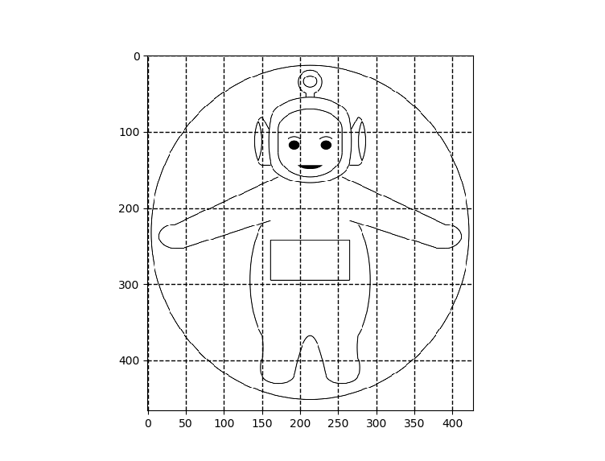
GRAPH

