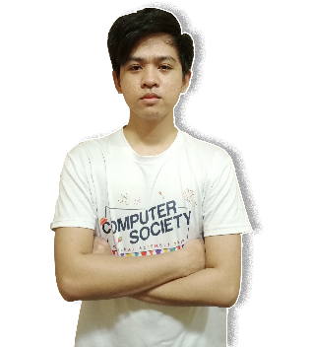Wendell Chan Suazo

Calamba City, Laguna

wendellchansuazo11@gmail.com

09959768531

Linked in: [**linkedin.com/in/wendell-suazo-8339251aa**](https://www.linkedin.com/in/wendell-suazo-8339251aa/)

Portfolio: [**https://wendell-suazo.netlify.app/**](https://wendell-suazo.netlify.app/)

Github: [**https://github.com/wendell1101**](https://github.com/wendell1101)

**Summary**

I am an aspiring Full Stack web developer. I've been practicing and honing my skills in different programming languages such as javascript and php. As well as different web frameworks like Laravel and Vue Js or sometimes React JS. I am trying to dive as deep as I can to these web technologies to use its full potential. I can do frontend and backend to develop different applications for both professional and personal use. I invest most of my time in programming because I really want to reach my goal which is to get a job as a Full Stack Web Developer or a Software Engineer.

**Experience**

I have no actual working experience yet but I guarantee that I’ve got the skills and dedication.

**Education**

* Logo for Polytechnic University of the Philippines

**Polytechnic University of the Philippines**

Bachelor of Science in Information Technology

2018 – 2022 (Third Year College)

* **STI College Calamba**

IT and Mobile App Development, Information Technology

2016 – 2018

Graduated senior high school in STI College Calamba with Technical Vocational strand specializing in IT and Mobile App Development

* **Majada In Integrated School**

2012 – 2016

Junior High School

* **Majada In Elementary School**

2008 – 2012

Elementary School

* **San Cristobal Elementary School**

2004 – 2008

Elementary School

**Skills/Tools/Frameworks**

HTML, CSS, SASS, Bootstrap, Javascript, Jquery, Vue JS, React JS, Laravel, Git

**Honors & awards**

* **President Lister -**Polytechnic University of the Philippines

Oct 2019

Awarded in recognition of my exemplary academic performance in the University during the Second Semester, Academic Year 2019-2020.

* **Computer Specialist of the Year -**Majada In Integrated School

Mar 2016

Awarded in recognition of my exemplary performance and achievement during Junior High School, Academic Year 2015-2016

* **Tarpaulin Making using Adobe Photoshop (Champion) -**Majada In Integrated School

Aug 2014

Champion in tarpaulin making in two consecutive year in division, composed of different schools in my cluster.

* **Class Valedictorian -**Majada In Elementary School

Mar 2010

Awarded in recognition of my academic performance during elementary school, Academic Year 2011-2012

* **First Honor -**Majada In Elementary School

2008 - 2010

Grade 4 – Grade 6

* **First Honor –**San Cristobal Elementary School

2005 - 2007

Grade 2 – Grade 3

**Previous Positions/Responsibilities that help me grow**

* **Editor In Chief – School Paper (SAGITSIT)** - Majada In Integrated School

2015-2016

Grade 10

* **Layout Artist – School Paper (SAGITSIT)** - Majada In Integrated School

2013-2016 – (3 consecutive years)

Grade 8 - Grade 10

* **Student Representative – Supreme Student Government (SSG)** - Majada In Integrated School

2012-2016 – (4 consecutive years)

Grade 7 - Grade 10