1. **Introduction**
2. **Related studies**

Considering the safety of the experimenters and the uncontrollable emergencies factors, real-world experiments have a variety of unpredictable security risks which reduce its  implementability. Conducting real-world human-based evacuation experiments for large building such as school,hospital and metro station under emergency situation like fire and earthquake could be more dangerous and cast more human and financial resources.With the development of

1. **Methods**

***3.1 Sample***

66 participants presented in the experiment were recruited from Southwest Jiaotong University, including 31 males and 35 females, all required to have normal or corrected-to-normal vision, no color blindness, no mobility impairment, no hearing impairment, and no heart-related disease.The mean age of the participants was 22.25 years old with an age SD=2.45.All participants obtained informed consent and received corresponding financial compensation.

***3.2 Apparatus***

The apparatus used in this experiment including an HTC VIVE Virtual Reality(VR) system and a desktop computer: computer was used to generate virtual environment, which would be displayed by the HTC VIVE VR system. The computer

The computer was responsible for generating and displaying the immersive virtual environment(IVE) in real time and transferring it to the VR system.Therefore, the computer must include a host fitting the minimum performance standards and a screen to display the current IVE for researchers which the participants is in at the same time. The specific computer parameters are:Inter Core i7-9700K, 16G RAM, GeForce RTX 2080, 480 SSD and 2T hard disk, a 1920×1080 pixels resolution screen and Windows 10.

The HTC VIVE Virtual Reality System includes a heat-mounted display(HMD),a VIVE controller and two locators.The HMD is connected to the computer to receive and display the IVE , so that participants can have a synchronous orientation like the virtual pedestrian has in the IVE.The VIVE controller is used to manipulate virtual pedestrian to navigate in the IVE (i.e, move forward, backward, left and right and switch between experiment scenes).The locators provide a 6m×6m positioning space, a 150-degree horizontal scanning field, a 110-degree vertical scanning filed, which is used to realize real-time position of the head-mounted display.The VR system adopts a HTC VIVE Pro Full Professional KIT including a 90HZ refresh rate, a monocular resolution of 1440×1600 pixels,a binocular resolution of 3K(2800×1600) pixels and a 110-degree diagonal field of view. In addition, the VR system uses a Hi-Res head-mounted Audio as audio output, a internal microphone as audio input.Furthermore, sensors with latest Steam VR tracking technology, G-sensor correction, gyroscope, proximity sensor and interpupillary distance sensor are used to enhance the immersion and virtual reality display.

***3.3 Virtual display***

Created by 3Ds Max, the IVE was a single-storey mirrored building as shown in Fig.1.The IVE had a 8m*8m rectangular room as initial room, where the virtual pedestrians would be created.The initial room was connected to 2 corridors(corridor 1 at left and corridor 1’ as right) with a width of 3m in opposite direction by 2 doors with width of 1m.Connected with corridor 1, corridor 2(width of 3m) were connected to corridor 3 and 3’ (width of 2m) at its head and tail. Corridors 3 and 3’ were both connected with 2 exits with width of 1m at their left and right. Corridor 1 and corridors connected to corridor 1 made up the evacuation route 1. Since the building was completely mirrored, so that corridor 1’ was connected to the exactly same structure as corridor 1, which made up the evacuation route 2. Additionally, exit signs were prominently place at every corridors showing currently available moving direction, by which the participants could achieve the exits of the virtual building and evacuate.

For large buildings including multiple exits, emergencies could make some of the exits unavailable. In this experiment, exit being available means that participants could evacuate by it and get out of the virtual building, therefore unavailable means that it wouldn’t let participant evacuate. To give out exit information, 2 blue signs showing exit information were installed above the 2 doors at the initial room. There were 2 types of exit information would be shown: current available exits of each route(N-value) and total exits of each route(T-value), they would be presented as N/T as shown in Fig.2. Specially,when there was no N-value shown, that means N-value was unknown, could be 4(all the exits available) or 0(all the exits unavailable). Every trail would be executed when participants finish their evacuation.

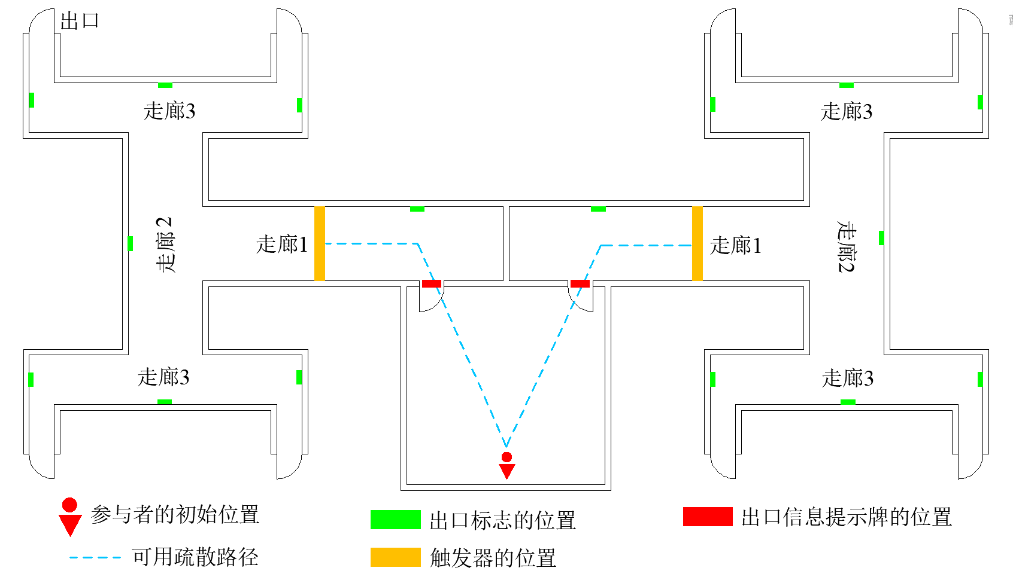

**Fig. 1.** The layout of the IVE

***3.4 Experimental design***

To study on the effect of exit information on participants’ route choices,there were 2 types of experimental scenarios:

Case 1: both 2 routes’ N-values were known by the participants(present them on the signs installed in the initial room) and different from each other. In this case, D-value as the difference between 2 N-values would be the main variable to analyze how the exit information effects participants’ route choices. Since there were 4 exits per route and in this case 2 N-values were different, D-value could only be: 1, 2, 3. Besides, route with larger N-value would be route 2 , another route would be route 1 in this case.

Case 2: one of the 2 N-values was known, another one was unknown. In this case, the known N-value would be the main variable to analyze how the exit information effects participants’ route choices. And N-value could only be: 1, 2, 3, 4. In addition, route with known N-value would be route 2, another route would be route 1 in this case.

All the experimental scenarios were ordered randomly .

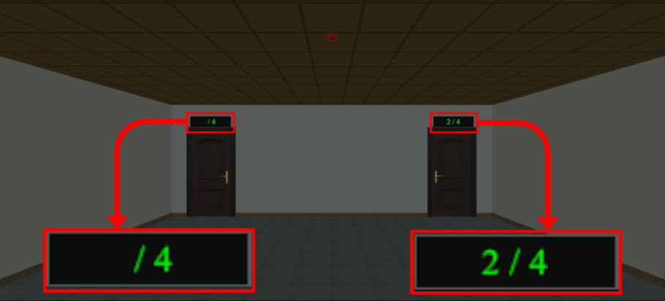

**Fig. 2.** The layout of the IVE

To eliminate the potential influence of route choice performance: people may have a preference for choosing the right or left door,half of the participants would experience the scenarios with route 1 located at left of the initial room, and rest of the participants would experience the scenarios with route 1 located at right of the initial room. Besides,N-value could only inform the number of available exits on a certain route, which exit of the total 4 exits was available was still unknown.

Neighbor behavior also has influence on participants’ route choices. In this experiment, neighbor behavior mainly referred to the choices behavior of neighbors:which route would the neighbor would choose to evacuate. The virtual neighbors would be created in front of the virtual pedestrian when the fire alarm starts and the red lights start flashing,and then move forward with a speed just slightly higher than the virtual pedestrian manipulated by the participants. The results indicated that the virtual neighbors could evacuate with the virtual pedestrian, and higher speed of the virtual neighbors ensured them always be ahead of virtual pedestrian, so that participants could constantly observe the route choices of the virtual neighbors. Moreover, there were 3 neighbor behaviors: no neighbor, neighbors choose route 1, neighbor choose route 2.

Based on variables above: D-value, N-value and neighbor behavior, 30 different scenarios were yielded by intersecting those 3 variables together as listed in Table 1 and table 2. Among them, experiment repeating were taken for D=2 and D=3 case to generate the same sample sizes as N=1 cases, so that potential impact of sample size on the experiment results was minimized. To achieve that: after all the participants finished the D=2 case, half of them would be chosen to accomplish the N=1 and N=3 scenarios, and rest of them would accomplish the N=2 and N=3 scenarios. For the D=3 case, participants were required to repeat all the scenarios for a total 3 times. Because of the repeated trails, 66 test experiments were performed for every scenarios when D=1, 99 test experiments were performed for all experimental scenarios when D=2, and 198 tests were performed for all experimental scenarios when D=3 experiment . It should be noted that in all repeated experiments, route 1 was located on the right size of the initial room, and route 2 was on the left side. In order to eliminate the potential influence on the experiment results that might be caused by the continuous repetition of the same scenarios, all repeated trials were not carried out consecutively, but crosswise in all scenarios.

**Table 1**

Design details of experimental scenarios under different D-values.

|  |  |  |  |  |
| --- | --- | --- | --- | --- |
| D -value | N-value for Route 1 | N-value for route 2 | Neighbor neighbor | Trail count |
| D=1 | 1 | 2 | No neighbor | 66 |
|  | 1 | 2 | Route 1 | 66 |
|  | 1 | 2 | Route2 | 66 |
|  | 2 | 3 | No neighbor | 66 |
|  | 2 | 3 | Route 1 | 66 |
|  | 2 | 3 | Route2 | 66 |
|  | 3 | 4 | No neighbor | 66 |
|  | 3 | 4 | Route 1 | 66 |
|  | 3 | 4 | Route2 | 66 |
| D=2 | 1 | 3 | No neighbor | 99 |
|  | 1 | 3 | Route 1 | 99 |
|  | 1 | 3 | Route2 | 99 |
|  | 2 | 4 | No neighbor | 99 |
|  | 2 | 4 | Route 1 | 99 |
|  | 2 | 4 | Route2 | 99 |
| D=3 | 1 | 4 | No neighbor | 198 |
|  | 1 | 4 | Route 1 | 198 |
|  | 1 | 4 | Route2 | 198 |

Previous studies have indicated that familiarity with the building is a key factor for people’s route choices. Participants were asked to finish all the evacuation in the same building repeatedly, which would change their familiarity with the building and have a influence on their route choices. To minimize the impact of familiarity, participants would travel the the IVE without limits to familiarize themselves with the layout of the entire building.

**Table 2**

Design details of experimental scenarios under different N-values.

|  |  |  |  |  |
| --- | --- | --- | --- | --- |
| N-value | N-value for Route 1 | N-value for route 2 | Neighbor neighbor | Trail count |
| N=1 | Unknown | 1 | No neighbor | 66 |
|  | Unknown | 1 | Route 1 | 66 |
|  | Unknown | 1 | Route2 | 66 |
| N=2 | Unknown | 2 | No neighbor | 66 |
|  | Unknown | 2 | Route 1 | 66 |
|  | Unknown | 2 | Route2 | 66 |
| N=3 | Unknown | 3 | No neighbor | 66 |
|  | Unknown | 3 | Route 1 | 66 |
|  | Unknown | 3 | Route2 | 66 |
| N=4 | Unknown | 4 | No neighbor | 66 |
|  | Unknown | 4 | Route 1 | 66 |
|  | Unknown | 4 | Route2 | 66 |

***3.5 Experimental procedure***

Before the experiment officially started, the experimental apparatuses were confirmed to be functioning properly, and 2 assistants were arranged: one was responsible for organizing the participants to complete the experiment and the other one would help participants using the VR equipment properly and comfortably.

The whole process of the experiment is as shown as Fig.3. At the beginning of the experiment, informed consent was given to every participants and needed to be signed. Subsequently, participants’ background information would be collected through questionnaires, including age, gender, educational level, and the familiarity with VR. After finishing the questionnaire, participants were guided to stand in the design area by the assistant, then took a HTC VIVE HMD and VIVE controller. Then, participant would learn how to navigate in the IVE by VIVE controller and get a bit of familiar with the IVE.

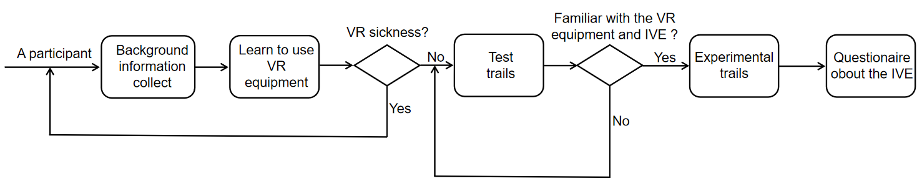

**Fig. 3.** The procedure of the experiment

VR sickness is .. Therefore, the participants would be confirmed to have no VR sickness. Then, participants would take test trails to get themselves familiar with the IVE, so that the effect of the familiarity on participants’ route choices could be minimized. In the test trails, all the scenarios were chosen from the designed experimental scenarios randomly. Additionally, participants were required to evacuate from the virtual building via route 1 and route 2 both. After test trails, participants were asked if they were familiar with the operation of the VR equipment and the layout of the IVE, till their answers were ‘yes’, they would repeat the test trails before taking the officially experimental trails.

Afterwards participants took all the experimental scenarios as listed in table 3.1 and 3.2, plus the repeated scenarios for D=2 and D=3 cases. During each scenario, fire alarm and red lights would be turned on 3 seconds later after the virtual pedestrian was created in the virtual initial room. The main goal for participants in every trail was to obtain the exit information after their virtual pedestrians were created, then chose a route to evacuate via after the fire alarm and red lights were turned on. Participants completed all the experimental scenarios in a random an non-repetitive order to eliminate the potential effect of the experimental order, and the trail ended when the participant have completed all the scenarios. Additionally, to minimize the effect of the VR sickness, participants were asked to give timely feedback about their physical condition, so that the experiment could be terminated as soon as the participant develops symptoms such as nausea and vomiting. Besides, between every 15 experimental scenarios, participants must take a rest.

lastly, all 66 participants completed the experiment as required without serious VR sickness reported, and total 2574 analyzable experimental data have been collected. After the experiment, participants were required to assess the whole experiment through a questionnaire. participants needed to evaluate the reality level of the experiment through: alarms, virtual neighbor, IVE, immersion level of the IVE. Each items had 5 levels: very unreal, unreal, normal, real, very real, and each level scored from 1 to 5.

1. **Experimental results**

***4.1 D-value’s influence on participants’ route choices***

The results of present experiment indicated that the D value(D value stands for available exits number difference when two routes have different numbers of exits and numbers been known by participants) significantly affected participants’ route choice. Table 3 summarized participants’ route choices under different D value. As can be seen, participants tended to choose routes have more exits(route 2) to evacuate through all 3 different D values experiments; with a larger D value, the proportion of people who chose routes with more available exits increase correspondingly. In the D = 1 scenarios, percentage for participants who chose route 2 was 93.43%, 97.64% for D=2, and 98.15% for D=3. The Chi-Square test suggested that the effect of D value for participants’ route choices were statistically significant((χ2 = 22.982，p < 0.05). Cross-tab was used to examine association between specific categorized variables, and the cross-tab Chi-Square test demonstrated that participants’ route choices were statistically different among 3 D-values, which meant there were at least 2 groups’ probability distributions were different, but weather the difference existed between any 2 groups was yet to cleared. To ascertain the exactly groups had probability distributions difference, a Post Hoc test after a Chi-Square test was adopted,which indicated that between D=1 and D=2, D=1 and D=3, there were statistically difference, while between D=2 and D=3 there wasn’t.

**Table 3**

Participants’ route choices under different N-values.

|  |  |  |  |  |  |
| --- | --- | --- | --- | --- | --- |
| Route choices | D=1 | D=2 | D=3 | $$χ^{2}$$ | *P value* |
| Route 1 | 39 | 14 | 11 | — | — |
| Route 2 | 555 | 580 | 583 | — | — |
| Percentage for Route 2 | 93.43% | 97.64% | 98.15% | 22.982 | 0.000 |

The effect of neighbor behavior for participants’ route choices can be confirmed based on the results as well. Participants’ route choices under different neighbor behavior were summarized in Table 4, in which the percentages of participants who chose route 2 were generally higher under different neighbor behavior, and the differences were not too much between each case. In all the experimental scenarios, there were 96.80% of participants who chose route 2 when there was no neighbors case, 96.80% for neighbor chose route 1 case, and 96.46% for neighbor chose route 2 case.The Chi-Square test’s results (summarized in Table 4) revealed that neighbor behavior had no significant influence(χ2=0.616, p>0.05) on participants’ route choices when two routes’ available exits were known and different.In order to further investigate whether neighbor behavior had an impact on people’s route choices under different available exits difference, which was the layer variable used in a cross-tab analysis. As the cross-tab results indicated in the Table 5, except when D=3 neighbor behavior has a substantial impact on participants’ route choices, when D=1(χ2=1.153, p >0.05) and D=2 cases(χ2=1.062 ,p>0.05) it had no substantial impact on participants’ route choices.

**Table 4**

Participants’ route choices under different neighbor behavior.

|  |  |  |  |  |  |
| --- | --- | --- | --- | --- | --- |
| Route choices | No neighbor | Neighbor choose route 1 | Neighbor choose route 2 | $$χ^{2}$$ | *P* value |
| Route 1 | 19 | 24 | 21 | — | — |
| Route 2 | 575 | 570 | 573 | — | — |
| Percentage of route 2 | 96.80% | 95.96% | 96.46 | 0.616 | 0.735 |

**Table 5**

Cross-tab analysis between neighbor behavior and path selection under different D values.

|  |  |  |  |  |  |  |
| --- | --- | --- | --- | --- | --- | --- |
| D value | Route choice | No neighbors | Neighbor choose route 1 | Neighbor choose route 2 | $$χ^{2}$$ | *P value* |
| D=1 | Route 1 | 11 | 12 | 16 | — | — |
|  | Route 2 | 187 | 186 | 182 | — | — |
|  | Percentage of route 2 | 94.44% | 93.94% | 91.92% | 1.153 | 0.562 |
| D=2 | Route 1 | 3 | 6 | 5 | — | — |
|  | Route 2 | 195 | 192 | 193 | — | — |
|  | Percentage of route 2 | 98.48% | 96.97% | 97.47% | 1.062 | 0.704 |
| D=3 | Route 1 | 5 | 6 | 0 | — | — |
|  | Route 2 | 193 | 192 | 198 | — | — |
|  | Percentage of route 2 | 97.47% | 96.97% | 100.00% | 6.828 | 0.035 |

Note：Fisher’s exact test was adopted in D=2 and D=3 scenarios, because of the expected frequency of 3 cells is less than 5 in both scenarios.

A binary logistic model was taken to fit the experiment data to have a more exhaustive data analyze. Based on the factors analysis above, only D-value had a obvious influence on participants’ route choices when two routes’ available exits were known and different, while neighbor behavior had no such obvious influence and thus participants’ route choices(i.e. whether to evacuate via route 2) could be predicted only by the difference of available exits number.As it can be seen from the above analysis that when D=1, the proportion of participants who used route 2 for evacuation is 93.43%, which was apparently higher than path 1. In binary logistic regression, D=1 was used as a reference, and the model results were shown in Table 6. According to Table 6, participants were more likely to evacuate via route 2 when the number of available exits for the two routes were known and different. The likelihood of participants evacuating via route 2 was further increased when both D=2 and D=3 compared to D=1, and this positive effect was further increased at D=3 (OR=3.724, 95% CI=[1.888,7.345]) was stronger than D=2 (OR=2.911, 95%CI=[1.563,5.421]).

**Table 6**

Results of binary logistic model for predicting route choices decisions based on D-values

|  |  |  |  |  |  |  |
| --- | --- | --- | --- | --- | --- | --- |
| — | B | S.E | p | OR | Lower（95%CI） | Higher（95%CI） |
| Constant values | 2.655 | 0.166 | 0.000 | 14.231 | — | — |
| D=1(Reference) | — | — | 0.000 | 1 | — | — |
| D=2 | 1.069 | 0.317 | 0.001 | 2.911 | 1.563 | 5.421 |
| D=3 | 1.315 | 0.347 | 0.000 | 3.724 | 1.888 | 7.345 |

Note:

***4.2 N-value’s influence on participants’ route choices***

Results of this experiment demonstrated that the number of available exits (N-value) has a significant effect on participants’ route choices when one of two routes’ N-value was known and another N-value was unknown. Participants’ route choices under different N-value were summarized in Table 7: 70.71% of participants chose known-N-value route(i.e. route 2) to evacuate when N=1, 86.87% for N=2, 97.98% for N=3, and 98.48% for N=4. As it can be seen, participants had a tendency to evacuate via route with a known N-value, and the percentage of participants who chose route 2 increased as the N-value increased. The Chi-Square test results revealed that N-value had a statistical significance(χ2=99.064，p<0.05). To determine between which 2 groups of N-values had this statistical difference, a Post Hoc test after Chi-Square test was adopted, and the results showed that the statistical difference existed between any 2 groups expect between group 3 and group 4.

**Table 7**

Participants’ route choices under different and known N-value.

|  |  |  |  |  |  |  |
| --- | --- | --- | --- | --- | --- | --- |
| Route choices | N=1 | N=2 | N=3 | N=4 | $$χ^{2}$$ | P value |
| Route 1 | 58 | 26 | 4 | 3 | — | — |
| Route 2 | 140 | 172 | 194 | 195 | — | — |
| Percentage for Route 2 | 70.71% | 86.87% | 97.98% | 98.48% | 99.064 | 0.000 |

Neighbor behavior was also confirmed to be inessential for participants’ route choices when one of the N-values was known and another was unknown. Participants’ route choices under different neighbor behavior were listed in table 8. For all the experiment scenarios, the percentages of participants choosing route 2 to evacuate was 90.15% for scenarios without neighbors, 85.98% for scenarios with neighbor choosing route 1 and 89.39% for scenarios with neighbors choosing route2. They were all high and having minor difference between each other percentages of participants choosing route 2 to evacuate . Table 8 presented the Chi-Square test results.According to the table, neighbor behaviors didn’t have a [momentous](https://www.powerthesaurus.org/momentous/synonyms" \o "momentous synonym) influence on participants’ route choices when the scenario had a known N-value and an unknown N-value.To further discuss the influence of neighbor behavior under a specific and known available exits number , a Cross-tab analysis using known N-value as layer variable was adopted and the results were summarized in table 9 . As can be seen in table 9 whether N=1 ((χ2 = 4.438, p >0.05), N=2((χ2=0.620, p>0.05), N=3(χ2=0.677, p>0.05) or N=4(χ2=1.848, p>0.05) neighbor behavior had no significant influence on participants’ route choices in all the known-unknown scenarios.

**Table 8**

Participants’ route choices under different neighbor behavior.

|  |  |  |  |  |  |
| --- | --- | --- | --- | --- | --- |
| Participants’ route choices | No neighbor | Neighbor chose route 1 | Neighbor chose route 2 | $$χ^{2}$$ | *P value* |
| Route 1 | 26 | 37 | 28 | — | — |
| Route 2 | 238 | 227 | 236 | — | — |
| Percentages of route 2 | 90.15% | 85.98% | 89.39% | 2.558 | 0.278 |

In order to have a detailed analysis of data, a binary logistic model was utilized to fit the analyzable data. Based on factors above, only known N-value had an essential influence on participants’ route choices when the scenarios is known-unknown case, so that route choices could be predicted only by the N-value in this type of evacuation situation. As presented in the Table 7, percentage of participants choosing route with known N-value(i.e. route 2) was 70.71% which was significantly higher than the percentage of participants choosing route 1. Table 10 has presented the results of the binary logistic regression which used N=1 scenarios as a refer. Pursuant to the results, participants had tendency to evacuate via route 2 whose available exits was known by participants while another route’s available exits information were unknown to the participants. The results suggested that people were more likely to use route 2 when N=2,N=3 and N=4 compared to N=1. Furthermore, the positive effect got stronger as the N-value increased: people were more likely to use route 2 when N=4(OR=26.929, 95%CI=[8.269,87.690]) than N=3(OR=20.093, 95%CI=[7.129,56.635]), and surely more likely to use route 2 when N=3(OR=20.093, 95%CI=[7.129,56.635]) than N=2(OR=2.741, 95%CI=[1.640,4.580]).

**Table 9**

Cross-tab analysis for known N-value and participants’ route choices.

|  |  |  |  |  |  |  |
| --- | --- | --- | --- | --- | --- | --- |
| N value | Route choices | No neighbor | Neighbor chose 1 | Neighbor chose 2 | $$χ^{2}$$ | *P* value |
| N=1 | Route 1 | 14 | 25 | 19 | — | — |
|  | Route 2 | 52 | 41 | 47 | — | — |
|  | Percentages of route 2 | 78.79% | 62.12% | 71.21% | 4.438 | 0.109 |
| N=2 | Route 1 | 10 | 9 | 7 | — | — |
|  | Route 2 | 56 | 57 | 59 | — | — |
|  | Percentages of route 2 | 84.85% | 86.36% | 89.39% | 0.620 | 0.733 |
| N=3 | Route 1 | 2 | 1 | 1 | — | — |
|  | Route 2 | 64 | 65 | 65 | — | — |
|  | Percentages of route 2 | 96.97% | 98.48% | 98.48% | 0.677 | 1.000 |
| N=4 | Route 1 | 0 | 2 | 1 | — | — |
|  | Route 2 | 66 | 64 | 65 | — | — |
|  | Percentages of route 2 | 100.00% | 96.97% | 98.48% | 1.848 | 0.774 |

**Table 10**

The results of the Binary Logistic Model for predicting route choices based on N-values.

|  |  |  |  |  |  |  |
| --- | --- | --- | --- | --- | --- | --- |
|  | B | S.E。 | p | OR | Lower（95%CI） | Upper（95%CI） |
| Constant | 0.881 | 0.156 | 0.000 | 2.414 | — | — |
| N=1 | — | — | 0.000 | 1 | — | — |
| N=2 | 1.008 | 0.262 | 0.000 | 2.741 | 1.640 | 4.580 |
| N=3 | 3.000 | 0.529 | 0.000 | 20.093 | 7.129 | 56.635 |
| N=4 | 3.293 | 0.602 | 0.000 | 26.929 | 8.269 | 87.690 |

***4.3 Experimental revolution***

Participants were asked to finish a questionnaire(results summarized in Table 11) in which participants would rate the reality level of the virtual experiment scene from alarm,virtual neighbor and building model,and rate their immersion level for the virtual environment as well.According to table 4.9, participants highly rated each items. Among them, the “alarm” has the highest score: 4.27. Virtual Neighbor scored the lowest, but also achieved a high 3.70, indicating that most people consider virtual Neighbors to be "very real" or "real". In addition, the immersion level was rated as 4.18,which showed that most participants can experience a realistic evacuation in the virtual environment.

**Table 11**

The results of questionnaires for virtual experiments.

|  |  |  |  |  |
| --- | --- | --- | --- | --- |
|  | Fire alarm | Virtual building | Virtual neighbor | Level of immersion |
| Score | 4.27 | 4.17 | 3.70 | 4.18 |

1. **Experimental results**

The present study focus on the impact of exit information and neighbor behavior on pedestrians’ route choices. By using VR technology to create a immersive virtual environment(IVE), the exit information and neighbor behavior were well controlled and potential danger of real-world experiment was minimized.

* 1. ***Influence of neighbor behavior***

***---***

* 1. ***Influence of N-value***

***---***

* 1. ***Influence of D-value***

***---***

未使用数据及场景细节

**表1 两路径上的可用出口数均未知**

|  |  |  |  |  |  |
| --- | --- | --- | --- | --- | --- |
| **试验编号** | **门1（房间左侧的门）** | | **门2（房间右侧的门）** | | **右侧比例** |
| **已知可用出口数** | **有无邻居(数量)** | **已知可用出口数** | **有无邻居(数量)** |
| 1-S4 | 未知 | 无 | 未知 | 无 |  |
|  | 28 | | 37 | | 56.92% |
| 2-S2 | 未知 | 无 | 未知 | 有（1） |  |
|  | 20 | | 45 | | 69.23% |
|  | 2.11 | | p=0.1459 | |  |

**表2 两路径上的可用出口数均已知且相同**

|  |  |  |  |  |  |
| --- | --- | --- | --- | --- | --- |
| **试验编号** | **门1（房间左侧的门）** | | **门2（房间右侧的门）** | | **右侧比例** |
| **已知可用出口数** | **有无NPC(数量)** | **已知可用出口数** | **有无NPC(数量)** |
| 1-S6 | 1 | 有（1） | 1 | 无 |  |
|  | 24 | | 41 | | 63.07% |
| 2-S9 | 2 | 无 | 2 | 有（1） |  |
|  | 21 | | 44 | | 67.69% |
| 3-S16 | 3 | 有（1） | 3 | 无 |  |
|  | 24 | | 41 | | 63.07% |
| 4-S18 | 4 | 无 | 4 | 有（1） |  |
|  | 28 | | 37 | | 56.92% |
| 5-S1 | 1 | 无 | 1 | 无 |  |
|  | 32 | | 33 | | 50.76% |
| 6-S8 | 2 | 无 | 2 | 无 |  |
|  | 30 | | 35 | | 53.84% |
| 7-S13 | 3 | 无 | 3 | 无 |  |
|  | 22 | | 43 | | 66.13% |
| 8-S5 | 4 | 无 | 4 | 无 |  |
|  | 26 | | 39 | | 66.66% |

就算是两条路径完全对等（1、5-8），参与者的选择会倾向右侧路径；

我在想要不要将这部分数据添加到论文里，论文可分析的内容会更多一些。