**Dijkstra's Algorithm:-**

#include <stdio.h>

#include <limits.h>

#include <stdbool.h>

// A utility function to find the vertex with minimum distance value,

// from the set of vertices not yet included in the shortest path tree

int minDistance(int dist[], bool visited[], int V) {

    // Initialize min value

    int min = INT_MAX, min_index;

    for (int v = 0; v < V; v++) {

        if (visited[v] == false && dist[v] <= min) {

            min = dist[v];

            min_index = v;

        }

    }

    return min_index;

}

// A utility function to print the constructed distance array along with paths

void printSolution(int dist[], int parent[], int V, int src) {

    printf("Vertex \t\t Distance from Source \t Path\n");

    for (int i = 0; i < V; i++) {

        printf("%d \t\t\t %d \t\t\t ", i + 1, dist[i]);

        // Print the path

        int current = i;

        while (current != src) {

            printf("%d <- ", current + 1);

            current = parent[current];

        }

        printf("%d", src + 1);

        printf("\n");

    }

}

// Function that implements Dijkstra's single source shortest path algorithm

// for a graph represented using adjacency matrix representation

void dijkstra(int V, int graph[V][V], int src) {

    int dist[V];    // The output array. dist[i] will hold the shortest distance from src to i

    int parent[V];  // Array to store the parent of each vertex in the shortest path

    bool visited[V]; // visited[i] will be true if vertex i is included in the shortest

                    // path tree or shortest distance from src to i is finalized

    // Initialize all distances as INFINITE, visited[] as false, and parent[] as -1

    for (int i = 0; i < V; i++) {

        dist[i] = INT_MAX;

        visited[i] = false;

        parent[i] = -1;

    }

    // Distance of source vertex from itself is always 0

    dist[src] = 0;

    // Find shortest path for all vertices

    for (int count = 0; count < V - 1; count++) {

        // Pick the minimum distance vertex from the set of vertices not yet processed

        int u = minDistance(dist, visited, V);

        // Mark the picked vertex as processed

        visited[u] = true;

        // Update dist value of the adjacent vertices of the picked vertex

        for (int v = 0; v < V; v++) {

            // Update dist[v] only if it is not in visited, there is an edge from u to v,

            // and the total weight of the path from src to v through u is smaller than the current value of dist[v]

            if (!visited[v] && graph[u][v] && dist[u] != INT_MAX && dist[u] + graph[u][v] < dist[v]) {

                dist[v] = dist[u] + graph[u][v];

                parent[v] = u;

            }

        }

    }

    // Print the constructed distance array along with paths

    printSolution(dist, parent, V, src);

}

// Driver's code

int main() {

    int V;

    printf("Enter the number of vertices in the graph: ");

    scanf("%d", &V);

    printf("Enter the values of the adjacency matrix:\n");

    int graph[V][V];

    for (int i = 0; i < V; ++i) {

        for (int j = 0; j < V; ++j) {

            scanf("%d", &graph[i][j]);

        }

    }

    // Function call

    dijkstra(V, graph, 0);

    return 0;

}

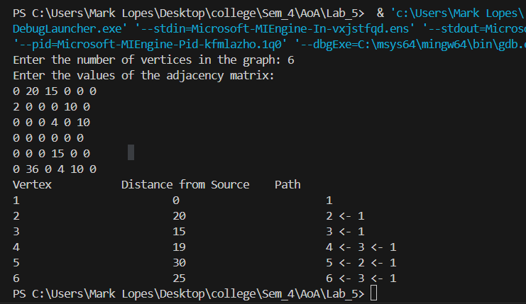

**Prims algorithm:-**

#include <stdio.h>

#include <limits.h>

#include <stdbool.h>

#define V 6 // Number of vertices in the graph

// A utility function to find the vertex with minimum distance value,

// from the set of vertices not yet included in the MST

int minKey(int key[], bool visited[]) {

    // Initialize min value

    int min = INT_MAX, min_index;

    for (int v = 0; v < V; v++) {

        if (visited[v] == false && key[v] < min) {

            min = key[v];

            min_index = v;

        }

    }

    return min_index;

}

// A utility function to print the constructed MST and distance from the source

void printMST(int parent[], int graph[V][V], int src) {

    printf("Node \tDistance from Source \tNearest Node\n");

    int cost = 0;

    for (int i = 0; i < V; i++) {

        printf("%d \t\t%d \t\t\t\t", i+1, graph[i][parent[i]]);

        cost += graph[i][parent[i]];

        // Print the path

        int current = i;

        while (current != src) {

            printf("%d <- ", current+1);

            current = parent[current];

        }

        printf("%d", src+1);

        printf("\n");

    }

    printf("The total cost is %d", cost);

}

// Function to construct and print MST for a graph represented using adjacency matrix representation

void primMST(int graph[V][V]) {

    int parent[V]; // Array to store constructed MST

    int key[V];    // Key values used to pick minimum weight edge in cut

    bool visited[V]; // To represent set of vertices not yet included in MST

    // Initialize all keys as INFINITE, visited[] as false

    for (int i = 0; i < V; i++) {

        key[i] = INT_MAX;

        visited[i] = false;

    }

    // Always include first vertex in MST

    key[0] = 0;     // Make key 0 so that this vertex is picked as first vertex

    parent[0] = -1; // First node is always root of MST

    // The MST will have V vertices

    for (int count = 0; count < V - 1; count++) {

        // Pick the minimum key vertex from the set of vertices not yet included in MST

        int u = minKey(key, visited);

        // Add the picked vertex to the MST Set

        visited[u] = true;

        // Update key value and parent index of the adjacent vertices of the picked vertex.

        // Consider only those vertices which are not yet included in MST

        for (int v = 0; v < V; v++) {

            // graph[u][v] is non-zero only for adjacent vertices of m

            // visited[v] is false for vertices not yet included in MST

            // Update the key only if graph[u][v] is smaller than key[v]

            if (graph[u][v] && visited[v] == false && graph[u][v] < key[v]) {

                parent[v] = u;

                key[v] = graph[u][v];

            }

        }

    }

    printMST(parent, graph, 0); // Assuming source node is 0

}

// Driver program to test above function

int main() {

    // Example graph representation using adjacency matrix

    int graph[V][V] = {

        {0, 6, 3, 0, 0, 0},

        {6, 0, 2, 5, 0, 0},

        {3, 2, 0, 3, 4, 0},

        {0, 5, 3, 0, 2, 3},

        {0, 0, 4, 2, 0, 5},

        {0, 0, 0, 3, 2, 0}

    };

    primMST(graph);

    return 0;

}

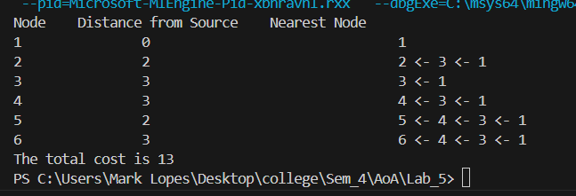

**POSTLAB:-**

