# FR. Conceicao Rodrigues College of Engineering Department of Computer Engineering

3. TO IMPLEMENT BLOCK TRANSFER

## Course, Subject & Experiment Details

| **Academic Year** | **2023-24** | **Estimated Time** | **Experiment No. 3– 02 Hours** |
| --- | --- | --- | --- |
| **Course & Semester** | **S.E. (Comps) – Sem. IV** | **Subject Name** | **Microprocessor** |
| **Chapter No.** | **2** | **Chapter Title** | **Instruction Set and Programming** |
| **Experiment Type** | **Software** | **Subject Code** | **CSC405** |

**Rubrics**

| **Timeline (2)** | **Practical Skill & Applied Knowledge**  **(2)** | **Output (3)** | **Postlab (3)** | **Total (10)** | **Sign** |
| --- | --- | --- | --- | --- | --- |
|  |  |  |  |  |  |

## Aim & Objective of Experiment

### **Aim:** Write a program to transfer a block of data from one location to another.

**Objective :** Program involves transferring source string from a particular location in source segment (Data Segment) to the desired location in destination segment (Extra Segment). The objective of this program is to give an overview of the String instructions of 8086.

## Software Required

### TASM Simulator

1. **Pre-Requisites:** 1. Knowledge of TASM directives.

### 2. Knowledge of String Instructions of 8086.

1. **Algorithm:** 1. Initialize the data segment.
   1. Store the source string in consecutive memory location
   2. Initialize the extra segment.
   3. Allocate consecutive memory locations for transfer.
   4. Load the effective address of source string in SI register.
   5. Load the effective address of destination string in DI register.
   6. Initialize the Direction flag for Auto increment or Auto Decrement.
   7. Store number of bytes to be transferred in any of the general Purpose registers.
   8. Transfer the source string using appropriate string instructions (MOVSB / MOVSW)
   9. Decrement count
   10. Check if count = 0.If yes then stop else repeat steps 9 - 11.
   11. Stop

# Conclusion:

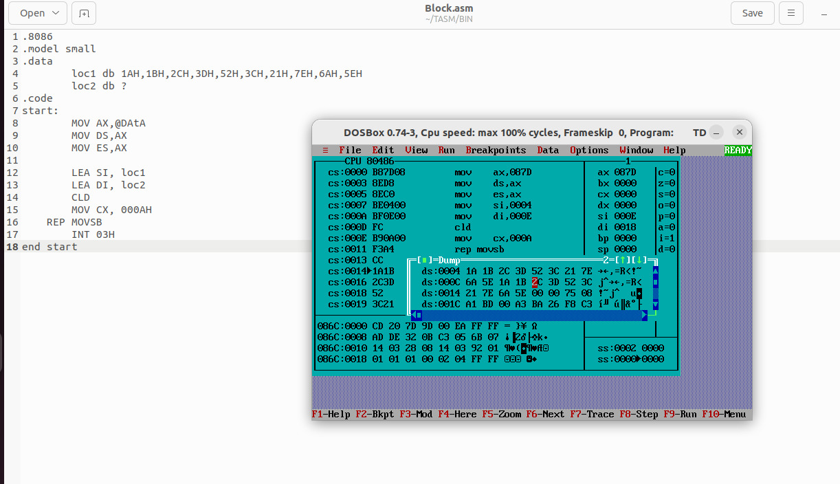

**Postlab:**

### What is the advantage of segmentation?

In the context of microprocessors, segmentation refers to a technique used to **divide the program's memory space into smaller, more manageable sections**. This technique offers several advantages:

**i) Improved Memory Management:** By dividing memory into segments, the microprocessor can track and protect different parts of the program more effectively. This prevents one program section from accidentally overwriting another, enhancing program stability and security.

**ii) Increased Efficiency:** Segmentation allows the microprocessor to translate logical addresses (used by the program) to physical addresses (used by memory) more efficiently. This is because the segment table helps map logical segment addresses to physical memory locations, reducing the number of memory accesses needed.

1. Explain the significance of REP Prefix

The REP (Repeat) prefix is an x86 instruction prefix that is used to repeat certain string and memory operations. It plays a crucial role in repetitive operations where the same operation needs to be performed multiple times on a sequence of data. The significance of the REP prefix lies in its ability to simplify and optimize repetitive string operations in x86 assembly language.