**Exercise on Functions**

**Mark Lopes**

**9913**

**S.E Comps_A Batch_C**

1. Write a function called showNumbers that takes a parameter called limit. It should print all the numbers between 0 and limit with a label to identify the even and odd numbers. For example, if the limit is 3, it should print:

0 EVEN

1 ODD

2 EVEN

3 ODD

def showNumbers(linit):

for i in range(0,linit):

if i%2==0:

print(f"{i} EVEN")

else:

print(f"{i} ODD")

limit = int(input("Enter the limit: "))

showNumbers(limit)

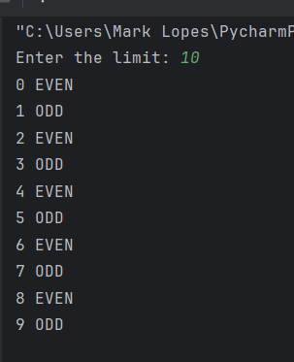

1. Write a function that returns the sum of multiples of 3 and 5 between 0 and limit (parameter). For example, if limit is 20, it should return the sum of 3, 5, 6, 9, 10, 12, 15, 18, 20.

def return_multiple_3_5(limit):

for i in range(1,limit+1):

if i%3==0 or i%5==0:

print(f"{i} ")

limit = int(input("Enter the limit: "))

return_multiple_3_5(limit)

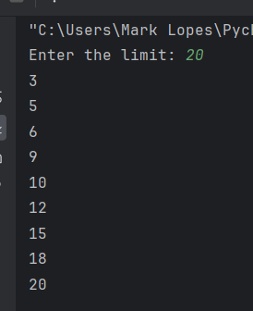

1. Write a function called show_stars(rows). If rows is 5, it should print the following:

*

**

***

****

*****

def show_stars(rows):

for i in range(1,rows+1):

for j in range(1,i+1):

print('*',end = '')

print()

rows = int(input("Enter the no. of rows: "))

show_stars(rows)

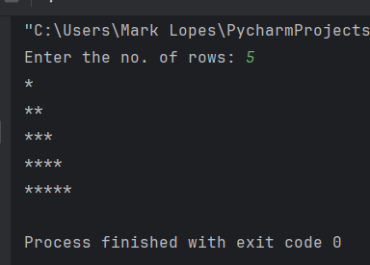

1. Write a function that prints all the prime numbers between 0 and limit where limit is a parameter.

def prime(limit):

for i in range(1,limit+1):

count = 0

for j in range(1,i+1):

if i%j==0:

count+=1

if count==2:

print(i)

limit = int(input("Enter the limit: "))

prime(limit)

