|  |  |  |  |
| --- | --- | --- | --- |
| SE-Computer A Batch C Roll number : 9913 | | | |
| Experiment no. : 3(Part-1) Date of Implementation : | | | |
| Aim : To implement data definition language (DDL) commands | | | |
| Tool Used : PostgreSQL | | | |
| Related Course outcome : At the end of the course, Students will be able to Use  SQL : Standard language of relational database | | | |
| **Rubrics for assessment of Experiment:**   |  |  |  |  | | --- | --- | --- | --- | | Indicator | Poor | Average | Good | | Timeliness   * Maintains assignment deadline (3) | Assignment not done (0) | One or More than One week late (1-2) | Maintains deadline (3) | | Completeness and neatness   * Complete all parts of assignment(3) | N/A | < 80% complete (1-2) | 100% complete (3) | | Originality   * Extent of plagiarism(2) | Copied it from someone else(0) | At least few questions have been done without copying(1) | Assignment has been solved completely without copying (2) | | Knowledge   * In depth knowledge of the assignment(2) | Unable to answer 2 questions(0) | Unable to answer 1 question (1) | Able to answer 2 questions (2) | | | | |
| **Assessment Marks :**   |  |  | | --- | --- | | Timeliness |  | | Completeness and neatness |  | | Originality |  | | Knowledge |  | | Total |  | | | | |
| **Total : (Out of 10)** | | | |
| **Teacher's Sign :** | | | |
|  | ***EXPERIMENT 3*** | DDL Commands |
|  | Aim | To implement DDL – Data definition language command |
|  | Tools | PostgreSQL/MYSQL |
|  | Theory | **SQL:** It is structured query language, basically used to pass the query to retrieve and manipulate the information from database  **DDL:** The Data Definition Language (DDL) is used to create the database (i.e. tables, keys, relationships etc), maintain the structure of the database and destroy databases and database objects.  Eg. Create, Drop, Alter, Describe, Truncate CREATE statements: It is used to create the table. CREATE TABLE table_name(columnName1 datatype(size), columnName2 datatype(size),………);   1. **DROP statements:** To destroy an existing database, table, index, or view. If a table is dropped all records held within it are lost and cannot be recovered.  DROP TABLE table_name;  1. **ALTER statements:** To modify an existing database object.   **Adding new columns:**  Alter table table_name Add(New_columnName1 datatype(size),  New_columnName2 datatype(size),………);  **Dropping a columns from a table** :  Alter table table_name DROP column columnName:  **Modifying Existing columns:**    Alter table table_name Modify (columnName1 Newdatatype(Newsize));   1. **Describe statements:** To describe the structure (column and data types) of an existing database, table, index, or view.  DESC table_name;  1. **Truncate statements:** To destroy the data in an existing database, table, index, or view. If a table is truncated all records held within it are lost and cannot be recovered but the table structure is maintained.  TRUNCATE TABLE table_name; |
|  | Procedure | 1. Write a query to create a table employee with empno, ename, designation, and salary. Emp (empno number (4), ename varchar (10), designation varchar (10), salary number (8,2)); 2. Write a Query to Alter the column empno number (4) to empno number (6). 3. Write a Query to Alter the table employee with multiple columns (empno, ename.) 4. Write a query to add a new column in to employee as qualification varchar2(6) 5. Write a query to add multiple columns in to employee dob date , doj date 6. Write a query to drop a column ‘doj’ from an existing table employee 7. Write a query to drop multiple columns ‘dob’ and ‘qualification’ from employee 8. Truncate table EMP 9. Drop table EMP |
|  | **Post Lab Questions:** | 1. What is Data Dictionary? 2. What is Schema? 3. What are different data types in SQL? |

1

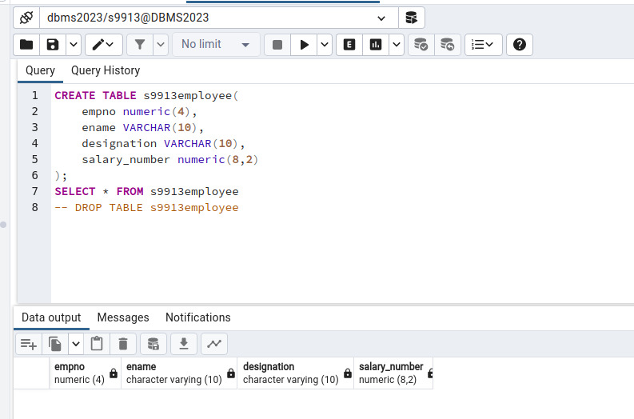

2

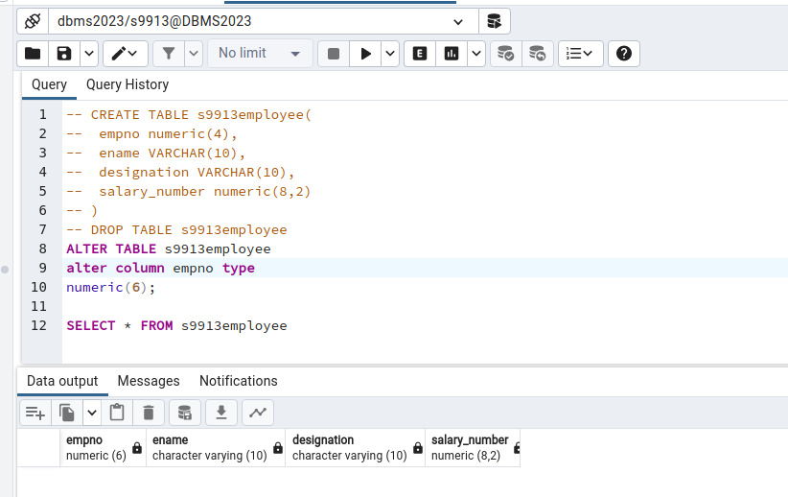

3

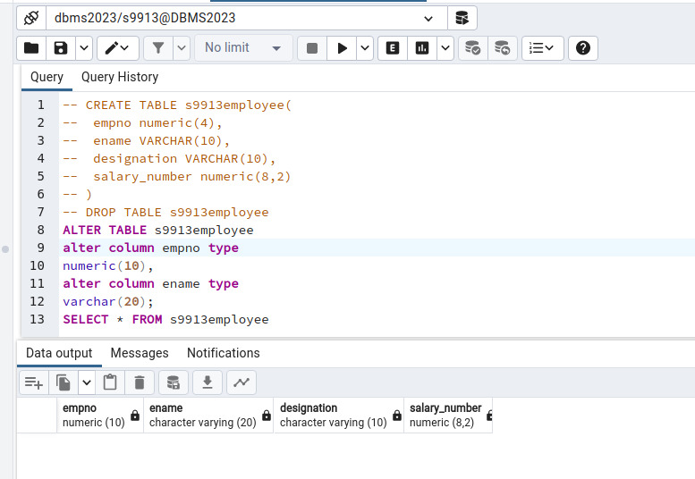

4

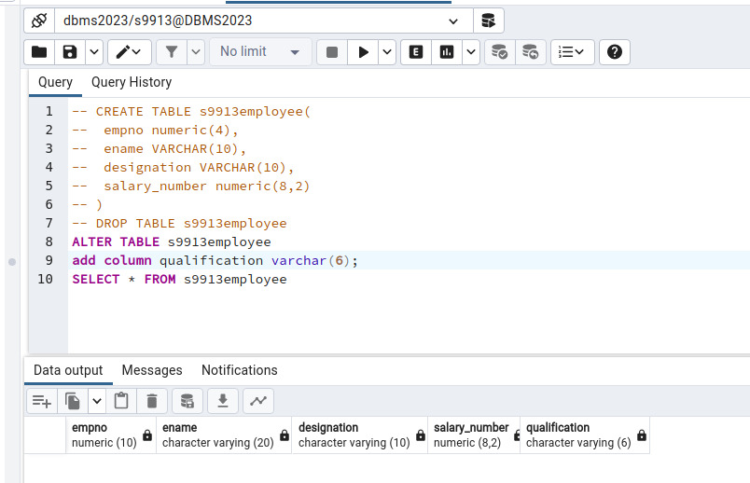

5

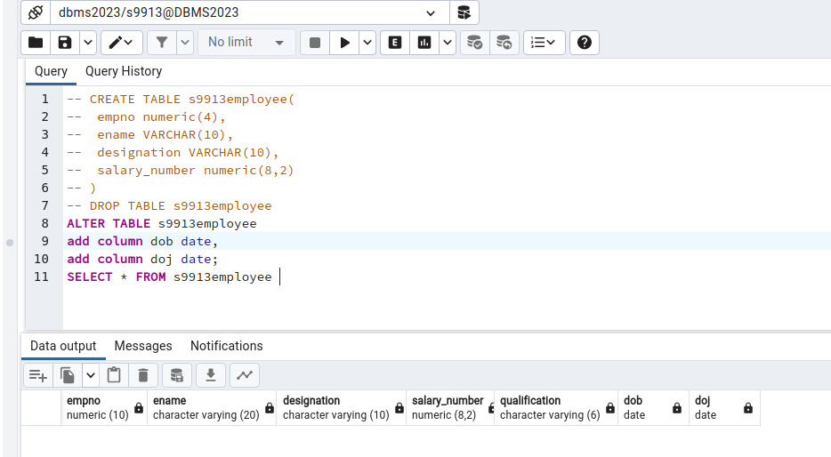

6

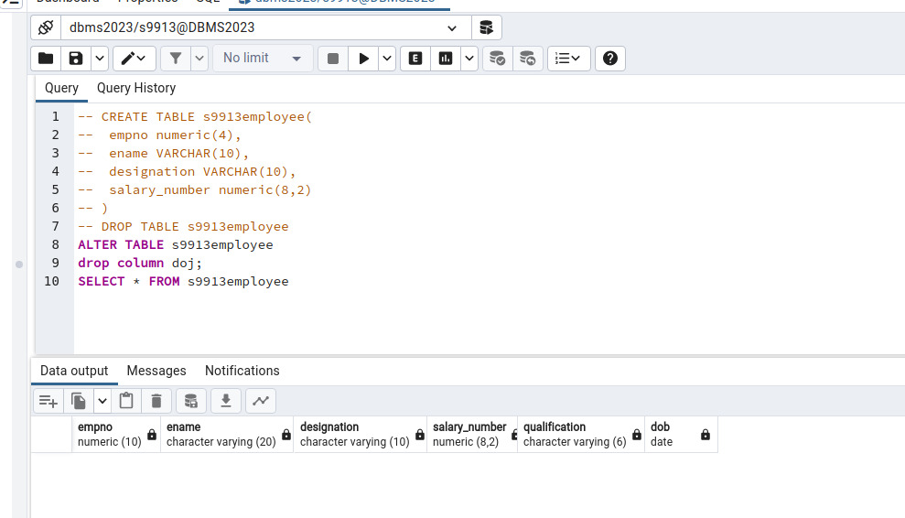

7

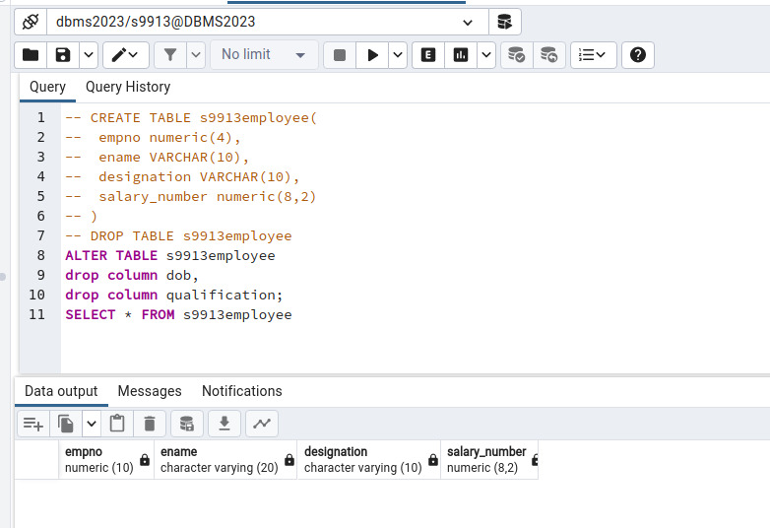

8

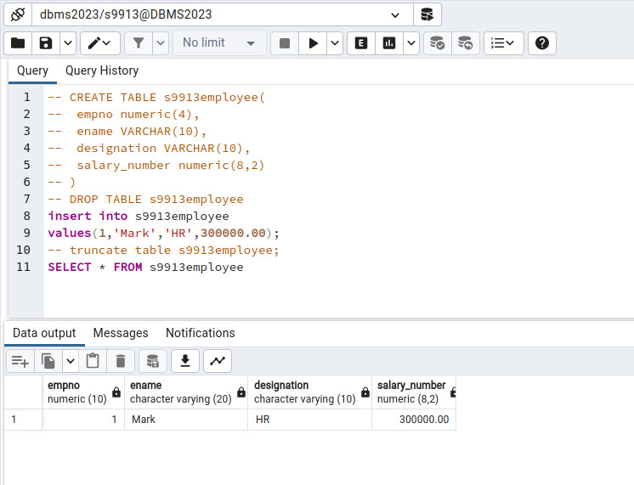

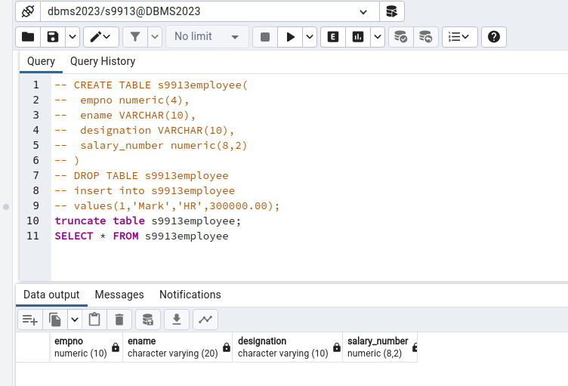

9

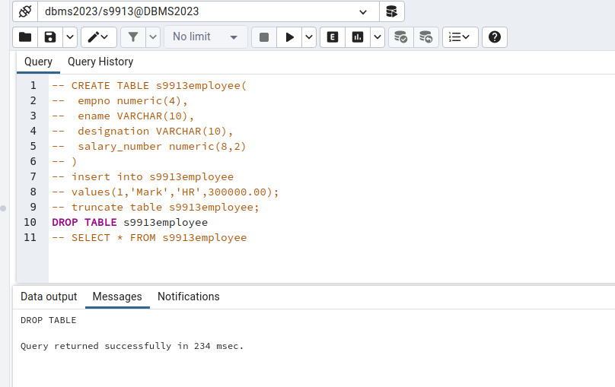

**POSTLAB:-**

**Q1**

A data dictionary is a centralized repository that stores metadata about a database, including definitions, data types, constraints, relationships, and other details. It serves as a reference guide for understanding and managing the structure and attributes of data within the database.

**Q2**

In a database, a schema is a logical container or namespace that holds a collection of database objects, including tables, views, indexes, and procedures. It provides a way to organize and manage database objects, allowing multiple users or applications to work independently within their designated schemas. Schemas help avoid naming conflicts and provide a structure for organizing and securing database elements.

**Q3**

Numeric Types:

INT, INTEGER: Integer.

SMALLINT: Small integer.

TINYINT: Very small integer.

BIGINT: Large integer.

DECIMAL(p, s), NUMERIC(p, s): Decimal number with a specified precision (p) and scale (s).

FLOAT: Floating-point number.

REAL: Real number.

Character/String Types:

CHAR(n): Fixed-length character string.

VARCHAR(n), VARCHAR(MAX): Variable-length character string with a maximum length of n characters or maximum allowed length.

TEXT: Variable-length character string with no specified maximum length.

Date and Time Types:

DATE: Date (year, month, day).

TIME: Time of day.

DATETIME, TIMESTAMP: Date and time.

INTERVAL: Time interval.

Boolean Type:

BOOLEAN, BOOL: Boolean