|  |  |  |  |
| --- | --- | --- | --- |
| SEcomputer A batch-C Roll number : 9913 | | | |
| Experiment no. : 3 part2 Date of Implementation : | | | |
| Aim : To implement data manipulation language (DML) commands | | | |
| Tool Used : PostgreSQL | | | |
| Related Course outcome : Students should be able to  Write queries in SQL to retrieve any type of information from a data base. | | | |
| **Rubrics for assessment of Experiment:**   |  |  |  |  | | --- | --- | --- | --- | | Indicator | Poor | Average | Good | | Timeliness  Maintains Experiment deadline (3) | Experiment not done (0) | One or More than One week late (1-2) | Maintains deadline (3) | | Completeness and neatness  Complete all parts of Experiment(3) | N/A | < 80% complete (1-2) | 100% complete (3) | | Originality  Extent of plagiarism(2) | Copied it from someone else(0) | At least try to implement but could not succeed (1) | Implemented (2) | | Knowledge  In depth knowledge of the Experiment(2) | Unable to answer any questions(0) | Unable to answer few questions (1) | Able to answer all questions (2) | | | | |
| **Assessment Marks :**   |  |  | | --- | --- | | Timeliness |  | | Completeness and neatness |  | | Originality |  | | Knowledge |  | | Total |  | | | | |
| **Total : (Out of 10)** | | | |
| **Teacher's Sign :** | | | |
|  | ***EXPERIMENT 3*** | **DDL and DML Commands** |
|  | Aim | To implement DDL with integrity constraints and DML – Data manipulation language command |
|  | Tools | PostgreSQL/MySql |
|  | Theory | Data Definition Language-1) Create 2) Alter 3) Drop 4) Rename 5) Truncate   * [**CREATE**](https://www.geeksforgeeks.org/sql-create/) – is used to create the database or its objects (like table, index, function, views, store procedure and triggers). * [**DROP**](https://www.geeksforgeeks.org/sql-drop-truncate/) – is used to delete objects from the database. * [**ALTER**](https://www.geeksforgeeks.org/sql-alter-add-drop-modify/)-is used to alter the structure of the database. * [**TRUNCATE**](https://www.geeksforgeeks.org/sql-drop-truncate/)–is used to remove all records from a table, including all spaces allocated for the records are removed. * [**COMMENT**](https://www.geeksforgeeks.org/sql-comments/) –is used to add comments to the data dictionary. * [**RENAME**](https://www.geeksforgeeks.org/sql-alter-rename/) –is used to rename an object existing in the database.   1) Create table  create table tablename  (column1 data type,  column2 data type,  column3 data type,  ...  columnN data type );  2) **DROP object object_name**  Examples:  DROP TABLE table_name;  table_name: Name of the table to be deleted.  DROP DATABASE database_name;  database_name: Name of the database to be deleted. |

**3) TRUNCATE**

TRUNCATE statement is a Data Definition Language (DDL) operation that is used to mark the extents of a table for deallocation (empty for reuse). The result of this operation quickly removes all data from a table, typically bypassing a number of integrity enforcing mechanisms. It was officially introduced in the standard.

The TRUNCATE TABLE mytable statement is logically (though not physically) equivalent to the DELETE FROM mytable statement (without a WHERE clause).

Syntax:

TRUNCATE TABLE table_name;

table_name: Name of the table to be truncated.

DATABASE name - student_data

* **cannot** be rolled back, so it must be used wisely.

**DROP vs TRUNCATE**

* Truncate is normally ultra-fast and its ideal for deleting data from a temporary table.
* Truncate preserves the structure of the table for future use, unlike drop table where the table is deleted with its full structure.

Table or Database deletion using DROP statement

* To delete the whole database

DROP DATABASE student_data;

After running the above query whole database will be deleted.

* To truncate Student_details table from student_data database.

TRUNCATE TABLE Student_details;

After running the above query Student_details table will be truncated, i.e, the data will be deleted but the structure will remain in the memory for further operations.

**Alter**

alter command is used for altering the table structure, such as,

* to add a column to existing table
* to rename any existing column
* to change data type of any column or to modify its size.
* to drop a column from the table.

ALTER TABLE table_name ADD(

column_name datatype);

|  |  |
| --- | --- |
| Procedure | **B)Data Manipulation Language**  A Data Manipulation Language enables programmers and users of the database to retrieve insert, delete and update data in a database. e.g. INSERT, UPDATE, DELETE, SELECT.  **INSERT:**  INSERT statement adds one or more records to any single table in a relational database.  INSERT INTO tablename VALUES (expr1,expr2……..);  **UPDATE:**  UPDATE statement that changes the data of one or more records in a table. Either all the rows can be updated, or a subset may be chosen using a condition.  UPDATE table_name SET column_name = value [, column_name = value ...] [WHERE condition]  **DELETE:**  DELETE statement removes one or more records from a table. A subset may be defined for deletion using a condition, otherwise all records are removed.  DELETE FROM tablename WHERE condition |

|  |  |  |  |  |  |  |  |  |  |  |  |  |  |  |  |  |  |  |  |  |  |  |  |  |  |  |  |  |  |  |  |  |  |  |  |  |  |  |  |  |  |  |  |  |  |  |  |  |  |  |  |  |  |  |  |  |  |  |  |  |  |  |  |  |  |  |  |  |  |
| --- | --- | --- | --- | --- | --- | --- | --- | --- | --- | --- | --- | --- | --- | --- | --- | --- | --- | --- | --- | --- | --- | --- | --- | --- | --- | --- | --- | --- | --- | --- | --- | --- | --- | --- | --- | --- | --- | --- | --- | --- | --- | --- | --- | --- | --- | --- | --- | --- | --- | --- | --- | --- | --- | --- | --- | --- | --- | --- | --- | --- | --- | --- | --- | --- | --- | --- | --- | --- | --- |
|  | Task1: 1. Create following tables:  Table name : client_master   |  |  |  |  | | --- | --- | --- | --- | | Column Name | Data type | Size |  | | Client_no | varchar | 6 | Primary key | | Name | varchar | 20 | Not null | | Address | varchar | 30 |  | | City | varchar | 15 |  | | Pincode | numeric | 8 |  | | State | varchar | 15 |  | | Bal_due | numeric | 10,2 | >0 |   Table name: Product_master   |  |  |  |  | | --- | --- | --- | --- | | Column Name | Data type | Size |  | | product_no | varchar | 6 | Primary key | | description | varchar | 15 | Not null | | Profit_percent | numeric | 4,2 |  | | Unit_measure | varchar | 10 |  | | Qty_on_hand | numeric | 8 | >0 | | Reorder_level | numeric | 8 |  | | Sell_price | numeric | 8,2 |  | | Cost_price | numeric | 8,2 |  |   2. Insert 5-6 records in each table.  3. Find out the names of all clients  4. Retrieve the entire contents of the client_master table.  5. Retrieve the list of names and cities of all the clients  6. List the various products available from the product_master table  7. List all the clients who are located in mumbai.  8. Change the city of client_no C001 to mumbai  9. Change the bal_due of client_no C005 to Rs. 1000  10. Change the cost price of 'hard disk' to Rs. 3000  11. Delete all the products from product_master where the qty_on_hand is less than 100  12. Delete from client_master where the column state holds the value 'Tamil Nadu'  Task2: Create the tables for EER diagram of EXPT. no 2 |
| **Post Lab Questions:** | 1. Explain different data types of Mysql/postgresql 2. Perform delete and truncate in lab and Differentiate delete and truncate |

Q1

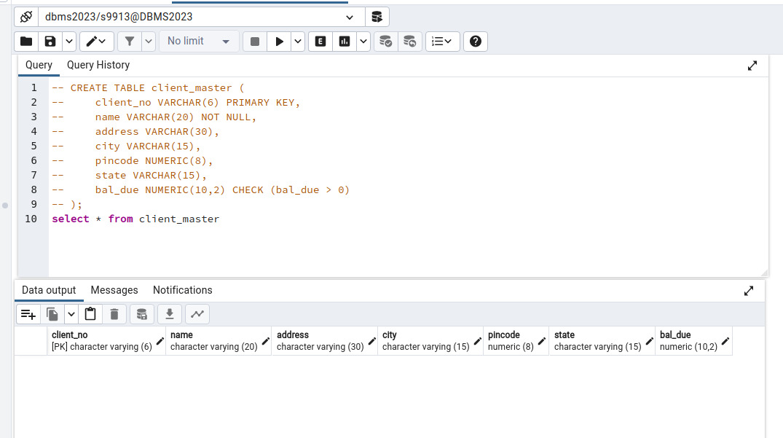

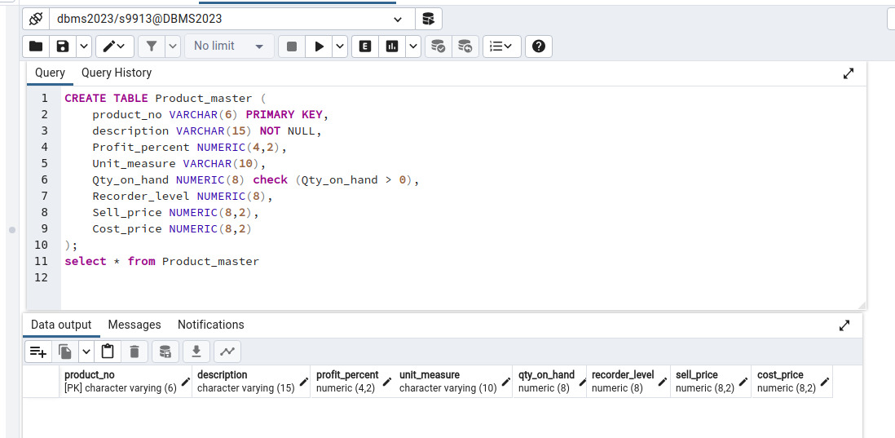

Q2

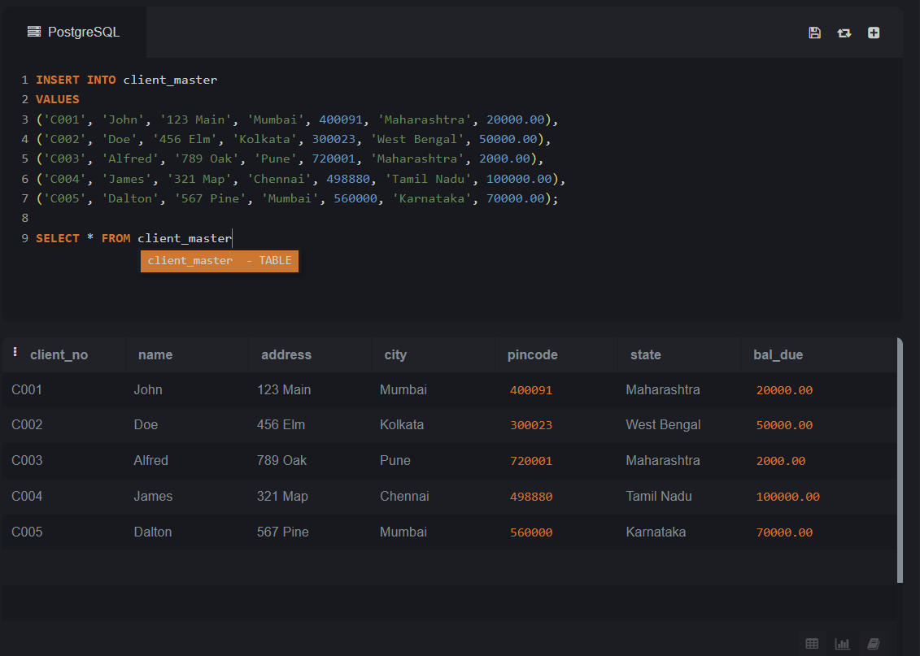

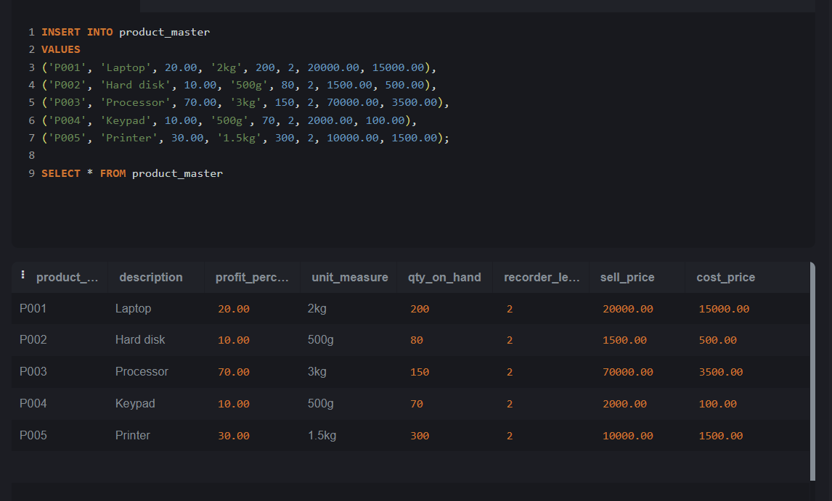

3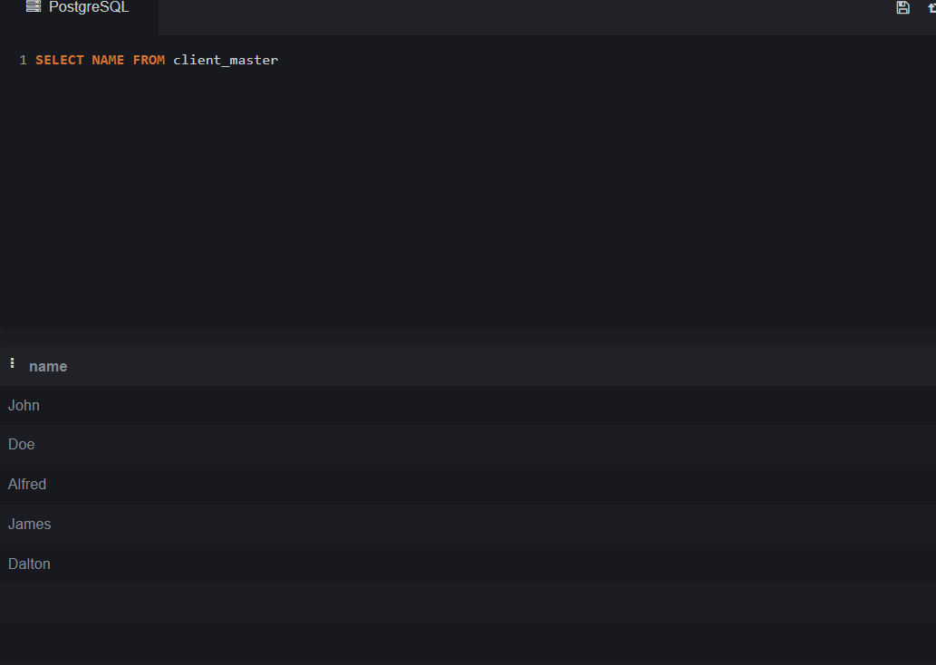

4



5

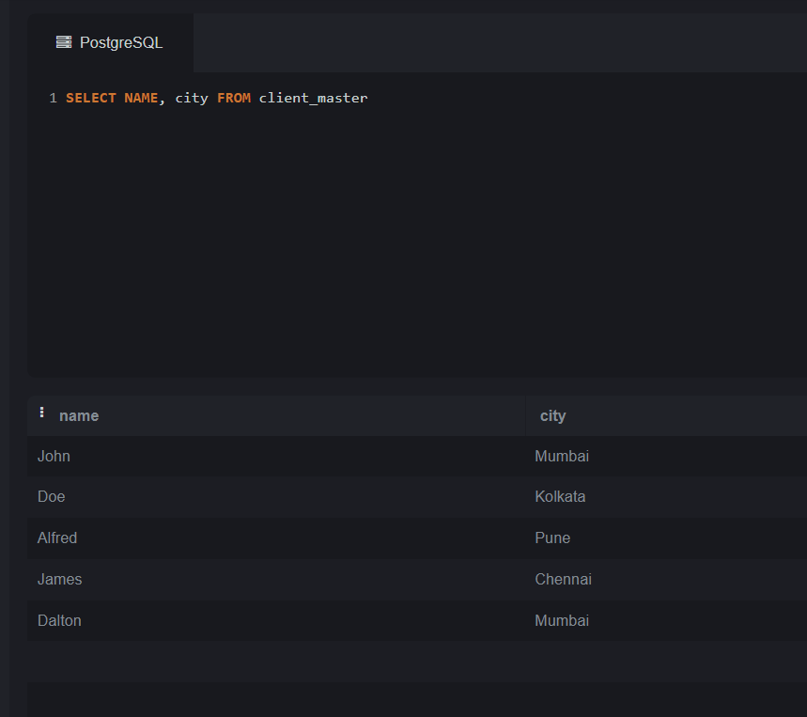

6

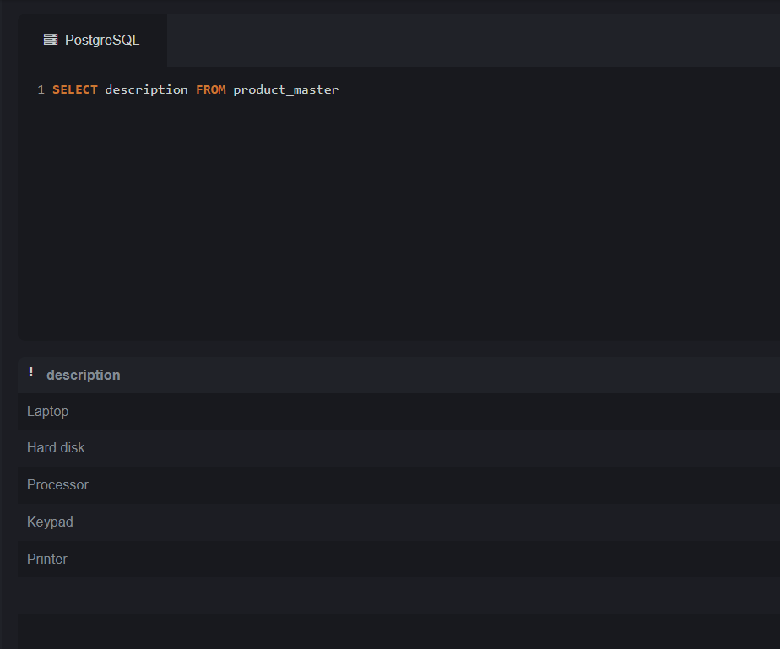

7

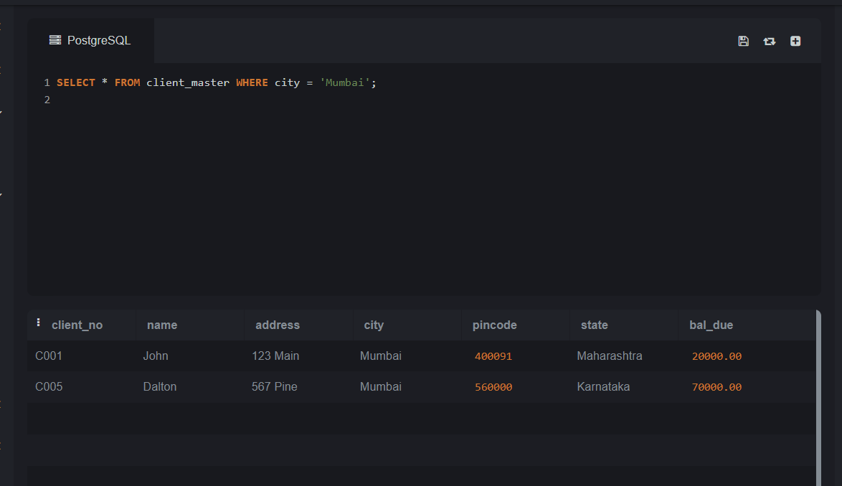

8

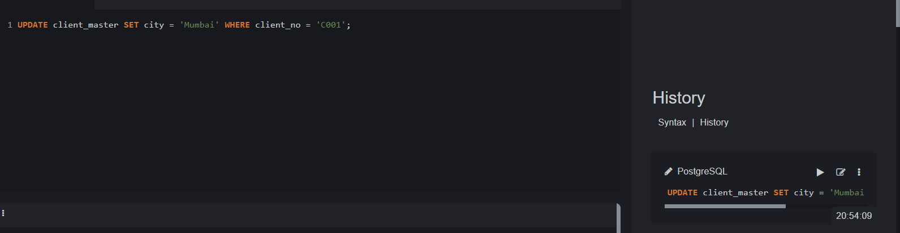

9

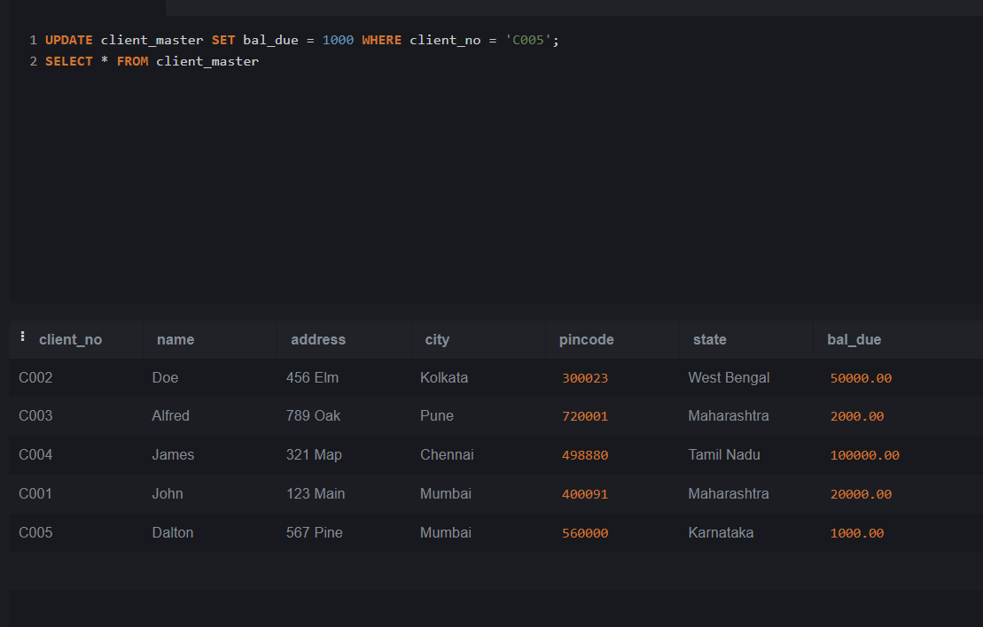

10

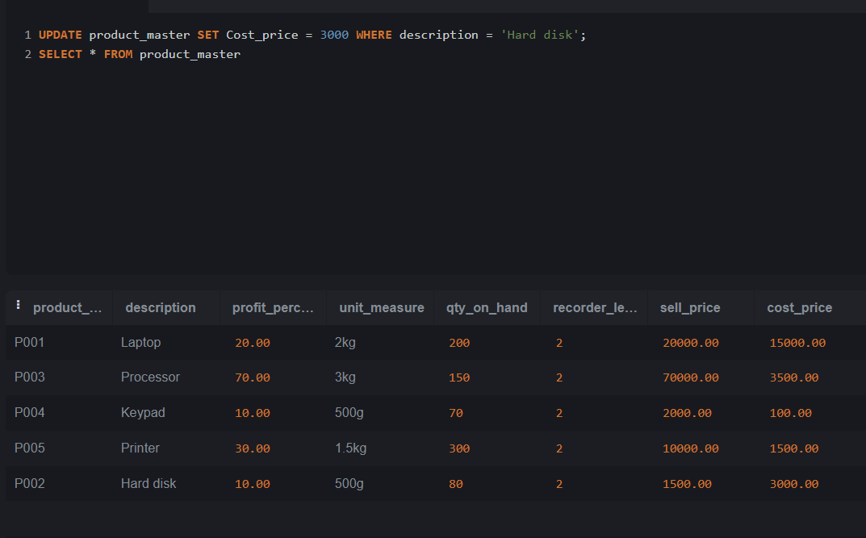

11

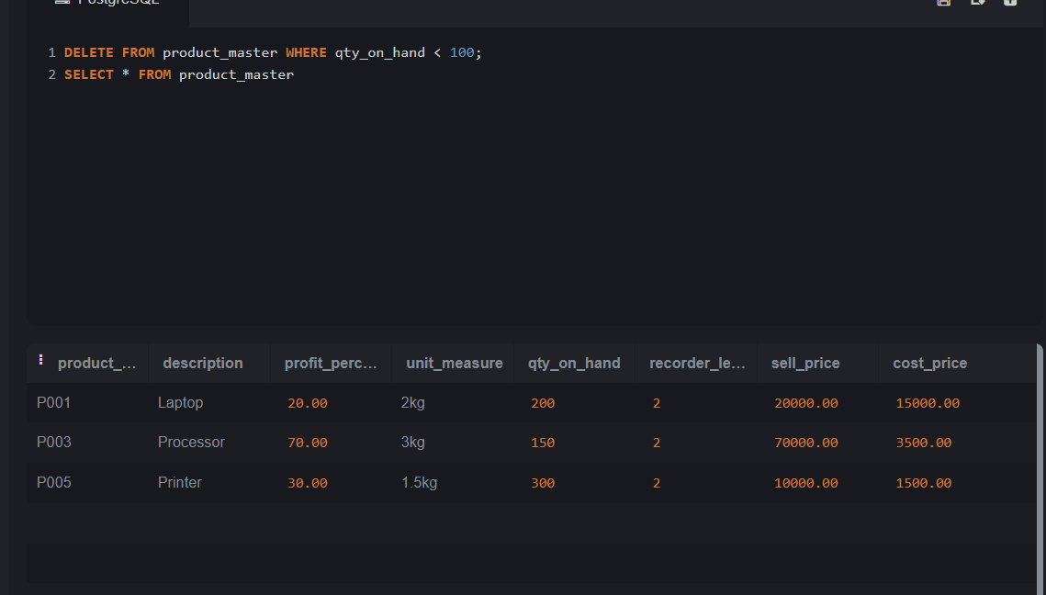

12

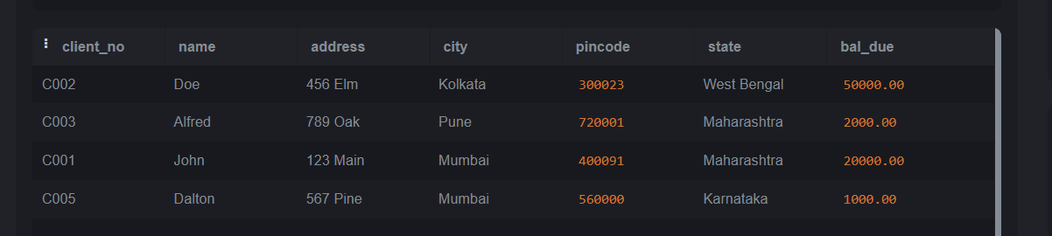

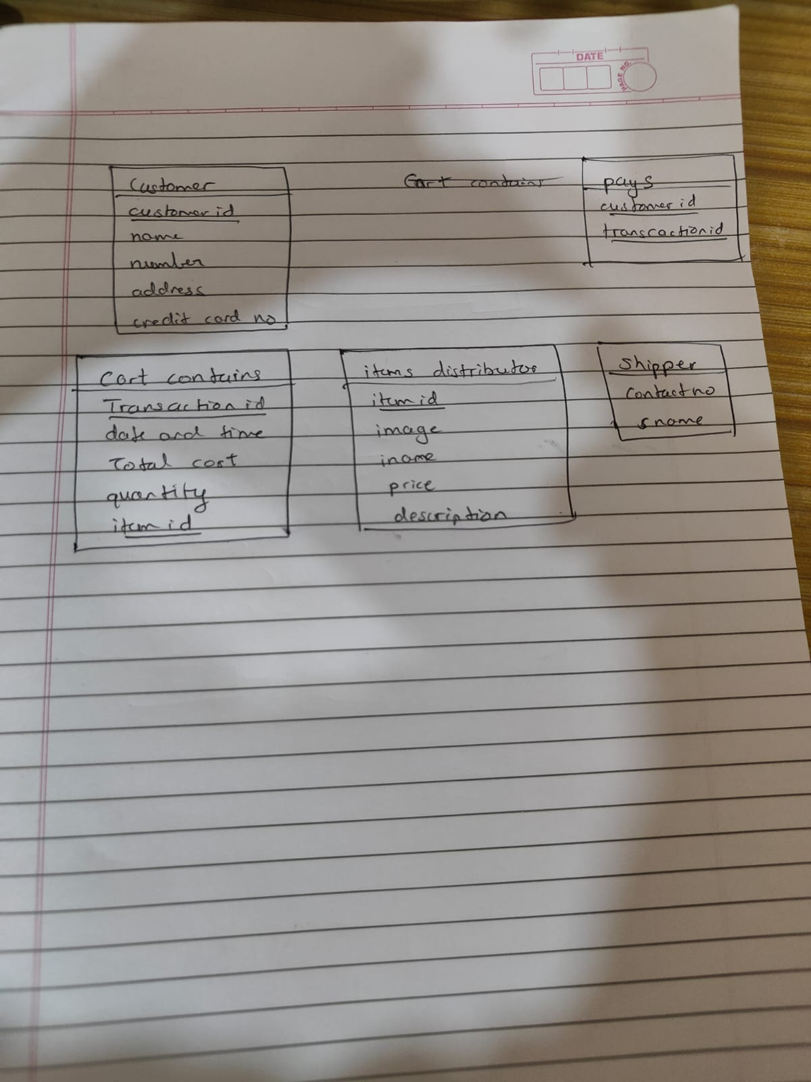

1. Integer Types:

MySQL:

TINYINT, SMALLINT, MEDIUMINT, INT, BIGINT

PostgreSQL:

SMALLINT, INTEGER, BIGINT

2. Decimal/Floating-Point Types:

MySQL:

DECIMAL, FLOAT, DOUBLE

PostgreSQL:

DECIMAL, NUMERIC, REAL, DOUBLE PRECISION

3. String/Character Types:

MySQL:

CHAR, VARCHAR, TEXT

PostgreSQL:

CHAR, VARCHAR, TEXT

4. Date and Time Types:

MySQL:

DATE, TIME, DATETIME, TIMESTAMP

PostgreSQL:

DATE, TIME, TIMESTAMP, INTERVAL

5. Boolean Type:

MySQL:

BOOLEAN

PostgreSQL:

BOOLEAN

DELETE:

The DELETE statement is used to remove specific rows from a table based on a condition specified in the WHERE clause.

It allows more flexibility as you can delete specific rows that meet certain criteria.

TRUNCATE:

The TRUNCATE statement is used to remove all rows from a table.

It removes all rows without considering any conditions. It effectively deletes all data from the table.