|  |
| --- |
| SE COMP - A Roll number : 9913 |
| Experiment no. : 7 Date of Implementation: 26/ 03/ 2024 |
| Aim : To implement Nested Sub-queries in SQL |
| Tool Used : PostgreSQL/ Mysql |
| Related Course outcome : At the end of the course, Students will be able to Use SQL : Standard language of relational database |
| **Rubrics for assessment of Experiment:** |
| **Assessment Marks :** |
| **Total : (Out of 10)** |

|  |  |  |  |
| --- | --- | --- | --- |
| Indicator | Poor | Average | Good |
| Timeliness   * Maintains assignment   deadline (3) | Assignment not done (0) | One or More than One week late (1-2) | Maintains  deadline (3) |
| Completeness and neatness   * Complete all parts of   assignment(3) | N/A | < 80% complete  (1-2) | 100%  complete (3) |
| Originality   * Extent of plagiarism(2) | Copied it from someone else(0) | At least few  questions have been done without copying(1) | Assignment has been solved completely without copying (2) |
| Knowledge   * In depth knowledge of the assignment(2) | Unable to answer 2 questions(0) | Unable to answer 1 question (1) | Able to answer 2 questions (2) |

|  |  |
| --- | --- |
| Timeliness |  |
| Completeness and neatness |  |
| Originality |  |
| Knowledge |  |
| Total |  |

|  |  |  |  |
| --- | --- | --- | --- |
|  | | | |
| **Teacher's Sign :** | | | |
|  | ***EXPERIMENT 7*** | Nested subqueries in SQL |  |
|  | Aim | To implementnested sub-queries in SQL |  |
|  | Tools | PostgreSQL/Mysql |  |

Procedure

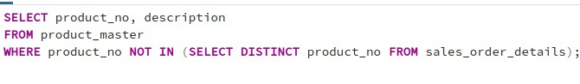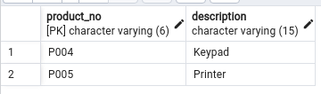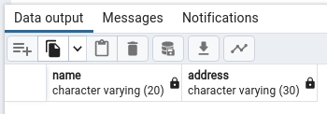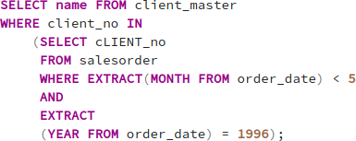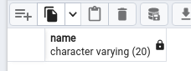

Use the tables created in the previous experiments and Perform the following queries using nested sub-queries.

**Client_master** (client_no, name, address, city, pincode, state, bal_due) **Product_master** (product_no, description, profit_percentage, unit_measure,qty_on_hand, reorder_level, sell_price, cost_price) **Sales_order**( order_no, order_date, client_no, dely_Addr, salesman_no, dely_type, billed_yn, dely_date, order_status) **Sales_order_details**(order_no, product_no, qty_ordered, qty_disp, product_rate)

1. Find the product no. and description of non-moving products i.e. products not being sold.
2. Find the customer name, address for the client who has placed order no ‘O191’
3. Find the clients names who have placed orders before the month of May’96
4. Find out if the product ‘1.44 Drive’ has been ordered by any client and print the client_no, name to whom it was sold

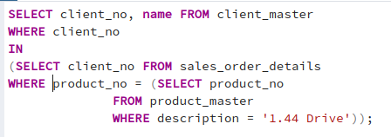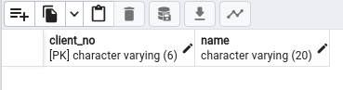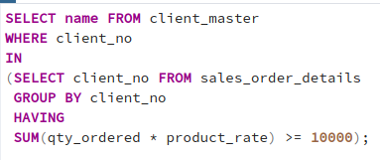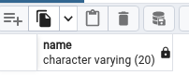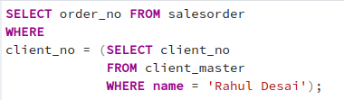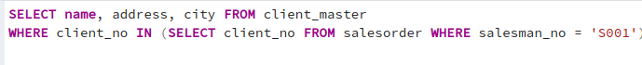

1. Find the names of clients who have placed orders worth Rs. 10000 or more
2. Retrieve all the orders placed by a client named ‘Rahul Desai’ from the sales_order table.
3. Retrieve name, address, city of all the clients who have placed an order through salesman no ‘s001’.

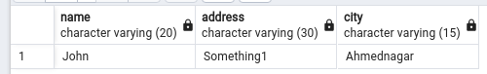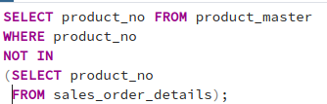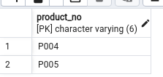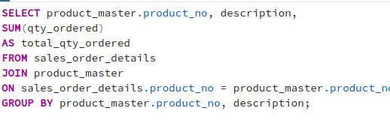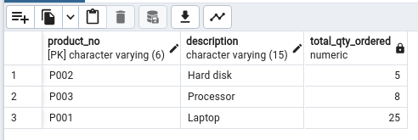

1. Find out all the products that are not being sold from the product_master table, based on the products actually sold as shown in the sales_order_details table.
2. Retrieve the product numbers, their description and the total quantity ordered for each product.
3. What is incremental Update?

In database management systems (DBMS), an incremental update refers to updating data by only modifying the specific changes made since the last update, rather than reprocessing the entire dataset. This method is efficient for large datasets where only a portion of the data has been altered.

1. Explain is use of **on delete cascade** and **on update cascade** with suitable example?

In DBMS, the "ON DELETE CASCADE" and "ON UPDATE CASCADE"

are referential actions that can be specified when defining foreign key constraints in relational databases. Here is how they are used:

* + - ON DELETE CASCADE: When a record in the parent table is deleted, all related records in the child table will be automatically deleted. This maintains referential integrity by removing dependent records when the referenced record is removed. It ensures that there are no orphaned rows in the child table(s).
    - ON UPDATE CASCADE: When a record in the parent table is updated, the matching records in the child table will be automatically updated. This action ensures that changes made to the parent table are reflected in the child table, maintaining consistency between the two tables.

**Post Lab Questions:**