|  |  |  |  |  |  |  |
| --- | --- | --- | --- | --- | --- | --- |
| SE Comp A Roll number : 9913 | | | | | | |
| Experiment no. : 8 Date of Implementation : 26/3/2024 | | | | | | |
| Aim : To implement PL/pgSQL | | | | | | |
| Tool Used : PostgreSQL | | | | | | |
| Related Course outcome : At the end of the course, Students will be able to Use SQL : Standard language of relational database | | | | | | |
| **Rubrics for assessment of Experiment:** | | | | | | |
|  | Indicator | | Poor | Average | Good |  |
|  | Timeliness   * Maintains assignment   deadline (3) | | Assignment not done (0) | One or More than One week late (1- 2) | Maintains deadline (3) |
|  | Completeness and neatness   * Complete all parts of   assignment(3) | | N/A | < 80% complete  (1-2) | 100%  complete (3) |
|  | Originality   * Extent of plagiarism(2) | | Copied it from someone else(0) | At least few questions have been done without copying(1) | Assignment has been solved completely without  copying (2) |
|  | Knowledge   * In depth knowledge of the assignment(2) | | Unable to answer 2 questions(0) | Unable to answer 1 question (1) | Able to answer 2 questions (2) |
| **Assessment Marks :**  Timeliness  Completeness and neatness  Originality Knowledge Total | | | | | | |
| **Total : (Out of 10)** | | | | | | |
| **Teacher's Sign :** | | | | | | |
|  | ***EXPERIMENT 8*** | PL/pgSQL | | | | |

|  |  |
| --- | --- |
|  |  |
|  |  |
|  |  |
|  |  |
|  |  |

|  |  |  |
| --- | --- | --- |
|  | Aim | To implement PL/pgSQL |
|  | Tools | PostgreSQL  <http://www.postgresqltutorial.com/postgresql-stored-procedures/> mysql  <https://dev.mysql.com/doc/refman/8.0/en/cursors.html> https://[www.mysqltutorial.org/mysql-error-handling-in-stored-](http://www.mysqltutorial.org/mysql-error-handling-in-stored-) procedures/  [https://dev.mysql.com/doc/refman/8.0/en/error-message-](https://dev.mysql.com/doc/refman/8.0/en/error-message-elements.html) [elements.html](https://dev.mysql.com/doc/refman/8.0/en/error-message-elements.html)  https://[www.mysqltutorial.org/mysql-stored-procedure-tutorial.aspx](http://www.mysqltutorial.org/mysql-stored-procedure-tutorial.aspx) |
|  | Procedure | PL/pgSQL is a loadable procedural language for the Postgres database system. |

This package was originally written by Jan Wieck. The design goals of PL/pgSQL were to create a loadable procedural language that can be used to create functions and trigger procedures, adds control structures to the SQL language.

Structure of PL/pgSQL

PL/pgSQL is a block-structured language. The complete text of a function definition must be a block. A block is defined as:

[<<label>>]

[ DECLARE Declarations ] BEGIN

statements END [label];

Each declaration and each statement within a block is terminated by a semicolon. A block that appears within another block must have a semicolon after END , as shown above; however the final END that concludes a function body does not require a semicolon

|  |  |
| --- | --- |
| IF boolean-expression THEN | IF boolean-expression |
| statements | THEN |
| END IF; | statements |
|  | ELSE statements |
|  | END IF; |

|  |  |
| --- | --- |
| WHILE boolean- | FOR name IN [ REVERSE ] |
| expression | expression..expression |
| LOOP | [ BY expression] LOOP |
| statements | statements |
| END LOOP [label]; | END LOOP [label]; |
|  | FOR i IN 1..10 LOOP |
|  | -- i will take on the values 1,2,3,4,5,6,7,8,9,10 |
|  | within the loop |
|  | END LOOP; |
|  | FOR i IN REVERSE 10..1 LOOP |
|  | -- i will take on the values 10,9,8,7,6,5,4,3,2,1 |
|  | within the loop |
|  | END LOOP; |
|  | FOR i IN REVERSE 10..1 BY 2 LOOP |
|  | -- i will take on the values 10,8,6,4,2 within the |
|  | loop |
|  | END LOOP; |

**Procedure**

1. Write a PROCEDURE to display sum of digits of a three digit number
2. Write a procedure/ block to display prime numbers

Input : N = 20

Output : 2, 3, 5, 7, 11, 13, 17, 19

1. Write a procedure/block to display Fibonacci series upto 8th term (start with 0,1)
2. Create or use EMP(eid, Name, location, mid). Write a procedure using cursor to display list of managers(mid) with name;

|  |  |  |
| --- | --- | --- |
|  | **Post Lab Questions:** | 1. Give advantages of PLSQL vs SQL 2. Explain data types of PgSQL/plsql of mysql |

Q1.Write a PROCEDURE to display sum of digits of a three digit number

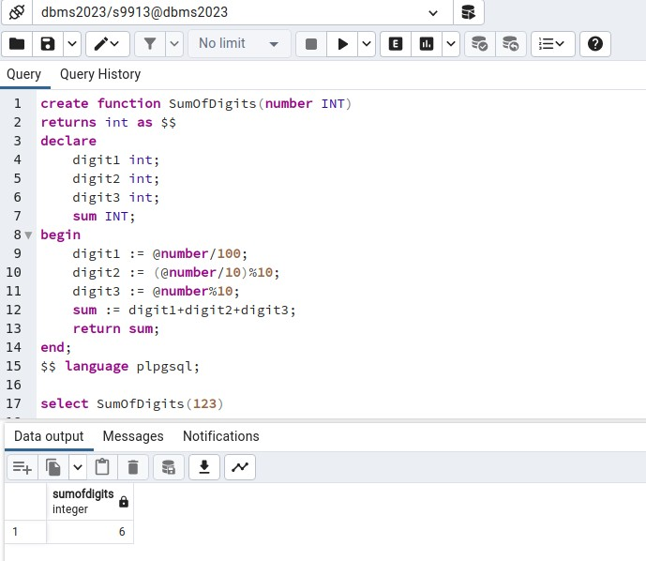

Q2 Write a procedure/ block to display prime numbers

CREATE OR REPLACE FUNCTION generate_primes(limit_num INT) RETURNS SETOF INT AS $$

DECLARE

num INT; divisor INT;

is_prime BOOLEAN;

BEGIN

num := 2; -- Starting from 2, as it's the smallest prime number

WHILE num <= limit_num LOOP is_prime := TRUE;

-- Check if num is divisible by any number other than 1 and itself FOR divisor IN 2..ROUND(SQRT(num)) LOOP

IF num % divisor = 0 THEN is_prime := FALSE;

EXIT;

END IF; END LOOP;

IF is_prime THEN RETURN NEXT num; END IF;

num := num + 1; END LOOP;

RETURN;

END;

$$ LANGUAGE PLPGSQL;

select generate_primes(20)

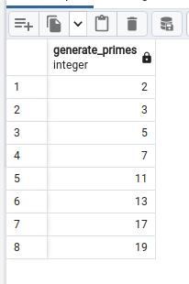

Q3 Write a procedure/block to display Fibonacci series upto 8th term (start with 0,1) CREATE OR REPLACE FUNCTION fibonacci(limit_num INT)

RETURNS SETOF INT AS $$ DECLARE

num1 int := 0; num2 int := 1;

num3 INT; n int := 2;

BEGIN

return next 0;

return next 1;

while n<limit_num LOOP num3 := num1 + num2; num1 := num2;

num2 := num3; n := n+1;

RETURN next num3;

end loop; return;

END;

$$ LANGUAGE PLPGSQL;

select fibonacci(8)

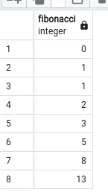

Q4 Create or use EMP(eid, Name, location, mid). Write a procedure using cursor to display list of managers(mid) with name;

CREATE TABLE EMP (

eid SERIAL PRIMARY KEY, Name VARCHAR(100),

location VARCHAR(100), mid INT,

FOREIGN KEY (mid) REFERENCES EMP(eid) -- Self-reference

);

-- Insert sample data

INSERT INTO EMP (Name, location, mid) VALUES ('John', 'New York', 1); INSERT INTO EMP (Name, location, mid) VALUES ('Alice', 'Los Angeles', 2); INSERT INTO EMP (Name, location, mid) VALUES ('Bob', 'Chicago', 1); INSERT INTO EMP (Name, location, mid) VALUES ('Carol', 'Houston', NULL); INSERT INTO EMP (Name, location, mid) VALUES ('David', 'Boston', 4);

-- Join EMP with itself based on eid=mid SELECT distinct e1.mid , e2.Name FROM EMP e1

join emp e2

on e1.mid = e2.eid

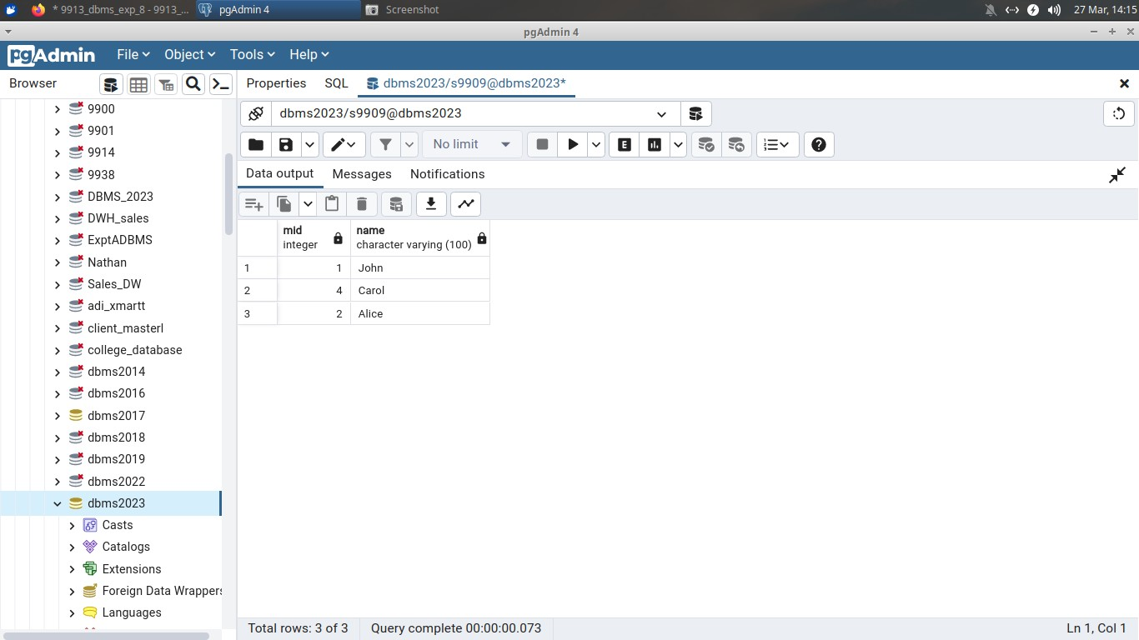

Postlab

Q1

PL/SQL offers several advantages over SQL:

* Procedural Capabilities: PL/SQL provides procedural constructs such as loops, conditional statements, exception handling, and subprograms like functions and procedures. This allows for more complex logic to be implemented directly within the database, reducing the need for round-trips between the application and the database server.
* Encapsulation and Modularity: PL/SQL allows for the encapsulation of SQL statements within blocks of code. This promotes modularity and code reusability, making it easier to maintain and update database logic.
* Performance Optimization: PL/SQL can improve performance by reducing the number of interactions between the application and the database. By executing multiple SQL statements within a single PL/SQL block, you can minimize network traffic and reduce overhead.
* Enhanced Error Handling: PL/SQL provides robust error handling mechanisms, including exception handling blocks, which allow for graceful handling of errors within the database. This improves the reliability and maintainability of database applications.

Q2 Explain data types of PgSQL/plsql of mysql

1. Numeric Data Types:

* PgSQL: Includes integer types like int, smallint, bigint, and floating-point types like real, double precision.
* PL/SQL: Offers similar numeric types such as INTEGER, SMALLINT, NUMBER, and FLOAT.
* MySQL: Provides numeric types like INT, SMALLINT, BIGINT, FLOAT, DOUBLE, etc.

1. Character Data Types:

* PgSQL: Offers character varying(n) (VARCHAR), character(n) (CHAR), text, etc.
* PL/SQL: Provides CHAR, VARCHAR2, CLOB for character data.
* MySQL: Supports CHAR, VARCHAR, TEXT, etc.

1. Date and Time Data Types:

* PgSQL: Includes timestamp, date, time, interval, etc.
* PL/SQL: Offers DATE, TIMESTAMP, INTERVAL for date and time handling.
* MySQL: Provides DATE, TIME, DATETIME, TIMESTAMP, YEAR, etc.