ISE-2 FOR Practical

Assignment: Evaluation of JIRA and Testing Tools for Course Scheduling System Total Marks: 25

Based on the requirements specification document provided for the course scheduling system, this assignment evaluates your understanding and practical application of JIRA and testing tools. Answer each question in detail, demonstrating your approach and explaining the use of tools where applicable.

Project Tracking, Requirement Breakdown, and Defect Management in JIRA (10 Marks – CO: CSC502.5)

* **Requirement Tracking: Describe how you would structure a JIRA project to manage the requirements for the course scheduling system, covering project setup, task breakdown, and the use of epics and stories.**

Create a JIRA project with epics for major features, break tasks into stories, and use sprints for milestone tracking.

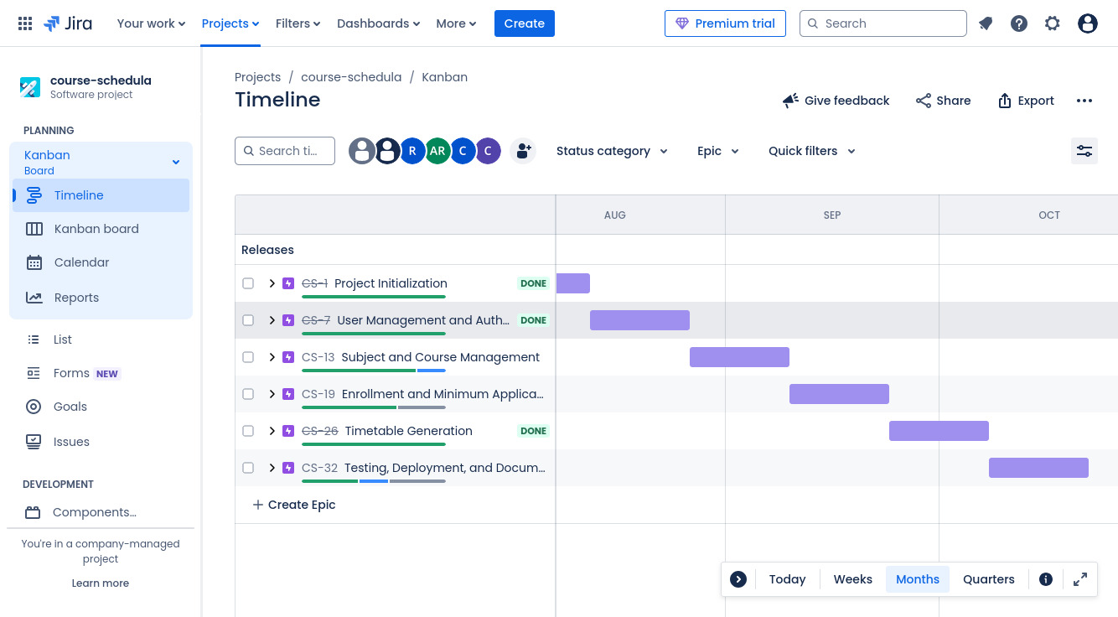

* **Defect Tracking: Identify three types of potential errors (e.g., input file errors, scheduling conflicts) based on the requirements, and explain how you would log and manage these issues in JIRA, focusing on risk identification and change management.**

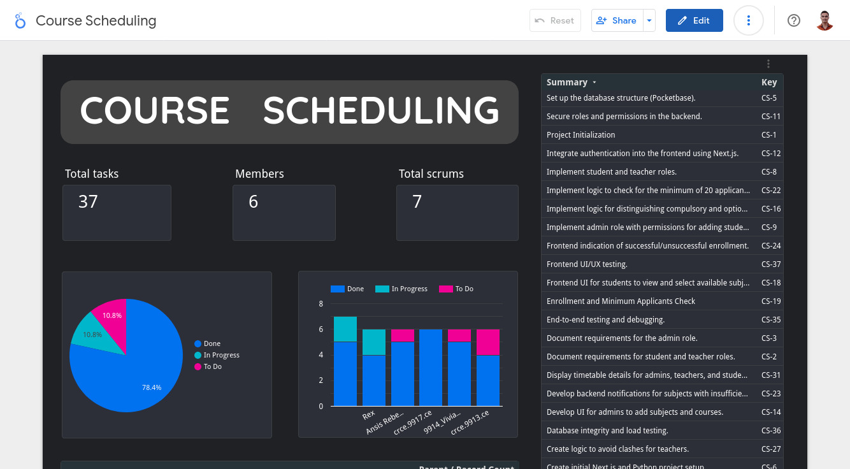

* **Progress Monitoring: Explain how JIRA can help in tracking project progress and implementing requirement changes effectively.**

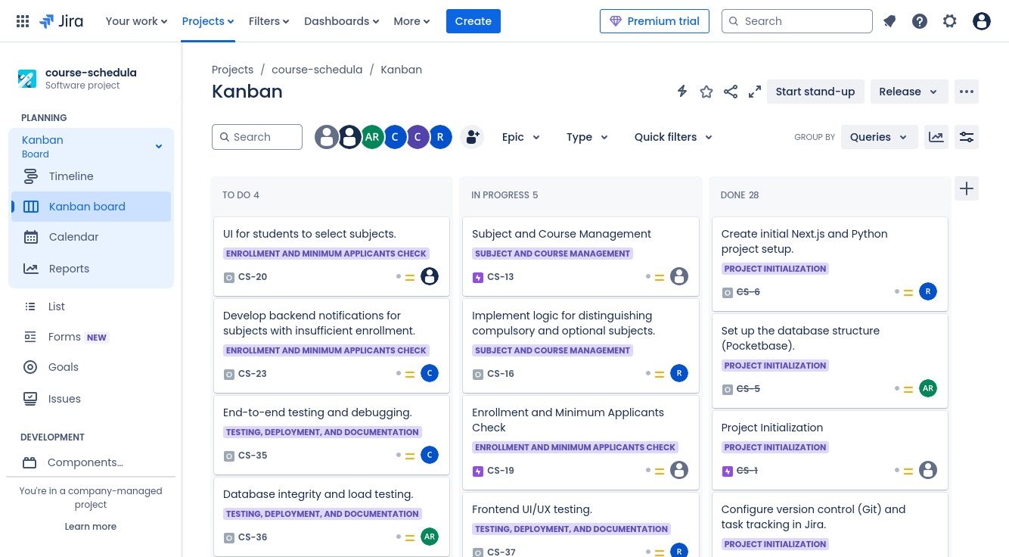

1. **Testing Automation and Performance Testing Using Testing Tools (10 Marks – CO: CSC502.4)**
   * **Test Case Design: Select three key functional requirements and describe how you would set up automated test cases for these using a testing tool. Include details on validation criteria for inputs, expected outputs, and error handling.**

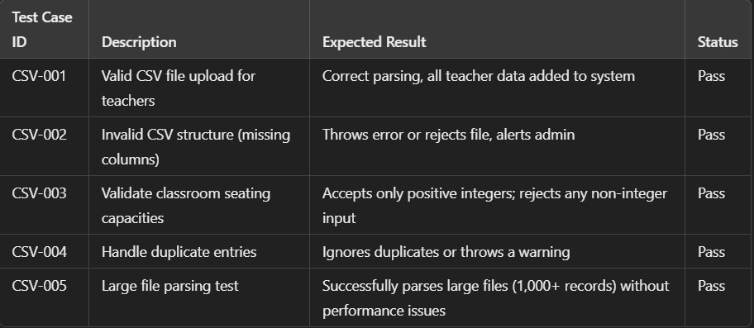

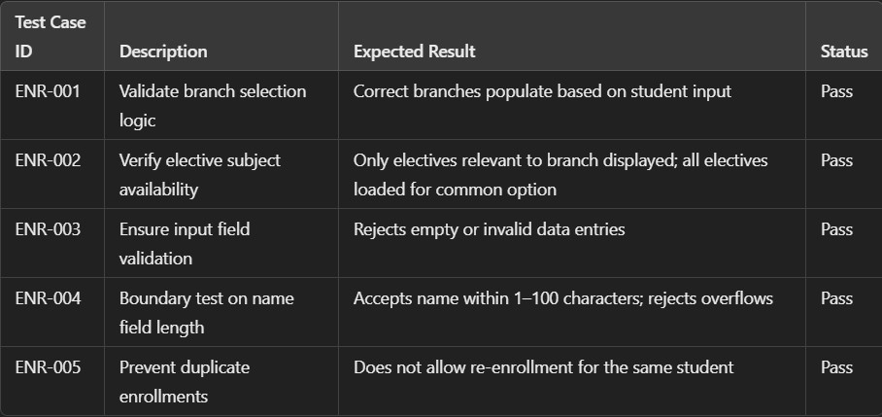

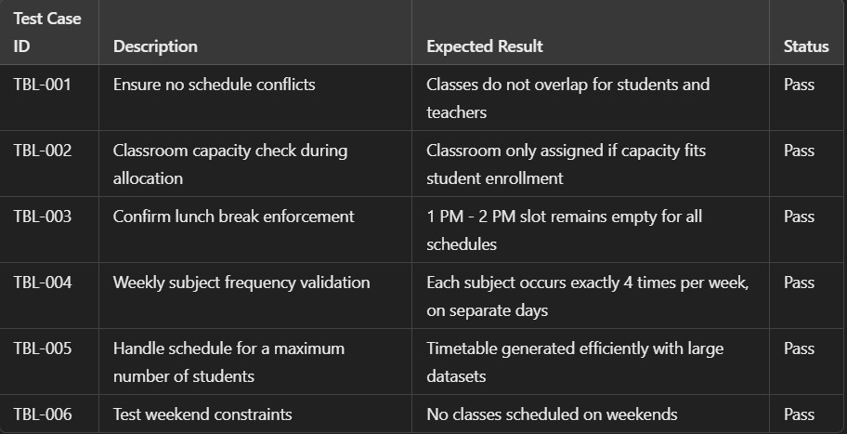

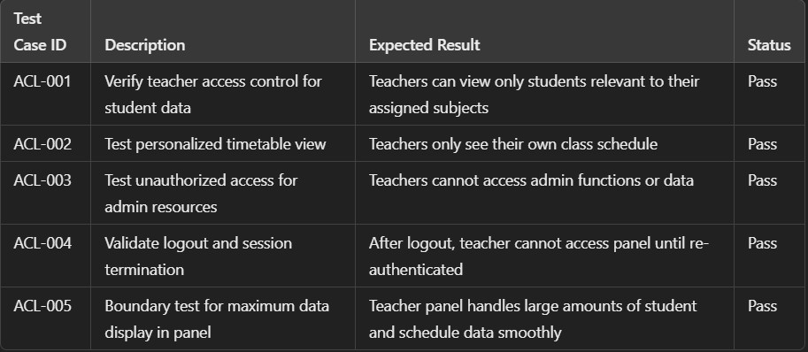

* + **Performance Testing: Given the performance constraint (generating reports within one minute for a dataset of 20 courses), outline a performance test plan and describe how you would use a testing tool to ensure compliance with this requirement.**

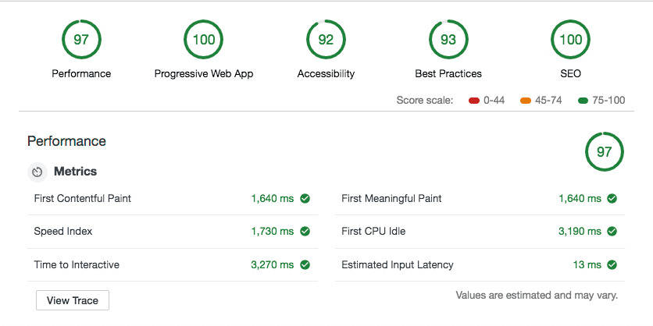

1. **Acceptance Criteria Management and Quality Assurance in JIRA (5 Marks – CO: CSC502.5)**
   * **Explain how you would define, manage, and document acceptance criteria in JIRA based on the requirements and acceptance criteria provided.**

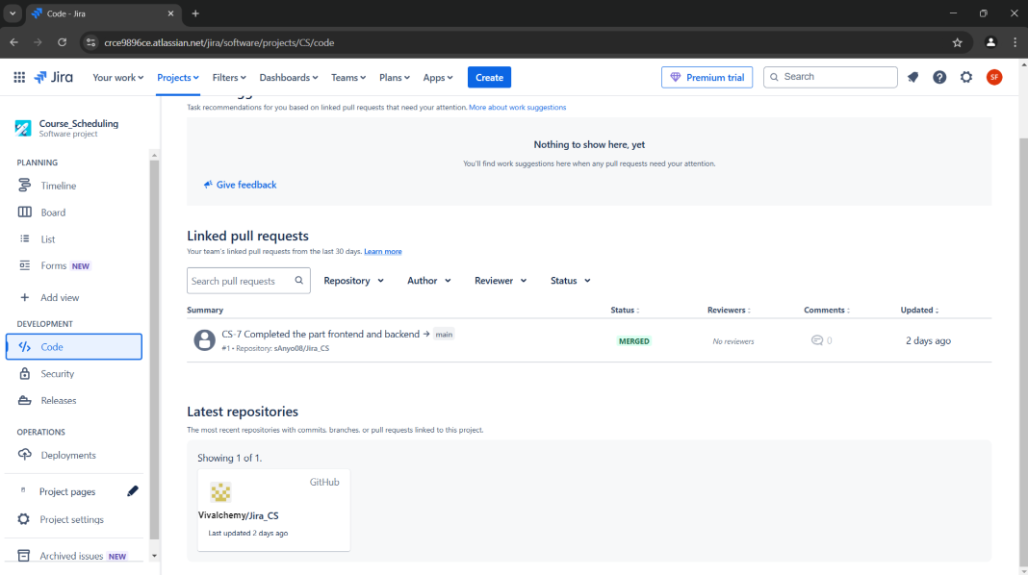

* + **Describe your approach to using JIRA for quality assurance, focusing on tracking acceptance criteria and organizing test cases to ensure alignment with the system**



requirements and project quality.

Rubrics :

COs Criteria Excellent

(10/5) Good (8/4) Satisfactory

Managemen

t in JIRA

(6/3)

o n

Needs

Improvemen t (4/2) Minimal (2/1)

Clear, well organized

Adequate design, basic

Limited setup, lacks

Lacks

CSC502. 5

structure,

performance organization

alignment

issues logged with detail

testing

Mostly

and detail

Minimal test

**and**

documentati o n

CSC502. 4

Well-defined aligned,

case design,

test cases,

adequate

lacking key

comprehensi documentati

v e o n

details

performance Basic

CSC502. 5

Project

Setup and

plan

Fully aligned with

structure, limited customizatio

Minimal alignment, lacks

Defect

requirements n, basic issue organization

Managemen t in JIRA

, clear documentati o n

tracking

Basic design, some test

Unclear setup, poorly managed

Test Case

Design and

Mostly clear setup, some

cases missing issues validation

Performance customizatio

Testing

n, issues logged

Partially aligned,

Minimal or missing test

Acceptance Criteria

missing some cases documentati