Cloud Computing Report

Environmental Impact of Cloud Computing

Mark Lopes(9913)

Chapter 1

Introduction

Cloud computing has revolutionized the way businesses and individuals store, process, and access data. However, the massive infrastructure supporting cloud services—data centers, networking equipment, and cooling systems—has a significant environmental impact. This report explores the energy consumption and carbon emissions associated with cloud computing, evaluates the sustainability efforts of major cloud providers, and assesses whether cloud computing is a more sustainable alternative to traditional data centers.

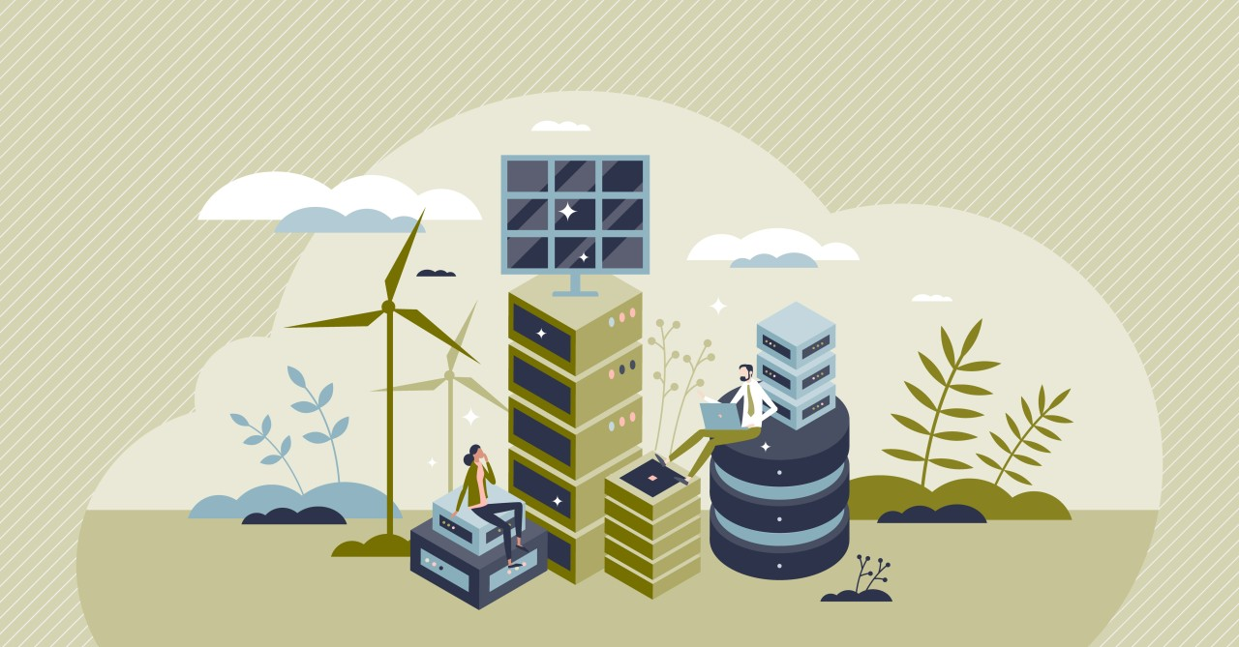

Chapter 2

Environmental Footprint of Cloud Computing

2.1 Energy Consumption

* Cloud computing relies on vast data centers that require continuous power for servers, storage, and networking.
* According to research, data centers account for approximately 1% of global electricity demand and are expected to increase with the growth of cloud services.
* High-performance computing, AI workloads, and large-scale storage contribute to high energy consumption.

2.2 Carbon Emissions

* The carbon footprint of cloud services comes from the electricity used by data centers, which often rely on fossil fuels.
* Studies estimate that the ICT sector, including cloud computing, contributes around 2-3% of global greenhouse gas emissions, comparable to the aviation industry.
* Emissions vary based on energy sources: data centers powered by renewable energy have a lower environmental impact than those using coal or natural gas.

2.3 Water Usage

* Data centers require water for cooling systems to prevent overheating.
* A single large-scale data center can consume millions of gallons of water annually, impacting local water resources, especially in drought-prone areas.

Chapter 3

Sustainability Efforts of Major Cloud Providers

3.1 Google Cloud

* Google Cloud has been carbon neutral since 2007 and aims for 100% renewable energy for all operations by 2030.
* Uses AI-powered energy-efficient cooling systems in its data centers.

3.2 Microsoft Azure

* Plans to be carbon negative by 2030, meaning it will remove more carbon than it emits.
* Committed to zero waste and water-positive operations in data centers by 2030.

3.3 Amazon Web Services (AWS)

* AWS aims for 100% renewable energy usage by 2025.
* Invests in wind and solar farms to offset data center energy consumption.

3.4 IBM Cloud

* IBM focuses on hybrid cloud solutions to reduce carbon footprint.
* Uses AI to optimize energy consumption in data centers.

Chapter 4

Effectiveness of Sustainability Measures

4.1 Renewable Energy Adoption

* Many cloud providers are shifting to solar, wind, and hydroelectric power, reducing dependence on fossil fuels.
* However, energy grids in some regions still rely on coal, limiting the effectiveness of renewable initiatives.

4.2 AI-Driven Efficiency Improvements

* AI and machine learning optimize cooling and workload distribution, reducing energy waste.
* Examples include Google’s AI-driven cooling, which has cut energy use by 30% in its data centers.

4.3 Carbon Offsetting Programs

* Companies invest in carbon credits and reforestation projects to balance emissions.
* While beneficial, carbon offsetting does not eliminate emissions at the source.

Chapter 5

Comparison: Cloud Computing vs. Traditional Data Centers

|  |  |  |
| --- | --- | --- |
| Factor | Traditional Data Centers | Cloud Computing |
| Energy Efficiency | Low – Often runs inefficient, outdated hardware. | High – Uses modern, optimized servers. |
| Carbon Emissions | Higher – Individual companies rely on local power sources. | Lower – Large providers use renewable energy. |
| Scalability | Limited – Requires physical expansion for more capacity. | High – Virtualized resources scale efficiently. |
| Resource Utilization | Low – Many on-premise data centers run under capacity. | High – Shared cloud infrastructure optimizes usage. |
| Cooling Efficiency | Varies – Older systems use inefficient cooling. | AI-driven cooling reduces energy consumption. |

Cloud computing is more sustainable than traditional data centers due to better resource utilization, energy-efficient hardware, and large-scale investments in green energy.

However, its sustainability depends on renewable energy availability, efficient cooling solutions, and responsible growth in emerging markets.

Chapter 8

Conclusion

Cloud computing has the potential to be a sustainable alternative to traditional IT infrastructure, but its environmental impact remains a concern. While major cloud providers are taking steps to improve energy efficiency and reduce carbon emissions, continued investment in renewable energy and innovative cooling solutions is necessary. The transition to a fully green cloud ecosystem will require a collaborative effort between governments, cloud providers, and businesses to ensure a sustainable digital future.

<https://earth.org/environmental-impact-of-cloud-computing>

<https://internationalbanker.com/technology/the-environmental-impact-of-cloud-computing-and-the-importance-of-greening-data-centres>