## Department of Computer Engineering Academic Term : Jan-Apr 2023

**Class :** T.E Computer Sem -VI

**Subject :** Mobile Computing

|  |  |
| --- | --- |
| **Practical No:** | **5** |
| **Title:** | To implement a basic function of Code Division Multiple Access (CDMA) to test the orthogonality and autocorrelation of a code to be used for CDMA operation |
| **Date of Performance:** | 31/03/2025 |
| **Date of Submission:** | 27/04/2025 |
| **Roll No:** | 9913 |
| **Name of the Student:** | Mark Lopes |

Evaluation:

|  |  |  |
| --- | --- | --- |
| **Sr. No** | **Rubric** | **Grade** |
| **1** | **On time Completion & Submission(2)** |  |
| **2** | **Output(3)** |  |
| **3** | **Code Optimization(3)** |  |
| **4** | **Knowledge of the topic(2)** |  |
| **5** | **Total (10)** |  |

**Signature of the Teacher :**

# ExperimentNo.:5

**Aim:** Theory:To implement a basic function of Code Division Multiple Access (CDMA) to test the orthogonality and autocorrelation of a code to be used for CDMA operation. Write an application based on the above concept.

Code-division multiple access (CDMA) is a channel access method used byvarious radio communication technologies. CDMA is an example of multiple access, whereseveral transmitters can send information simultaneously over a single communication channel.This allows several users to share a band of frequencies (see bandwidth). To permit this

withoutundue interference between the users, CDMA employs spread spectrum technology and a specialcodingscheme(whereeachtransmitteris assignedacode).

CDMAisusedastheaccessmethodinmany mobilephonestandards. IS-95,alsocalled"cdmaOne", and its 3G evolution CDMA2000, are often simply referred to as "CDMA",but UMTS, the 3G standard used by GSM carriers, also uses "wideband CDMA", or W-CDMA,aswellasTD-CDMAandTD-SCDMA, asitsradio technologies.

The intended 4G successor to CDMA2000 was UMB (Ultra Mobile Broadband); however, inNovember2008, Qualcomm announceditwasendingdevelopmentofthetechnology,favoringLTEinstead

CDMAOrthogonality:

Techniquesgenerallyusedaredirectsequencespreadspectrummodulation(DS-CDMA),frequenc y hopping or mixed CDMA detection (JDCDMA). Here, a signal is generated whichextends over a wide bandwidth. A code called spreading code is used to perform this action.Using a group of codes, which are orthogonal to each other, it is possible to select a signal with agivencodeinthepresence ofmanyothersignals withdifferent orthogonalcodes.

CDMAAutocorrelation:

Autocorrelation of the sequence, it determines the ability to synchronize and lock the spreadingcodeforthereceivedsignal.

# https://[www.youtube.com/watch?v=UzLUJuvNi_U](http://www.youtube.com/watch?v=UzLUJuvNi_U)

## Conclusion:

Thus, we have studied the CDMA code to test auto correlation and orthogonality of codes and executed the same using the java code as above and got proper output for it. OUTPUT

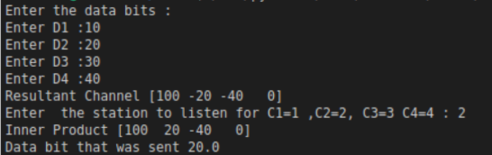

**Postlab: OBSERVATION:**

