FR. CONCEICAO RODRIGUES COLLEGE OF ENGINEERING

Department of Computer Engineering
Academic Year 2025-26

Rubrics for Lab Experiments

Class | : B.E. Computer  Engineering | Subject Name :DC Lab
Semester | : VIII | Subject Code : CSL801

Practical No: | 4
Title: | Implement a message passing framework using middleware(Rabbitmq)
Date of Performance: | 13/11/25
Roll No: | 9913
Name of the Student: | Mark Lopes
Evaluation:

Performance Indicator | Below average | Average | Good | Excellent | Marks
On time Submission (2) | Not submitted (0) | Submitted after deadline (1) | Early or on time submission(2) | ---
Test cases and output  (4) | Incorr ect output (1) | The expected output is verified only a for  few test cases (2) | The expected output is Verified for all test cases but is not presentable (3) | Expected output is obtained for all test cases. Presentable and easy to follow (4)
Coding efficiency (2) | The code is not structured at all (0) | The code is structured but not efficient (1) | The code is Structured and efficient. (2) | -
Knowledge(2) | Basic concepts not clear (0) | Understood the basic concepts (1) | Could explain the concept with  suitable example (1.5) | Could relate the theory with real world application(2)
Total

Signature of the Teacher:

Aim:Implement a message-passing system using a middleware framework

Introduction:

A message queueing system is a software architecture pattern that enables communication between different parts of a distributed system by allowing them to exchange messages. In this system, messages are stored in a queue and are retrieved by consumers when they are ready to process them. This decouples the producers and consumers of messages, allowing them to operate independently and asynchronously.
Message queueing systems can be implemented using various technologies, including open-source solutions like Apache Kafka, RabbitMQ, and ActiveMQ. In this practical we are going to implement a simple message queueing system using RabbitMQ.

RabbitMQ Model:

RabbitMQ is one of the most widely used message brokers, it acts as the message broker, “the mailman”, a microservice architecture needs.
RabbitMQ consists of:

- producer — the client that creates a message

- consumer — receives a message

- queue — stores messages

- exchange — enables to route messages and send them to queues

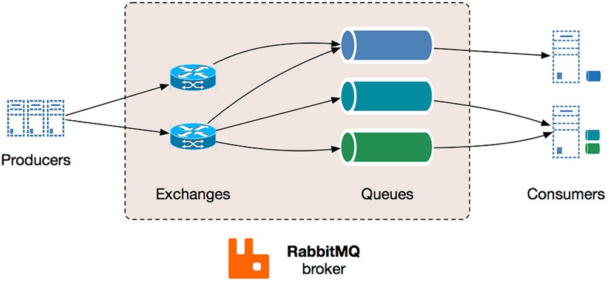

The system functions in the following way:

- producer creates a message and sends it to an exchange

- exchange receives a message and routes it to queues subscribed to it

- consumer receives messages from those queues he/she is subscribed to

Implementation:

We are going to implement a job manager as described in the below figure. Components of our message queueing system are:
  - Publisher – produces jobs/messages into the queue

  - Consumers – consumes the jobs

  - RabbitMQ broker – contains the exchange and queue

  - Connections – denoted by double-sided arrows

  - Channels – denoted by colourful bands within the connections

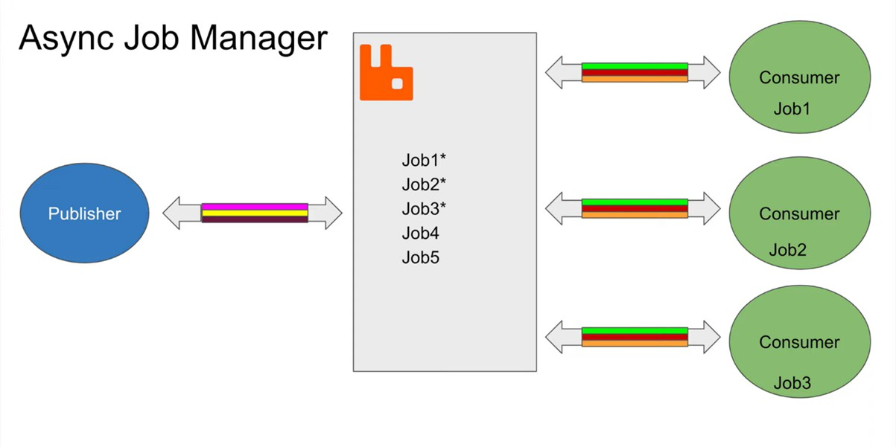

Fig. Message Queuing System

Technologies Used:

- Docker
- RabbitMQ Image
- Node.js
- amqplib Library

Step 1: Run RabbitMQ’s Docker Image

Step 2: Write a Producer Program

Step 3: Write a Consumer Program

Publisher.js:

const amqp = require('amqplib');

const RABBITMQ_URL = 'amqp://localhost'; // Use 'amqp://localhost' if running on host or appropriate Docker network setting
const QUEUE_NAME = 'job_queue';

async function connectAndPublish() { try {
// 1. Connect to RabbitMQ server

const connection = await amqp.connect(RABBITMQ_URL); const channel = await connection.createChannel();

// 2. Assert the queue (makes sure the queue exists, or creates it)

// 'durable: true' ensures the queue survives a broker restart await channel.assertQueue(QUEUE_NAME, {
durable: true

});

// The messages (jobs) to be sent const jobs = [
"Job 1: Process User Data", "Job 2: Generate Report PDF", "Job 3: Send Email Notification", "Job 4: Backup Database"
];

for (let i = 0; i < jobs.length; i++) { const msg = jobs[i];

// 3. Send the message to the queue

// `Buffer.from(msg)` converts the string to a Buffer

// `persistent: true` marks the message as persistent, so it survives a broker restart channel.sendToQueue(QUEUE_NAME, Buffer.from(msg), {
persistent: true

});
console.log(`✅ [Producer] Sent job: '${msg}'`);
}

// Close the connection after a short delay to ensure messages are sent setTimeout(() => {
connection.close(); process.exit(0);
}, 500);

} catch (error) {
console.error("❌ Error in Producer:", error.message); process.exit(1);
}

}

connectAndPublish();

—

Consumer.js

const amqp = require('amqplib');

const RABBITMQ_URL = 'amqp://localhost'; // Use 'amqp://localhost' or appropriate Docker network setting
const QUEUE_NAME = 'job_queue';

async function connectAndConsume() { try {
// 1. Connect to RabbitMQ server

const connection = await amqp.connect(RABBITMQ_URL); const channel = await connection.createChannel();

// 2. Assert the queue (must be the same as the producer's) await channel.assertQueue(QUEUE_NAME, {
durable: true

});

// Ensure only one message is delivered to the consumer at a time

// This distributes jobs more evenly across multiple consumers (if running) channel.prefetch(1);

console.log("⏳ [Consumer] Waiting for jobs in %s. To exit press CTRL+C", QUEUE_NAME);

// 3. Start consuming messages channel.consume(QUEUE_NAME, (msg) => {

if (msg !== null) {

const jobContent = msg.content.toString();
console.log(`➡ [Consumer] Received job: '${jobContent}'`);

// Simulate processing time

const processingTime = Math.floor(Math.random() * 3000) + 1000; // 1 to 4
seconds

console.log(` [Consumer] Processing job... (simulated time:
${processingTime}ms)`);

setTimeout(() => {

// 4. Acknowledge the message (tells RabbitMQ the job is done) channel.ack(msg);
console.log(`✅ [Consumer] Finished and acknowledged: '${jobContent}'`);
}, processingTime);

}

}, {

// `noAck: false` is critical for reliable messaging. The consumer must explicitly acknowledge.
noAck: false

});

} catch (error) {
console.error("❌ Error in Consumer:", error.message); process.exit(1);
}

}

connectAndConsume();

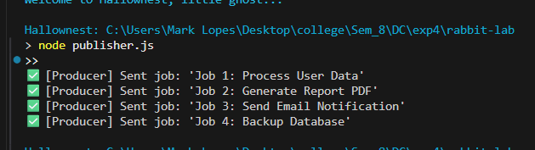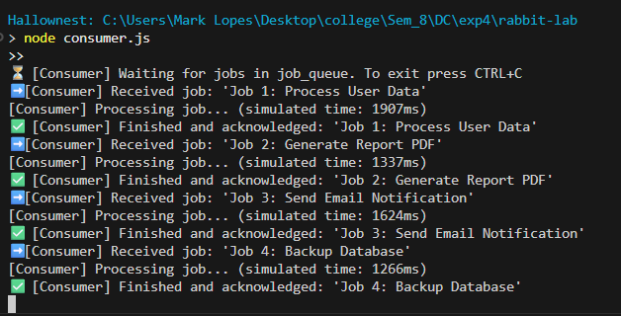
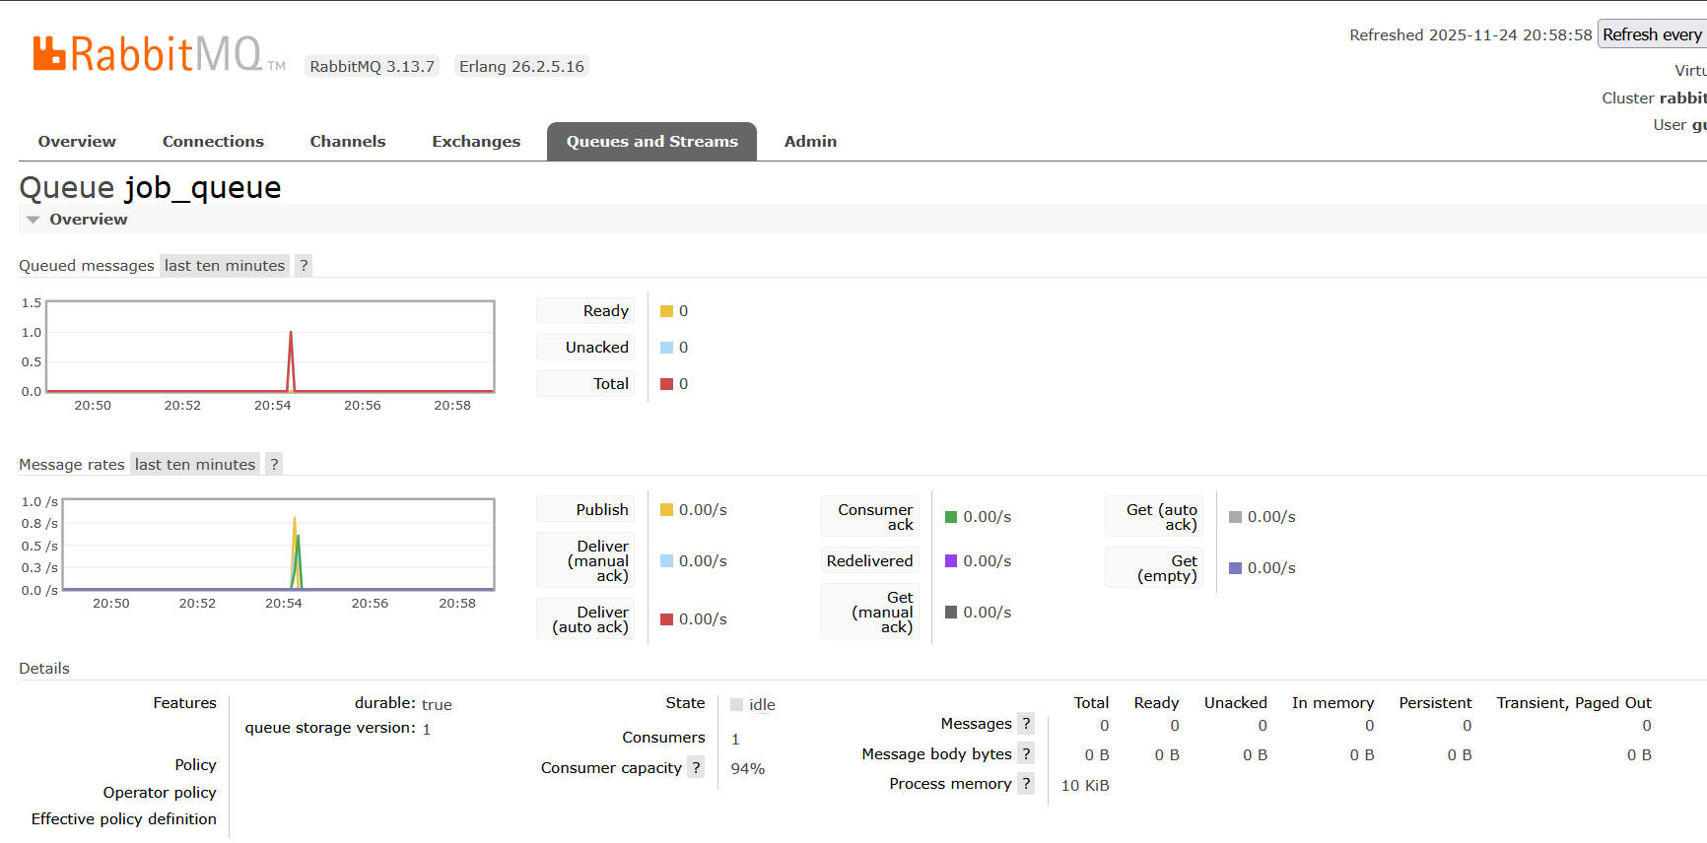

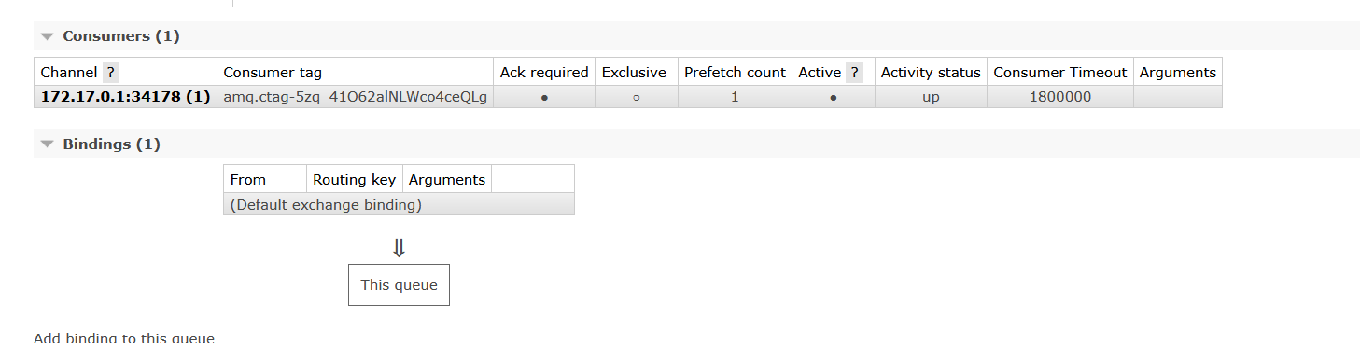

Conclusion:
This lab successfully implemented a basic, yet robust, message-passing system using Node.js and the RabbitMQ broker. By utilizing key RabbitMQ concepts—the Queue, Publisher (Producer), and Consumer—we achieved Decoupling, Asyncrnonity and persistence.

Postlab:

1) What is message queuing?
Message queuing is a software pattern that enables asynchronous communication between different parts of a distributed system. It allows a producer to send a message to a queue and immediately continue its work without waiting for the consumer to respond. This helps in decoupling the services and ensures smooth, independent operation of different system components.

2) What are the benefits of message queuing?
Message queuing makes producers and consumers independent, so even if one service fails, the other continues to work without being affected. If the consumer service is unavailable, the message is not lost and simply waits in the queue until it can be processed. It also helps in handling traffic spikes by queueing extra messages and preventing consumer services from becoming overloaded.

