FR. CONCEICAO RODRIGUES COLLEGE OF ENGINEERING
Department of Computer Engineering
Academic Year 2025-26

Rubrics for Lab Experiments

Class : B.E. Computer Subject Name :BDA Lab Engineering
Semester : VII Subject Code :CSL702

Practical No: | 2
Title: | Hands on Hadoop HDFS
Date of Performance: | 15/07/2025
Roll No: | 9913
Name of the Student: | Mark Lopes
Evaluation:

Performance  Indicator | Below average | Average | Good | Excellent | Marks
On time  Submission (2) | Not submitted  (0) | Submitted after deadline (1) | Early or on time submission(2) | ---
Test cases and output  (4) | Incorr ect output  (1) | The expected output is verified only a for few test cases (2) | The expected  output is Verified for all test cases but is not  presentable (3) | Expected output is obtained for all test cases. Presentable and easy to follow  (4)
Coding efficiency (2) | The code is not  structured at all (0) | The code is structured but not efficient (1) | The code is Structured and efficient.  (2) | -
Knowledge(2) | Basic concepts not clear  (0) | Understood the basic concepts  (1) | Could explain the concept with suitable example (1.5) | Could relate the theory with real world application(2)
Total

Experiment No 2
Aim: Hands on Hadoop HDFS
Objective:
The objective of this lab experiment is to provide hands-on experience with Hadoop
Distributed File System (HDFS). Students will learn how to interact with HDFS, manage
files and directories, understand replication and fault tolerance, and perform basic
administrative tasks.
Tools and Technologies:
● Hadoop: Specifically focusing on HDFS (Hadoop Distributed File System).
● Virtual or physical machines capable of running a Linux distribution (e.g., Ubuntu, CentOS).
Pre-requisites:
● Basic understanding of Linux/Unix commands.
● Familiarity with Java programming (helpful but not mandatory).
Equipment Required:
● Virtual or physical machines capable of running a Linux distribution (e.g., Ubuntu, CentOS).
● Sufficient memory and disk space to accommodate Hadoop&#39;s requirements (minimum of 4GB
RAM recommended per node).
Experiment Steps:
1. Setting Up the Environment:
o Prepare the environment by setting up virtual machines (VMs) or physical machines
with a Linux distribution (e.g., Ubuntu Server).
o Ensure that each machine has a static IP address and can communicate with each
other over the network.

2. Installing Java Development Kit (JDK):
o Hadoop requires Java, so install JDK on all machines that will be part of the Hadoop
cluster.
o Example command to install OpenJDK:
bash
Copy code
sudo apt-get update
sudo apt-get install openjdk-8-jdk
3. Downloading and Extracting Hadoop:
o Download the desired version of Hadoop from the Apache Hadoop website
(https://hadoop.apache.org/releases.html).
o Extract the downloaded Hadoop tarball to a suitable directory on each machine in
your cluster.
bash
Copy code
tar -xzvf hadoop-3.x.x.tar.gz -C /opt

4. Configuring Hadoop Environment Variables:
o Set up Hadoop environment variables in the .bashrc or .bash_profile file for each user:
bash
Copy code
export HADOOP_HOME=/opt/hadoop-3.x.x
export PATH=$PATH:$HADOOP_HOME/bin:$HADOOP_HOME/sbin

5. Configuring HDFS:
o Navigate to the Hadoop configuration directory ($HADOOP_HOME/etc/hadoop)
and edit core-site.xml and hdfs-site.xml files.
o core-site.xml:
xml
Copy code
&lt;configuration&gt;
&lt;property&gt;
&lt;name&gt;fs.defaultFS&lt;/name&gt;
&lt;value&gt;hdfs://namenode_host:9000&lt;/value&gt;
&lt;/property&gt;
&lt;/configuration&gt;
o hdfs-site.xml:
xml
Copy code
&lt;configuration&gt;
&lt;property&gt;
&lt;name&gt;dfs.replication&lt;/name&gt;
&lt;value&gt;3&lt;/value&gt; &lt;!-- Adjust replication factor as needed --&gt;
&lt;/property&gt;
&lt;/configuration&gt;

6. Formatting HDFS Namenode:
o Before starting HDFS, format the namenode to initialize the filesystem metadata:
bash
Copy code
hdfs namenode -format
7. Starting HDFS Services:
o Start HDFS services using the provided scripts:
bash
Copy code
start-dfs.sh
8. Interacting with HDFS:
o Use Hadoop commands (hdfs dfs) to interact with HDFS:
▪ Creating a directory in HDFS:
bash
Copy code
hdfs dfs -mkdir /user
▪ Copying files from local filesystem to HDFS:

bash
Copy code
hdfs dfs -put /local/path/to/file /hdfs/path/
▪ Listing files in a directory in HDFS:
bash
Copy code
hdfs dfs -ls /hdfs/path/
▪ Reading files from HDFS:
bash
Copy code
hdfs dfs -cat /hdfs/path/to/file

9. Understanding Replication and Fault Tolerance:
o Discuss the concept of replication factor and how it ensures fault tolerance.
o Simulate a failure scenario (e.g., shutdown a datanode) and observe how HDFS
maintains data availability.
10. Stopping HDFS Services:
o Stop HDFS services when done experimenting:
bash
Copy code
stop-dfs.sh

11. Observations and Conclusion:
o Document any issues encountered during setup and how they were resolved.
o Discuss the benefits of using HDFS for storing and managing large datasets.
o Reflect on the role of HDFS in the Hadoop ecosystem and its importance in big data
processing.
Expected Outcome:
By the end of this experiment, students should have a solid understanding of how HDFS
operates within a Hadoop cluster. They should be able to perform basic administrative tasks
such as creating directories, copying files, and understanding replication strategies. Students
should also gain insights into HDFS&#39;s fault tolerance mechanisms and its role in supporting
distributed data storage.

Conclusion:
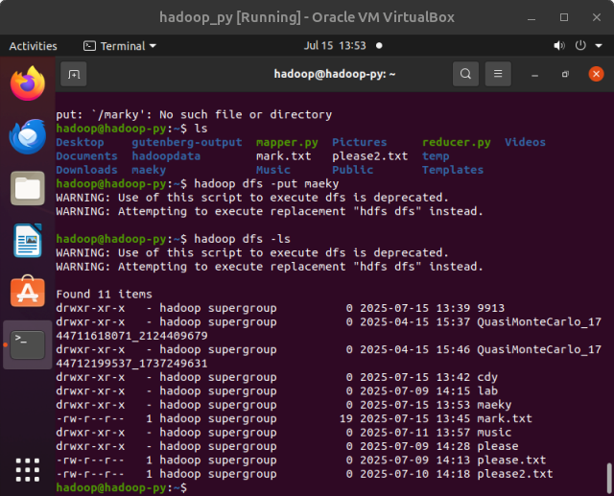
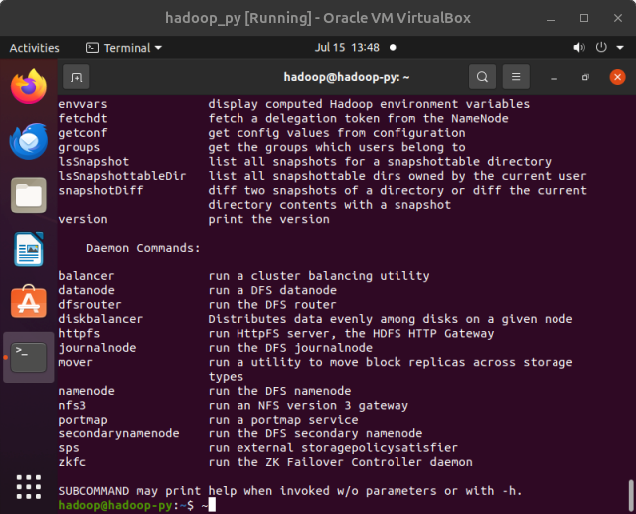
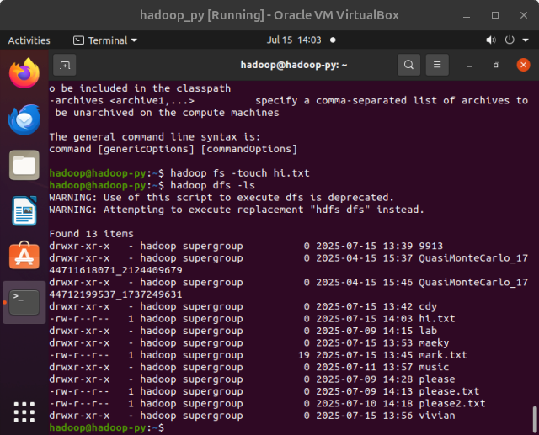
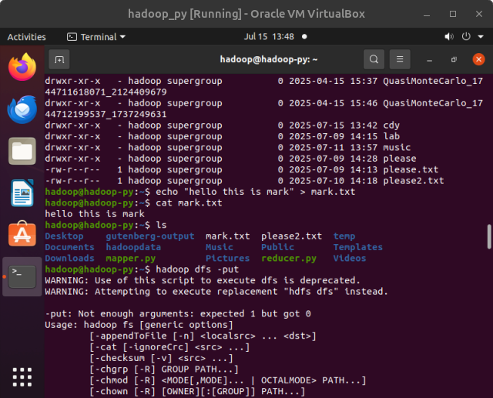
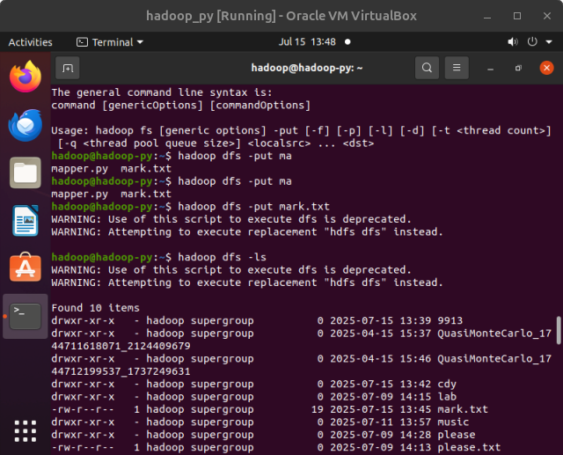
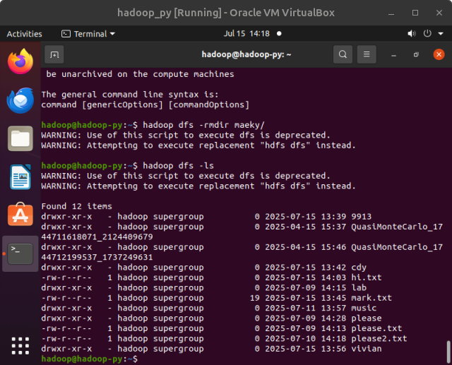
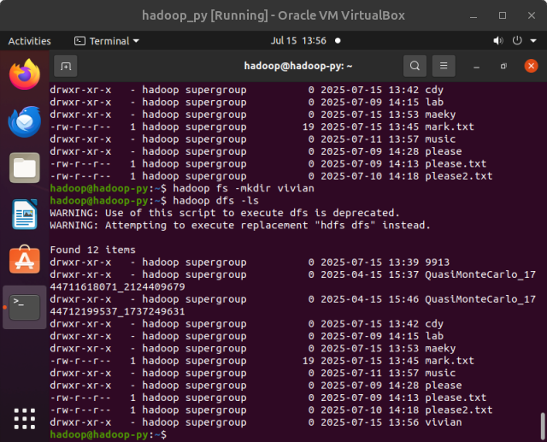
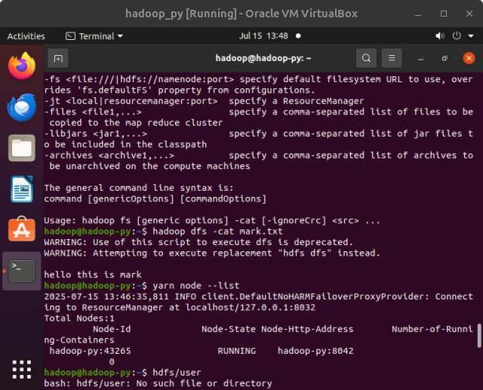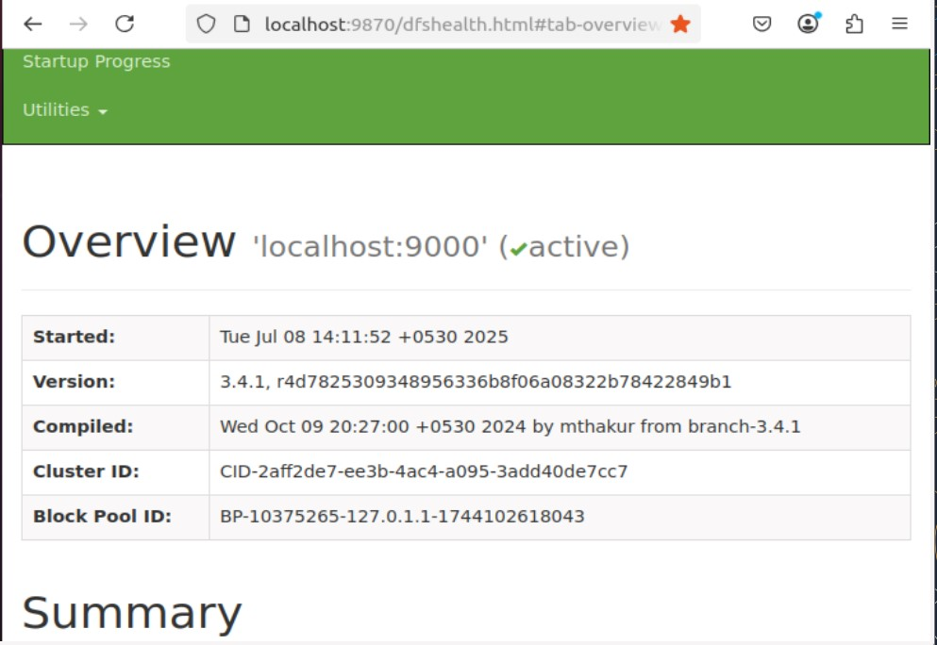
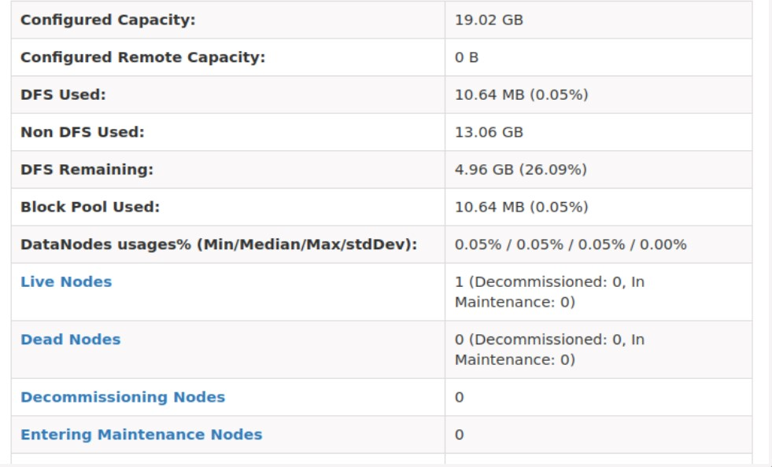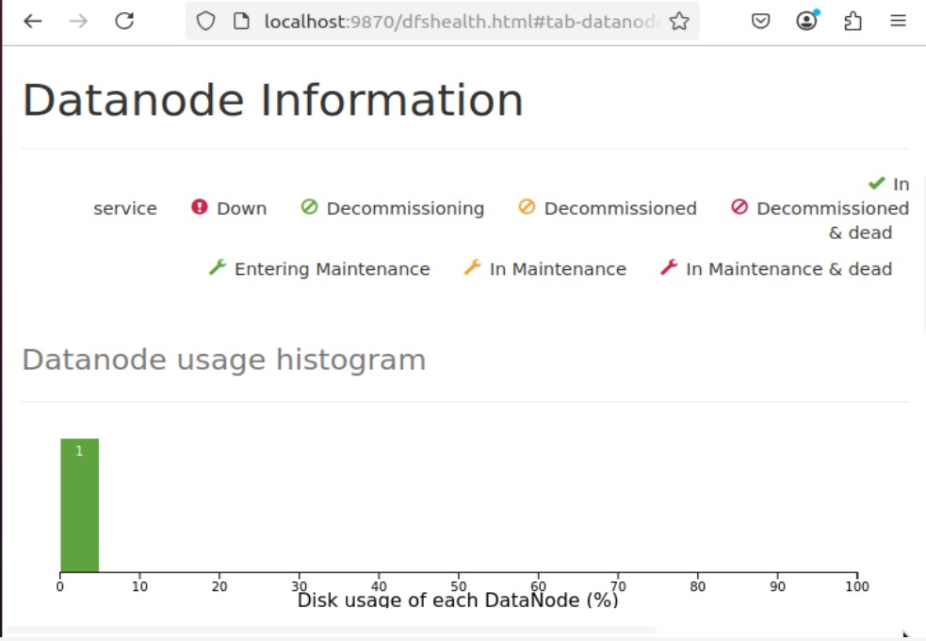
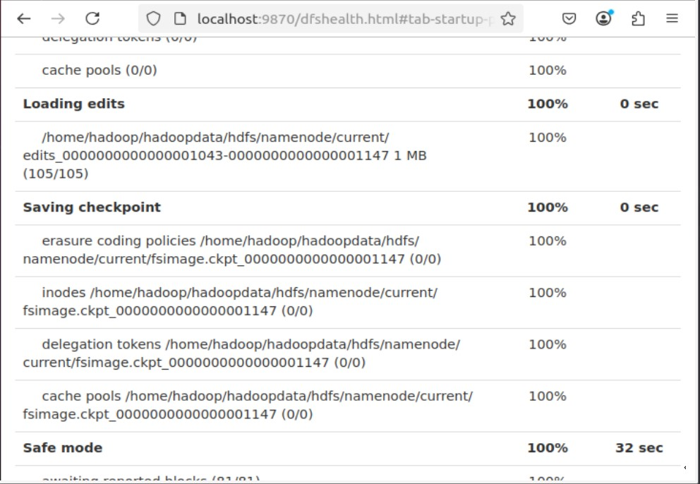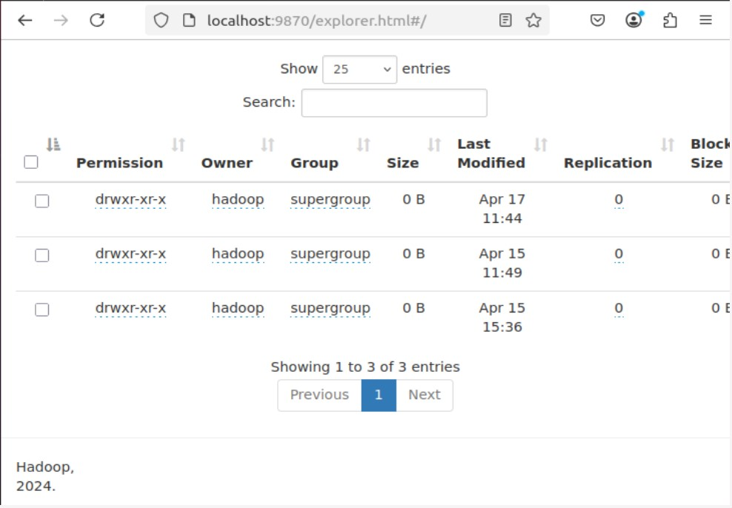

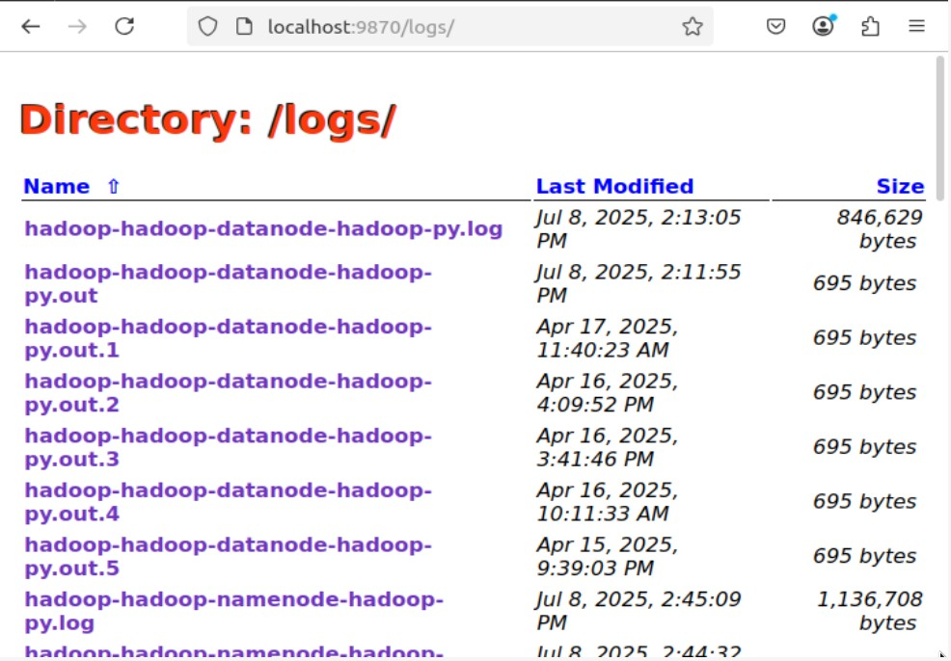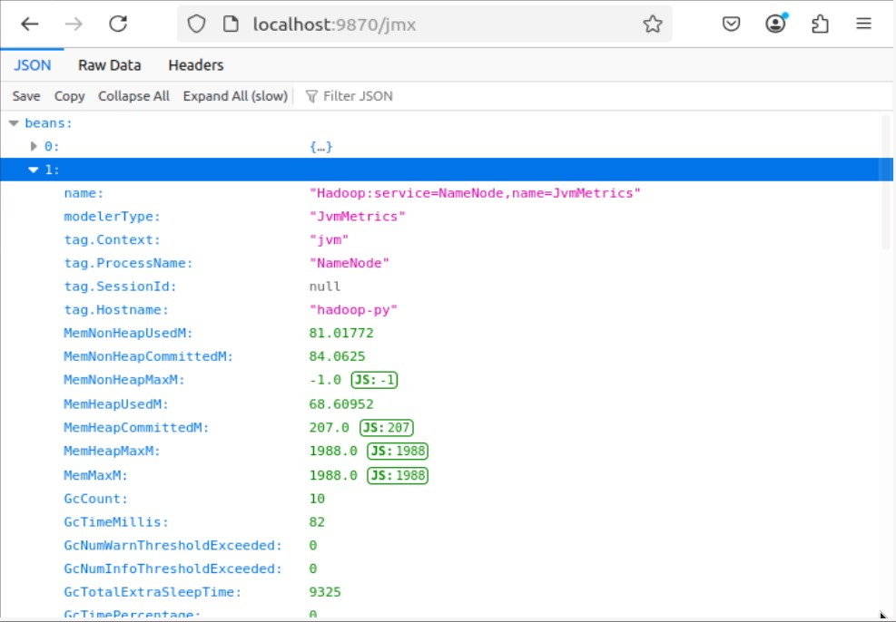

Postlab:-
1. What are the main components of a Hadoop application?
HDFS (Hadoop Distributed File System):
Stores large files across multiple machines with fault tolerance using replication.
YARN (Yet Another Resource Negotiator):
Manages cluster resources and job scheduling.
MapReduce:
A programming model used for distributed data processing (map = split, reduce = aggregate).
Hadoop Common:
Provides essential Java libraries and utilities used by other modules.
- Difference between NameNode, Backup Node, and Checkpoint Node:
Component | Function | Real-Time  Sync | Failure Recovery  Role
NameNode | Manages file system metadata like file names, directories, and block locations. | Yes | Acts as the master; essential for HDFS operation.
Backup Node | Maintains an in-memory, up-to-date copy of metadata from the NameNode. | Yes | Can immediately take over if  NameNode fails.
Checkpoint  Node | Periodically downloads and merges fsimage and edits, then sends a new fsimage to NameNode. | No | Reduces NameNode  startup time, not used for failover.

- Explain the use of cat, du, du -s:
  - cat (concatenate):
Used to view the contents of files in the terminal. Example: cat file.txt

  - du (disk usage):
Shows the space used by files and directories. Example: du myfolder/

  - du -s (summary):
Displays the total size of a folder, instead of listing all subdirectories. Example: du
-s myfolder/

