FR. CONCEICAO RODRIGUES COLLEGE OF ENGINEERING
Department of Computer Engineering Academic Year 2025-2026

Rubrics for Lab Exp eriments

Class: | B.E. Computer  Engineering | Subject Name: | SMA Lab
Semster: | VIII | Subject Code: | CSDL8023

Practical No. | 4
Title: | Exploratory Data Analysis and visualization of Social Media Data for business.
Date of Performance: | 28-11-2025
Roll No. | 9913
Student | Mark Lopes
Evaluation

Performance  Indicator | Below  Average | Average | Good | Excellent | Marks
On Time Submission (2) | Not submitted(0) | Submitted after  deadline (1) | Early or on time submission (2) | —
Test cases and output (4) | Incorrect output (1) | The expected output is verified only a for few test  cases (2) | The expected output is Verified for all test cases but is not  presentable (3) | Expected output is obtained for all test cases.  Presentable and  easy to follow (4)
Coding efficiency (2) | The code is not structured at  all (0) | The code is structured but not  efficient (1) | The code is Structured and efficient. (2) | -
Knowledge(2) | Basic concepts not clear (0) | Understood the basic concepts (1) | Could explain the concept with suitable example  (1.5) | Could relate the theory with real world  application(2)
Total
Signature of the Teacher:

In [2]:
import pandas as pd
import matplotlib.pyplot as plt import plotly.express as px import warnings warnings.filterwarnings('ignore')

#
# 1. MANUALLY CREATED SAMPLE DATASET #

data = {
"Tweet_ID": range(1, 31), "Entity": [
"PlayStation","Xbox","Nintendo","Steam","Valorant","Fortnite", "PlayStation","Xbox","Nintendo","Steam","Valorant","Fortnite", "PlayStation","Xbox","Nintendo","Steam","Valorant","Fortnite", "PlayStation","Xbox","Nintendo","Steam","Valorant","Fortnite", "PlayStation","Xbox","Nintendo","Steam","Valorant","Fortnite"
],
"Sentiment": [ "Positive","Negative","Neutral","Positive","Negative","Positive", "Neutral","Positive","Positive","Neutral","Negative","Neutral", "Negative","Positive","Neutral","Positive","Positive","Negative", "Neutral","Neutral","Positive","Negative","Positive","Neutral", "Positive","Negative","Positive","Neutral","Negative","Positive"
],
"Tweet_Content": [
"Great console!", "Bad experience", "Okay product", "Loved it", "Laggy game "Fine", "Super smooth", "Very fun", "Decent", "Unstable servers", "Good", "Not good", "Excellent", "No issues", "Awesome", "Fun gameplay", "Not worki "Alright", "Meh", "Very good", "Poor performance", "Enjoyable", "Good updat "Cool", "Worst service", "Loved it a lot", "Fine game", "Buggy", "Great imp
]
}

df = pd.DataFrame(data) print(df.head())

0
 |  |  |  | Tweet_ID | Entity | Sentiment | Tweet_Content
 |  |  |  | 1 | PlayStation | Positive | Great console!
 |  |  |  | 2 | Xbox | Negative | Bad experience
 |  |  |  | 3 | Nintendo | Neutral | Okay product
 |  |  |  | 4 | Steam | Positive | Loved it
 |  |  |  | 5 | Valorant | Negative | Laggy game
In | [3]: |  | #
# Select Top 6 Entities #
top_entities = df['Entity'].value_counts().head(6).index df_filtered = df[df['Entity'].isin(top_entities)]

print("\nTop Entities:", top_entities.tolist())

1
2
3
4

Top Entities: ['PlayStation', 'Xbox', 'Nintendo', 'Steam', 'Valorant', 'Fortnite']

In [4]:
#
# 3.1 PIE CHART – SENTIMENT DISTRIBUTION #

plt.figure(figsize=(8,8))
sentiment_counts = df['Sentiment'].value_counts()

plt.pie(sentiment_counts.values, labels=sentiment_counts.index, autopct='%1.1f%%',
colors=['#ff9999','#66b3ff','#99ff99','#ffcc99'], startangle=90)

plt.title('Overall Sentiment Distribution') plt.axis('equal')
plt.show()

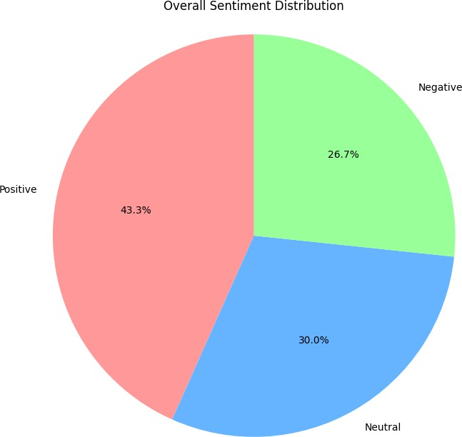

In [5]:
#
# 3.2 STACKED AREA CHART – BY ENTITY #

pivot_stacked = pd.crosstab(df_filtered['Entity'], df_filtered['Sentiment']) pivot_stacked = pivot_stacked.reindex(top_entities)

pivot_stacked.plot(kind='area',
stacked=True, figsize=(12,6),
color=['#ff9999','#66b3ff','#99ff99','#ffcc99'])

plt.title('Stacked Area Chart: Sentiment by Entity') plt.xlabel('Entity')
plt.ylabel('Tweet Count') plt.xticks(rotation=45) plt.tight_layout() plt.show()

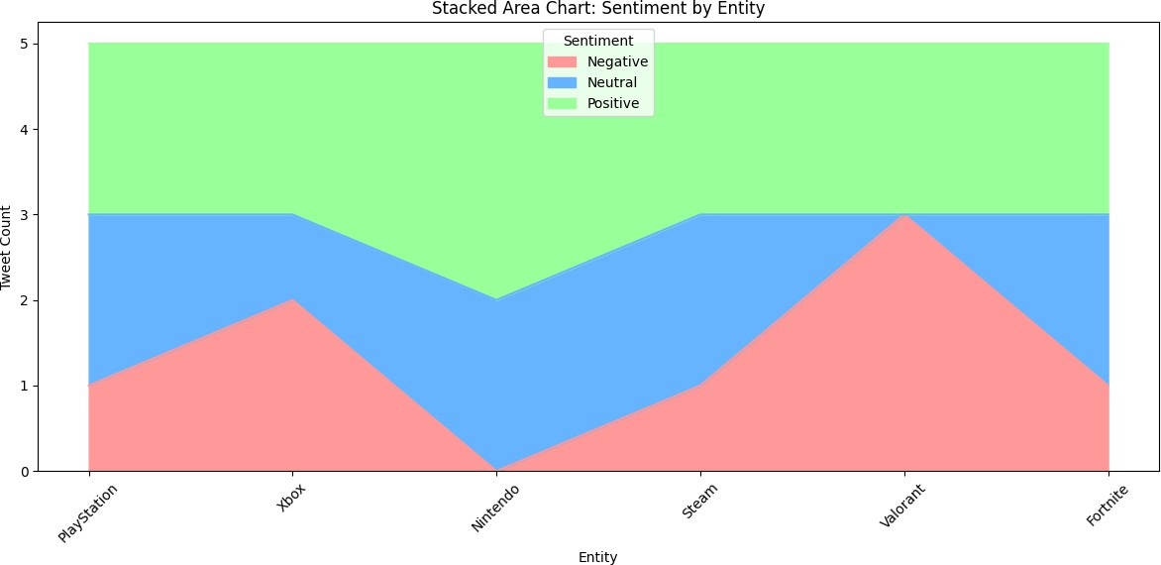

In [6]:
#
# 3.3 RIBBON (CUMULATIVE AREA) CHART #

df_ribbon = df_filtered.groupby(['Entity','Sentiment']).size().unstack(fill_value=0 df_ribbon = df_ribbon.cumsum()

fig = px.area(df_ribbon.reset_index(), x='Entity', y=df_ribbon.columns,
title='Ribbon Chart – Cumulative Sentiment Flow', labels={'value':'Count','variable':'Sentiment'}, color_discrete_sequence=['#ff9999','#66b3ff','#99ff99','#ffcc99'])
fig.show()

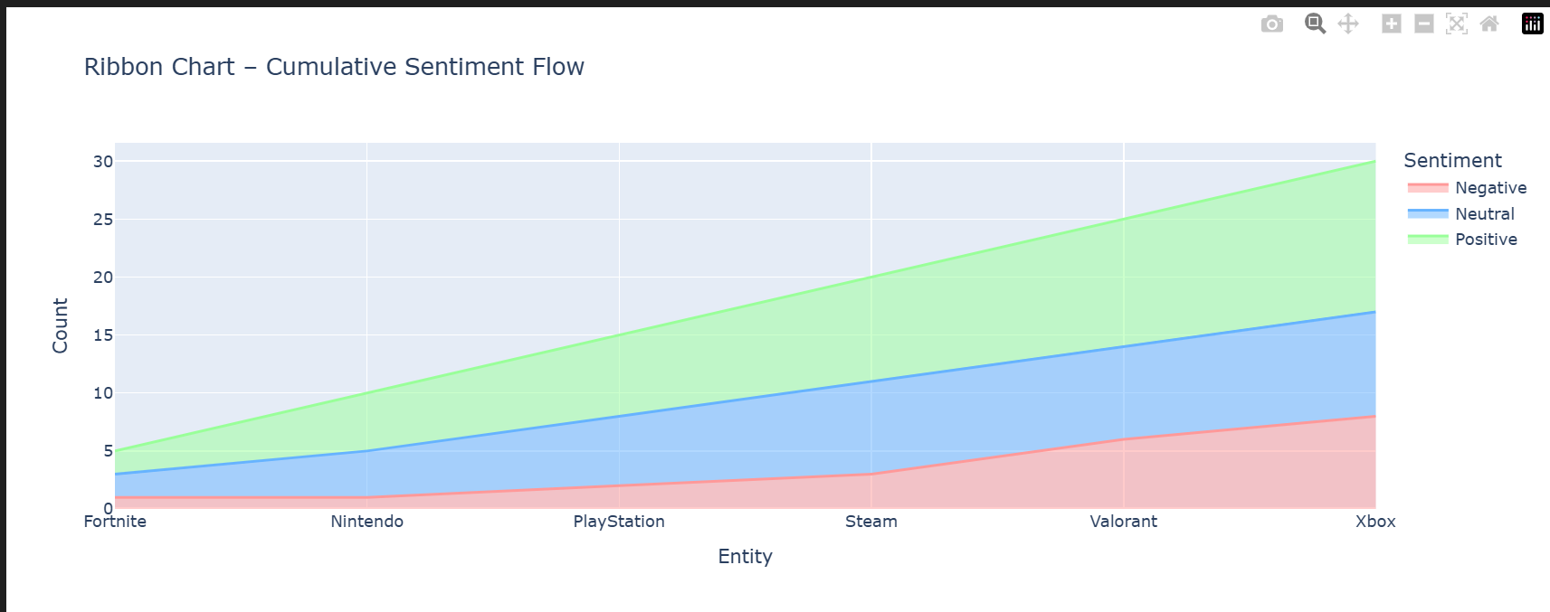

In [7]:
#
# 3.4 TREE MAP – ENTITY → SENTIMENT #

fig = px.treemap(df_filtered,
path=['Entity','Sentiment'], color='Sentiment', color_discrete_map={
'Positive':'#99ff99', 'Negative':'#ff9999', 'Neutral':'#66b3ff'
},
title='Tree Map: Sentiment by Entity')

fig.update_traces(textinfo="label+percent parent+value") fig.show()

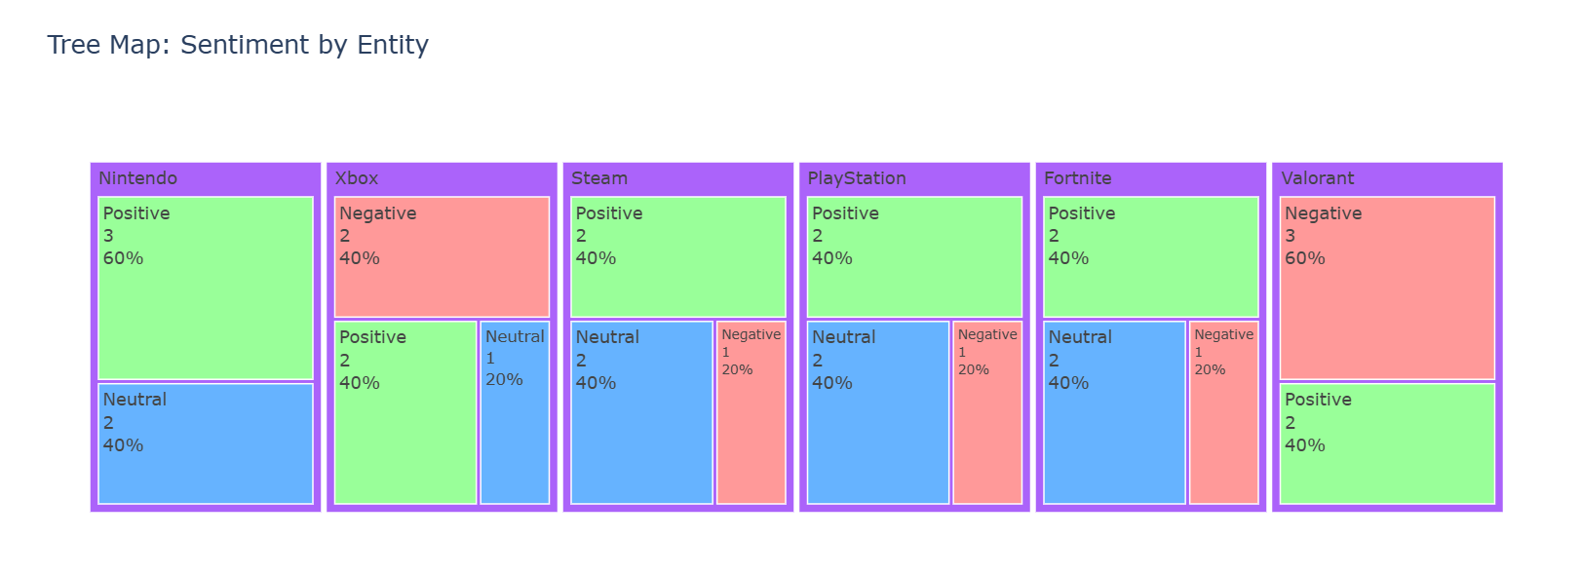

In [8]:
#
# 3.5 FUNNEL CHART – SENTIMENT FILTER #

funnel_data = pd.DataFrame({
'Stage': ['Total Tweets', 'Non-Negative', 'Positive'], 'Count': [
len(df_filtered), len(df_filtered[df_filtered['Sentiment'] != 'Negative']), len(df_filtered[df_filtered['Sentiment'] == 'Positive'])
]
})

fig = px.funnel(funnel_data,
x='Count', y='Stage',
title='Sentiment Funnel Chart')
fig.show()

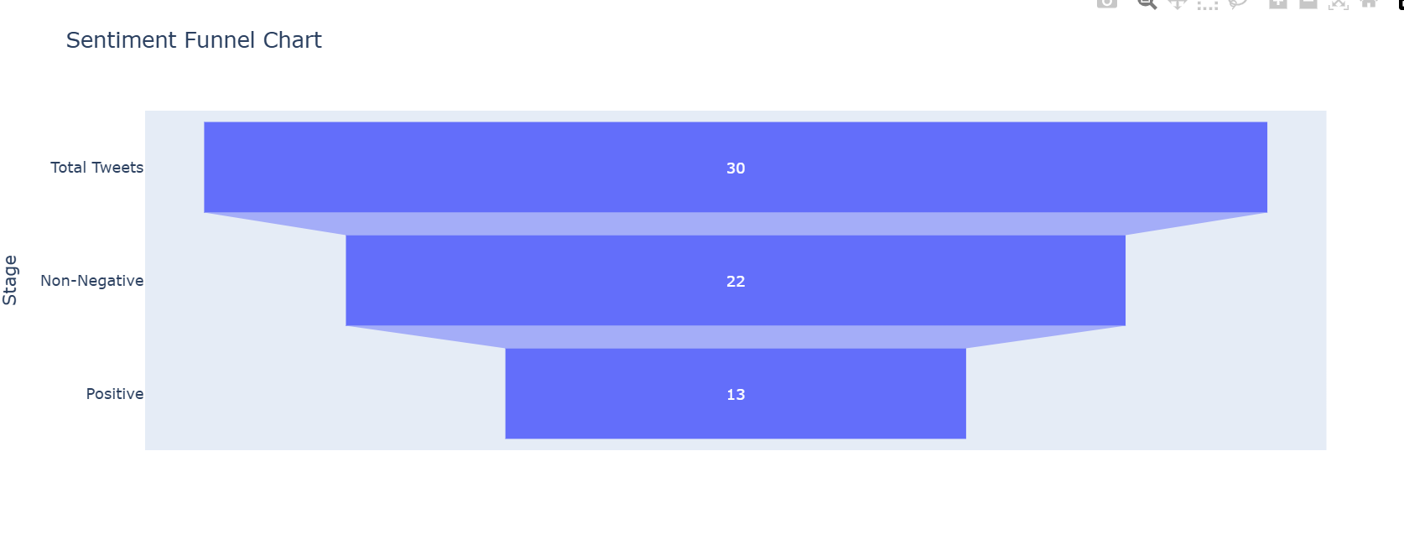
In [9]:
#
# 3.6 LINE CHART – SENTIMENT TREND BY ENTITY #

sentiment_by_entity = df_filtered.groupby(['Entity','Sentiment']).size().unstack(fi sentiment_by_entity = sentiment_by_entity.loc[top_entities]

plt.figure(figsize=(12,6))
for sentiment in sentiment_by_entity.columns: plt.plot(sentiment_by_entity.index,
sentiment_by_entity[sentiment], marker='o',
label=sentiment)

plt.title('Sentiment Trend Across Entities') plt.xlabel('Entity')
plt.ylabel('Tweet Count') plt.xticks(rotation=45) plt.legend()
plt.grid(True, linestyle='--', alpha=0.7) plt.tight_layout()
plt.show()

