FR. CONCEICAO RODRIGUES COLLEGE OF ENGINEERING
Department of Computer Engineering

1. Course , Subject & Experiment Details
Academic Year | 2024-25 | Estimated Time | 03 - Hours
Course & Semester | T.E. (CMPN)- Sem VI | Subject Name & Code | CSS – CSC602
Chapter No. | 02 – Mapped to CO2,CO3 | Chapter Title | Basics of Cryptography

Practical No: | 7
Title: | Implementation and analysis of RSA cryptosystem and Digital signature scheme using RSA.
Date of Performance: | 03-04-2025
Date of Submission: | 27-04-2025
Roll No: | 9913
Name of the Student: | Mark Lopes

Evaluation:
Sr. No | Rubric | Grade
1 | On time submission Or completion (2)
2 | Preparedness(2)
3 | Skill (4)
4 | Output (2)

Signature of the Teacher:

Date:

Lab Manual Prepared by : Prof. Monali Shetty
Title: Implementation and analysis of RSA cryptosystem and Digital signature scheme using RSA/ElGamal.

Lab Objective:

This lab provides insight into:
- How the public-key algorithms work and understand the working of RSA.
Reference : “Cryptography and Network Security” B. A. Forouzan “Information Security Principles and Practice” Mark Stamp “Cryptography and Network Security” Atul Kahate

Prerequisite : Any programming language and Knowledge of Ciphering .

Theory:

To overcome the problems faced in symmetric key algorithms, people have chosen Asymmetric Key algorithms for communication. Communication with Asymmetric algorithms will give us transmission of information without exchanging the key.

Public-key cryptography refers to a cryptographic system requiring two separate keys, one of which is secret and one of which is public. Public-key cryptography is widely used. It is an approach used by many cryptographic algorithms and cryptosystems. It underpins such Internet standards as Transport Layer Security(TLS), PGP, and GPG. RSA and Diffie–Hellman key exchange are the most widely used public key distribution systems, while the Digital Signature Algorithm is the most widely used digital signature system. Asymmetric algorithms which are mostly used are RSA cryptosystem and ElGamal Cryptosystem.

The RSA algorithm is the most commonly used encryption and authentication algorithm and is included as part of the Web browsers from Microsoft and Netscape.RSA is an algorithm for public key cryptography that is based on the presumed difficulty of factoring large integers, the factoring problem.The RSA algorithm involves threesteps: key generation, encryption and decryption.

ElGamal System is a public-key cryptosystem based on the discrete logarithm problem. It consists of both encryption and Signature algorithms. ElGamal encryption is used in the free GNU Privacy Guard software, recent versions of PGP, and other cryptosystems. ElGamal encryption consists of three components: the key generator, the encryptionalgorithm, and the decryption algorithm.

ALGORITHM RSA

Lab Manual Prepared by : Prof. Monali Shetty
Example of RSA

>> Generating Public Key :
- Select two prime no's. Suppose P = 53 and Q = 59. Now First part of the Public key : n = P*Q = 3127.
- We also need a small exponent say e :But e Must be

An integer.
Not be a factor of n.

1 < e < Φ(n) *Φ(n) is discussed below+, Let us now consider it to be equal to 3.
- Our Public Key is made of n and e

>> Generating Private Key:

Lab Manual Prepared by : Prof. Monali Shetty

We need to calculate Φ(n) : Such that Φ(n) = (P-1)(Q 1) so, Φ(n) = 3016
Now calculate Private Key, d :
d = (k*Φ(n) + 1) / e for some integer
kFor k = 2, value of d is 201

Now we are ready with our – Public Key ( n = 3127 and e = 3) and Private Key(d = 2011)Now we will encrypt “HI” :

- Convert letters to numbers : H = 8 and I = 9
- Thus Encrypted Data c = 89e mod n.
Thus our Encrypted Data comes out to be 1394

Now we will decrypt 1349 :
- Decrypted Data = c^{d} mod n.
Thus our Encrypted Data comes out to be 89
8 = H and I = 9 i.e. "HI".


Conclusion:
The program was tested for different sets of inputs.
Program is working SATISFACTORY NOT SATISFACTORY ( Tick
appropriate outcome)


Post Lab Assignment:
Test above an experiment to estimate the amount of time to
- Generate key pair (RSA )
- Encrypt n bit message (RSA)
- Decrypt n bit message (RSA)
As function of key size, experiment with different n-bit messages. Summarize your Conclusion.

Lab Manual Prepared by : Prof. Monali Shetty Lab Manual Prepared by : Prof. Monali Shetty

Rsa_Server.py

import socket import hashlib

def power(base, expo, m): res = 1
base = base % m while expo > 0:
if expo & 1:
res = (res * base) % m base = (base * base) % m expo //= 2
return res

def modInverse(e, phi): for d in range(2, phi):
if (e * d) % phi == 1: return d
return -1

def gcd(a, b): while b:
a, b = b, a % b return a

def generateKeys(p, q): n = p * q
phi = (p - 1) * (q - 1)
e = next(i for i in range(2, phi) if gcd(i, phi) == 1) d = modInverse(e, phi)
return e, d, n

def encrypt(m, e, n): return power(m, e, n)

def decrypt(c, d, n): return power(c, d, n)

def text_to_number(text):
return ' '.join(str(ord(c)) for c in text)

def number_to_text(number_str):
return ''.join(chr(int(n)) for n in number_str.split())

def encrypt_text(text, e, n): num_str = text_to_number(text)
encrypted_numbers = [str(encrypt(int(num), e, n)) for num in num_str.split()]

return ' '.join(encrypted_numbers)

p_server, q_server = 7919, 1009
e_server, d_server, n_server = generateKeys(p_server, q_server)

server_socket = socket.socket(socket.AF_INET, socket.SOCK_STREAM) server_socket.bind(('0.0.0.0', 12345))
server_socket.listen(1)

conn, addr = server_socket.accept()
conn.send(f"{e_server},{n_server}".encode()) client_key_data = conn.recv(4096).decode()
e_client, n_client = map(int, client_key_data.split(','))

message = "This is a secure message from the server." hashed_msg = hashlib.md5(message.encode()).hexdigest()

encrypted_message = encrypt_text(message, e_client, n_client) print("Encrypted message: ", encrypted_message)
signature = encrypt_text(hashed_msg, d_server, n_server) print("Digital Signature: ", signature)
conn.send(f"{encrypted_message}||{signature}".encode()) conn.close()
server_socket.close()

Rsa_Client.py:

import socket import hashlib

def power(base, expo, m): res = 1
base = base % m while expo > 0:
if expo & 1:
res = (res * base) % m base = (base * base) % m expo //= 2
return res

def modInverse(e, phi): for d in range(2, phi):
if (e * d) % phi == 1: return d
return -1

def gcd(a, b): while b:
a, b = b, a % b return a

def generateKeys(p, q): n = p * q
phi = (p - 1) * (q - 1)
e = next(i for i in range(2, phi) if gcd(i, phi) == 1) d = modInverse(e, phi)
return e, d, n

def encrypt(m, e, n): return power(m, e, n)

def decrypt(c, d, n): return power(c, d, n)

def text_to_number(text):
return ' '.join(str(ord(c)) for c in text)

def number_to_text(number_str):
return ''.join(chr(int(n)) for n in number_str.split())

def encrypt_text(text, e, n): num_str = text_to_number(text)

encrypted_numbers = [str(encrypt(int(num), e, n)) for num in num_str.split()] return ' '.join(encrypted_numbers)

def decrypt_text(encrypted_str, d, n): encrypted_numbers = encrypted_str.split()
decrypted_numbers = [str(decrypt(int(num), d, n)) for num in encrypted_numbers]
return number_to_text(' '.join(decrypted_numbers))

p_client, q_client = 7877, 1013
e_client, d_client, n_client = generateKeys(p_client, q_client)

client_socket = socket.socket(socket.AF_INET, socket.SOCK_STREAM) client_socket.connect(('127.0.0.1', 12345))

server_key_data = client_socket.recv(4096).decode() e_server, n_server = map(int, server_key_data.split(','))

client_socket.send(f"{e_client},{n_client}".encode())

data = client_socket.recv(8192).decode() encrypted_message, signature = data.split('||') print("Received data: ", data)

message = decrypt_text(encrypted_message, d_client, n_client) print("Decrypted message: ", message)
# message += "!"

hashed_msg = hashlib.md5(message.encode()).hexdigest() print("Message hashed value: ", hashed_msg)

decrypted_signature = decrypt_text(signature, e_server, n_server) print("Digital Signature hashed: ", decrypted_signature)

if hashed_msg == decrypted_signature: print(f"Verified message: {message}")
else:
print("Signature verification failed.") client_socket.close()

OUTPUT:

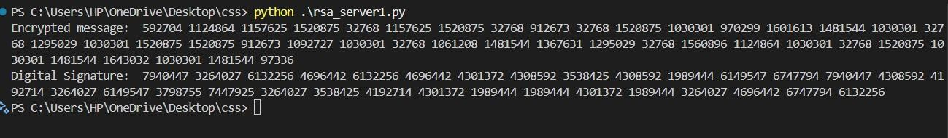
Server.py

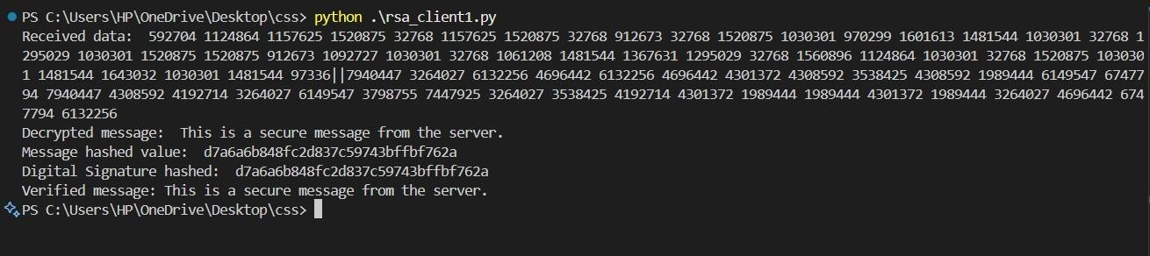
Client.py

