Department of Computer Engineering Academic Term : Jan-Apr 2023
Class : T.E Computer Sem -VI
Subject : Mobile Computing
Practical No: | 5
Title: | To implement a basic function of Code Division Multiple Access (CDMA) to test the orthogonality and autocorrelation of a code to be used for CDMA operation
Date of Performance: | 31/03/2025
Date of Submission: | 27/04/2025
Roll No: | 9913
Name of the Student: | Mark Lopes

Evaluation:
Sr. No | Rubric | Grade
1 | On time Completion & Submission(2)
2 | Output(3)
3 | Code Optimization(3)
4 | Knowledge of the topic(2)
5 | Total (10)

Signature of the Teacher :

ExperimentNo.:5
Aim: Theory:To implement a basic function of Code Division Multiple Access (CDMA) to test the orthogonality and autocorrelation of a code to be used for CDMA operation. Write an application based on the above concept.

Code-division multiple access (CDMA) is a channel access method used byvarious radio communication technologies. CDMA is an example of multiple access, whereseveral transmitters can send information simultaneously over a single communication channel.This allows several users to share a band of frequencies (see bandwidth). To permit this

withoutundue interference between the users, CDMA employs spread spectrum technology and a specialcodingscheme(whereeachtransmitteris assignedacode).
CDMAisusedastheaccessmethodinmany mobilephonestandards. IS-95,alsocalled"cdmaOne", and its 3G evolution CDMA2000, are often simply referred to as "CDMA",but UMTS, the 3G standard used by GSM carriers, also uses "wideband CDMA", or W-CDMA,aswellasTD-CDMAandTD-SCDMA, asitsradio technologies.
The intended 4G successor to CDMA2000 was UMB (Ultra Mobile Broadband); however, inNovember2008, Qualcomm announceditwasendingdevelopmentofthetechnology,favoringLTEinstead
CDMAOrthogonality:
Techniquesgenerallyusedaredirectsequencespreadspectrummodulation(DS-CDMA),frequenc y hopping or mixed CDMA detection (JDCDMA). Here, a signal is generated whichextends over a wide bandwidth. A code called spreading code is used to perform this action.Using a group of codes, which are orthogonal to each other, it is possible to select a signal with agivencodeinthepresence ofmanyothersignals withdifferent orthogonalcodes.
CDMAAutocorrelation:
Autocorrelation of the sequence, it determines the ability to synchronize and lock the spreadingcodeforthereceivedsignal.

https://www.youtube.com/watch?v=UzLUJuvNi_U

Conclusion:
Thus, we have studied the CDMA code to test auto correlation and orthogonality of codes and executed the same using the java code as above and got proper output for it. OUTPUT
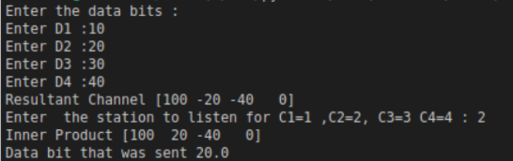
Postlab: OBSERVATION:

