Distributed Computing Exp-1
9913 Mark Lopes
Be Comps A
Client.c
#include <stdio.h>
#include <stdlib.h>
#include <string.h>
#include <winsock2.h>
#include <ws2tcpip.h>
#include <process.h>

#pragma comment(lib, "ws2_32.lib")

#define SERVER_IP "127.0.0.1"
#define PORT 5555
#define BUFFER_SIZE 1024

unsigned __stdcall receive_messages(void *arg) {
SOCKET client_socket = (SOCKET)arg;
char buffer[BUFFER_SIZE];
int recv_len;

while ((recv_len = recv(client_socket, buffer, BUFFER_SIZE, 0)) > 0) {
buffer[recv_len] = '\0';
if (strcmp(buffer, "NICK") == 0) {
// Server is asking for nickname, main thread will handle this
} else {
printf("%s\n", buffer);
}
}
if (recv_len <= 0) {
printf("Disconnected from server.\n");
closesocket(client_socket);
exit(0);
}
return 0;
}

int main() {
WSADATA wsa;
SOCKET client_socket;
struct sockaddr_in server_addr;
char nickname[50];
char message[BUFFER_SIZE];

printf("Choose your nickname: ");
fgets(nickname, 50, stdin);
nickname[strcspn(nickname, "\n")] = 0; // Remove newline

printf("Initialising Winsock...\n");
if (WSAStartup(MAKEWORD(2, 2), &wsa) != 0) {
printf("Failed. Error Code : %d", WSAGetLastError());
return 1;
}
printf("Initialised.\n");

if ((client_socket = socket(AF_INET, SOCK_STREAM, 0)) == INVALID_SOCKET) {
printf("Could not create socket : %d", WSAGetLastError());
}
printf("Socket created.\n");

server_addr.sin_addr.s_addr = inet_addr(SERVER_IP);
server_addr.sin_family = AF_INET;
server_addr.sin_port = htons(PORT);

if (connect(client_socket, (struct sockaddr *)&server_addr, sizeof(server_addr)) < 0) {
puts("connect error");
return 1;
}
puts("Connected");

// Wait for NICK prompt
char server_prompt[5];
int recv_len = recv(client_socket, server_prompt, 4, 0);
if (recv_len > 0) {
server_prompt[recv_len] = '\0';
if (strcmp(server_prompt, "NICK") == 0) {
send(client_socket, nickname, strlen(nickname), 0);
}
}

_beginthreadex(NULL, 0, &receive_messages, (void*)client_socket, 0, NULL);

while (1) {
fgets(message, BUFFER_SIZE, stdin);
message[strcspn(message, "\n")] = 0; // Remove newline
char full_message[BUFFER_SIZE + 52];
sprintf(full_message, "%s: %s", nickname, message);
if (send(client_socket, full_message, strlen(full_message), 0) < 0) {
puts("Send failed");
return 1;
}
}

closesocket(client_socket);
WSACleanup();
return 0;
}

Server.c
#include <stdio.h>
#include <stdlib.h>
#include <string.h>
#include <winsock2.h>
#include <ws2tcpip.h>
#include <process.h>

#pragma comment(lib, "ws2_32.lib")

#define PORT 5555
#define MAX_CLIENTS 10
#define BUFFER_SIZE 1024

typedef struct {
SOCKET socket;
char nickname[50];
} client_t;

client_t *clients[MAX_CLIENTS];
int client_count = 0;

void broadcast(char *message, SOCKET sender_socket) {
for (int i = 0; i < client_count; i++) {
if (clients[i]->socket != sender_socket) {
send(clients[i]->socket, message, strlen(message), 0);
}
}
}

unsigned __stdcall handle_client(void *arg) {
SOCKET client_socket = (SOCKET)arg;
char buffer[BUFFER_SIZE];
int recv_len;

// Get nickname
send(client_socket, "NICK", 4, 0);
recv_len = recv(client_socket, buffer, BUFFER_SIZE, 0);
if (recv_len <= 0) {
closesocket(client_socket);
return 1;
}
buffer[recv_len] = '\0';

int current_client_index = -1;
for(int i=0; i<client_count; ++i){
if(clients[i]->socket == client_socket){
strcpy(clients[i]->nickname, buffer);
current_client_index = i;
break;
}
}

printf("Nickname of client is %s\n", buffer);
char join_msg[128];
sprintf(join_msg, "%s joined the chat!", buffer);
broadcast(join_msg, client_socket);

while ((recv_len = recv(client_socket, buffer, BUFFER_SIZE, 0)) > 0) {
buffer[recv_len] = '\0';
printf("[MESSAGE] %s\n", buffer);
broadcast(buffer, client_socket);
}

closesocket(client_socket);
if(current_client_index != -1){
char leave_msg[128];
sprintf(leave_msg, "%s left the chat.", clients[current_client_index]->nickname);
broadcast(leave_msg, client_socket);
free(clients[current_client_index]);
for(int i = current_client_index; i < client_count - 1; i++){
clients[i] = clients[i+1];
}
client_count--;
}
return 0;
}

int main() {
WSADATA wsa;
SOCKET server_socket, client_socket;
struct sockaddr_in server_addr, client_addr;
int client_addr_len = sizeof(client_addr);

printf("Initialising Winsock...\n");
if (WSAStartup(MAKEWORD(2, 2), &wsa) != 0) {
printf("Failed. Error Code : %d", WSAGetLastError());
return 1;
}
printf("Initialised.\n");

if ((server_socket = socket(AF_INET, SOCK_STREAM, 0)) == INVALID_SOCKET) {
printf("Could not create socket : %d", WSAGetLastError());
}
printf("Socket created.\n");

server_addr.sin_family = AF_INET;
server_addr.sin_addr.s_addr = INADDR_ANY;
server_addr.sin_port = htons(PORT);

if (bind(server_socket, (struct sockaddr *)&server_addr, sizeof(server_addr)) == SOCKET_ERROR) {
printf("Bind failed with error code : %d", WSAGetLastError());
exit(EXIT_FAILURE);
}
puts("Bind done");

listen(server_socket, 3);

puts("Waiting for incoming connections...");

while ((client_socket = accept(server_socket, (struct sockaddr *)&client_addr, &client_addr_len)) != INVALID_SOCKET) {
puts("Connection accepted");

if (client_count < MAX_CLIENTS) {
client_t *new_client = (client_t *)malloc(sizeof(client_t));
new_client->socket = client_socket;
clients[client_count++] = new_client;
_beginthreadex(NULL, 0, &handle_client, (void*)client_socket, 0, NULL);
} else {
char *message = "Server is full.";
send(client_socket, message, strlen(message), 0);
closesocket(client_socket);
}
}

if (client_socket == INVALID_SOCKET) {
printf("accept failed with error code : %d", WSAGetLastError());
return 1;
}

closesocket(server_socket);
WSACleanup();
return 0;
}

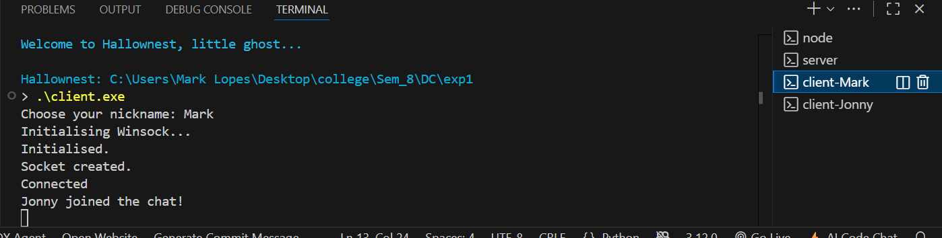
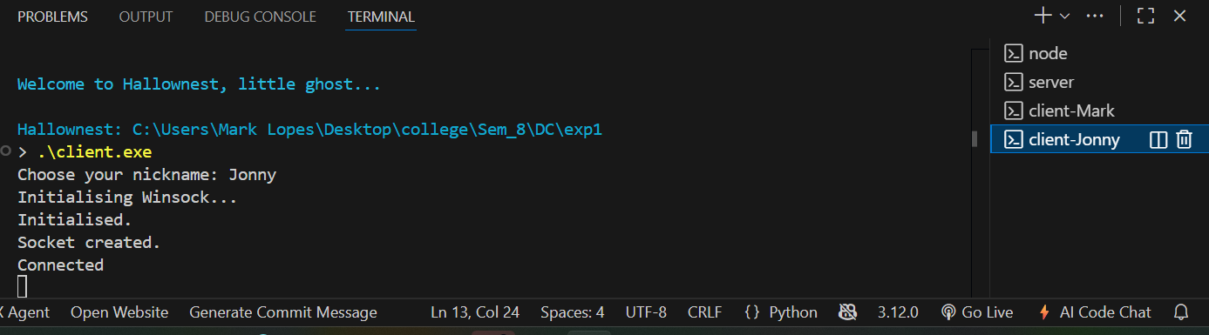
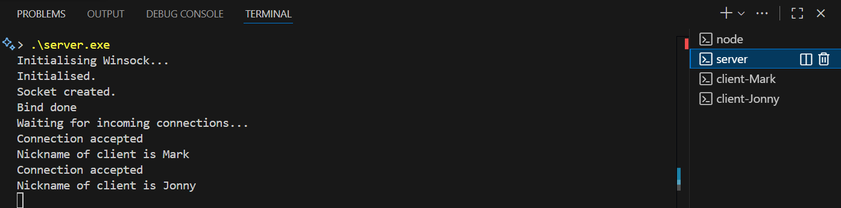
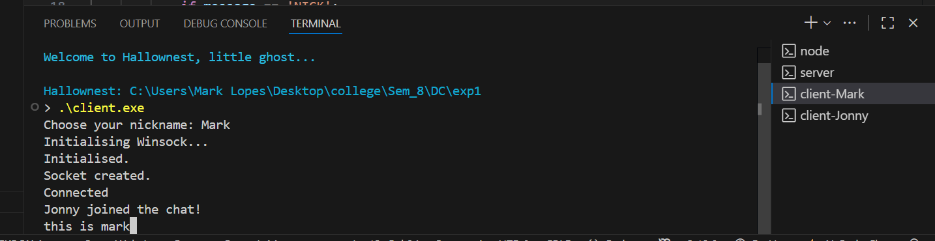
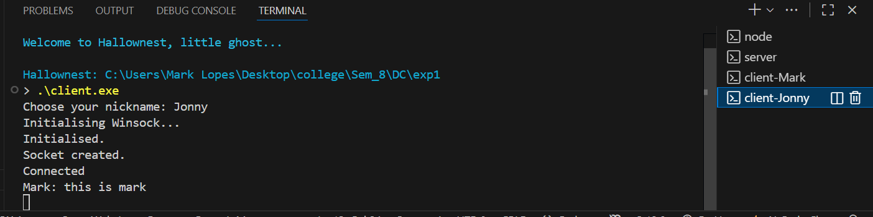
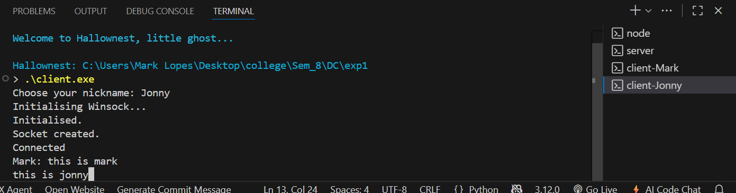
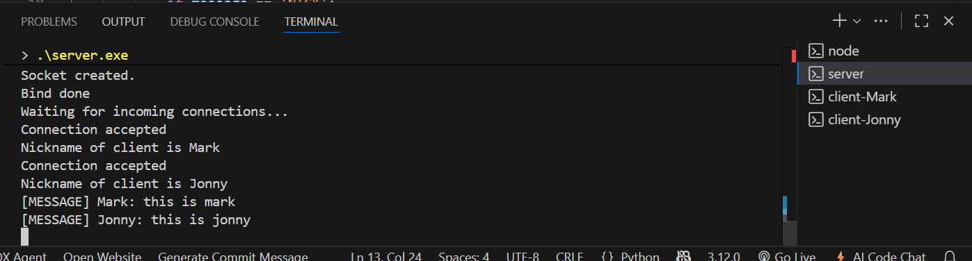
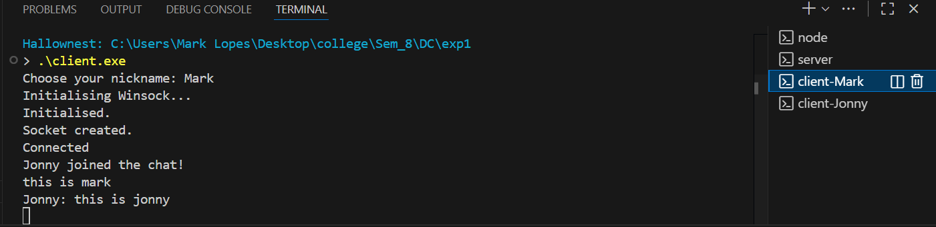
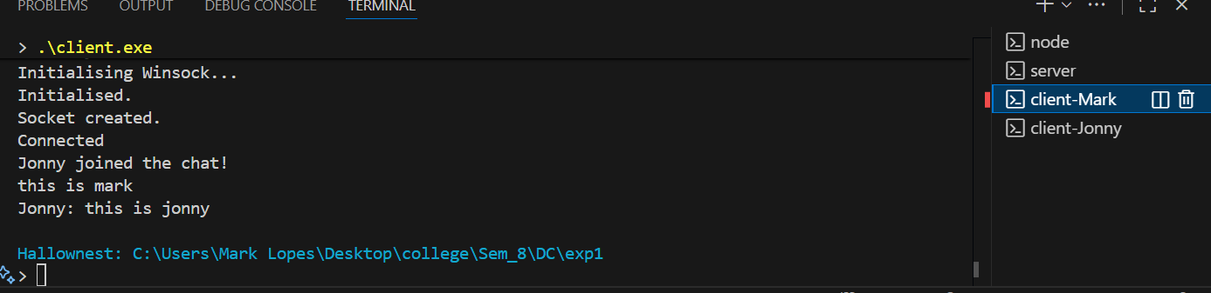
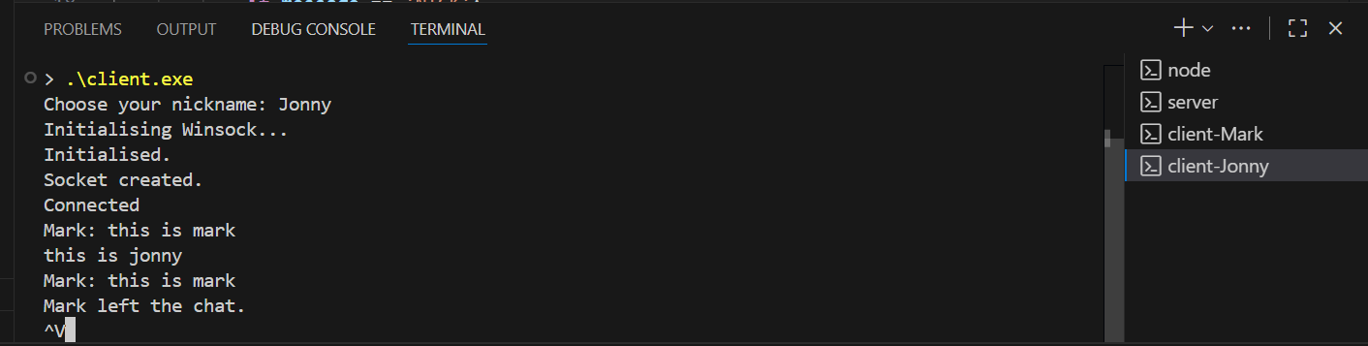

Postlab:-
